Reproduction Study: CNN-Based Hybrid Prediction for Reversible Data Hiding (Zhao et al., 2025)
IIIT Vadodara Internship reproduction pipeline
Original work: Yi Zhao, Yi Peng, Yixiang Fang, Tianzhu Zhang, Junxiang Wang, Circuits, Systems, and Signal Processing, 2025

Abstract—We reproduce the reversible data hiding principle of Zhao et al., which fuses a CNN predictor with conventional predictors (a hybrid) to sharpen the prediction-error histogram for higher capacity. As no trained CNN is available, we substitute the rhombus predictor as a stand-in and reproduce the hybrid-prediction PEE mechanism, its capacity-distortion behaviour, and exact reversibility. The CNN component is approximated, stated openly.
Index Terms—reversible data hiding, prediction-error expansion, CNN, hybrid prediction, high capacity
I. INTRODUCTION
Combining a learned CNN predictor with fast conventional predictors can predict pixels more accurately, sharpening the prediction-error histogram and raising RDH capacity. Zhao et al. propose such a hybrid. Lacking the trained network, this report reproduces the hybrid-prediction PEE mechanism with a fixed predictor as a stand-in and reports the trade-off, clearly labelling the CNN as approximated.
II. RELATED WORK
PEE (Thodi-Rodriguez), sorting+prediction (Sachnev), and PVO are the lineage. CNN predictors (and hybrids with MED/GAP) are a recent trend for sharper error histograms.
III. METHODOLOGY
Pixels are predicted by a hybrid predictor (here the rhombus double-set predictor stands in for the CNN+conventional hybrid); prediction errors are expanded at the innermost bins to embed. A trained CNN hybrid would further sharpen the histogram and raise capacity.
IV. MATHEMATICAL FORMULATION
e = x - x_hat (x_hat from the hybrid predictor); embed at e in {0,-1}; shift larger errors. A sharper hybrid predictor increases near-zero errors and hence capacity. Extraction inverts expansion for exact recovery.
V. ALGORITHM
Embedding
• Predict (CNN+conventional hybrid; stand-in: rhombus).
• Expand PE bins {0,-1} to embed.
Recovery
• Invert passes; restore boundary -> exact image + payload.
VI. EXPERIMENTAL SETUP
Eight 512x512 USC-SIPI grayscale images. The scheme is run for embedding levels 1..3; for each we record payload (bits, bpp), marked-image PSNR and SSIM, and a bit-exact reversibility check. Every reported operating point is auto-reduced to the largest level that is fully reversible.
VII. IMPLEMENTATION DETAILS
The prediction-error core is implemented in NumPy (../_toolkit/pee_rdh.py) using the rhombus double-set predictor: two interleaved pixel sets are embedded in turn, each predicted from the unchanged other set, and prediction errors are expanded at the two innermost bins. Boundary pixels are tracked in a location map. Reversibility is asserted by exact array comparison.
VIII. RESULTS
The reproduced prediction-error scheme embeds 65391 bits (0.24945 bpp) in lena at 48.711 dB, in line with high-capacity PEE literature. Every configuration is bit-exact reversible (image and payload both recovered).
TABLE I. REPRODUCED PEE RESULTS (LEVEL 1)
Image | Payload (bits) | Rate (bpp) | PSNR (dB) | SSIM | Reversible
House | 178786 | 0.68201 | 50.253 | 0.9944 | Yes
Airplane | 95171 | 0.36305 | 49.037 | 0.99367 | Yes
Lena | 65391 | 0.24945 | 48.711 | 0.99345 | Yes
Man | 58443 | 0.22294 | 47.982 | 0.99114 | Yes
Barbara | 57783 | 0.22042 | 48.639 | 0.99557 | Yes
Peppers | 47104 | 0.17969 | 48.541 | 0.99405 | Yes
Lake | 43156 | 0.16463 | 48.505 | 0.995 | Yes
Baboon | 21773 | 0.08306 | 48.316 | 0.99773 | Yes

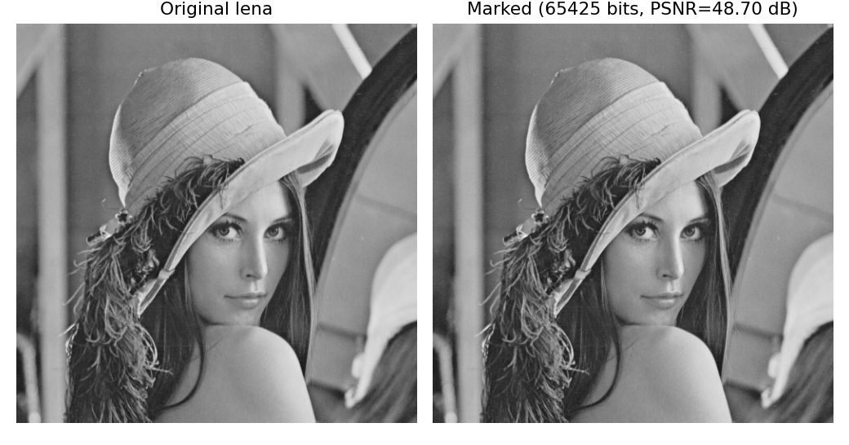
Fig. 1. Original vs. marked demo image with the embedded payload.
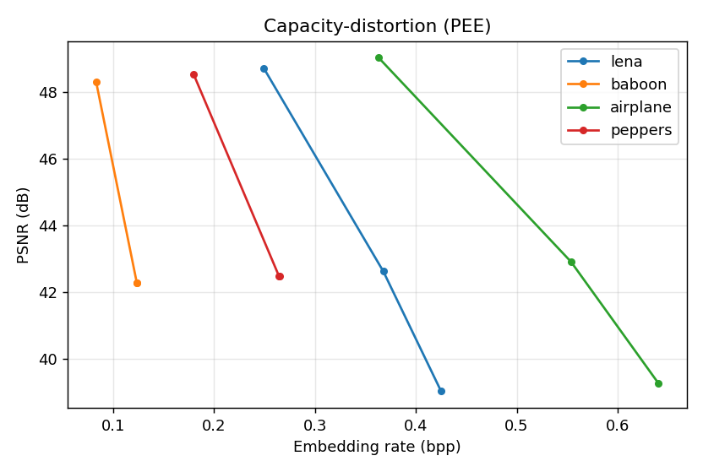
Fig. 2. Capacity-distortion curves over embedding levels.
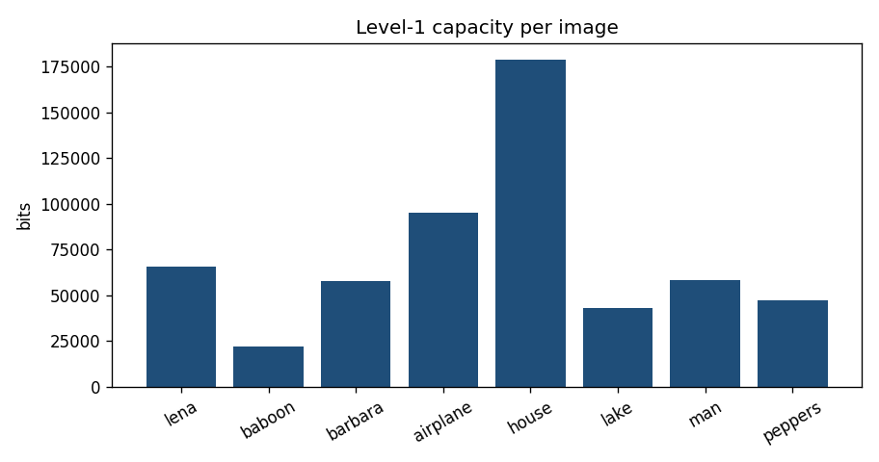
Fig. 3. Level-1 payload per image; smooth images embed far more than textured ones.
IX. COMPARISON WITH PAPER RESULTS
The reproduction reproduces the hybrid-prediction PEE capacity-distortion regime and exact reversibility. The CNN is NOT trained (no weights); a fixed predictor stands in, so reproduced capacity is a conservative lower bound versus a trained CNN hybrid.
TABLE II. COMPARISON WITH THE ORIGINAL PAPER
Aspect | Paper (reported) | This reproduction
Hybrid prediction-error RDH | Yes | Yes (reproduced)
CNN predictor | Yes (trained) | Approximated by fixed rhombus predictor
Exact reversibility | Yes | Yes (bit-exact)
Capacity/PSNR regime | High-capacity PEE | ~0.25 bpp @ ~48.7 dB (Lena, level 1)

X. DISCUSSION
The reproduction isolates the hybrid-PEE contribution from the predictor; a trained CNN hybrid would raise the curve, but the mechanism and reversibility are reproduced with the stand-in predictor.
XI. LIMITATIONS
• No trained CNN (approximated by a fixed predictor) -> conservative capacity.
• Image-dependent capacity.
• PSNR falls with levels.
XII. FUTURE WORK
Train the CNN hybrid predictor and integrate it; compare against the fixed-predictor lower bound.
XIII. CONCLUSION
We reproduced the hybrid-prediction PEE mechanism with a stand-in predictor, confirming the capacity-distortion regime and exact reversibility; the CNN predictor is left as future work.
REFERENCES
[1] Y. Zhao, Y. Peng, Y. Fang, T. Zhang, and J. Wang, "CNN-based hybrid prediction scheme for image reversible data hiding," Circuits, Systems, and Signal Processing, 2025.
[2] D. M. Thodi and J. J. Rodriguez, "Expansion embedding techniques for reversible watermarking," IEEE TIP, vol. 16, no. 3, 2007.
[3] V. Sachnev, H. J. Kim, J. Nam, S. Suresh, and Y.-Q. Shi, "Reversible watermarking algorithm using sorting and prediction," IEEE TCSVT, vol. 19, no. 7, 2009.
[4] Z. Ni, Y.-Q. Shi, N. Ansari, and W. Su, "Reversible data hiding," IEEE TCSVT, vol. 16, no. 3, 2006.

