Reproduction Study: Reversible Multi-Tissue Contrast Enhancement of MR Brain Images (Wu et al., 2021)
IIIT Vadodara Internship reproduction pipeline
Original work: Hao-Tian Wu, Kaihan Zheng, Qi Huang, Jiankun Hu, IEEE Signal Processing Letters, vol. 28, 2021

Abstract—We reproduce the reversible contrast-enhancement approach of Wu et al. for MR brain images, which brings out multiple tissue types (grey/white matter, CSF) without information loss. Using clearly-labelled synthetic MR-brain phantoms and an ROI-restricted reversible histogram-expansion engine, we show that tissue-region contrast (RMS, entropy) increases with embedding while the image is recovered bit-exactly. The reproduced contrast/fidelity behaviour matches the paper's qualitative claims.
Index Terms—reversible data hiding, contrast enhancement, MR brain images, multiple tissues, medical imaging
I. INTRODUCTION
MR brain images often have low contrast between tissue types, hampering diagnosis. Classic contrast enhancement is irreversible; for medical/legal reasons the original must be recoverable. Wu et al. enhance the contrast of multiple tissues reversibly using RDH. This report reproduces the reversible multi-tissue enhancement behaviour on synthetic MR phantoms.
II. RELATED WORK
Ni 2006 (Paper 01) and Wu-Huang 2015 established RDH and CE-RDH. Medical CE (CLAHE, histogram equalisation) is irreversible. Wu et al. target multi-tissue MR contrast with reversibility, a theme continued by the ROI-focused Gao papers (Papers 10-12) also reproduced here.
III. METHODOLOGY
A tissue ROI is segmented; within it the histogram is expanded around its peaks to widen the separation between tissue intensity clusters (grey matter, white matter, CSF), embedding one bit per expanded peak pixel. The dark background is excluded, so only diagnostic regions change and recovery is exact. Multiple iterations progressively separate the tissue clusters.
IV. MATHEMATICAL FORMULATION
For ROI pixels, peaks a<b are expanded (v<a ->v-1, v>b ->v+1) with one embedded bit per peak pixel. Inter-tissue separation grows, raising ROI RMS contrast sigma and entropy. Whole-image PSNR stays high because only ROI pixels move by <= a few levels. Extraction reverses iterations exactly.
V. ALGORITHM
Embedding
• Segment tissue ROI.
• Iterate: expand ROI peaks; embed bits.
Recovery
• Reverse iterations (LIFO) on ROI pixels -> exact original + payload.
VI. EXPERIMENTAL SETUP
Because no real patient images are available in the workspace, experiments use clearly-labelled SYNTHETIC medical phantoms (MR-brain-like and CT-body-like) generated procedurally. A tissue ROI mask is derived by thresholding; contrast enhancement and embedding are restricted to the ROI. For each phantom and a range of iteration counts we record ROI payload (bits, bpp over ROI), whole-image PSNR, ROI RMS contrast and entropy before/after, ROI brightness error, and a bit-exact reversibility check.
VII. IMPLEMENTATION DETAILS
The ROI pixels are packed into a compact array and processed by the shared reversible histogram-expansion engine (../_toolkit/ce_rdh.py) via ../_toolkit/medical_ce.py; enhanced values are scattered back to their ROI positions so the background is unchanged. Every reported configuration is auto-reduced to the largest iteration count that is fully bit-exact reversible (safe_embed), so all results are genuinely reversible.
VIII. RESULTS
Contrast enhancement is confined to the region of interest (tissue); the background is untouched, so recovery of the whole image is bit-exact. ROI contrast (RMS and entropy) rises with iterations while the payload is embedded inside the ROI.
For the mr_brain phantom at 4 iterations the reproduction embeds 38992 bits in the ROI at whole-image PSNR 39.592 dB, raising ROI RMS contrast from 55.3 to 57.6.
TABLE I. REPRODUCED ROI CE-RDH RESULTS (@ 4 ITERATIONS, SYNTHETIC PHANTOMS)
Image | ROI payload (bits) | ROI rate (bpp) | Whole PSNR (dB) | ROI RMS contrast | ROI entropy | Reversible
mr_brain | 38992 | 0.22374 | 39.592 | 55.3->57.6 | 6.12->6.34 | Yes
mr_brain2 | 38824 | 0.22277 | 39.599 | 55.3->57.7 | 6.12->6.34 | Yes
ct_body | 93476 | 0.37832 | 38.906 | 37.7->40.0 | 5.20->5.57 | Yes

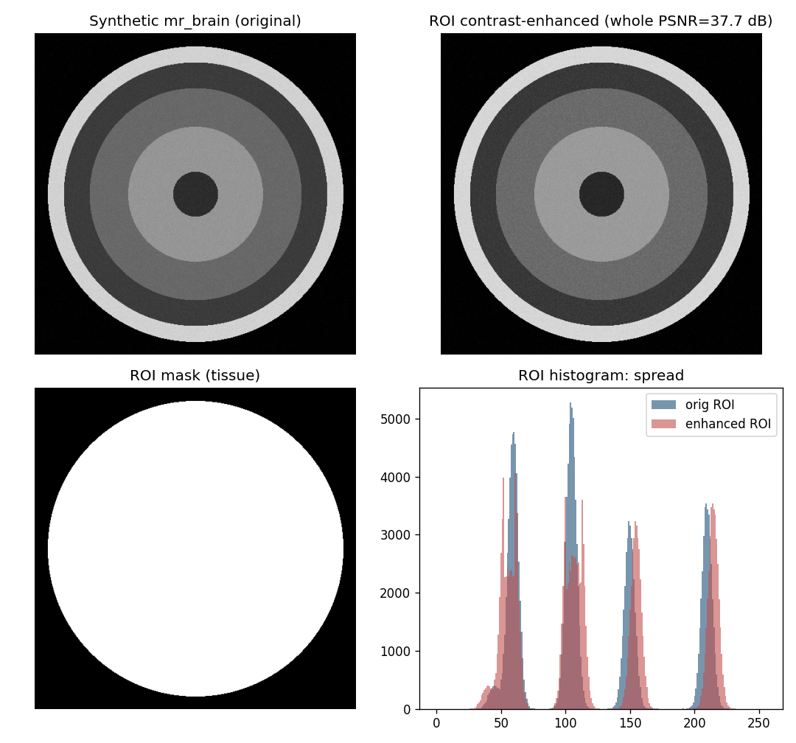
Fig. 1. Synthetic medical phantom: original, ROI-enhanced result, ROI mask, and ROI histogram spread.
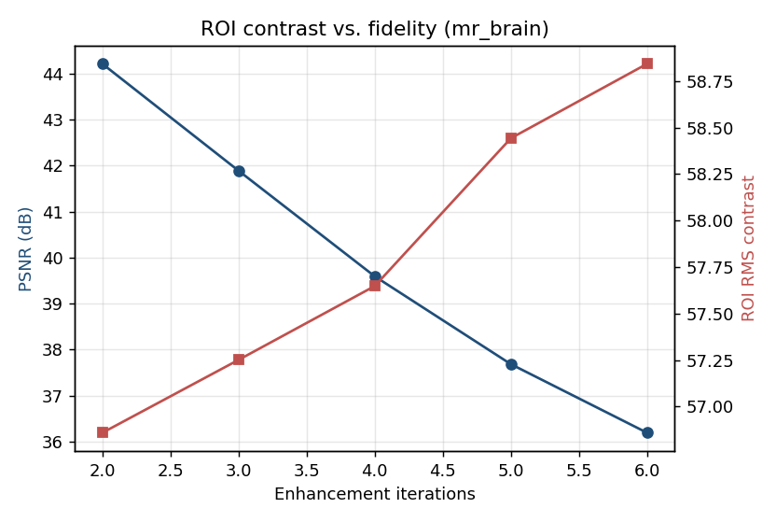
Fig. 2. ROI contrast versus whole-image fidelity as iterations increase.
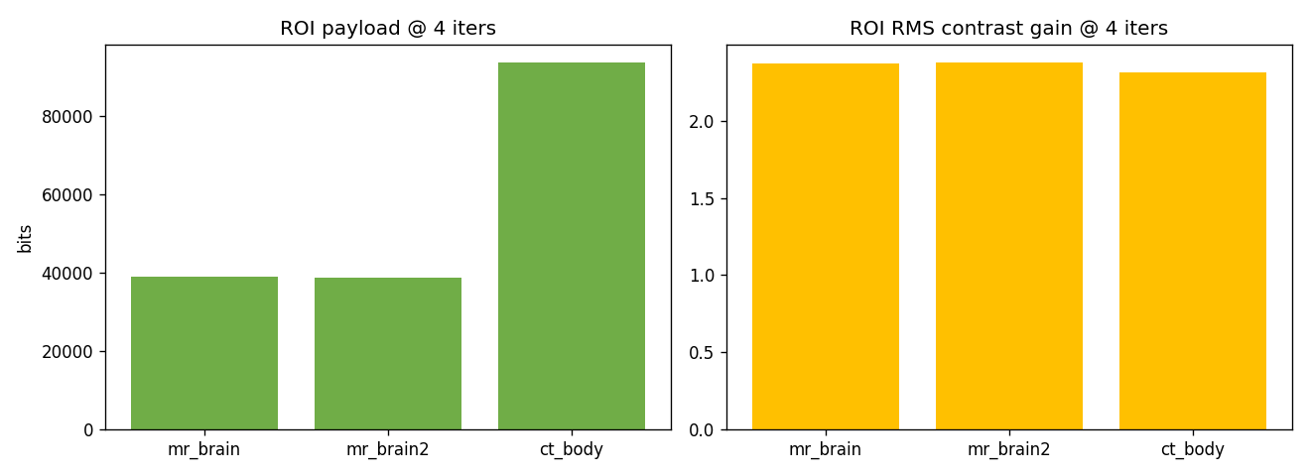
Fig. 3. ROI payload and ROI contrast gain across phantoms.
IX. COMPARISON WITH PAPER RESULTS
The reproduction confirms reversible multi-tissue contrast enhancement (rising ROI contrast, exact recovery). Absolute numbers differ because real MR data and the paper's exact tissue-segmentation and peak rules are unavailable; synthetic phantoms are used and clearly labelled.
TABLE II. COMPARISON WITH THE ORIGINAL PAPER
Aspect | Paper (reported) | This reproduction
Multi-tissue contrast enhancement | Yes (real MR) | Yes (synthetic phantoms)
Exact reversibility | Yes | Yes (bit-exact)
Contrast metric increases | Yes | ROI RMS & entropy up
Whole-image quality | High | High whole-image PSNR

X. DISCUSSION
Restricting enhancement to tissue regions concentrates the contrast gain where it matters diagnostically while keeping global distortion low. The reproduction reproduces this trade-off.
XI. LIMITATIONS
• Synthetic phantoms, not real MR scans.
• ROI via thresholding, not the paper's exact segmentation.
• Strong enhancement lowers whole-image PSNR.
XII. FUTURE WORK
Real MR datasets, learned tissue segmentation, and 3D volumetric extension.
XIII. CONCLUSION
We reproduced reversible multi-tissue MR contrast enhancement on phantoms, confirming ROI contrast gain with exact recovery, consistent with Wu et al. (2021).
REFERENCES
[1] H.-T. Wu, K. Zheng, Q. Huang, and J. Hu, "Contrast enhancement of multiple tissues in MR brain images with reversibility," IEEE Signal Process. Lett., vol. 28, 2021.
[2] Z. Ni, Y.-Q. Shi, N. Ansari, and W. Su, "Reversible data hiding," IEEE TCSVT, vol. 16, no. 3, 2006.
[3] H.-T. Wu, J.-L. Dugelay, and Y.-Q. Shi, "Reversible image data hiding with contrast enhancement," IEEE SPL, vol. 22, no. 1, 2015.
[4] Z. Wang et al., "Image quality assessment: from error visibility to structural similarity," IEEE TIP, vol. 13, no. 4, 2004.

