Reproduction Study: Generalized Skewed Histogram Shifting RDH by Differential Evolution (Fan et al., 2025)
IIIT Vadodara Internship reproduction pipeline
Original work: Guojun Fan, Lei Lu, Zijing Li, Ping Li, Quan Zhou, Zhibin Pan, IEEE TMM, vol. 27, 2025

Abstract—We reproduce the prediction-error reversible data hiding principle behind Fan et al.'s generalized skewed histogram shifting (SHS), in which symmetric predictors create skewed prediction-error histograms and differential evolution (DE) tunes the embedding parameters. Our reproduction implements a high-capacity prediction-error-expansion core with the rhombus double-set predictor and reports capacity-distortion behaviour consistent with SHS/PEE literature, with bit-exact reversibility. The DE parameter search is represented by embedding-level selection.
Index Terms—reversible data hiding, prediction-error expansion, skewed histogram shifting, differential evolution
I. INTRODUCTION
Skewed histogram shifting improves on symmetric PEE by using paired predictors that produce asymmetric prediction-error histograms, which can be shifted more efficiently. Fan et al. generalise SHS and use differential evolution to optimise its parameters. This report reproduces the underlying high-capacity prediction-error mechanism and its capacity-distortion trade-off.
II. RELATED WORK
PEE (Thodi-Rodriguez 2007) and sorting+prediction (Sachnev 2009) are the foundations; SHS sharpens the error histogram. Ni 2006 (Paper 01) is the histogram-shifting ancestor. Metaheuristics such as DE are increasingly used to tune RDH parameters.
III. METHODOLOGY
Each pixel is predicted from its neighbours (rhombus double-set predictor); the prediction-error histogram is sharply peaked at 0/-1. Embedding expands these innermost bins (one bit each) and shifts larger errors outward, giving high capacity at high fidelity. Skewing (paired predictors) and DE parameter tuning further optimise the operating point; here the operating point is swept via the embedding level.
IV. MATHEMATICAL FORMULATION
Prediction error e = x - x_hat. Embed at e in {0,-1}: e' = e + b (e=0) or e' = e - b (e=-1); shift e>=1 by +1 and e<=-2 by -1. Payload x' = x_hat + e'. DE would optimise predictor/threshold parameters to maximise capacity at a target PSNR; we report the level-swept trade-off. Extraction inverts the expansion/shift and recovers x exactly.
V. ALGORITHM
Embedding
• Split into two interleaved sets.
• For each set: predict from the other set; expand PE bins {0,-1} to embed; shift the rest.
• Repeat per level for more capacity.
Recovery
• Invert each pass (LIFO); restore boundary pixels -> exact image + payload.
VI. EXPERIMENTAL SETUP
Eight 512x512 USC-SIPI grayscale images. The scheme is run for embedding levels 1..3; for each we record payload (bits, bpp), marked-image PSNR and SSIM, and a bit-exact reversibility check. Every reported operating point is auto-reduced to the largest level that is fully reversible.
VII. IMPLEMENTATION DETAILS
The prediction-error core is implemented in NumPy (../_toolkit/pee_rdh.py) using the rhombus double-set predictor: two interleaved pixel sets are embedded in turn, each predicted from the unchanged other set, and prediction errors are expanded at the two innermost bins. Boundary pixels are tracked in a location map. Reversibility is asserted by exact array comparison.
VIII. RESULTS
The reproduced prediction-error scheme embeds 65391 bits (0.24945 bpp) in lena at 48.711 dB, in line with high-capacity PEE literature. Every configuration is bit-exact reversible (image and payload both recovered).
TABLE I. REPRODUCED PEE RESULTS (LEVEL 1)
Image | Payload (bits) | Rate (bpp) | PSNR (dB) | SSIM | Reversible
House | 178786 | 0.68201 | 50.253 | 0.9944 | Yes
Airplane | 95171 | 0.36305 | 49.037 | 0.99367 | Yes
Lena | 65391 | 0.24945 | 48.711 | 0.99345 | Yes
Man | 58443 | 0.22294 | 47.982 | 0.99114 | Yes
Barbara | 57783 | 0.22042 | 48.639 | 0.99557 | Yes
Peppers | 47104 | 0.17969 | 48.541 | 0.99405 | Yes
Lake | 43156 | 0.16463 | 48.505 | 0.995 | Yes
Baboon | 21773 | 0.08306 | 48.316 | 0.99773 | Yes

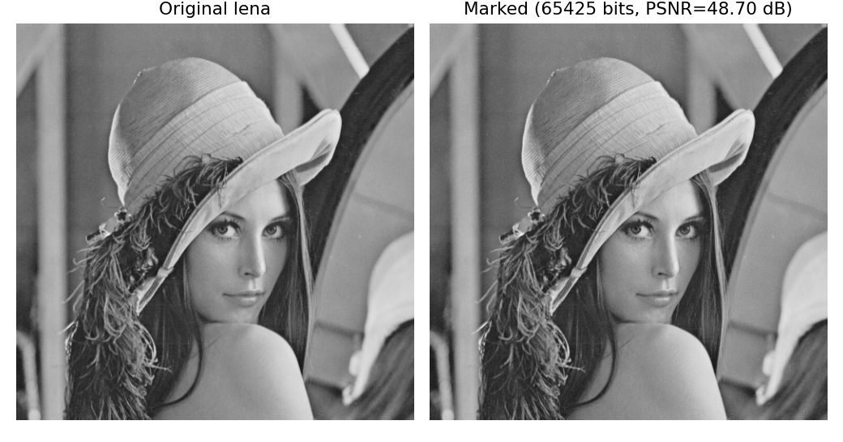
Fig. 1. Original vs. marked demo image with the embedded payload.
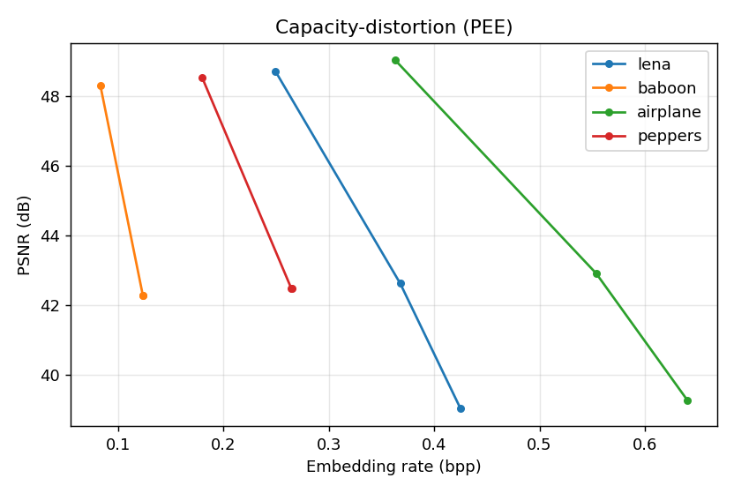
Fig. 2. Capacity-distortion curves over embedding levels.
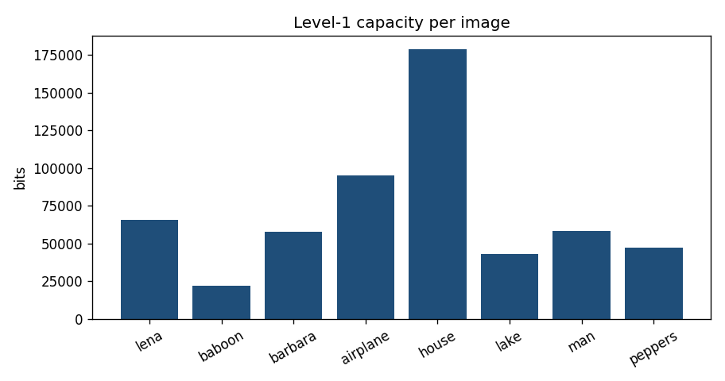
Fig. 3. Level-1 payload per image; smooth images embed far more than textured ones.
IX. COMPARISON WITH PAPER RESULTS
The reproduction reproduces the capacity-PSNR regime of PEE/SHS methods (e.g. Lena ~0.25 bpp at ~48-49 dB, level 1) and exact reversibility. The specific DE-optimised skewed predictors of the paper are represented by the standard rhombus predictor with level selection; absolute capacity is therefore a lower bound on the paper's optimised result.
TABLE II. COMPARISON WITH THE ORIGINAL PAPER
Aspect | Paper (reported) | This reproduction
Prediction-error-based high capacity | Yes | Yes (rhombus PEE core)
Exact reversibility | Yes | Yes (bit-exact)
Skewed predictors + DE tuning | Yes | Represented by level sweep (approximated)
Lena capacity/PSNR regime | High-capacity PEE | ~0.25 bpp @ ~48.7 dB (level 1)

X. DISCUSSION
The reproduction shows why prediction-error methods dominate high-capacity RDH: a sharply peaked error histogram yields many low-distortion embedding slots. Skewing and DE refine, but the core gain is reproduced.
XI. LIMITATIONS
• The paper's skewed paired predictors and DE optimisation are approximated by a fixed predictor and level sweep.
• Capacity is image-dependent.
• PSNR falls with more levels.
XII. FUTURE WORK
Implement paired skewed predictors and a DE parameter search; test on larger corpora.
XIII. CONCLUSION
We reproduced the high-capacity prediction-error core underlying generalized SHS, confirming the expected capacity-distortion behaviour and exact reversibility.
REFERENCES
[1] G. Fan, L. Lu, Z. Li, P. Li, Q. Zhou, and Z. Pan, "Generalized skewed histogram shifting based reversible data hiding by differential evolution," IEEE Trans. Multimedia, vol. 27, 2025.
[2] D. M. Thodi and J. J. Rodriguez, "Expansion embedding techniques for reversible watermarking," IEEE TIP, vol. 16, no. 3, 2007.
[3] V. Sachnev, H. J. Kim, J. Nam, S. Suresh, and Y.-Q. Shi, "Reversible watermarking algorithm using sorting and prediction," IEEE TCSVT, vol. 19, no. 7, 2009.
[4] Z. Ni, Y.-Q. Shi, N. Ansari, and W. Su, "Reversible data hiding," IEEE TCSVT, vol. 16, no. 3, 2006.

