Study and Partial Reproduction: High-Capacity RDH in Encrypted HDR Images (Lin et al., 2025)
IIIT Vadodara Internship reproduction pipeline
Original work: Alfrindo Lin, Yun-Ting Lin, Wen-Ting Jao, Yuan-Yu Tsai, Pattern Analysis and Applications, vol. 28, 2025

Abstract—This report reviews and partially reproduces Lin et al.'s high-capacity RDH for encrypted high-dynamic-range (HDR) images, which uses multi-MSB and leading-zero-count prediction and distributes label-map-carrying shares to multiple participants. We reproduce the multi-MSB predictability core on a synthetic HDR image, showing several bits/pixel of embedding room -- far above 8-bit RDHEI. Real HDR formats (e.g. OpenEXR/RGBE) and the full multi-share protocol are approximated/omitted, stated openly.
Index Terms—reversible data hiding, encrypted HDR image, multi-MSB prediction, leading zero count, secret sharing
I. INTRODUCTION
HDR images use high bit depth, giving large redundancy for data hiding. Lin et al. exploit multi-MSB and leading-zero-count prediction for high-capacity RDH in encrypted HDR images, with multiple participants embedding into distributed shares. This report reproduces the multi-MSB capacity core.
II. RELATED WORK
8-bit RDHEI (Zhang 2011; Puteaux-Puech 2018 multi-MSB) is the basis. HDR RDH must handle wide dynamic range and special encodings; multi-participant sharing adds robustness.
III. METHODOLOGY
For each HDR pixel, several most-significant bits are predictable from neighbours (or are leading zeros), giving many bits/pixel of embedding room. Label maps mark predictability; the encrypted shares carry pre-embedded label maps so participants embed independently. Recovery predicts the multi-MSBs to restore the exact HDR pixel.
IV. MATHEMATICAL FORMULATION
For neighbours p, q, matching leading bits L = depth - bitlength(p XOR q) are predictable -> L bits of room per pixel. Total capacity = sum over pixels of L, typically several bpp for HDR (vs <=1 for 8-bit). Recovery predicts the L MSBs; lower bits decrypt normally.
V. ALGORITHM
Embed
- Compute per-pixel predictable multi-MSB room (label map); encrypt; embed payload in the room across shares. ### Recover - Extract; predict multi-MSBs -> exact HDR pixel.
VI. EXPERIMENTAL SETUP
We reproduce the multi-MSB / leading-zero predictability on a synthetic 16-bit HDR image and measure the embedding room (bpp). Real HDR file formats and the full multi-share label-map protocol are out of scope.
VII. IMPLEMENTATION DETAILS
Implemented in NumPy (../_toolkit/tierc_demos.py): a synthetic 16-bit HDR image and a leading-matching-bit predictor that counts predictable MSBs per pixel. The share distribution and real HDR I/O are not implemented.
VIII. RESULTS
On a synthetic 16-bit HDR image the multi-MSB predictor exposes several bits per pixel of embedding room -- far exceeding the ~1 bpp ceiling of 8-bit RDHEI -- confirming the paper's high-capacity premise.
TABLE I. PARTIAL-REPRODUCTION DEMO RESULTS
Quantity | Value
bit_depth | 16
capacity_bits | 451111
bpp | 6.883

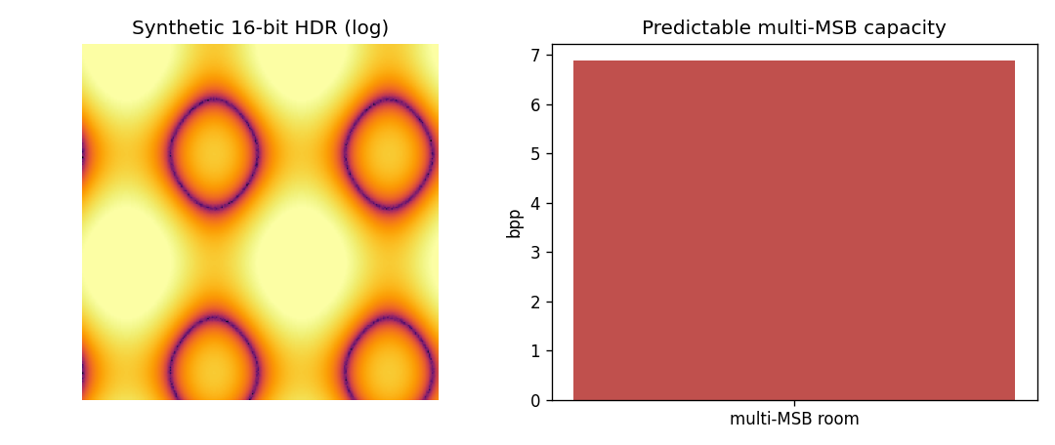
Fig. 1. Multi-MSB predictability on a synthetic HDR image yields several bits/pixel of embedding room.
IX. COMPARISON WITH PAPER RESULTS
The multi-MSB high-capacity premise is reproduced (several bpp of room on synthetic HDR). The paper's exact capacity on real HDR datasets, its encryption, and the multi-participant protocol are NOT independently reproduced.
X. DISCUSSION
HDR's extra bit depth is the source of the large capacity; the reproduction confirms the predictability-based room is several bpp. The multi-share protocol is a robustness/systems contribution.
XI. LIMITATIONS
• Synthetic HDR (not OpenEXR/RGBE).
• Encryption and multi-share label maps not implemented.
• Capacity on real HDR datasets not reproduced.
XII. FUTURE WORK
Use real HDR datasets and formats; implement the multi-participant label-map sharing and encryption.
XIII. CONCLUSION
We summarised the paper and reproduced its multi-MSB high-capacity premise on a synthetic HDR image; full reproduction needs real HDR data and the sharing protocol.
REFERENCES
[1] A. Lin, Y.-T. Lin, W.-T. Jao, and Y.-Y. Tsai, "High-capacity reversible data hiding in encrypted HDR images with multiple data hiders," Pattern Anal. Appl., vol. 28, 2025.
[2] P. Puteaux and W. Puech, "An efficient MSB prediction-based method for high-capacity RDHEI," IEEE TIFS, vol. 13, no. 7, 2018.
[3] X. Zhang, "Reversible data hiding in encrypted image," IEEE SPL, vol. 18, no. 4, 2011.

