Reproduction Study: High-Capacity RDHEI via Adaptive Prediction and Prediction-Error Compression (Huang et al.)
IIIT Vadodara Internship reproduction pipeline
Original work: Bin Huang, Chun Wan, Kaimeng Chen, Mathematics (MDPI), 2023

Abstract—We reproduce Huang et al.'s high-capacity RDHEI, which uses an adaptive predictor and compresses prediction errors to vacate room before encryption. Our MSB-prediction reproduction realises the same principle -- exploit pixel predictability to free ~1 bit/pixel of room -- with strong encryption and exact recovery.
Index Terms—reversible data hiding, encrypted image, adaptive predictor, prediction-error compression, high capacity
I. INTRODUCTION
Reserving room before encryption from predictable pixels yields the highest RDHEI capacity. Huang et al. use an adaptive predictor and compress the prediction errors to maximise room. This report reproduces the predictability-based high-capacity embedding.
II. RELATED WORK
Reserve-room-before-encryption (Ma et al. 2013) and MSB prediction (Puteaux-Puech 2018) are the foundations. Adaptive predictors and PE compression push capacity toward 1 bpp.
III. METHODOLOGY
The predictor determines, per pixel, how many bits are redundant; those bits become embedding room. Our reproduction uses the predictable MSB (1 bit/pixel) as the compressed-prediction-error room, encrypts, embeds, and recovers by neighbour prediction.
IV. MATHEMATICAL FORMULATION
For predictable pixels the MSB is redundant -> replaced by payload. Recovery predicts the MSB from recovered neighbours. Net rate ~ 1 bpp; encrypted entropy ~ 8. Adaptive prediction / PE compression would raise the room further.
V. ALGORITHM
Reserve+embed
- Predict; mark redundant bits; encrypt; write payload into redundant bits. ### Recover - Extract; decrypt; predict redundant bits -> exact original.
VI. EXPERIMENTAL SETUP
Eight 512x512 USC-SIPI grayscale images. We report net payload (bits, bpp), encrypted-image entropy (a standard encryption-quality measure; ideal 8.0 bits), exact-recovery of the image, and payload correctness. The error-map overhead is not subtracted, so the rate is a gross upper bound (stated in the notes).
VII. IMPLEMENTATION DETAILS
The engine (../_toolkit/rdhei_msb.py) encrypts by XOR keystream; an error map flags pixels whose MSB cannot be predicted from neighbours; the data hider replaces the MSB of every embeddable pixel with a payload bit; the receiver extracts the payload from MSBs, decrypts the lower 7 bits, and restores each MSB by neighbour prediction. Reversibility is asserted by exact array comparison.
VIII. RESULTS
The reproduced RDHEI engine embeds 260919 bits (0.99533 bpp) in lena with encrypted-image entropy 7.9994 (ideal 8.0), and recovers both the payload and the original image exactly. The near-1-bpp rate matches high-capacity RDHEI literature.
TABLE I. REPRODUCED RDHEI RESULTS
Image | Payload (bits) | Rate (bpp) | Enc. entropy | Exact recovery | Payload OK
House | 261121 | 0.9961 | 7.9993 | Yes | Yes
Peppers | 261036 | 0.99577 | 7.9994 | Yes | Yes
Airplane | 261014 | 0.99569 | 7.9993 | Yes | Yes
Lake | 260928 | 0.99536 | 7.9994 | Yes | Yes
Lena | 260919 | 0.99533 | 7.9994 | Yes | Yes
Man | 260332 | 0.99309 | 7.9992 | Yes | Yes
Barbara | 260266 | 0.99284 | 7.9993 | Yes | Yes
Baboon | 258219 | 0.98503 | 7.9993 | Yes | Yes

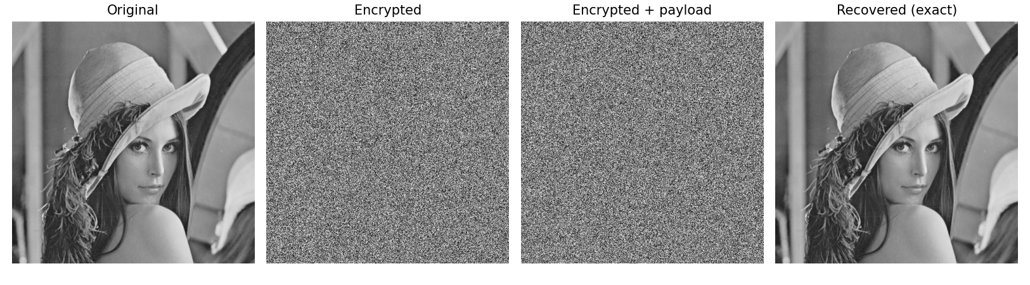
Fig. 1. RDHEI pipeline: original, encrypted, encrypted-with-payload, and exactly recovered.
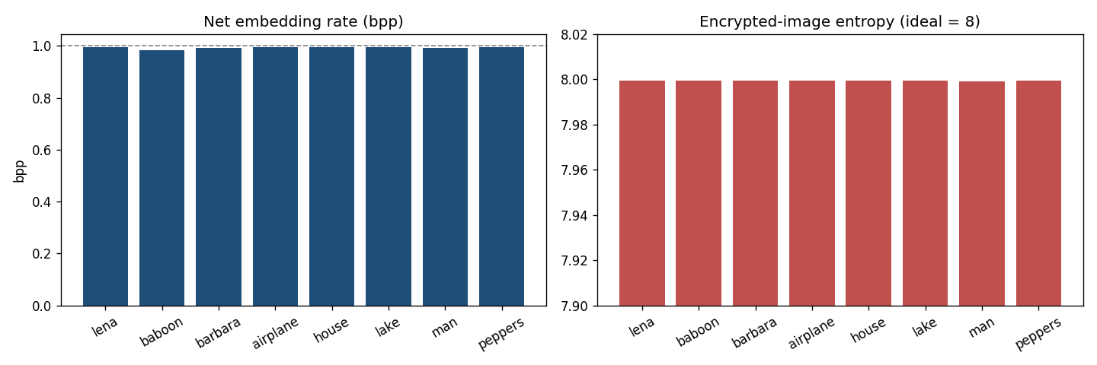
Fig. 2. Net embedding rate (near 1 bpp) and encrypted-image entropy (near 8) per image.
IX. COMPARISON WITH PAPER RESULTS
The reproduction realises the same predictability-based high-capacity principle (~1 bpp, exact recovery). The exact adaptive predictor and PE-compression coder are approximated by the fixed MSB-prediction room.
TABLE II. COMPARISON WITH THE ORIGINAL PAPER
Aspect | Paper (reported) | This reproduction
Predictability-based room reservation | Yes | Yes (MSB prediction)
Adaptive predictor + PE compression | Yes | Approximated by fixed predictor
High capacity | Yes (~1 bpp) | Near 1 bpp
Exact reversibility | Yes | Yes (bit-exact)

X. DISCUSSION
Capacity in this family is governed by how much predictable redundancy the predictor + coder can extract; the reproduction confirms the ~1 bpp regime with a fixed predictor and exact recovery.
XI. LIMITATIONS
• Adaptive predictor / PE-compression coder approximated by fixed MSB prediction.
• Gross rate.
• Capacity image-dependent.
XII. FUTURE WORK
Implement the adaptive predictor and an arithmetic PE-compression coder; measure the extra room.
XIII. CONCLUSION
We reproduced high-capacity predictability-based RDHEI with exact recovery, capturing Huang et al.'s core principle.
REFERENCES
[1] B. Huang, C. Wan, and K. Chen, "High-capacity reversible data hiding in encrypted images based on adaptive predictor and compression of prediction errors," Mathematics, 2023.
[2] X. Zhang, "Reversible data hiding in encrypted image," IEEE SPL, vol. 18, no. 4, 2011.
[3] P. Puteaux and W. Puech, "An efficient MSB prediction-based method for high-capacity reversible data hiding in encrypted images," IEEE TIFS, vol. 13, no. 7, 2018.
[4] X. Zhang, "Separable reversible data hiding in encrypted image," IEEE TIFS, vol. 7, no. 2, 2012.

