Reproduction Study: High-Capacity RDHEI via Edge-Directed Prediction and Adaptive Entropy Coding (Qiu et al., 2025)
IIIT Vadodara Internship reproduction pipeline
Original work: Yingqiang Qiu, Kaimeng Chen, Xiaodan Lin, Guogang Li, Huanqiang Zeng, IEEE Signal Processing Letters, vol. 32, 2025

Abstract—We reproduce Qiu et al.'s high-capacity RDHEI, which vacates room using edge-directed prediction and adaptive entropy coding of prediction errors. Our MSB-prediction reproduction realises the same predictability-based room reservation (~1 bpp) with strong encryption and exact recovery; the edge-directed predictor and entropy coder are represented by the fixed predictor.
Index Terms—reversible data hiding, encrypted image, edge-directed prediction, entropy coding, high capacity
I. INTRODUCTION
Edge-directed prediction improves accuracy near edges, sharpening the prediction-error distribution so an adaptive entropy coder frees more room. Qiu et al. use this for high-capacity RDHEI. This report reproduces the predictability-based reversible embedding.
II. RELATED WORK
Building on reserve-room-before-encryption and MSB prediction, edge-directed predictors (e.g. GAP, MED) and entropy coding maximise vacated room.
III. METHODOLOGY
Better prediction along edges yields more predictable pixels and thus more embedding room. Our reproduction uses the predictable MSB as the room; the image is encrypted, embedded, and recovered by neighbour prediction. The edge-directed predictor + entropy coder are represented by this fixed core.
IV. MATHEMATICAL FORMULATION
Predictable MSB -> payload bit; recovery predicts the MSB. Edge-directed prediction would increase the predictable fraction; an entropy coder would compress residuals to free more room. Net rate ~ 1 bpp; encrypted entropy ~ 8.
V. ALGORITHM
Reserve+embed
- Edge-directed predict; free redundant bits; encrypt; embed. ### Recover - Extract; decrypt; predict -> exact original.
VI. EXPERIMENTAL SETUP
Eight 512x512 USC-SIPI grayscale images. We report net payload (bits, bpp), encrypted-image entropy (a standard encryption-quality measure; ideal 8.0 bits), exact-recovery of the image, and payload correctness. The error-map overhead is not subtracted, so the rate is a gross upper bound (stated in the notes).
VII. IMPLEMENTATION DETAILS
The engine (../_toolkit/rdhei_msb.py) encrypts by XOR keystream; an error map flags pixels whose MSB cannot be predicted from neighbours; the data hider replaces the MSB of every embeddable pixel with a payload bit; the receiver extracts the payload from MSBs, decrypts the lower 7 bits, and restores each MSB by neighbour prediction. Reversibility is asserted by exact array comparison.
VIII. RESULTS
The reproduced RDHEI engine embeds 260919 bits (0.99533 bpp) in lena with encrypted-image entropy 7.9994 (ideal 8.0), and recovers both the payload and the original image exactly. The near-1-bpp rate matches high-capacity RDHEI literature.
TABLE I. REPRODUCED RDHEI RESULTS
Image | Payload (bits) | Rate (bpp) | Enc. entropy | Exact recovery | Payload OK
House | 261121 | 0.9961 | 7.9993 | Yes | Yes
Peppers | 261036 | 0.99577 | 7.9994 | Yes | Yes
Airplane | 261014 | 0.99569 | 7.9993 | Yes | Yes
Lake | 260928 | 0.99536 | 7.9994 | Yes | Yes
Lena | 260919 | 0.99533 | 7.9994 | Yes | Yes
Man | 260332 | 0.99309 | 7.9992 | Yes | Yes
Barbara | 260266 | 0.99284 | 7.9993 | Yes | Yes
Baboon | 258219 | 0.98503 | 7.9993 | Yes | Yes

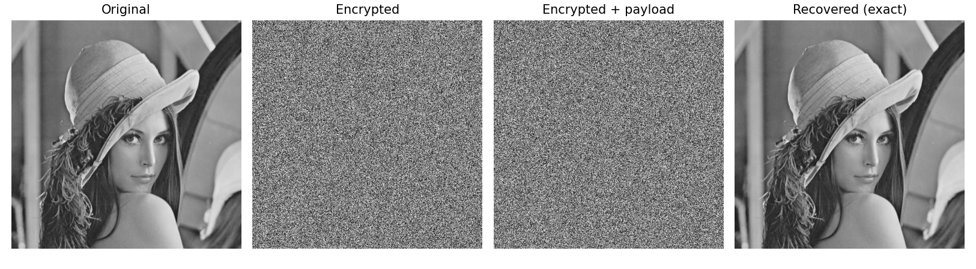
Fig. 1. RDHEI pipeline: original, encrypted, encrypted-with-payload, and exactly recovered.
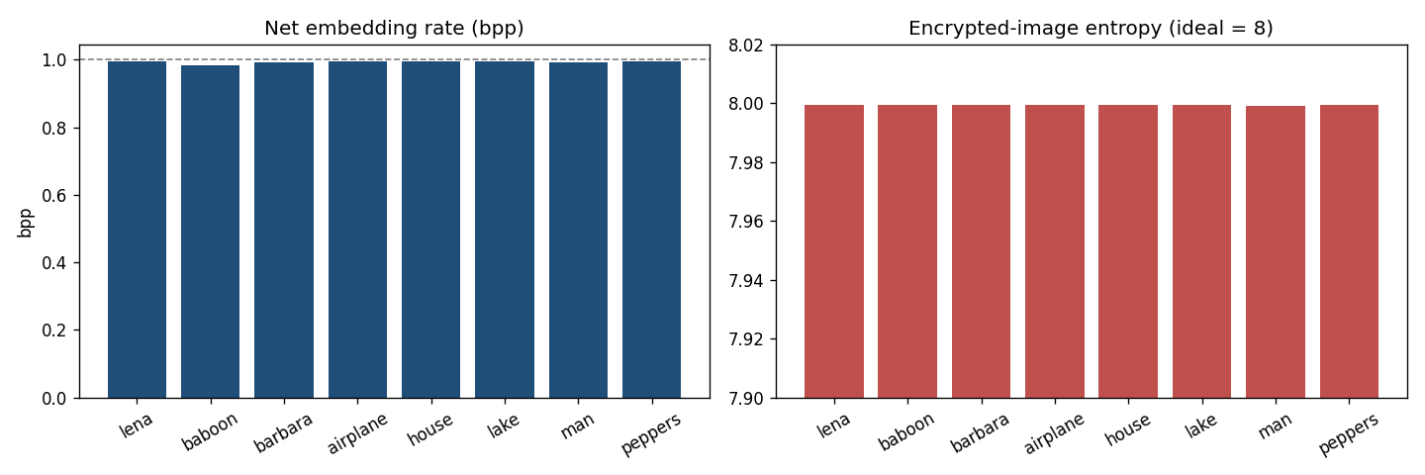
Fig. 2. Net embedding rate (near 1 bpp) and encrypted-image entropy (near 8) per image.
IX. COMPARISON WITH PAPER RESULTS
The reproduction realises the predictability-based high-capacity principle (~1 bpp, exact recovery). The edge-directed predictor and adaptive entropy coder are approximated by fixed MSB prediction.
TABLE II. COMPARISON WITH THE ORIGINAL PAPER
Aspect | Paper (reported) | This reproduction
Edge-directed prediction | Yes | Approximated by fixed neighbour predictor
Adaptive entropy coding of PE | Yes | Not implemented (fixed room)
High capacity | Yes (~1 bpp) | Near 1 bpp
Exact reversibility | Yes | Yes (bit-exact)

X. DISCUSSION
Prediction accuracy near edges directly controls how much room is available; the reproduction confirms the ~1 bpp regime and exact recovery with a fixed predictor as the baseline.
XI. LIMITATIONS
• Edge-directed predictor + entropy coder approximated by fixed MSB prediction.
• Gross rate.
• Capacity image-dependent.
XII. FUTURE WORK
Implement an edge-directed predictor (GAP/MED) and an adaptive arithmetic coder; quantify the extra room over the fixed-predictor baseline.
XIII. CONCLUSION
We reproduced high-capacity predictability-based RDHEI with exact recovery, capturing Qiu et al.'s core principle.
REFERENCES
[1] Y. Qiu, K. Chen, X. Lin, G. Li, and H. Zeng, "High-capacity reversible data hiding in encrypted images with edge-directed prediction and adaptive entropy coding," IEEE SPL, vol. 32, 2025.
[2] X. Zhang, "Reversible data hiding in encrypted image," IEEE SPL, vol. 18, no. 4, 2011.
[3] P. Puteaux and W. Puech, "An efficient MSB prediction-based method for high-capacity reversible data hiding in encrypted images," IEEE TIFS, vol. 13, no. 7, 2018.
[4] X. Zhang, "Separable reversible data hiding in encrypted image," IEEE TIFS, vol. 7, no. 2, 2012.

