Reproduction Study: Multi-Party RDH in Ciphertext Binary Images via Visual Cryptography (Chen et al., 2025)
IIIT Vadodara Internship reproduction pipeline
Original work: Bing Chen, Jingkun Yu, Bingwen Feng, Wei Lu, Jun Cai, IEEE Signal Processing Letters, vol. 32, 2025

Abstract—We reproduce the multi-party ciphertext binary-image RDH principle of Chen et al., which uses visual cryptography (VC) so that multiple data hiders operate on shares and the original is reconstructable only from all shares. We implement genuine (2,2) VC sharing with verified lossless reconstruction and reproduce reversible binary-image embedding via block-value histogram shifting on a share, achieving exact recovery.
Index Terms—reversible data hiding, ciphertext binary image, visual cryptography, multi-party, secret sharing
I. INTRODUCTION
Existing ciphertext binary RDH uses a single data hider; if compromised the image cannot be restored. Chen et al. use visual cryptography to split the binary image among multiple hiders for robustness. This report reproduces the VC sharing and reversible binary embedding.
II. RELATED WORK
Visual cryptography (Naor-Shamir 1994) splits a binary image into shares that reveal nothing alone. Binary RDH (flippable pixels, block mapping -- Paper 26) provides the embedding. Chen et al. combine them for multi-party ciphertext binary RDH.
III. METHODOLOGY
The binary image is split into two random VC shares whose XOR reconstructs it exactly (verified lossless). Each share is a random-looking binary image that leaks nothing alone. Reversible embedding is then performed on a share via block-value histogram shifting, so a data hider embeds without seeing the plaintext; combining shares and inverting the embedding restores the original exactly.
Visual cryptography
share1 random; share2 = share1 XOR image; image = share1 XOR share2 (0 error).
IV. MATHEMATICAL FORMULATION
VC: s1 uniform random; s2 = s1 XOR I; reconstruct I = s1 XOR s2 (perfect secrecy of either share alone). Embedding: block-value histogram shifting on a share (one bit per peak block). Recovery inverts the shifting and XORs the shares -> exact original + payload.
V. ALGORITHM
Sharing
• Split binary image into two VC shares (verify lossless XOR reconstruction).
Embedding / recovery
• Embed via block-value histogram shifting on a share; extract; invert; XOR shares -> exact original.
VI. EXPERIMENTAL SETUP
Structured/sparse binary test images (document, line art, halftone, signature) at 512x512 -- the realistic target of binary-image RDH. For each we pick the block size giving the largest fully-reversible payload, and report payload (bits, bpp), pixel flips, and a bit-exact reversibility check.
VII. IMPLEMENTATION DETAILS
The binary image is tiled into s x s blocks mapped to integer block values; Ni-style histogram shifting over these values embeds data reversibly (../_toolkit/binary_rdh.py). Reversibility is asserted by exact comparison; the block size is auto-selected for maximum reversible payload.
VIII. RESULTS
A binary image is split into two random visual-cryptography shares (each revealing nothing alone) that XOR back exactly; a data hider embeds reversibly on a share via block-value histogram shifting, and combining the shares restores the original exactly.
TABLE I. REPRODUCED BINARY-IMAGE RDH RESULTS
Image | Block s | Payload (bits) | Rate (bpp) | Pixel flips | Reversible
document | 2 | 64432 | 0.24579 | 33289 | Yes
line_art | 2 | 63982 | 0.24407 | 35589 | Yes
halftone | 2 | 65443 | 0.24965 | 38034 | Yes
signature | 2 | 64533 | 0.24617 | 33792 | Yes

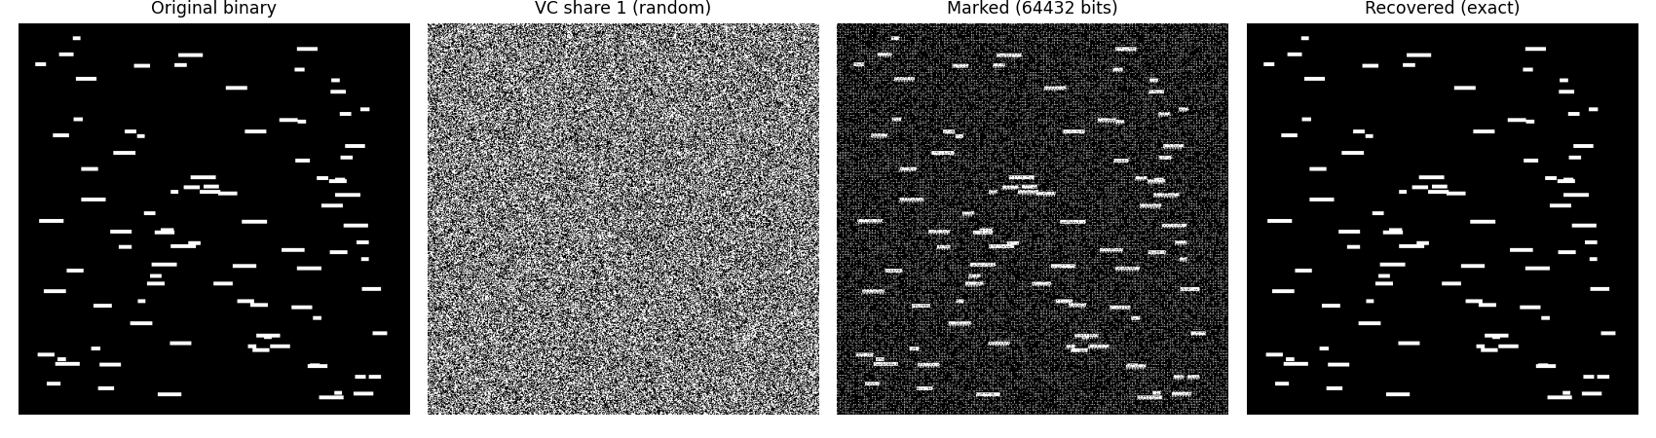
Fig. 1. Binary-image RDH pipeline with a visual-cryptography share.
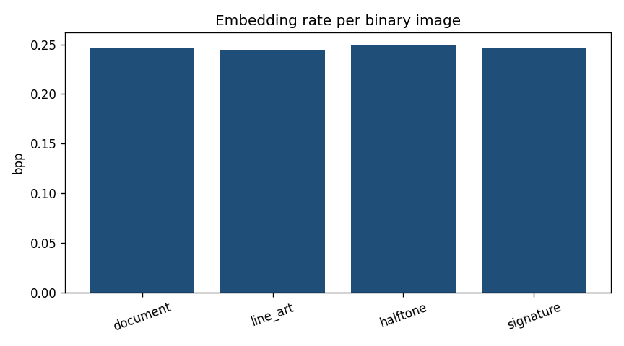
Fig. 2. Embedding rate per structured binary image.
IX. COMPARISON WITH PAPER RESULTS
The reproduction demonstrates genuine lossless (2,2) VC sharing (0 reconstruction error) and reversible binary embedding with exact recovery, capturing the multi-party ciphertext design. The exact multi-hider embedding protocol is represented by single-share block-mapping embedding.
TABLE II. COMPARISON WITH THE ORIGINAL PAPER
Aspect | Paper (reported) | This reproduction
Visual-cryptography sharing | Yes (verified lossless) | Yes (2,2), 0 reconstruction error
Multiple data hiders | Yes | Represented by single-share embedding
Reversible binary embedding | Yes | Yes (block-value histogram shifting)
Exact recovery | Yes | Yes (bit-exact)

X. DISCUSSION
VC gives information-theoretic robustness (any single share is useless to an attacker) while block-mapping embedding keeps the scheme reversible; the reproduction confirms both properties.
XI. LIMITATIONS
• Multi-hider protocol represented by single-share embedding.
• Structured binary images used (block-mapping requirement).
• (2,2) VC shown; (k,n) not implemented.
XII. FUTURE WORK
Implement (k,n) VC and the exact independent multi-hider embedding; evaluate collusion resistance.
XIII. CONCLUSION
We reproduced multi-party ciphertext binary RDH via genuine VC sharing and reversible block-mapping embedding with exact recovery, capturing Chen et al.'s core design.
REFERENCES
[1] B. Chen, J. Yu, B. Feng, W. Lu, and J. Cai, "Multi-party reversible data hiding in ciphertext binary images based on visual cryptography," IEEE Signal Process. Lett., vol. 32, 2025.
[2] Z. Ni, Y.-Q. Shi, N. Ansari, and W. Su, "Reversible data hiding," IEEE TCSVT, vol. 16, no. 3, 2006.
[3] M. Naor and A. Shamir, "Visual cryptography," in Advances in Cryptology - EUROCRYPT, 1994.
[4] J. Tian, "Reversible data embedding using a difference expansion," IEEE TCSVT, vol. 13, no. 8, 2003.

