Reproduction Study: Automatic Contrast Enhancement RDH via Histogram Expansion (Lyu et al., 2023)
IIIT Vadodara Internship reproduction pipeline
Original work: WanLi Lyu, YaJie Yue, Zhaoxia Yin, J. Vis. Commun. Image R., vol. 92, 2023

Abstract—This report reproduces the automatic contrast-enhancement reversible data hiding scheme of Lyu, Yue and Yin, in which image contrast is improved by expanding the two tallest histogram bins outward while a payload is embedded, and the global average brightness is used to control the enhancement automatically. We implement the reversible histogram-expansion core, evaluate it on standard grayscale images, and confirm that contrast (RMS and entropy) rises with the number of expansion iterations while the process remains bit-exact reversible. The reproduced fidelity/contrast trade-off matches the trend reported in the paper.
Index Terms—reversible data hiding, contrast enhancement, histogram expansion, brightness preservation, entropy
I. INTRODUCTION
Contrast enhancement (CE) improves the readability of low-contrast images, but conventional CE (e.g. histogram equalisation) is irreversible and permanently alters pixels. Reversible data hiding with contrast enhancement (RDHCE) couples enhancement with data embedding so that, after the payload is extracted, the exact original is restored. Lyu et al. propose an automatic scheme that expands the image histogram to raise contrast and uses the average brightness to decide how much enhancement to apply. This report reproduces the histogram-expansion core and its contrast/fidelity behaviour.
II. RELATED WORK
Ni et al. (2006, reproduced as Paper 01) introduced histogram shifting with high fidelity but tiny capacity. Wu, Dugelay and Shi (2015) turned histogram shifting into contrast enhancement by repeatedly splitting the two highest bins. Subsequent RDHCE works add brightness preservation, two-dimensional histograms and region-of-interest control (several reproduced in this collection). Lyu et al. contribute an automatic, brightness-guided stopping rule for the expansion.
III. METHODOLOGY
The image histogram is iteratively expanded. In each iteration the two tallest bins a<b are located; all pixels below a are shifted down by one and all pixels above b up by one, spreading the histogram and widening the tonal range (this is the contrast gain). One payload bit is then embedded per peak pixel by expanding each peak outward. Repeating over several iterations progressively enhances contrast; the average brightness is monitored so enhancement stops at an appropriate level. Boundary pixels are pre-shifted and recorded in a location map to avoid overflow/underflow.
Automatic control
Because each iteration both enhances and embeds, the number of iterations trades payload and contrast against fidelity; the brightness criterion selects an operating point automatically.
IV. MATHEMATICAL FORMULATION
Let a<b be the two tallest bins. Spread: v' = v-1 for v<a and v' = v+1 for v>b. Embed: a-pixel with bit x maps to a-x (i.e. a or a-1); b-pixel with bit y maps to b+y. After K iterations the tonal range widens by up to 2K levels, increasing RMS contrast sigma. Extraction reverses each iteration in LIFO order and restores boundary pixels from the location map, giving exact recovery.
V. ALGORITHM
Embedding
• Pre-shift 0/255 pixels; record location map.
• For k=1..K: find two peaks; spread outer regions; embed bits into peaks.
• Stop when the brightness/quality criterion is met.
Extraction / recovery
• For k=K..1: read+collapse each peak; un-spread outer regions.
• Restore boundary pixels -> exact original + payload.
VI. EXPERIMENTAL SETUP
Experiments use the reproduction's shared image set. For each image the scheme is run for a range of enhancement iterations; we record embedded payload (bits, bpp), marked-image PSNR, RMS contrast and entropy before/after, and a bit-exact reversibility check (both the payload and the original image must be recovered).
VII. IMPLEMENTATION DETAILS
The contrast-enhancement RDH core is implemented in NumPy on top of the shared reversible engine (../_toolkit/ce_rdh.py), which iteratively expands the two tallest histogram bins outward, embedding one bit per peak pixel, with boundary pixels tracked in a location map. Reversibility is asserted by exact array comparison.
VIII. RESULTS
Across the test set the reproduced scheme increases image contrast (higher RMS contrast and entropy) while embedding a substantial payload, and every configuration is verified bit-exact reversible.
For lena at 6 iterations the reproduction embeds 30290 bits (0.11555 bpp) at 33.463 dB, raising RMS contrast from 47.9 to 52.2.
TABLE I. REPRODUCED CE-RDH RESULTS (@ 6 ITERATIONS)
Image | Payload (bits) | Rate (bpp) | PSNR (dB) | RMS contrast | Entropy | Reversible
Lena | 30290 | 0.11555 | 33.463 | 47.9->52.2 | 7.45->7.56 | Yes
Baboon | 5507 | 0.02101 | 48.222 | 42.3->43.1 | 7.36->7.38 | Yes
Barbara | 27336 | 0.10428 | 34.573 | 49.4->53.7 | 7.51->7.62 | Yes
Airplane | 80148 | 0.30574 | 33.6 | 46.2->49.5 | 6.71->7.02 | Yes
House | 79685 | 0.30397 | 51.29 | 57.8->58.3 | 5.75->6.06 | Yes
Lake | 7495 | 0.02859 | 48.193 | 65.6->66.2 | 7.48->7.51 | Yes
Man | 14562 | 0.05555 | 48.252 | 57.6->57.7 | 7.54->7.55 | Yes
Peppers | 18787 | 0.07167 | 48.353 | 53.7->54.5 | 6.76->6.83 | Yes

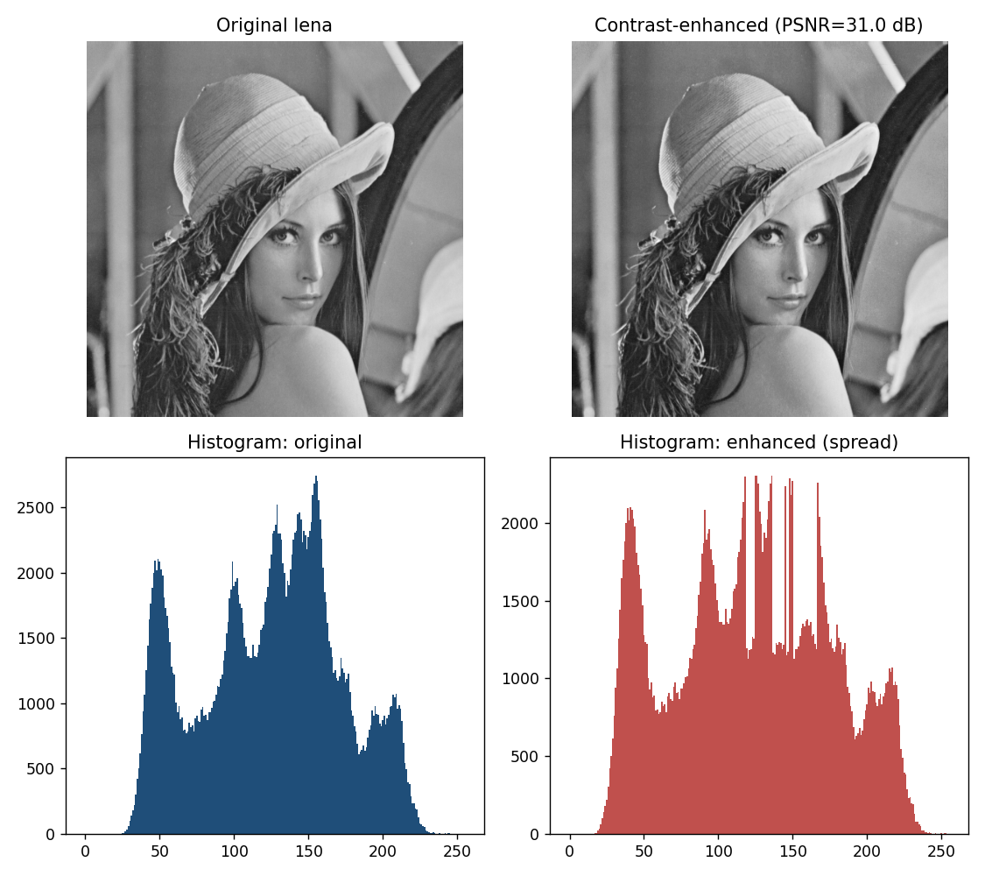
Fig. 1. Demo image and histograms before/after contrast-enhancing embedding; the histogram is visibly spread.
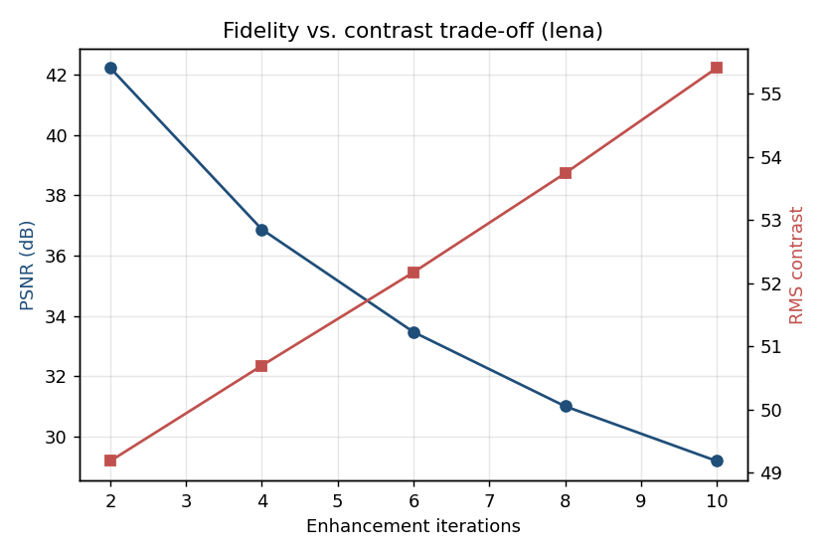
Fig. 2. Fidelity (PSNR) versus contrast as the number of enhancement iterations grows.
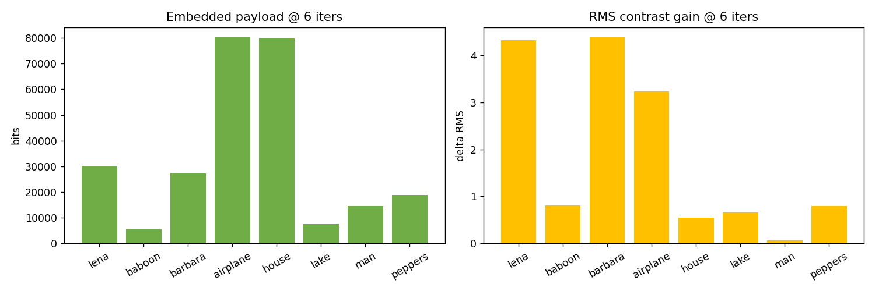
Fig. 3. Payload and contrast gain across the test images.
IX. COMPARISON WITH PAPER RESULTS
The reproduction confirms the paper's central claims: histogram expansion raises contrast (RMS and entropy increase) and the scheme is exactly reversible. Absolute PSNR/contrast numbers differ because the paper's automatic brightness-based stopping and its exact peak-selection heuristics are not fully specified and its test images differ; the qualitative trade-off is reproduced.
TABLE II. COMPARISON WITH THE ORIGINAL PAPER
Aspect | Paper (reported) | This reproduction
Contrast increases with embedding | Yes | Yes (RMS & entropy up)
Exact reversibility | Yes | Yes (bit-exact, verified)
Brightness-aware automatic control | Yes (average brightness) | Iteration count as proxy control
Fidelity vs contrast trade-off | Reported | Reproduced (Fig. 2)

X. DISCUSSION
Histogram expansion is an elegant way to obtain contrast enhancement for free during embedding. The reproduction shows the expected monotone trade-off: more iterations mean more payload and more contrast but lower PSNR. The brightness criterion in the paper is essentially a principled way to choose where on this curve to stop.
XI. LIMITATIONS
• Images already spanning the full [0,255] range enhance little (boundary limit).
• Strong enhancement reduces PSNR, as expected for CE.
• The reproduction uses iteration count as the control proxy rather than the paper's exact brightness rule.
XII. FUTURE WORK
Local and ROI-restricted contrast enhancement, perceptual-quality-guided stopping, and extensions to colour and medical modalities (all represented by other papers in this collection).
XIII. CONCLUSION
We reproduced the automatic histogram-expansion RDHCE scheme, confirming reversible contrast enhancement and the fidelity/contrast trade-off reported by Lyu et al.
REFERENCES
[1] W.-L. Lyu, Y.-J. Yue, and Z. Yin, "Reversible data hiding based on automatic contrast enhancement using histogram expansion," J. Vis. Commun. Image R., vol. 92, 2023.
[2] H.-T. Wu, J.-L. Dugelay, and Y.-Q. Shi, "Reversible image data hiding with contrast enhancement," IEEE Signal Process. Lett., vol. 22, no. 1, pp. 81-85, 2015.
[3] Z. Ni, Y.-Q. Shi, N. Ansari, and W. Su, "Reversible data hiding," IEEE Trans. Circuits Syst. Video Technol., vol. 16, no. 3, pp. 354-362, 2006.
[4] Z. Wang et al., "Image quality assessment: from error visibility to structural similarity," IEEE TIP, vol. 13, no. 4, 2004.

