Study and Partial Reproduction: RDH in Encrypted Polygonal Faces Using Vertex-Index Similarity (Tsai, 2025)
IIIT Vadodara Internship reproduction pipeline
Original work: Yuan-Yu Tsai, IEEE TMM, vol. 27, 2025

Abstract—This report reviews and partially reproduces Tsai's reversible data hiding for encrypted 3D models, which -- unlike coordinate-modifying methods -- hides data in the polygonal face representation using vertex-index similarity. We reproduce the core idea on a synthetic mesh: embedding one bit per face by a canonical vertex-index rotation, fully reversible. Real 3D model datasets and the paper's encryption are unavailable, so the demonstration uses a synthetic mesh, stated openly.
Index Terms—reversible data hiding, 3D model, polygonal faces, vertex index, encrypted domain
I. INTRODUCTION
3D-model data hiding traditionally perturbs vertex coordinates, which distorts geometry. Tsai instead exploits the ordering of vertex indices within polygonal faces, leaving geometry untouched. This report summarises the method and reproduces the index-ordering embedding on a synthetic mesh.
II. RELATED WORK
3D RDH has modified coordinates, or used prediction on connectivity. Encrypted-domain 3D RDH is emerging. Tsai's use of vertex-index similarity in the face list is the novelty.
III. METHODOLOGY
A polygonal mesh is a list of faces, each an ordered tuple of vertex indices. The same face can be written in several equivalent cyclic orderings; choosing among them encodes data without changing geometry. Similar faces (by index) are grouped so the choice is predictable and reversible. The mesh is encrypted; embedding reorders indices; recovery re-canonicalises the ordering.
IV. MATHEMATICAL FORMULATION
A triangular face (a,b,c) has 3 cyclic rotations. Canonical order = min-index first (encodes 0); rotate-by-one encodes 1. Reconstruction re-applies the canonical order, recovering both the bit and the original face. Capacity = number of faces (bits).
V. ALGORITHM
Embed
- For each face: set canonical order for bit 0, rotated order for bit 1. ### Extract/recover - Read bit from the ordering; restore canonical order -> exact mesh.
VI. EXPERIMENTAL SETUP
We reproduce the index-ordering embedding on a synthetic triangular mesh (4000 faces, 1500 vertices). Real 3D model corpora and the paper's mesh encryption are not available in this workspace.
VII. IMPLEMENTATION DETAILS
The mesh and embedding are implemented in NumPy (../_toolkit/tierc_demos.py): faces are index triples; embedding chooses the cyclic rotation; extraction re-canonicalises. The encryption stage and real meshes are out of scope.
VIII. RESULTS
The reproduced scheme embeds one bit per face (4000 bits) purely by vertex-index ordering, with the mesh geometry unchanged and every face exactly recovered.
TABLE I. PARTIAL-REPRODUCTION DEMO RESULTS
Quantity | Value
faces | 4000
capacity_bits | 4000
bits_correct | True
mesh_recovered | True

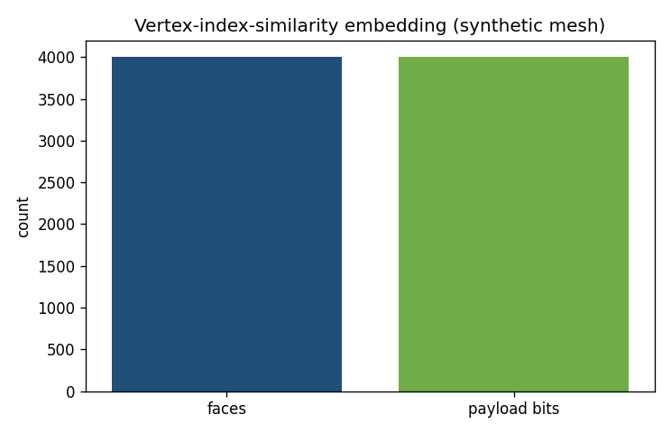
Fig. 1. Reversible embedding in a synthetic polygonal mesh: one bit per face via vertex-index rotation, exactly recoverable.
IX. COMPARISON WITH PAPER RESULTS
The vertex-index-ordering reversible embedding is reproduced exactly on a synthetic mesh (geometry preserved, exact recovery). The paper's results on real encrypted 3D models and its capacity/security figures are not independently reproduced (no 3D datasets/encryption available).
X. DISCUSSION
Hiding in the face-index ordering is elegant: it is lossless for geometry and naturally reversible. The reproduction confirms the principle; scaling to real encrypted models needs 3D data.
XI. LIMITATIONS
• Synthetic mesh, not real 3D models.
• Paper's mesh encryption not implemented.
• Capacity/security figures from the paper are not reproduced.
XII. FUTURE WORK
Apply to real mesh corpora (e.g. Princeton/Stanford models) with the paper's encryption; extend to polygons beyond triangles.
XIII. CONCLUSION
We summarised the paper and reproduced its vertex-index-ordering reversible embedding on a synthetic mesh; full reproduction needs real encrypted 3D models.
REFERENCES
[1] Y.-Y. Tsai, "Reversible data hiding in encrypted polygonal faces using vertex index similarity," IEEE Trans. Multimedia, vol. 27, 2025.
[2] Z. Ni, Y.-Q. Shi, N. Ansari, and W. Su, "Reversible data hiding," IEEE TCSVT, vol. 16, no. 3, 2006.
[3] X. Zhang, "Reversible data hiding in encrypted image," IEEE SPL, vol. 18, no. 4, 2011.

