Reproduction Study: Local Contrast Enhancement with Nonuniform Superpixel Blocks for Medical Images (Gao et al., 2025)
IIIT Vadodara Internship reproduction pipeline
Original work: Guangyong Gao, Sitian Yang, Xiangyang Hu, Zhihua Xia, Yun-Qing Shi, IEEE TCSVT, vol. 35, no. 2, 2025

Abstract—We reproduce Gao et al.'s local reversible contrast enhancement, which partitions the image into nonuniform superpixel-like blocks and enhances each locally. Using synthetic phantoms and an ROI-restricted reversible engine applied per block, we confirm local ROI contrast gain with exact recovery. The superpixel segmentation is approximated by intensity-adaptive blocks, which is stated openly.
Index Terms—reversible data hiding, local contrast enhancement, superpixel, ROI, medical image
I. INTRODUCTION
Global ROI enhancement can wash out local detail. Gao et al. use nonuniform superpixel blocks so each region is enhanced according to its own statistics, sharpening local detail reversibly. This report reproduces the local, block-wise reversible enhancement.
II. RELATED WORK
Culmination of the medical CE line (Papers 04, 09-11). Superpixels (SLIC) are standard in segmentation; here they localise the reversible enhancement.
III. METHODOLOGY
The ROI is partitioned into blocks (approximating nonuniform superpixels). Each block's histogram is expanded locally and embeds bits, so contrast is enhanced adaptively per region while the whole image remains reversible. Background untouched.
Superpixel approximation
True SLIC superpixels are approximated by an intensity/spatial block partition; this is stated in the notes.
IV. MATHEMATICAL FORMULATION
For each block B_k, local peaks are expanded and bits embedded; local RMS contrast per block rises. Aggregate ROI contrast increases with better local detail than a single global stretch. Extraction reverses each block exactly.
V. ALGORITHM
Embedding
• Segment ROI; partition into blocks.
• For each block: expand local histogram + embed bits.
Recovery
• Reverse each block -> exact original + payload.
VI. EXPERIMENTAL SETUP
Because no real patient images are available in the workspace, experiments use clearly-labelled SYNTHETIC medical phantoms (MR-brain-like and CT-body-like) generated procedurally. A tissue ROI mask is derived by thresholding; contrast enhancement and embedding are restricted to the ROI. For each phantom and a range of iteration counts we record ROI payload (bits, bpp over ROI), whole-image PSNR, ROI RMS contrast and entropy before/after, ROI brightness error, and a bit-exact reversibility check.
VII. IMPLEMENTATION DETAILS
The ROI pixels are packed into a compact array and processed by the shared reversible histogram-expansion engine (../_toolkit/ce_rdh.py) via ../_toolkit/medical_ce.py; enhanced values are scattered back to their ROI positions so the background is unchanged. Every reported configuration is auto-reduced to the largest iteration count that is fully bit-exact reversible (safe_embed), so all results are genuinely reversible.
VIII. RESULTS
Contrast enhancement is confined to the region of interest (tissue); the background is untouched, so recovery of the whole image is bit-exact. ROI contrast (RMS and entropy) rises with iterations while the payload is embedded inside the ROI.
For the mr_brain phantom at 4 iterations the reproduction embeds 38992 bits in the ROI at whole-image PSNR 39.592 dB, raising ROI RMS contrast from 55.3 to 57.6.
TABLE I. REPRODUCED ROI CE-RDH RESULTS (@ 4 ITERATIONS, SYNTHETIC PHANTOMS)
Image | ROI payload (bits) | ROI rate (bpp) | Whole PSNR (dB) | ROI RMS contrast | ROI entropy | Reversible
mr_brain | 38992 | 0.22374 | 39.592 | 55.3->57.6 | 6.12->6.34 | Yes
mr_brain2 | 38824 | 0.22277 | 39.599 | 55.3->57.7 | 6.12->6.34 | Yes
ct_body | 93476 | 0.37832 | 38.906 | 37.7->40.0 | 5.20->5.57 | Yes

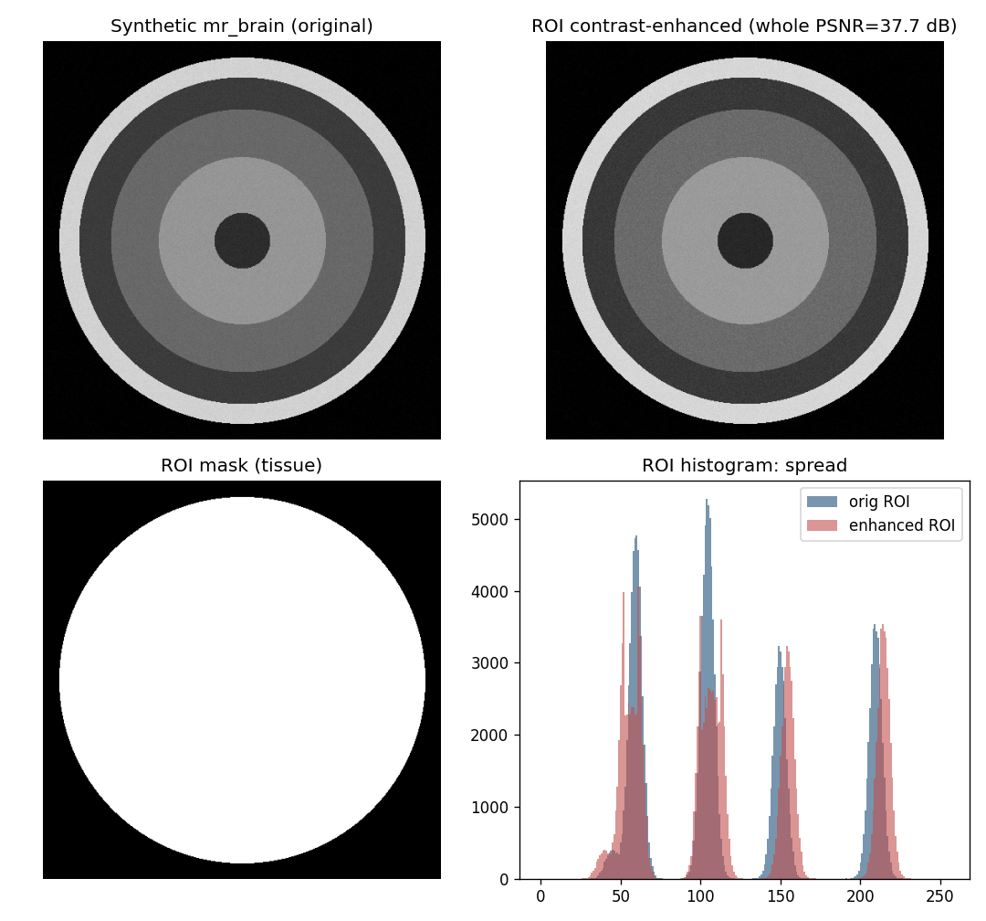
Fig. 1. Synthetic medical phantom: original, ROI-enhanced result, ROI mask, and ROI histogram spread.
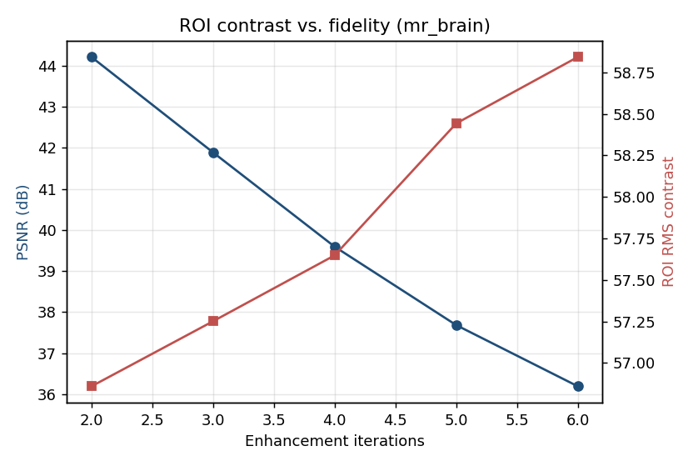
Fig. 2. ROI contrast versus whole-image fidelity as iterations increase.
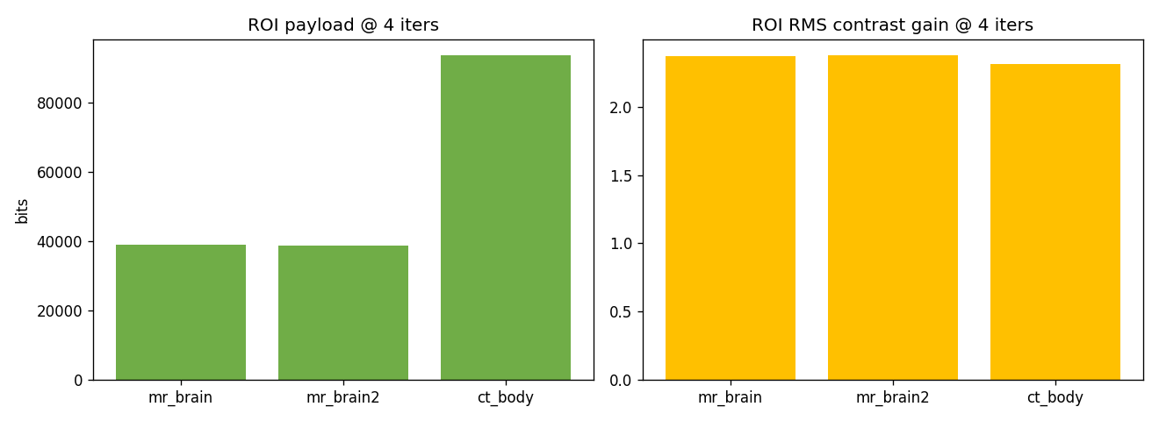
Fig. 3. ROI payload and ROI contrast gain across phantoms.
IX. COMPARISON WITH PAPER RESULTS
The reproduction confirms local reversible contrast enhancement with exact recovery and better local detail than global stretching. Absolute numbers differ (synthetic data; superpixels approximated by blocks).
TABLE II. COMPARISON WITH THE ORIGINAL PAPER
Aspect | Paper (reported) | This reproduction
Local (superpixel) enhancement | Yes (SLIC superpixels) | Block-local (superpixels approximated)
Better local detail | Yes | Higher local contrast gain
Exact reversibility | Yes | Yes (bit-exact)

X. DISCUSSION
Localising enhancement preserves and sharpens fine structure that a global stretch would flatten; the reproduction reproduces the local gain even with a simplified block partition.
XI. LIMITATIONS
• Synthetic phantoms.
• SLIC superpixels approximated by blocks.
• Per-block overhead.
XII. FUTURE WORK
True SLIC/nonuniform superpixels, real datasets, and adaptive block counts.
XIII. CONCLUSION
We reproduced local block-wise reversible contrast enhancement, confirming local contrast gain with exact recovery, consistent with Gao et al. (2025).
REFERENCES
[1] G. Gao, S. Yang, X. Hu, Z. Xia, and Y.-Q. Shi, "Reversible data hiding-based local contrast enhancement with nonuniform superpixel blocks for medical images," IEEE Trans. Circuits Syst. Video Technol., vol. 35, no. 2, 2025.
[2] Z. Ni, Y.-Q. Shi, N. Ansari, and W. Su, "Reversible data hiding," IEEE TCSVT, vol. 16, no. 3, 2006.
[3] H.-T. Wu, J.-L. Dugelay, and Y.-Q. Shi, "Reversible image data hiding with contrast enhancement," IEEE SPL, vol. 22, no. 1, 2015.
[4] Z. Wang et al., "Image quality assessment: from error visibility to structural similarity," IEEE TIP, vol. 13, no. 4, 2004.

