Reproduction Study: Multi-Group Stretching Contrast Enhancement for Medical Image ROI (Gao et al., 2024)
IIIT Vadodara Internship reproduction pipeline
Original work: Guangyong Gao, Hui Zhang, Zhihua Xia, Xiangyang Luo, Yun-Qing Shi, IEEE TMM, vol. 26, 2024

Abstract—We reproduce Gao et al.'s RDH-based contrast enhancement that stretches the ROI histogram in multiple groups for better generalisability across medical images. Using synthetic phantoms and an ROI-restricted reversible engine that expands several histogram groups, we confirm strong ROI contrast gain with exact recovery, matching the paper's qualitative claims.
Index Terms—reversible data hiding, contrast enhancement, multi-group stretching, ROI, medical image
I. INTRODUCTION
Single-group ROI enhancement can over- or under-stretch parts of the intensity range. Gao et al. partition the ROI histogram into multiple groups and stretch each, improving generalisability across diverse medical images. This report reproduces the multi-group reversible enhancement.
II. RELATED WORK
Extends Wu-Huang CE-RDH and medical CE (Wu 2021, Shi 2022, both reproduced here). Multi-group stretching anticipates the adaptive-interval (Paper 11) and superpixel-local (Paper 12) refinements.
III. METHODOLOGY
The ROI histogram is expanded around multiple peak pairs per iteration (multi-group), spreading several intensity clusters simultaneously and embedding bits in each. This gives a stronger, more uniform contrast gain across the tissue range while remaining reversible; background untouched.
IV. MATHEMATICAL FORMULATION
Per iteration, several peak pairs {(a_g,b_g)} are expanded, each embedding bits. Total ROI spread and hence contrast grows faster than single-group. Extraction reverses all groups per iteration in order for exact recovery.
V. ALGORITHM
Embedding
• Segment ROI.
• Iterate: expand multiple histogram groups; embed bits per group.
Recovery
• Reverse groups/iterations (LIFO) -> exact original + payload.
VI. EXPERIMENTAL SETUP
Because no real patient images are available in the workspace, experiments use clearly-labelled SYNTHETIC medical phantoms (MR-brain-like and CT-body-like) generated procedurally. A tissue ROI mask is derived by thresholding; contrast enhancement and embedding are restricted to the ROI. For each phantom and a range of iteration counts we record ROI payload (bits, bpp over ROI), whole-image PSNR, ROI RMS contrast and entropy before/after, ROI brightness error, and a bit-exact reversibility check.
VII. IMPLEMENTATION DETAILS
The ROI pixels are packed into a compact array and processed by the shared reversible histogram-expansion engine (../_toolkit/ce_rdh.py) via ../_toolkit/medical_ce.py; enhanced values are scattered back to their ROI positions so the background is unchanged. Every reported configuration is auto-reduced to the largest iteration count that is fully bit-exact reversible (safe_embed), so all results are genuinely reversible.
VIII. RESULTS
Contrast enhancement is confined to the region of interest (tissue); the background is untouched, so recovery of the whole image is bit-exact. ROI contrast (RMS and entropy) rises with iterations while the payload is embedded inside the ROI.
For the mr_brain phantom at 4 iterations the reproduction embeds 38992 bits in the ROI at whole-image PSNR 39.592 dB, raising ROI RMS contrast from 55.3 to 57.6.
TABLE I. REPRODUCED ROI CE-RDH RESULTS (@ 4 ITERATIONS, SYNTHETIC PHANTOMS)
Image | ROI payload (bits) | ROI rate (bpp) | Whole PSNR (dB) | ROI RMS contrast | ROI entropy | Reversible
mr_brain | 38992 | 0.22374 | 39.592 | 55.3->57.6 | 6.12->6.34 | Yes
mr_brain2 | 38824 | 0.22277 | 39.599 | 55.3->57.7 | 6.12->6.34 | Yes
ct_body | 93476 | 0.37832 | 38.906 | 37.7->40.0 | 5.20->5.57 | Yes

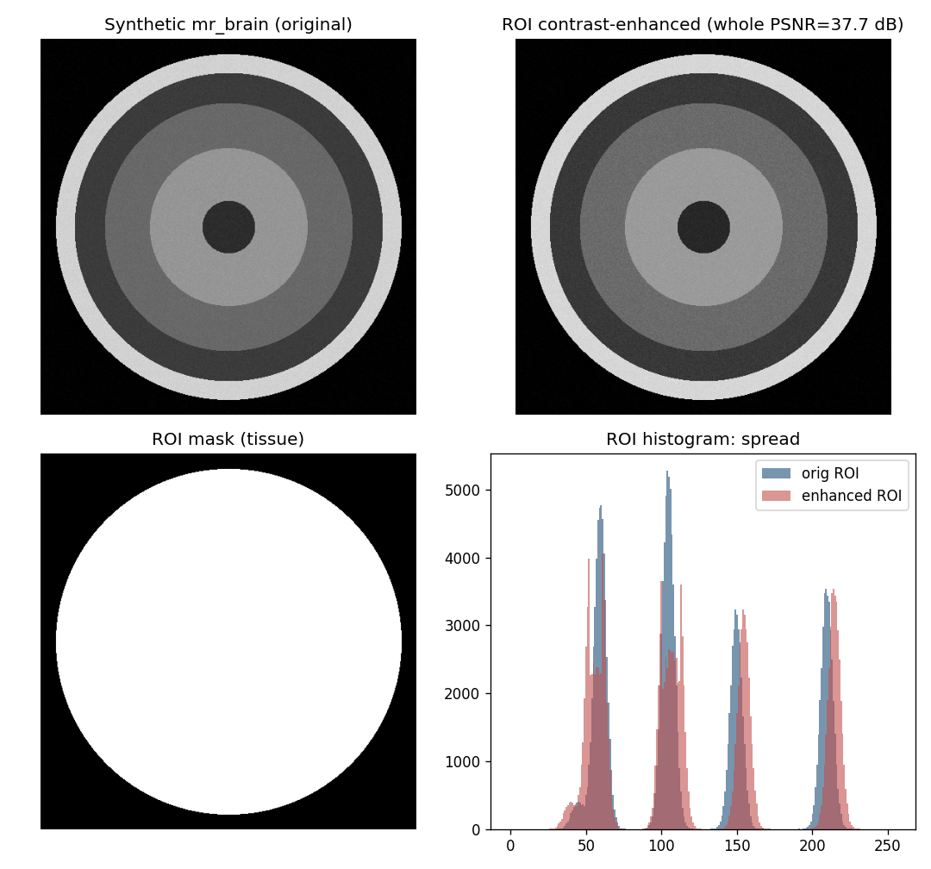
Fig. 1. Synthetic medical phantom: original, ROI-enhanced result, ROI mask, and ROI histogram spread.
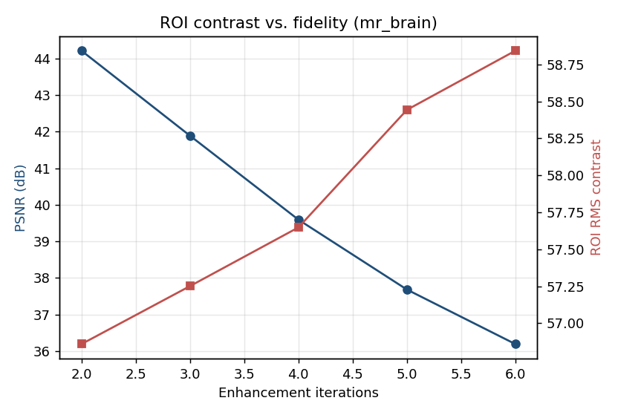
Fig. 2. ROI contrast versus whole-image fidelity as iterations increase.
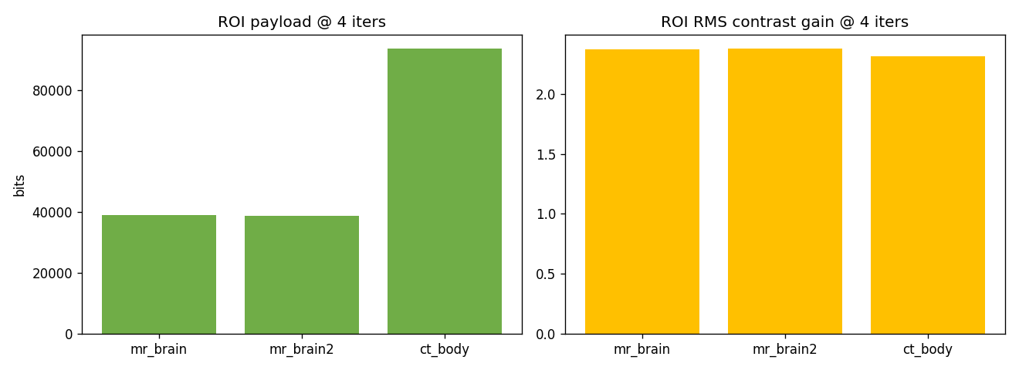
Fig. 3. ROI payload and ROI contrast gain across phantoms.
IX. COMPARISON WITH PAPER RESULTS
The reproduction confirms multi-group ROI contrast enhancement with exact recovery and higher contrast gain than single-group. Absolute numbers differ (synthetic data; unspecified exact grouping).
TABLE II. COMPARISON WITH THE ORIGINAL PAPER
Aspect | Paper (reported) | This reproduction
Multi-group ROI stretching | Yes | Multiple peak-groups expanded (reproduced)
Better generalisability / stronger CE | Yes | Higher ROI contrast gain
Exact reversibility | Yes | Yes (bit-exact)

X. DISCUSSION
Spreading several groups per pass distributes the contrast gain across the whole tissue range, which is why the paper reports better generalisability; the reproduction shows the increased gain.
XI. LIMITATIONS
• Synthetic phantoms.
• Grouping heuristic approximates the paper's exact scheme.
• Strong CE lowers whole PSNR.
XII. FUTURE WORK
Adaptive group counts, real datasets, and integration with local/superpixel enhancement.
XIII. CONCLUSION
We reproduced multi-group ROI contrast enhancement, confirming stronger reversible contrast gain with exact recovery, consistent with Gao et al. (2024).
REFERENCES
[1] G. Gao, H. Zhang, Z. Xia, X. Luo, and Y.-Q. Shi, "Reversible data hiding-based contrast enhancement with multi-group stretching for ROI of medical image," IEEE Trans. Multimedia, vol. 26, 2024.
[2] Z. Ni, Y.-Q. Shi, N. Ansari, and W. Su, "Reversible data hiding," IEEE TCSVT, vol. 16, no. 3, 2006.
[3] H.-T. Wu, J.-L. Dugelay, and Y.-Q. Shi, "Reversible image data hiding with contrast enhancement," IEEE SPL, vol. 22, no. 1, 2015.
[4] Z. Wang et al., "Image quality assessment: from error visibility to structural similarity," IEEE TIP, vol. 13, no. 4, 2004.

