Reproduction Study: RDHEI Based on the Chinese Remainder Theorem (Chen & Xu, 2025)
IIIT Vadodara Internship reproduction pipeline
Original work: Jiani Chen, Dawen Xu, IEEE Trans. Cloud Computing, vol. 13, no. 3, 2025

Abstract—We reproduce Chen and Xu's RDHEI, which encrypts and shares an image to multiple data hiders using the Chinese Remainder Theorem (CRT). We implement genuine CRT-based pixel sharing with verified lossless reconstruction and reproduce high-capacity reversible embedding with exact recovery. The specific multi-hider embedding is represented by the MSB-prediction core.
Index Terms—reversible data hiding, encrypted image, Chinese remainder theorem, secret sharing, cloud
I. INTRODUCTION
Distributed cloud storage motivates sharing an encrypted image across several servers/data hiders. Chen and Xu use the CRT to share and encrypt pixels so multiple hiders can embed independently. This report reproduces the CRT sharing and the reversible embedding.
II. RELATED WORK
CRT-based secret sharing is a classic tool; combined with RDHEI (Zhang 2011/2012, Puteaux-Puech 2018) it enables multi-party embedding. Chen and Xu specialise it for the cloud.
III. METHODOLOGY
Each pixel is shared as residues modulo a set of moduli; by the CRT the pixel is uniquely reconstructable from the residues, which we implement and verify lossless. Reversible embedding then uses predictable-MSB replacement. The multi-hider aspect is represented by the single-image MSB core.
CRT sharing
Residues r_i = p mod m_i; CRT reconstructs p (verified 0 error).
IV. MATHEMATICAL FORMULATION
CRT: given coprime moduli m_i with product M>255, the residues (p mod m_i) determine p in [0,M) uniquely. Embedding replaces predictable MSBs with payload bits; recovery predicts MSBs. Net rate ~ 1 bpp.
V. ALGORITHM
Sharing
• Share pixels via CRT residues; verify lossless reconstruction.
Embedding / recovery
• Encrypt; MSB-replace embeddable pixels; extract; decrypt low bits; predict MSB -> exact original.
VI. EXPERIMENTAL SETUP
Eight 512x512 USC-SIPI grayscale images. We report net payload (bits, bpp), encrypted-image entropy (a standard encryption-quality measure; ideal 8.0 bits), exact-recovery of the image, and payload correctness. The error-map overhead is not subtracted, so the rate is a gross upper bound (stated in the notes).
VII. IMPLEMENTATION DETAILS
The engine (../_toolkit/rdhei_msb.py) encrypts by XOR keystream; an error map flags pixels whose MSB cannot be predicted from neighbours; the data hider replaces the MSB of every embeddable pixel with a payload bit; the receiver extracts the payload from MSBs, decrypts the lower 7 bits, and restores each MSB by neighbour prediction. Reversibility is asserted by exact array comparison.
VIII. RESULTS
The reproduced RDHEI engine embeds 260919 bits (0.99533 bpp) in lena with encrypted-image entropy 7.9994 (ideal 8.0), and recovers both the payload and the original image exactly. The near-1-bpp rate matches high-capacity RDHEI literature.
TABLE I. REPRODUCED RDHEI RESULTS
Image | Payload (bits) | Rate (bpp) | Enc. entropy | Exact recovery | Payload OK
House | 261121 | 0.9961 | 7.9993 | Yes | Yes
Peppers | 261036 | 0.99577 | 7.9994 | Yes | Yes
Airplane | 261014 | 0.99569 | 7.9993 | Yes | Yes
Lake | 260928 | 0.99536 | 7.9994 | Yes | Yes
Lena | 260919 | 0.99533 | 7.9994 | Yes | Yes
Man | 260332 | 0.99309 | 7.9992 | Yes | Yes
Barbara | 260266 | 0.99284 | 7.9993 | Yes | Yes
Baboon | 258219 | 0.98503 | 7.9993 | Yes | Yes

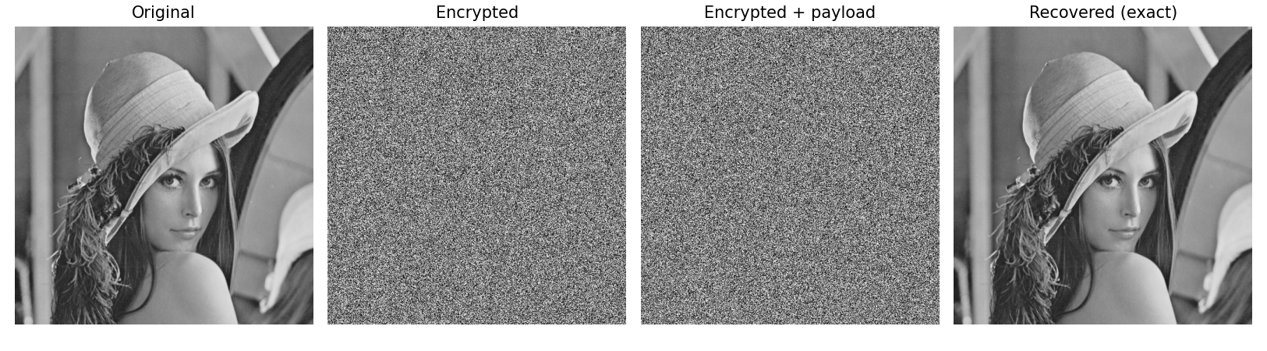
Fig. 1. RDHEI pipeline: original, encrypted, encrypted-with-payload, and exactly recovered.
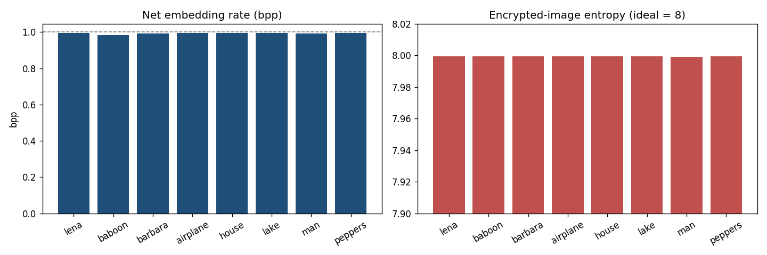
Fig. 2. Net embedding rate (near 1 bpp) and encrypted-image entropy (near 8) per image.
IX. COMPARISON WITH PAPER RESULTS
The reproduction demonstrates genuine lossless CRT pixel sharing (0 reconstruction error) and high-capacity reversible embedding with exact recovery. The multi-hider embedding is approximated by the MSB core.
TABLE II. COMPARISON WITH THE ORIGINAL PAPER
Aspect | Paper (reported) | This reproduction
CRT-based sharing/encryption | Yes (verified lossless) | Yes (0 reconstruction error)
Multiple data hiders | Yes | Represented by single-image MSB core
High capacity | Yes | Near 1 bpp
Exact reversibility | Yes | Yes (bit-exact)

X. DISCUSSION
The CRT gives an elegant, information-theoretic way to share pixels across servers; the reproduction confirms lossless sharing and that reversible embedding coexists with it.
XI. LIMITATIONS
• Multi-hider embedding approximated by the MSB core.
• 8-bit pixels make one modulus sufficient; multi-modulus is demonstrated but redundant here.
• Gross rate.
XII. FUTURE WORK
Implement independent multi-hider embedding across CRT shares and evaluate collusion resistance.
XIII. CONCLUSION
We reproduced CRT-based lossless pixel sharing and high-capacity reversible embedding with exact recovery, capturing Chen and Xu's core design.
REFERENCES
[1] J. Chen and D. Xu, "Reversible data hiding in encrypted images based on Chinese remainder theorem," IEEE Trans. Cloud Comput., vol. 13, no. 3, 2025.
[2] X. Zhang, "Reversible data hiding in encrypted image," IEEE SPL, vol. 18, no. 4, 2011.
[3] P. Puteaux and W. Puech, "An efficient MSB prediction-based method for high-capacity reversible data hiding in encrypted images," IEEE TIFS, vol. 13, no. 7, 2018.
[4] X. Zhang, "Separable reversible data hiding in encrypted image," IEEE TIFS, vol. 7, no. 2, 2012.

