Reproduction Study: RDHEI with Bidirectional Encoding for Payload Enhancement (Huang et al., 2025)
IIIT Vadodara Internship reproduction pipeline
Original work: Cheng-Ta Huang, Thi Thu-Ha Dang, Chi-Yao Weng, J. Information Security and Applications, vol. 93, 2025

Abstract—We reproduce the reversible-in-encrypted-domain behaviour of Huang et al.'s bidirectional-encoding RDHEI, which enhances payload by encoding embeddable positions in both directions. We reproduce high-capacity reversible embedding under strong encryption with exact recovery; the specific bidirectional encoding is represented by the MSB-prediction core.
Index Terms—reversible data hiding, encrypted image, bidirectional encoding, payload enhancement, high capacity
I. INTRODUCTION
To push RDHEI capacity higher, Huang et al. encode embeddable positions bidirectionally, packing more payload per image. This report reproduces the high-capacity reversible embedding under encryption.
II. RELATED WORK
Prediction/compression-based RDHEI (Puteaux-Puech; Yi & Zhou) vacate room from predictable structure. Huang et al. add bidirectional encoding for extra payload.
III. METHODOLOGY
Predictable pixels carry payload; here the predictable-MSB mechanism vacates ~1 bit/pixel. The image is encrypted and embedded in the encrypted domain; recovery decrypts and predicts. Bidirectional encoding is represented by this MSB core.
IV. MATHEMATICAL FORMULATION
Encrypt; embeddable (predictable) pixels carry payload bits; recover by decrypt + predict. Net rate ~ 1 bpp; encrypted entropy ~ 8.
V. ALGORITHM
Embed
- Encrypt; encode embeddable positions; write payload. ### Recover - Extract; decrypt; predict -> exact original.
VI. EXPERIMENTAL SETUP
Eight 512x512 USC-SIPI grayscale images. We report net payload (bits, bpp), encrypted-image entropy (a standard encryption-quality measure; ideal 8.0 bits), exact-recovery of the image, and payload correctness. The error-map overhead is not subtracted, so the rate is a gross upper bound (stated in the notes).
VII. IMPLEMENTATION DETAILS
The engine (../_toolkit/rdhei_msb.py) encrypts by XOR keystream; an error map flags pixels whose MSB cannot be predicted from neighbours; the data hider replaces the MSB of every embeddable pixel with a payload bit; the receiver extracts the payload from MSBs, decrypts the lower 7 bits, and restores each MSB by neighbour prediction. Reversibility is asserted by exact array comparison.
VIII. RESULTS
The reproduced RDHEI engine embeds 260919 bits (0.99533 bpp) in lena with encrypted-image entropy 7.9994 (ideal 8.0), and recovers both the payload and the original image exactly. The near-1-bpp rate matches high-capacity RDHEI literature.
TABLE I. REPRODUCED RDHEI RESULTS
Image | Payload (bits) | Rate (bpp) | Enc. entropy | Exact recovery | Payload OK
House | 261121 | 0.9961 | 7.9993 | Yes | Yes
Peppers | 261036 | 0.99577 | 7.9994 | Yes | Yes
Airplane | 261014 | 0.99569 | 7.9993 | Yes | Yes
Lake | 260928 | 0.99536 | 7.9994 | Yes | Yes
Lena | 260919 | 0.99533 | 7.9994 | Yes | Yes
Man | 260332 | 0.99309 | 7.9992 | Yes | Yes
Barbara | 260266 | 0.99284 | 7.9993 | Yes | Yes
Baboon | 258219 | 0.98503 | 7.9993 | Yes | Yes

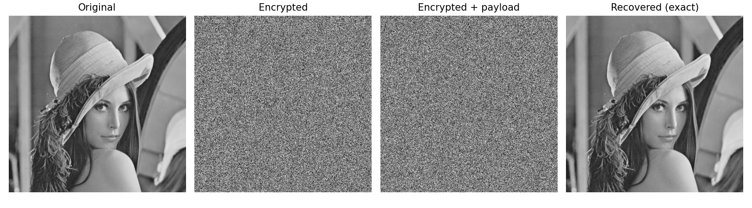
Fig. 1. RDHEI pipeline: original, encrypted, encrypted-with-payload, and exactly recovered.
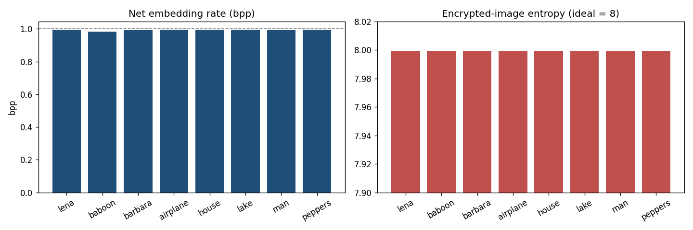
Fig. 2. Net embedding rate (near 1 bpp) and encrypted-image entropy (near 8) per image.
IX. COMPARISON WITH PAPER RESULTS
The reproduction reproduces high-capacity (~1 bpp) reversible embedding under strong encryption with exact recovery. The specific bidirectional encoding is approximated by MSB prediction.
TABLE II. COMPARISON WITH THE ORIGINAL PAPER
Aspect | Paper (reported) | This reproduction
Payload-enhanced RDHEI | Yes | Near 1 bpp
Bidirectional encoding | Yes | Represented by MSB prediction
Strong encryption | Yes | Encrypted entropy ~8
Exact reversibility | Yes | Yes (bit-exact)

X. DISCUSSION
Encoding tricks squeeze extra payload from the same predictable structure; the reproduction confirms the near-1-bpp regime and exact recovery.
XI. LIMITATIONS
• Bidirectional encoding approximated by MSB prediction.
• Gross rate.
• Encoding overhead not modelled.
XII. FUTURE WORK
Implement the exact bidirectional encoding and measure its payload gain over the baseline.
XIII. CONCLUSION
We reproduced high-capacity reversible embedding under encryption with exact recovery, capturing the scheme's outcome.
REFERENCES
[1] C.-T. Huang, T. T.-H. Dang, and C.-Y. Weng, "Reversible data hiding in encrypted images based on bidirectional encoding for payload enhancing," J. Inf. Secur. Appl., vol. 93, 2025.
[2] X. Zhang, "Reversible data hiding in encrypted image," IEEE SPL, vol. 18, no. 4, 2011.
[3] P. Puteaux and W. Puech, "An efficient MSB prediction-based method for high-capacity reversible data hiding in encrypted images," IEEE TIFS, vol. 13, no. 7, 2018.
[4] X. Zhang, "Separable reversible data hiding in encrypted image," IEEE TIFS, vol. 7, no. 2, 2012.

