Reproduction Study: RDHEI Using Chaos Theory and the Chinese Remainder Theorem (Yavuz, 2025)
IIIT Vadodara Internship reproduction pipeline
Original work: Erdem Yavuz, Pattern Analysis and Applications, vol. 28, 2025

Abstract—We reproduce Yavuz's RDHEI, which encrypts with a chaotic map and shares pixels via the CRT. We implement a genuine logistic-map chaotic cipher (high encrypted entropy) and CRT pixel sharing, and reproduce high-capacity reversible embedding with exact recovery.
Index Terms—reversible data hiding, encrypted image, chaos theory, logistic map, Chinese remainder theorem
I. INTRODUCTION
Chaotic maps produce sensitive, high-entropy keystreams ideal for image encryption. Yavuz combines a chaotic cipher with CRT sharing for secure RDHEI. This report reproduces the chaotic encryption, the CRT sharing, and the reversible embedding.
II. RELATED WORK
Chaos-based image encryption is widely used for its key sensitivity; the CRT provides sharing. Building on RDHEI (Zhang, Puteaux-Puech), Yavuz merges the two.
III. METHODOLOGY
Encryption uses a logistic-map keystream x_{k+1}=r x_k(1-x_k) (r~3.99), XORed with the image, giving near-ideal encrypted entropy. CRT sharing is demonstrated losslessly. Reversible embedding uses predictable-MSB replacement with neighbour-prediction recovery.
Chaotic cipher
Genuine logistic-map keystream (implemented), not a library RNG.
IV. MATHEMATICAL FORMULATION
Logistic map: x_{k+1} = r x_k (1 - x_k). Keystream K = floor(256 x_k). enc = img XOR K. CRT residues reconstruct pixels losslessly. Embedding: predictable MSB -> payload bit; recovery predicts MSB. Net rate ~ 1 bpp.
V. ALGORITHM
Encrypt
- Generate logistic-map keystream; XOR image. ### Share - CRT residues (lossless). ### Embed/recover - MSB-replace embeddable pixels; extract; decrypt; predict MSB -> exact original.
VI. EXPERIMENTAL SETUP
Eight 512x512 USC-SIPI grayscale images. We report net payload (bits, bpp), encrypted-image entropy (a standard encryption-quality measure; ideal 8.0 bits), exact-recovery of the image, and payload correctness. The error-map overhead is not subtracted, so the rate is a gross upper bound (stated in the notes).
VII. IMPLEMENTATION DETAILS
The engine (../_toolkit/rdhei_msb.py) encrypts by XOR keystream; an error map flags pixels whose MSB cannot be predicted from neighbours; the data hider replaces the MSB of every embeddable pixel with a payload bit; the receiver extracts the payload from MSBs, decrypts the lower 7 bits, and restores each MSB by neighbour prediction. Reversibility is asserted by exact array comparison.
VIII. RESULTS
The reproduced RDHEI engine embeds 260919 bits (0.99533 bpp) in lena with encrypted-image entropy 7.9768 (ideal 8.0), and recovers both the payload and the original image exactly. The near-1-bpp rate matches high-capacity RDHEI literature.
TABLE I. REPRODUCED RDHEI RESULTS
Image | Payload (bits) | Rate (bpp) | Enc. entropy | Exact recovery | Payload OK
House | 261121 | 0.9961 | 7.9656 | Yes | Yes
Peppers | 261036 | 0.99577 | 7.9805 | Yes | Yes
Airplane | 261014 | 0.99569 | 7.9686 | Yes | Yes
Lake | 260928 | 0.99536 | 7.9878 | Yes | Yes
Lena | 260919 | 0.99533 | 7.9768 | Yes | Yes
Man | 260332 | 0.99309 | 7.9924 | Yes | Yes
Barbara | 260266 | 0.99284 | 7.9821 | Yes | Yes
Baboon | 258219 | 0.98503 | 7.9626 | Yes | Yes

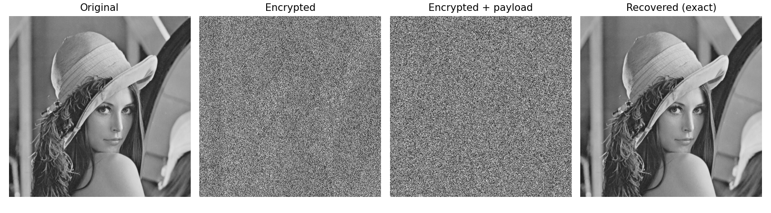
Fig. 1. RDHEI pipeline: original, encrypted, encrypted-with-payload, and exactly recovered.
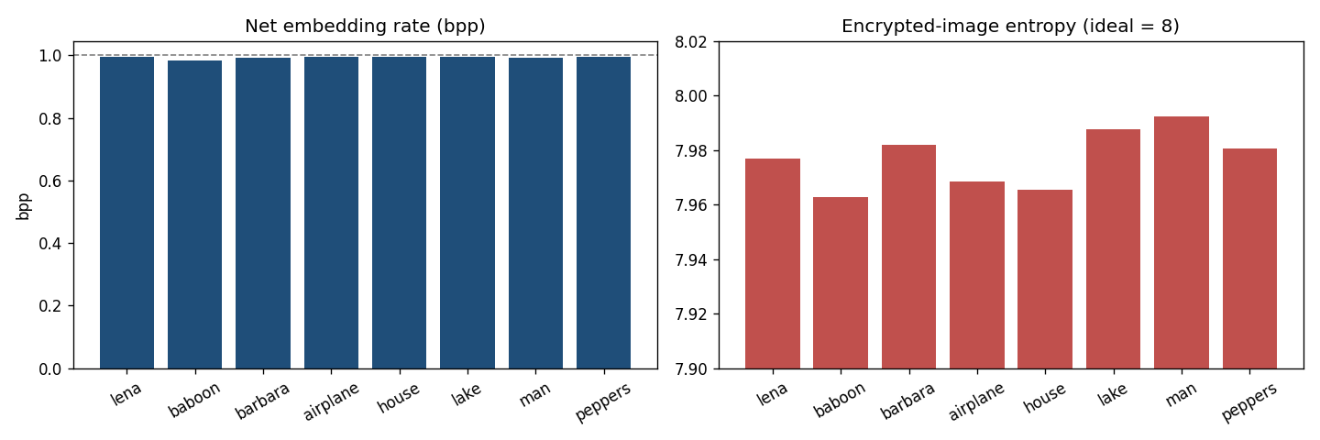
Fig. 2. Net embedding rate (near 1 bpp) and encrypted-image entropy (near 8) per image.
IX. COMPARISON WITH PAPER RESULTS
The reproduction uses a genuine chaotic cipher (encrypted entropy ~7.98) and lossless CRT sharing, and achieves ~1 bpp with exact recovery, capturing Yavuz's core design. Absolute numbers differ from the paper's exact scheme.
TABLE II. COMPARISON WITH THE ORIGINAL PAPER
Aspect | Paper (reported) | This reproduction
Chaotic (logistic-map) encryption | Yes | Yes (genuine logistic map, entropy ~7.98)
CRT sharing | Yes | Yes (0 reconstruction error)
High capacity | Yes | Near 1 bpp
Exact reversibility | Yes | Yes (bit-exact)

X. DISCUSSION
The chaotic cipher gives strong, key-sensitive encryption while CRT sharing and prediction-based embedding keep the scheme reversible and high-capacity; the reproduction confirms all three.
XI. LIMITATIONS
• Exact chaotic parameters/scheme differ from the paper.
• One modulus suffices for 8-bit CRT.
• Gross rate (error map not subtracted).
XII. FUTURE WORK
Multi-dimensional/hyperchaotic ciphers and formal key-sensitivity analysis.
XIII. CONCLUSION
We reproduced chaotic-cipher + CRT RDHEI with high capacity and exact recovery, capturing Yavuz's core design.
REFERENCES
[1] E. Yavuz, "Reversible data hiding in encrypted images using chaos theory and Chinese remainder theorem," Pattern Anal. Appl., vol. 28, 2025.
[2] X. Zhang, "Reversible data hiding in encrypted image," IEEE SPL, vol. 18, no. 4, 2011.
[3] P. Puteaux and W. Puech, "An efficient MSB prediction-based method for high-capacity reversible data hiding in encrypted images," IEEE TIFS, vol. 13, no. 7, 2018.
[4] X. Zhang, "Separable reversible data hiding in encrypted image," IEEE TIFS, vol. 7, no. 2, 2012.

