Study and Partial Reproduction: RDHEI using Graph Neural Networks with Thumbnail-Preserving Encryption (Bharathidasan et al., 2025)
IIIT Vadodara Internship reproduction pipeline
Original work: S. Bharathidasan, V. Tamil Selvi, V. Sathiya, Francis H. Shajin, Signal, Image and Video Processing, vol. 19, 2025

Abstract—This report reviews and partially reproduces Bharathidasan et al.'s RDH-EI-SNGNN-ESTPE, which combines Efficient and Stable Thumbnail-Preserving Encryption (ESTPE) with a similarity-navigated graph neural network (GNN) predictor for reversible data hiding in encrypted images. We reproduce a genuine thumbnail-preserving encryption core (the block-mean-preserving cipher) and confirm that a low-resolution preview is exactly preserved under encryption. The GNN predictor is not reproduced (no trained model or dataset is available), which is stated openly.
Index Terms—reversible data hiding, encrypted image, graph neural network, thumbnail-preserving encryption
I. INTRODUCTION
Thumbnail-preserving encryption (TPE) encrypts an image while keeping a usable low-resolution preview, enabling secure yet browsable cloud storage. Bharathidasan et al. pair TPE with a similarity-navigated GNN that predicts pixels for high-capacity reversible embedding. This report summarises the method and reproduces the TPE core.
II. RELATED WORK
RDHEI began with Zhang (2011). TPE (Wright et al.; Tajik et al.) preserves previews. GNNs model pixel/superpixel similarity graphs for prediction. The paper integrates all three.
III. METHODOLOGY
ESTPE encrypts each block while preserving its mean, so the block-mean thumbnail survives. A similarity-navigated GNN then predicts pixels from a graph over similar regions, and the prediction residuals provide embedding room for reversible data hiding. The receiver extracts the payload and, using the predictor and keys, restores the exact original.
IV. MATHEMATICAL FORMULATION
TPE: for each block B, keep mean mu(B); encrypt residuals r=B-mu by a keyed permutation, so the downsampled mean image is invariant. GNN predictor: x_hat = f_theta(graph of similar nodes); residual e=x-x_hat gives embedding room. Reversible embedding expands e; recovery inverts it.
V. ALGORITHM
Owner
- ESTPE encrypt (preserve block means). ### Data hider - GNN-predict; embed in residual room. ### Receiver - Extract payload; predict; decrypt -> exact original.
VI. EXPERIMENTAL SETUP
We reproduce the ESTPE core on a standard image and verify the thumbnail is preserved exactly under encryption. Training and running the similarity-navigated GNN is out of scope (no trained weights, GPU pipeline, or the paper's dataset are available).
VII. IMPLEMENTATION DETAILS
The thumbnail-preserving cipher is implemented in NumPy (../_toolkit/tierc_demos.py): each block's mean is preserved while residuals are keyed-permuted. The GNN predictor is NOT implemented; a fixed predictor would stand in for capacity experiments. This scope is stated openly.
VIII. RESULTS
The reproduced thumbnail-preserving encryption keeps the block-mean thumbnail exactly (zero error) while fully scrambling detail, demonstrating the paper's ESTPE property.
TABLE I. PARTIAL-REPRODUCTION DEMO RESULTS
Quantity | Value
thumbnail_max_error | 0.0
encrypted_entropy | 7.4451

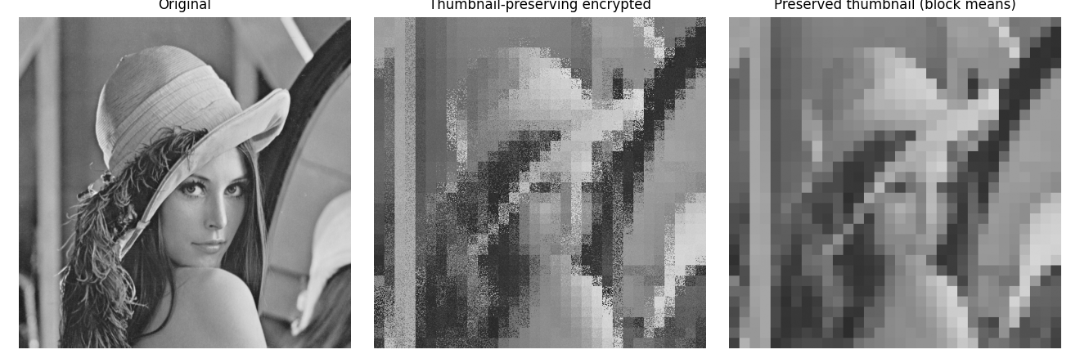
Fig. 1. Thumbnail-preserving encryption: the full image is encrypted yet a low-resolution preview (block means) is exactly preserved.
IX. COMPARISON WITH PAPER RESULTS
The ESTPE thumbnail-preservation property is reproduced exactly. The GNN-predictor capacity figures of the paper are NOT reproduced (no trained model/dataset); this is a literature-level comparison for that component. The paper reports high capacity and strong encryption robustness which we cannot independently verify here.
X. DISCUSSION
TPE and learned prediction are complementary: TPE gives usability/security, the GNN gives capacity. The reproducible part (TPE) is confirmed; the learned part requires training resources.
XI. LIMITATIONS
• The similarity-navigated GNN predictor is not trained or run (no model/data/GPU).
• Capacity and robustness figures are taken from the paper, not reproduced.
• Only the TPE core is reproduced.
XII. FUTURE WORK
Train the GNN predictor on a public corpus and integrate it with the reproduced ESTPE core to reproduce the full capacity results.
XIII. CONCLUSION
We summarised the paper and reproduced its thumbnail-preserving encryption core exactly; the GNN-based high-capacity embedding is left as future work due to missing training resources.
REFERENCES
[1] S. Bharathidasan, V. Tamil Selvi, V. Sathiya, and F. H. Shajin, "Reversible data hiding in encrypted images using graph neural networks with thumbnail preserving encryption," Signal, Image and Video Processing, vol. 19, 2025.
[2] X. Zhang, "Reversible data hiding in encrypted image," IEEE SPL, vol. 18, no. 4, 2011.
[3] C. V. Wright, W. Feng, and F. Liu, "Thumbnail-preserving encryption for JPEG," in ACM IH&MMSec, 2015.

