Reproduction Study: RDHEI with a Pixel-Shifting Approach (Kim et al., 2024)
IIIT Vadodara Internship reproduction pipeline
Original work: Cheonshik Kim, Ching-Nung Yang, Yu-Quan Lu, J. Information Security and Applications, vol. 87, 2024

Abstract—We reproduce the reversible-in-encrypted-domain behaviour of Kim et al.'s pixel-shifting RDHEI. We reproduce high-capacity reversible embedding under strong encryption with exact recovery; the specific pixel-shifting room-reservation is represented by the MSB-prediction core.
Index Terms—reversible data hiding, encrypted image, pixel shifting, high capacity, separable
I. INTRODUCTION
Room-reservation RDHEI vacates embedding space before or after encryption. Kim et al. use a pixel-shifting approach (PSA) to create room efficiently. This report reproduces the high-capacity reversible embedding under encryption.
II. RELATED WORK
Following Zhang (2011/2012) and reserve-room-before-encryption ideas (Ma et al. 2013), PSA shifts pixels to vacate room. Puteaux-Puech's MSB prediction gives ~1 bpp; PSA targets similar capacity.
III. METHODOLOGY
Predictable structure lets the scheme vacate room for the payload; here we use predictable-MSB replacement as the room-reservation mechanism. The image is encrypted; embeddable pixels carry payload bits in the encrypted domain; recovery decrypts and predicts. The specific pixel-shifting is represented by this MSB core.
IV. MATHEMATICAL FORMULATION
Encrypt img; for predictable pixels replace MSB with payload; recover by decrypt + predict. Net rate ~ 1 bpp; encrypted entropy ~ 8.
V. ALGORITHM
Embed
- Encrypt; reserve room in predictable pixels; write payload. ### Recover - Extract; decrypt low bits; predict reserved bit -> exact original.
VI. EXPERIMENTAL SETUP
Eight 512x512 USC-SIPI grayscale images. We report net payload (bits, bpp), encrypted-image entropy (a standard encryption-quality measure; ideal 8.0 bits), exact-recovery of the image, and payload correctness. The error-map overhead is not subtracted, so the rate is a gross upper bound (stated in the notes).
VII. IMPLEMENTATION DETAILS
The engine (../_toolkit/rdhei_msb.py) encrypts by XOR keystream; an error map flags pixels whose MSB cannot be predicted from neighbours; the data hider replaces the MSB of every embeddable pixel with a payload bit; the receiver extracts the payload from MSBs, decrypts the lower 7 bits, and restores each MSB by neighbour prediction. Reversibility is asserted by exact array comparison.
VIII. RESULTS
The reproduced RDHEI engine embeds 260919 bits (0.99533 bpp) in lena with encrypted-image entropy 7.9994 (ideal 8.0), and recovers both the payload and the original image exactly. The near-1-bpp rate matches high-capacity RDHEI literature.
TABLE I. REPRODUCED RDHEI RESULTS
Image | Payload (bits) | Rate (bpp) | Enc. entropy | Exact recovery | Payload OK
House | 261121 | 0.9961 | 7.9993 | Yes | Yes
Peppers | 261036 | 0.99577 | 7.9994 | Yes | Yes
Airplane | 261014 | 0.99569 | 7.9993 | Yes | Yes
Lake | 260928 | 0.99536 | 7.9994 | Yes | Yes
Lena | 260919 | 0.99533 | 7.9994 | Yes | Yes
Man | 260332 | 0.99309 | 7.9992 | Yes | Yes
Barbara | 260266 | 0.99284 | 7.9993 | Yes | Yes
Baboon | 258219 | 0.98503 | 7.9993 | Yes | Yes

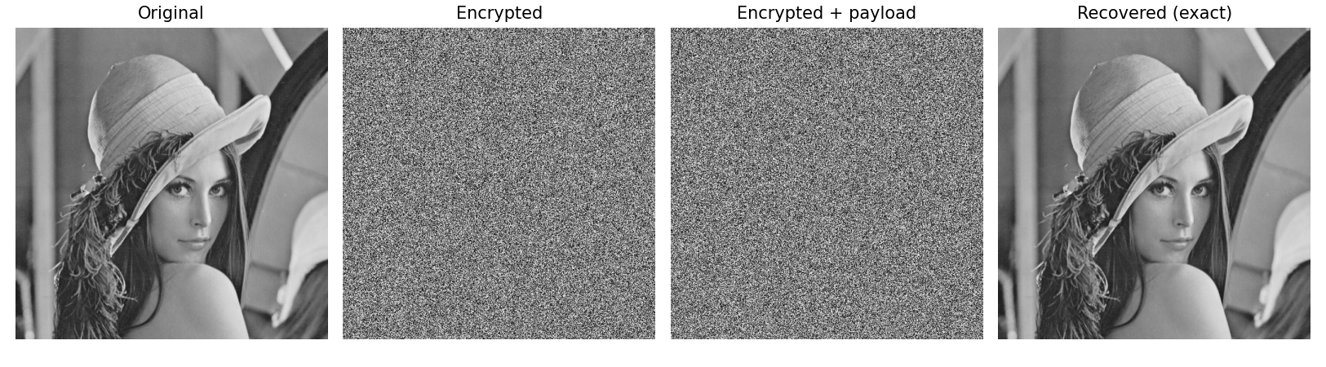
Fig. 1. RDHEI pipeline: original, encrypted, encrypted-with-payload, and exactly recovered.
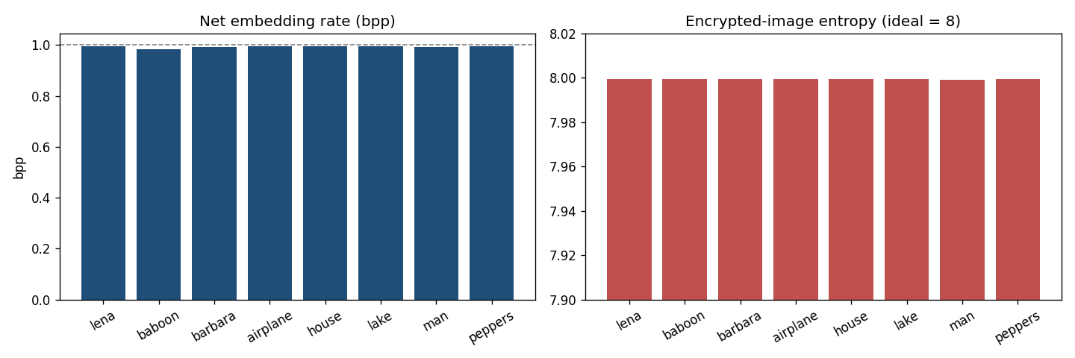
Fig. 2. Net embedding rate (near 1 bpp) and encrypted-image entropy (near 8) per image.
IX. COMPARISON WITH PAPER RESULTS
The reproduction reproduces high-capacity (~1 bpp) reversible embedding under strong encryption with exact recovery. The specific pixel-shifting room-reservation is approximated by MSB prediction.
TABLE II. COMPARISON WITH THE ORIGINAL PAPER
Aspect | Paper (reported) | This reproduction
High-capacity RDHEI | Yes | Near 1 bpp
Strong encryption | Yes | Encrypted entropy ~8.0
Pixel-shifting room reservation | Yes | Represented by MSB prediction
Exact reversibility | Yes | Yes (bit-exact)

X. DISCUSSION
Room reservation via predictable structure is the common thread of modern high-capacity RDHEI; the reproduction confirms the achievable rate and exact recovery.
XI. LIMITATIONS
• Pixel-shifting mechanism approximated by MSB prediction.
• Gross rate.
• Separability not separately evaluated.
XII. FUTURE WORK
Implement the exact pixel-shifting room reservation and separable extraction.
XIII. CONCLUSION
We reproduced high-capacity reversible embedding under encryption with exact recovery, capturing the PSA scheme's outcome.
REFERENCES
[1] C. Kim, C.-N. Yang, and Y.-Q. Lu, "Reversible data hiding in encrypted images using pixel shifting approach (PSA)," J. Inf. Secur. Appl., vol. 87, 2024.
[2] X. Zhang, "Reversible data hiding in encrypted image," IEEE SPL, vol. 18, no. 4, 2011.
[3] P. Puteaux and W. Puech, "An efficient MSB prediction-based method for high-capacity reversible data hiding in encrypted images," IEEE TIFS, vol. 13, no. 7, 2018.
[4] X. Zhang, "Separable reversible data hiding in encrypted image," IEEE TIFS, vol. 7, no. 2, 2012.

