**Docker-compose**

sudo apt install docker-compose

docker-compose images

docker-compose up -d

docker exec -it arunesh_db_1 /bin/bash

sudo nano docker-compose.yaml

mysql -u root -p

exit

docker-compose ps

docker-compose down

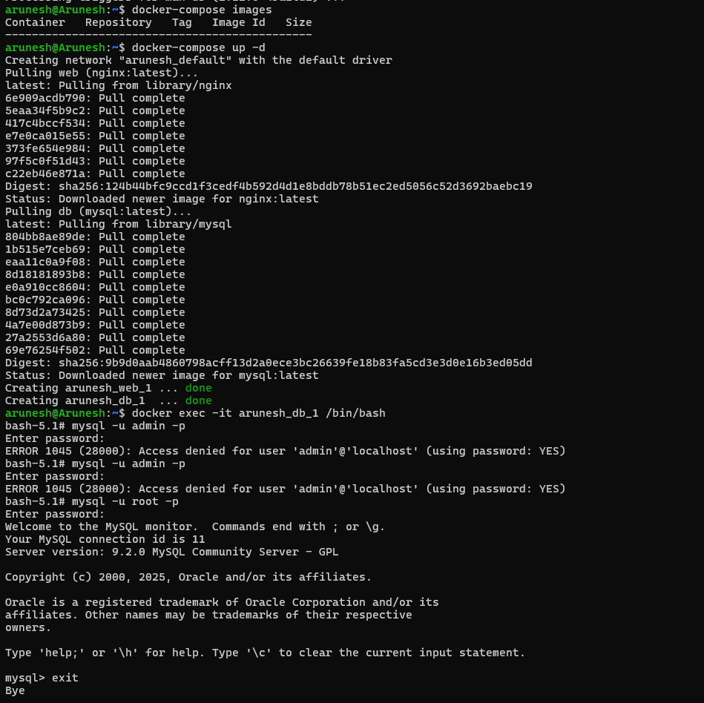

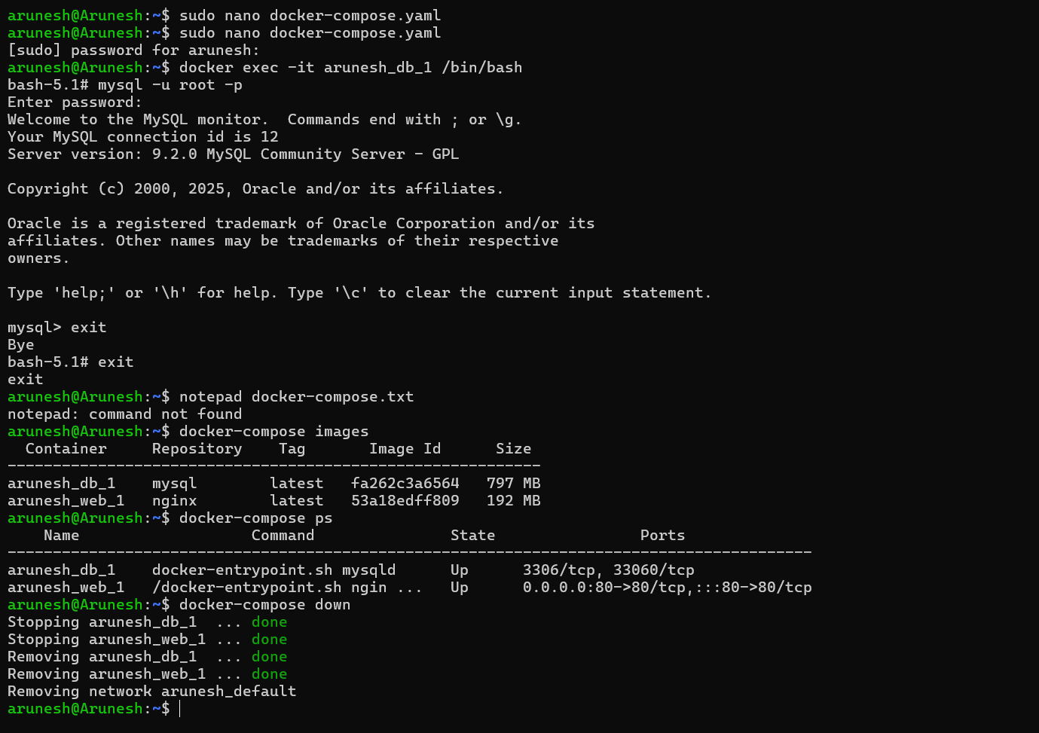

**DOCKER COMPOSE:**

sudo nano docker-compose.yaml

version: '3'

services:

web:

image: nginx:latest

ports:

- 80:80

db:

image: mysql:latest

environment:

- MYSQL_ROOT_PASSWORD=secret

sudo apt install docker-compose -y

docker-compose up -d

docker exec -it arunesh-db-1 /bin/bash