**Kubernetes (K8s)**

Kubernetes is an opensource container orchestration engine for automating deployment, scaling, and management of containerized applications. The opensource project is hosted by the Cloud Native Computing Foundation (CNCF).

It provides a scalable and resilient framework for automating the deployment, scaling, and management of applications across clusters of servers.

**Architecture**

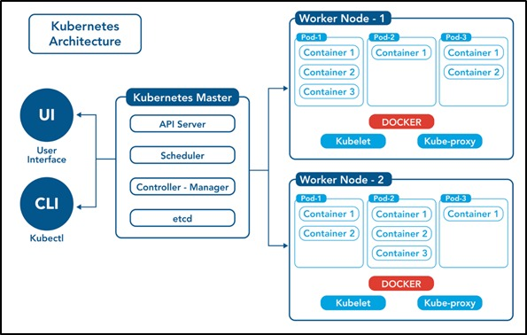

**Control Plane /Master Node**

The control plane's components make global decisions about the cluster (for example, scheduling), as well as detecting and responding to cluster events (for example, starting up a new pod when a deployment's replicas field is unsatisfied).

Control plane components can be run on any machine in the cluster. Do not run user containers on this machine.

Node Components / Worker Nodes

Node components run on every node, maintaining running pods and providing the Kubernetes runtime environment.

1. Master Node: The master node is responsible for managing the cluster and coordinating the overall state of the system. It includes the following components:

a. API Server: The API server is the central control point for all interactions with the cluster. It exposes the Kubernetes API and handles requests from users and other components.

b. Scheduler: The scheduler is responsible for assigning workloads (pods) to individual worker nodes based on resource requirements, constraints, and other policies.

c. Controller Manager: The controller manager runs various controllers that monitor the cluster state and drive it towards the desired state. Examples include the replication controller, node controller, and service controller.

d. etcd: etcd is a distributed key-value store used by Kubernetes to store cluster state and configuration data.

**Commands**

1. Create a pod using run command

$ kubectl run <pod-name> --image=<image-name> --port=<container-port>

$ kubectl run my-pod --image=nginx --port=80

2. View all the pods

(In default namespace)

$ kubectl get pods

(In All namespace)

$ kubectl get pods -A

# For a specific namespace

$ kubectl get pods -n kube-system

# For a specific type

$ kubectl get pods <pod-name>

$ kubectl get pods <pod-name> -o wide

$ kubectl get pods <pod-name> -o yaml

$ kubectl get pods <pod-name> -o json

3. Describe a pod (View Pod details)

$ kubectl describe pod <pod-name>

$ kubectl describe pod my-pod

4. View Logs of a pod

$ kubectl logs <pod-name>

$ kubectl logs my-pod

5. Execute any command inside Pod (Inside Pod OS)

$ kubectl exec <pod-name> -- <command>