- **Title**: **"AI-Based Diabetes Prediction System"**

- "Empowering Healthcare through Artificial Intelligence"

- NAME: ARUNACHALAESHWARAN.K

- Date:4/10/2023

**Abstract**:

This project introduces an innovative AI-based Diabetes Detection System leveraging advanced machine learning techniques for early and accurate diagnosis of diabetes mellitus. The prevalence of diabetes has reached alarming levels globally, necessitating efficient and accessible diagnostic tools. Our system utilizes a diverse dataset comprising clinical records, physiological parameters, and demographic information to train a deep learning model. Through comprehensive feature extraction and selection, the model achieves high accuracy in discriminating between diabetic and non-diabetic individuals. The proposed system not only offers a non-invasive, cost-effective solution but also provides timely intervention opportunities for effective management and prevention of complications associated with diabetes. The validation of the system is performed on a diverse set of real-world patient data, demonstrating promising results and paving the way for its potential integration into clinical practice. This project represents a significant stride towards democratizing diabetes diagnosis, with the ultimate goal of improving public health outcomes.

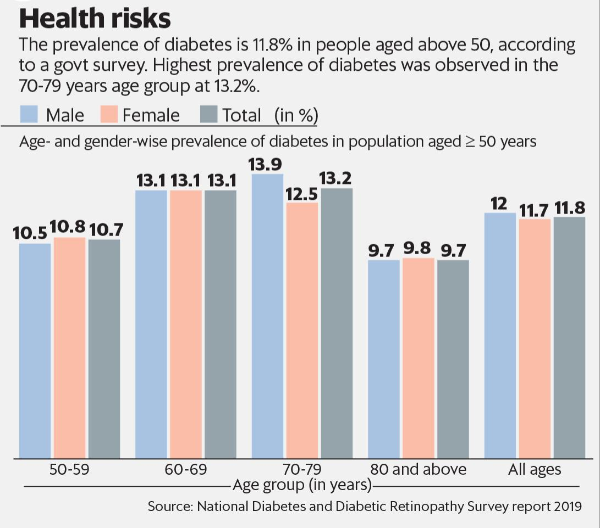

**FOR THIS SYSTEM WE USING THE DATASET FROM KAGLE**

WE are using the following parameters

**AGE**

**Glucose**

**Blood pressure**

**Insulin**

Data Collection: We need a dataset containing medical features such as glucose levels, blood pressure,etc., along with information about whether the individual has diabetes or not.

Data Preprocessing: The medical data needs to be cleaned, normalized, and prepared for training machine learning models.

Feature Selection: We will select relevant features that can impact diabetes risk prediction.

Model Selection: We can experiment with various machine learning algorithms like Logistic Regression, Random Forest, and Gradient Boosting.

Evaluation: We will evaluate the model’s performance using metrics like accuracy, precision, recall, F1-score, and ROC-AUC.

Iterative Improvement: We will fine-tune the model parameters and explore techniques like feature engineering to enhance prediction accuracy

The algorithm used for this system is discussed later

- Introduction to Diabetes:

Diabetes is a chronic, metabolic disease characterized by elevated levels of blood glucose (or blood sugar), which leads over time to serious damage to the heart, blood vessels, eyes, kidneys and nerves.

**User-Centered Design**

- Understanding the User:

Detailed analysis of key stakeholders (patients, healthcare professionals, researchers) and their specific needs.

Defining User Personas:

Creating profiles to represent different user groups and their requirements.

**Design Thinking Approach**

**Design Thinking for AI-Based Diabetes Prediction**

Refining the Problem Statement:

In-depth examination of the problem in the context of AI-based prediction for diabetes.

- Ideation Phase:

- Detailed brainstorming of potential AI models, data sources, and features for accurate prediction.

- Prototyping:

- Developing a conceptual framework for the AI-based system, including data flow, algorithms, and user interface.

**Testing, Feedback, and Ethical Considerations**

User Testing:

Describing the process of testing the system with real users and obtaining feedback.

Iterative Refinement:

Explaining how the system evolves based on user feedback and continuous testing.

Ethical Considerations:

- Addressing privacy, transparency, fairness, and accountability in AI-based healthcare applications.

**Design Thinking Phases:**

Empathize:

Conduct user interviews, surveys, and research to understand the needs and concerns of potential users, including patients, healthcare professionals, and caregivers.

Gather insights into current diabetes diagnosis and management practices, as well as pain points experienced by stakeholders.

Define:

Define the primary objective: To develop a user-centric, reliable, and accessible system for predicting diabetes risk.

Clearly articulate the problem statement and establish specific goals, such as achieving high accuracy in predictions, user-friendliness, and adherence to privacy and ethical standards.

Ideate:

Brainstorm innovative features and functionalities that address the identified needs and challenges, considering both technical capabilities and user preferences.

Generate ideas for data sources, including medical records, lifestyle information, and biometric data, to be used for training the AI models.

Prototype:

Develop a basic interactive prototype showcasing the system’s key features, user interface, and workflow.

Incorporate a simplified version of the AI algorithm for preliminary testing and validation.

Test:

Conduct usability testing with potential end-users to gather feedback on the prototype’s functionality, user experience, and overall effectiveness.

Collect data on prediction accuracy and refine the AI model based on initial test results.

Implement:

Develop the full-scale system integrating the refined AI model, user interface, and backend infrastructure.

Ensure compatibility with various devices and platforms, such as mobile phones, tablets, and web browsers.

Evaluate:

Conduct thorough testing, including stress testing, security assessments, and user acceptance testing.

Monitor the system’s performance in real-world scenarios to identify and address any unforeseen issues.

Iterate:

Continuously gather user feedback and monitor system performance post-launch.

Implement regular updates and improvements based on user suggestions, technological advancements, and emerging healthcare practices.

**Conclusion and Future Direction**

- Summary of Problem and Solution:

- Concise recap of the problem statement and the proposed AI-based solution.

- Potential Impact and Benefits:

- Discussing the anticipated benefits of the system on diabetes management and patient outcomes.

- Future Enhancements and Research Avenues:

- Listing potential areas for further research, development, and integration in healthcare systems.