Spring Data JPA – Quick Example
Spring Data JPA helps us interact with the database without writing SQL queries or Hibernate boilerplate code. We only create an interface, and Spring automatically provides the implementation at runtime.
EXAMPLE : MANAGING COUNTRY

Step 1: Create a Spring Boot Project
Create a Spring Boot project with the following dependencies:
- Spring Web
- Spring Data JPA
- MySQL Driver

Step 2: Configure Database
In application.properties
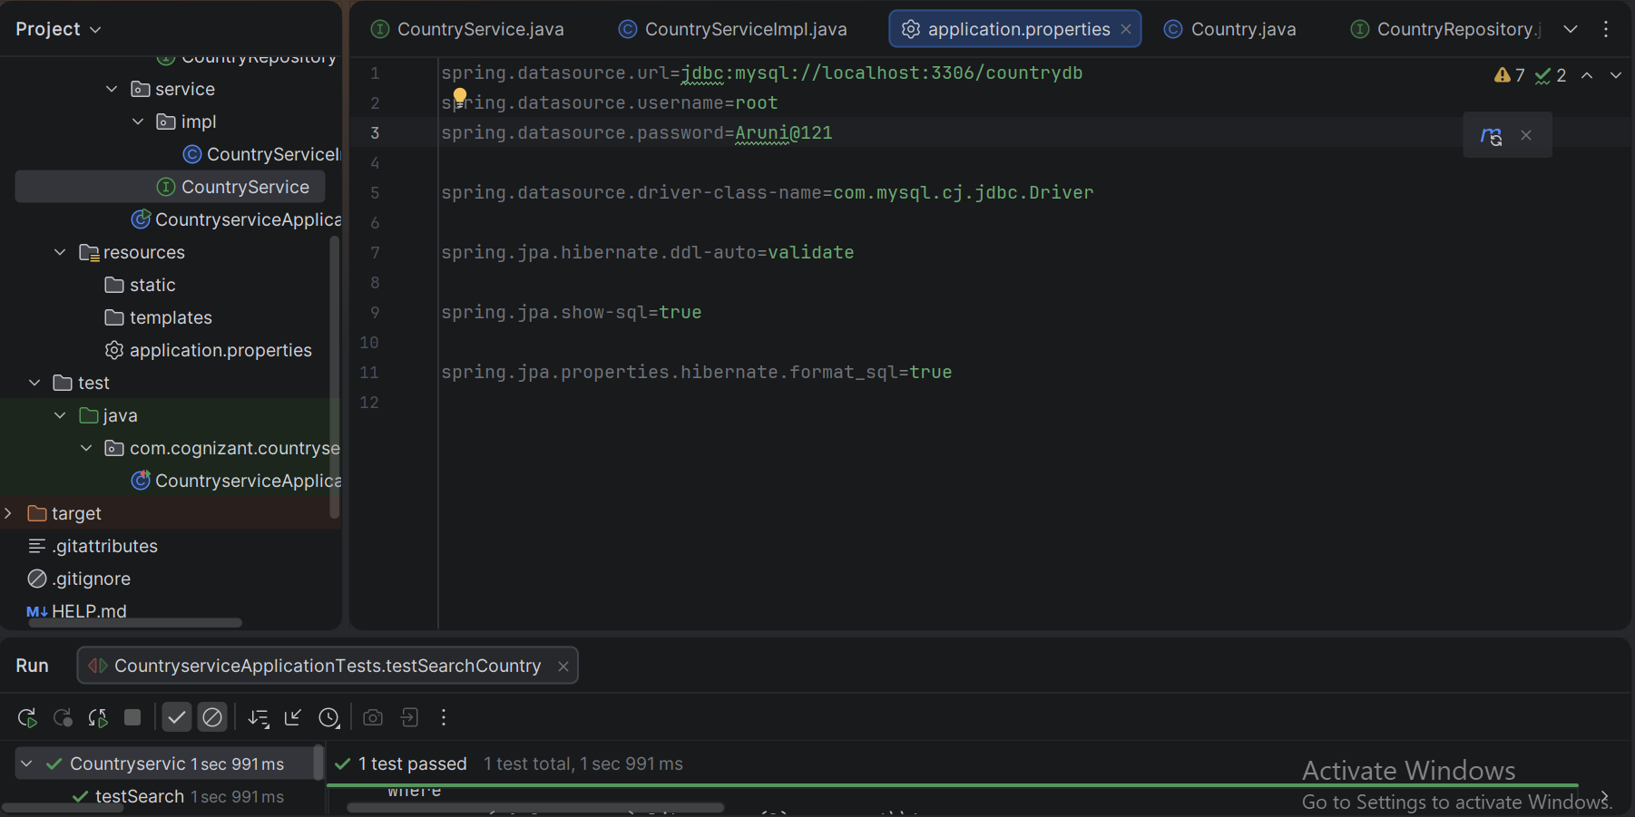

Step 3: Create Country Table
Since ddl-auto=validate will not create the table, we must create it manually.
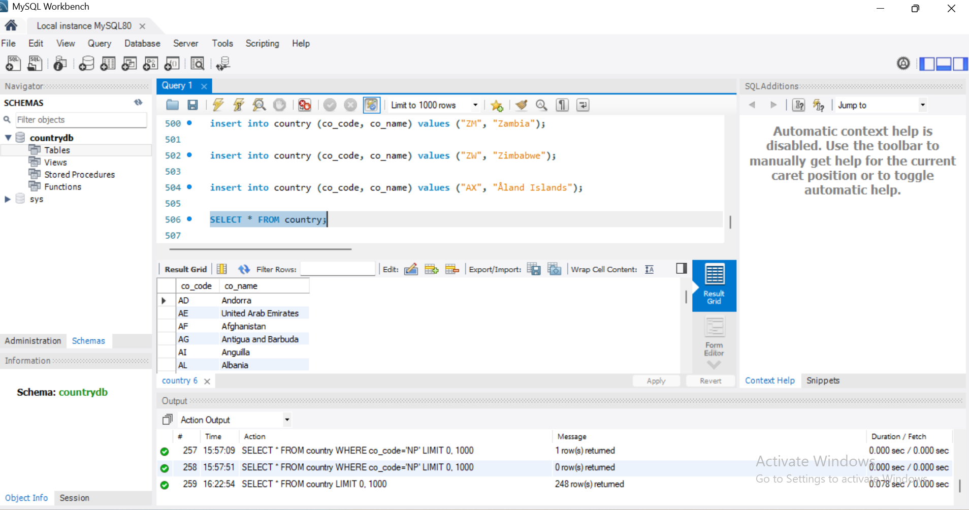

Step 5: Create Entity
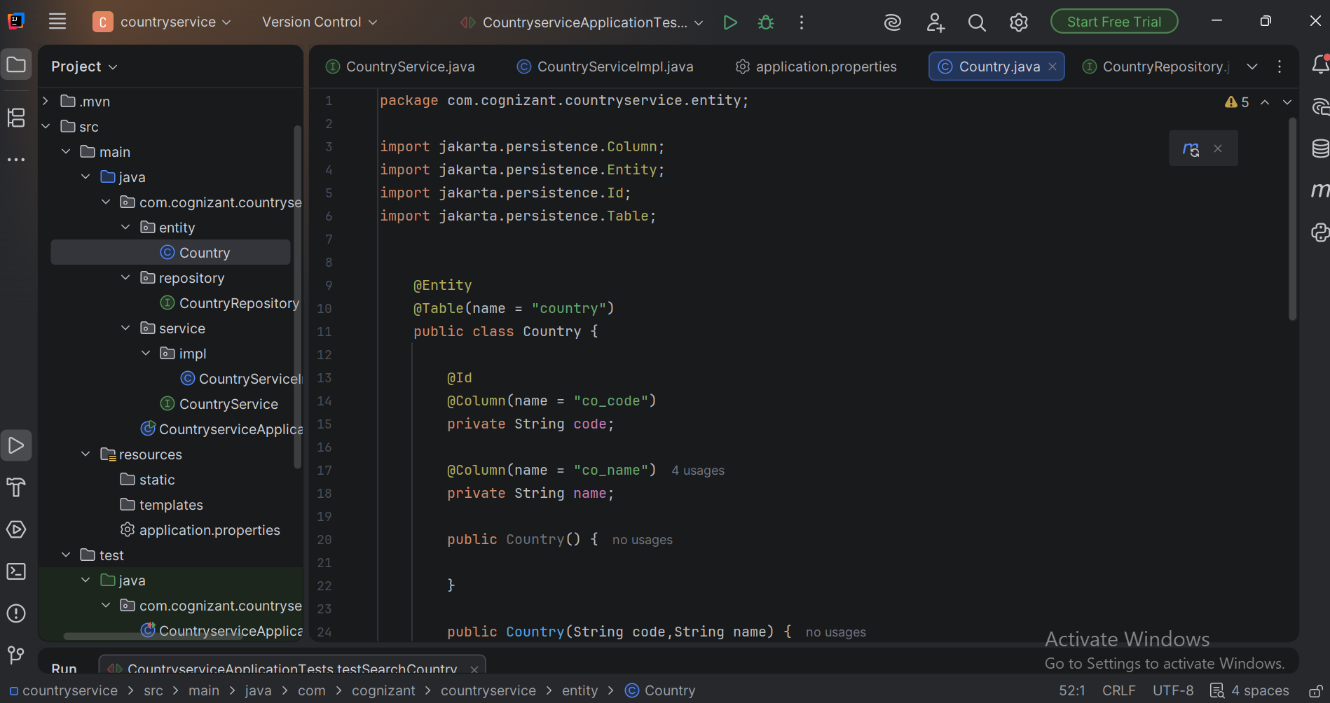

Step 6: Create Repository
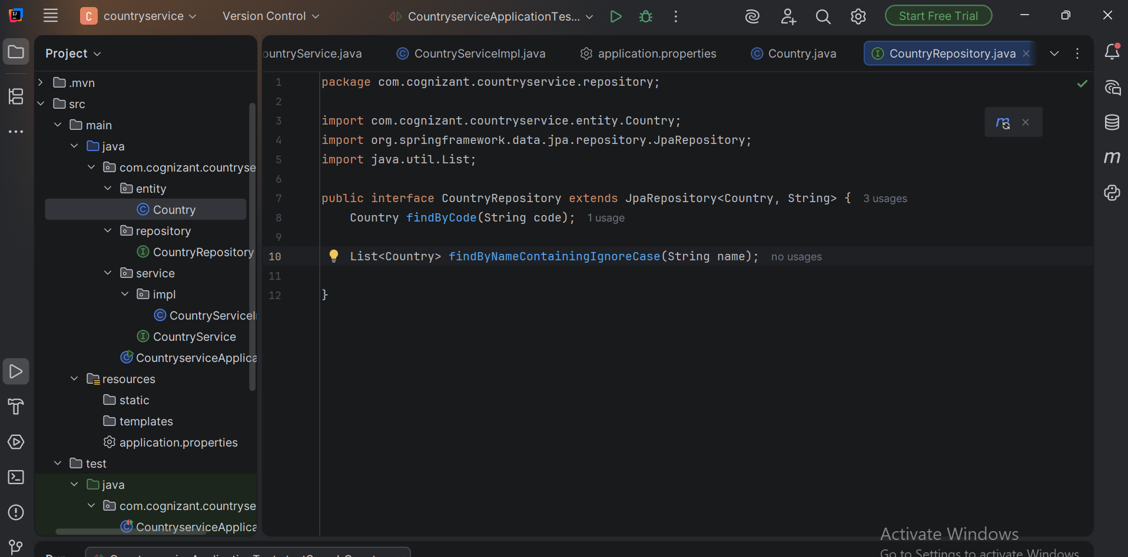

Step 7: Implement Service
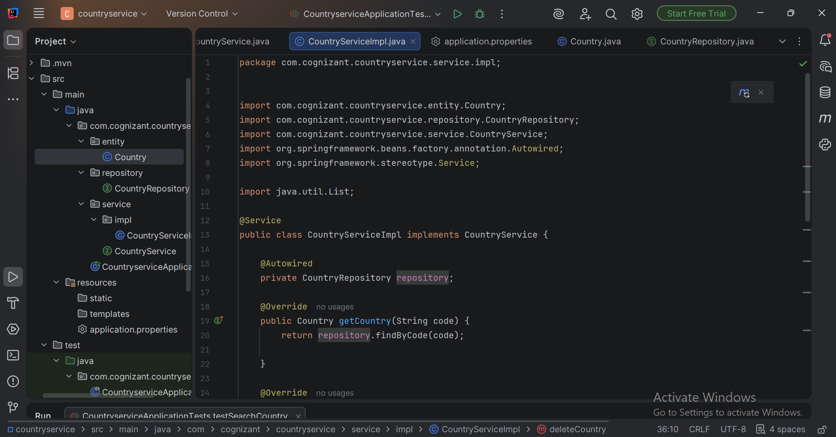

Step 8: Testing using Junit
