Flow Charts
How the automated suite works - Employer and Employee Onboarding Journey
This document contains two flow charts. The same images are saved as PNG files in the docs/flowcharts folder so they can be used in slides or the README.
Chart | What it shows
Figure 1 - End-to-end journey | The business journey the suite automates, from the Admin login to the Employer logout, the data-driven validations, the API checks and the result
Figure 2 - How the framework runs | The Jenkins pipeline (trigger, five stages, unstable or success) and what happens inside one test run (suite, tests, page objects, configuration, browser or HTTP, QA environment, report)

How to read the charts
- White boxes are actions or components. Green boxes are checks that are asserted. Orange boxes are the test inbox and the QA environment. Red boxes are failure handling.
- Arrows show the order of execution. A step that fails stops the steps that depend on it, and those steps are reported as skipped.
- Figure 1 follows the assignment: Admin creates employer, Admin adds employer admin, the invite email gives the code, the employer admin adds employees, and the journey ends with a logout.
- Figure 2 shows that credentials come from the Jenkins credentials store, that a failing test marks the build UNSTABLE, and that every test writes to the HTML report with a screenshot on failure.

Figure 1 - End-to-end journey
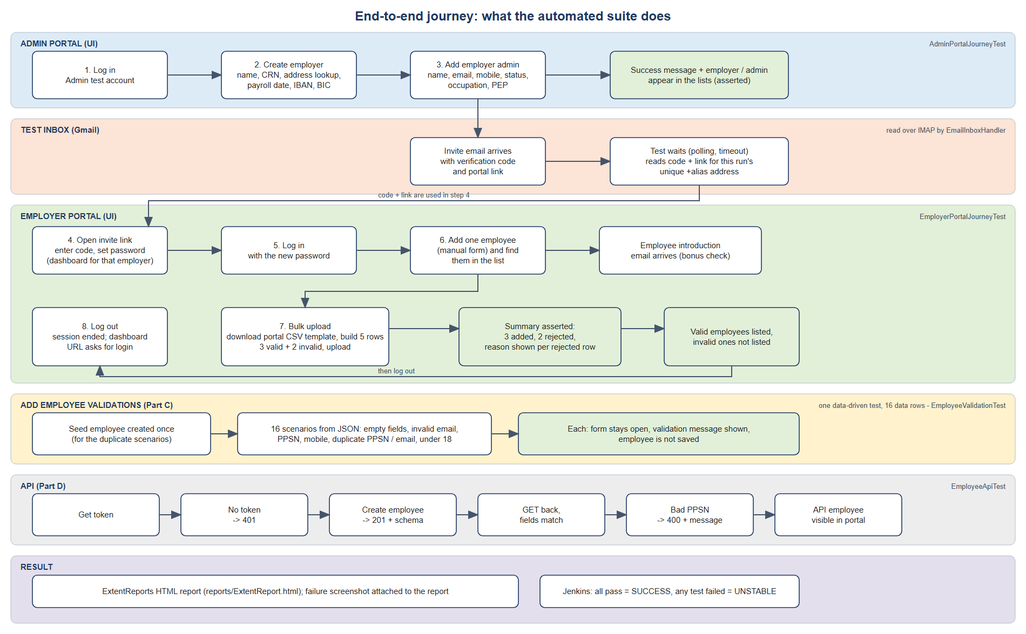

Figure 2 - How the framework runs
