Creating VMWare and Virtual Machines :

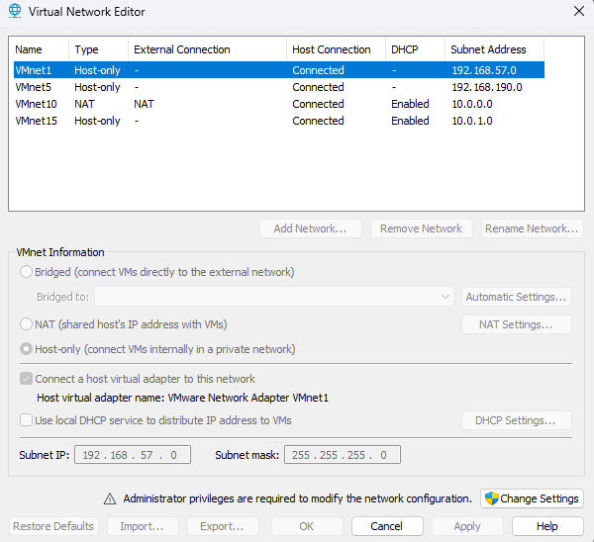

Creating the headnode VM:

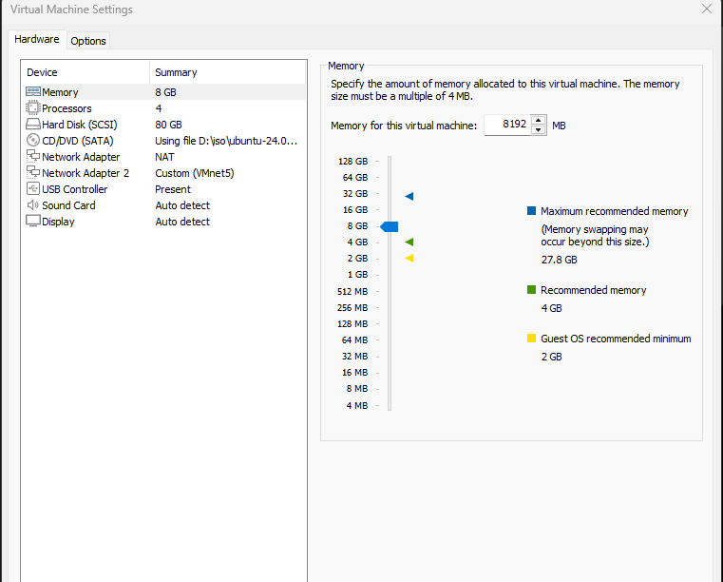

Setting firmware to UEFI:

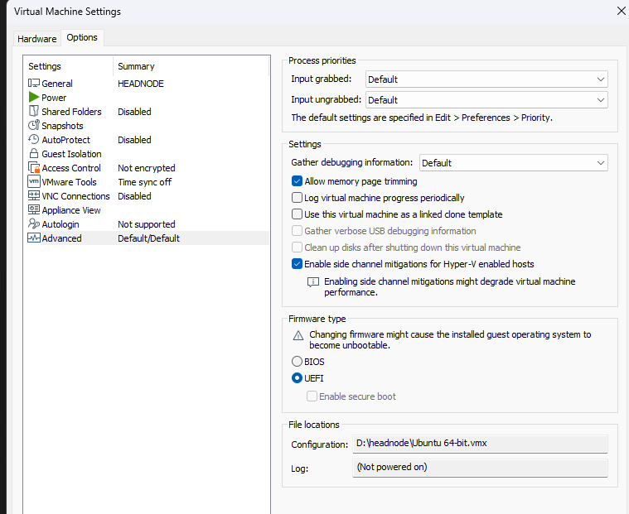

As internet was not working in the headnode VM so we tried the following troubleshoot steps:

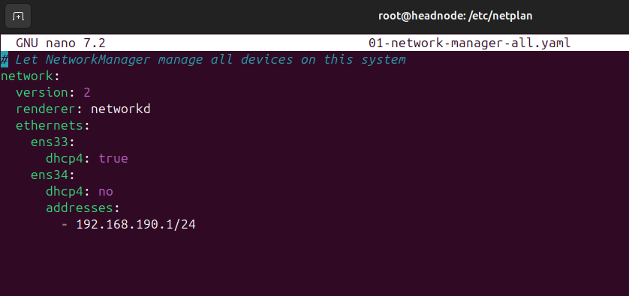

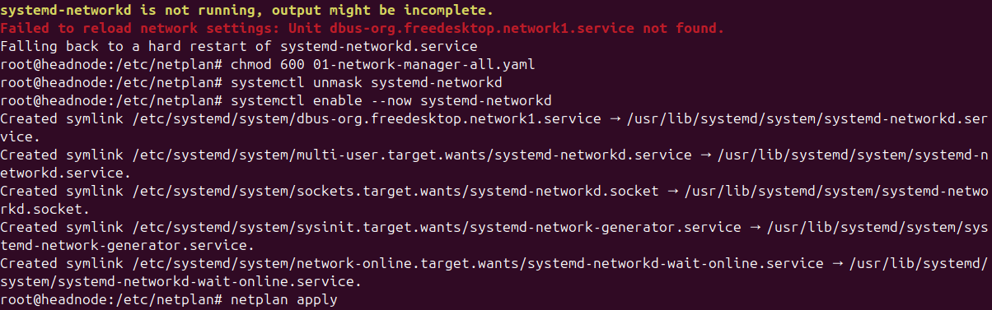

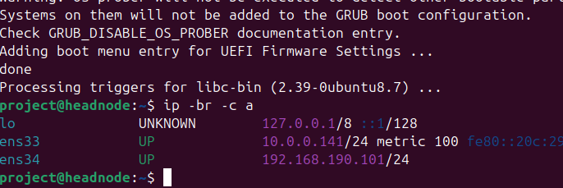

- $ sudo nano /etc/netplan/01-netcfg.yaml
network:
version: 2
renderer: networkd
ethernets:
ens33:
dhcp4: true
ens34:
dhcp4: no
addresses:
- 192.168.190.101/24

- Fixed permissions:
$ chmod 600 /etc/netplan/01-network-manager-all.yaml

- Enable & Start systemd-networkd and Start the systemd network daemon and try applying the Netplan configuration again:
$ systemctl unmask systemd-networkd
$ systemctl enable --now systemd-networkd
$ netplan apply

- $ sudo apt update
$ sudo apt full-upgrade -y
$ sudo reboot

Creating the second VM : LDAP_SERVER
Following the same steps like before->

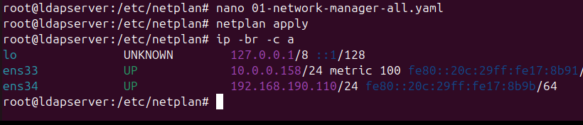

Creating the compute node VM’s:
Just created two new VM’s with no OS as we are going to install it through warewulf later.

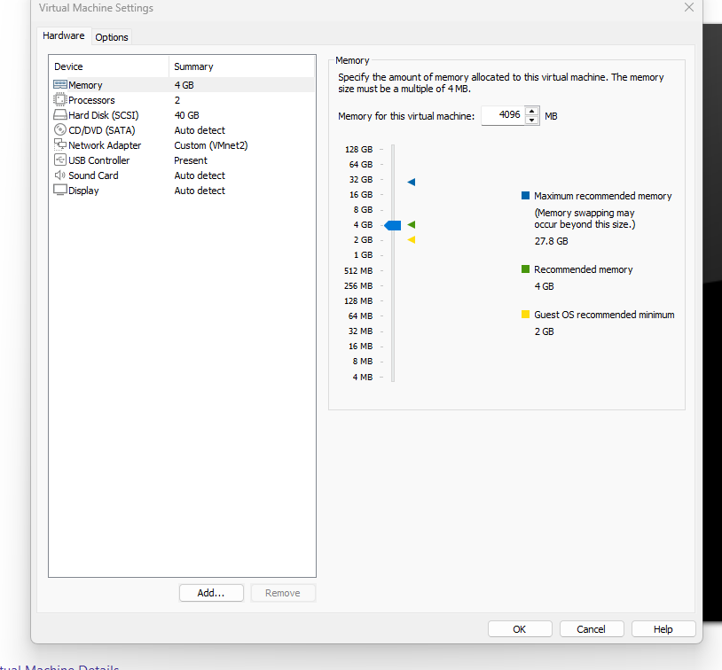
Preparing the headnode for warewulf:

Adding entries to /etc/hosts in headnode VM and ldapserver VM:

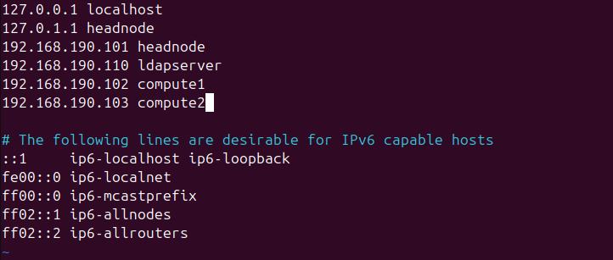

Installing common packages:

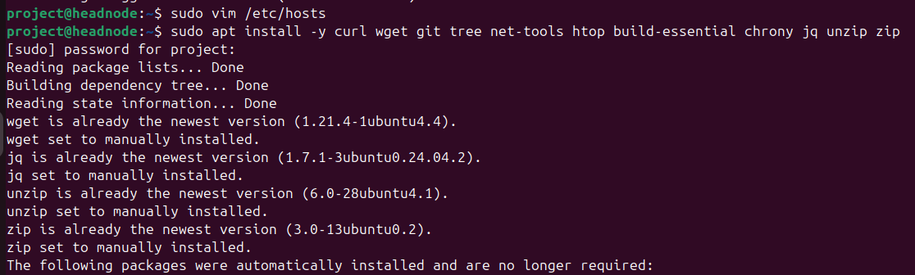

Verifying network:

