**ARUNIMA SINGH THAKUR**

**180905218**

**SECTION C**

**ROLL NO. 31**

**DS LAB END SEM**

**8TH JUNE 2021**

**QUESTION 1:**

**server.py**

import socket

HOST = '127.0.0.1'

PORT = 31621

s = socket.socket()

s.bind((HOST, PORT))

s.listen()

print("Waiting for incoming connections.... \n")

conn, addr = s.accept()

print("Recieved Connection from ", addr[0], "(", addr[1], ")\n")

s_num = conn.recv(1024)

s_num = s_num.decode()

print("Number: ", s_num, " recieved from client \n")

rev_num = s_num[::-1]

conn.send(rev_num.encode())

**client.py**

import socket

HOST = '127.0.0.1'

PORT = 31621

s = socket.socket()

num = input(str("Enter your Number to send to Server: \n"))

print("\nTrying to connect to ", HOST, "(", PORT, ")\n")

s.connect((HOST, PORT))

print("Connected...\n")

s.send(num.encode())

print("\nSent Server", num, "\n")

rev_num = s.recv(1024)

rev_num = rev_num.decode()

print("Server sent reversed number: ", rev_num, "\n")

**OUTPUT:**

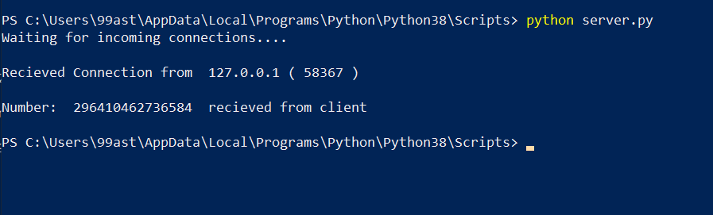

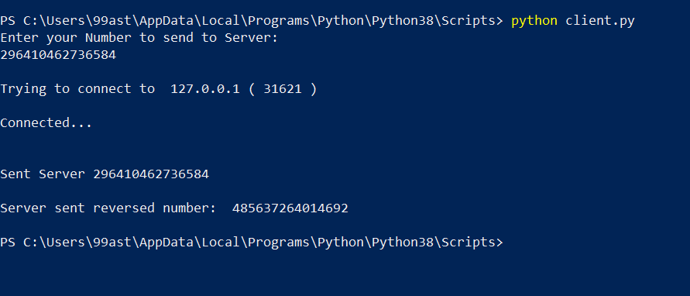

**QUESTION 2:**

**itemmap_expensive.py**

import fileinput

for line in fileinput.input():

data = line.strip().split(",")

if len(data) == 6:

country, continent, year, lifeExpectancy, population, gdpPerCapita = data

if country!= "country":

print ("{0}\t{1}".format(country, int(population)))

**itemred_expensive.py**

import fileinput

max_value = 0

old_key = None

for line in fileinput.input():

data = line.strip().split("\t")

if len(data) != 2:

# Something has gone wrong. Skip this line.

continue

current_key, current_value = data

# Refresh for new keys (i.e. locations in the example context)

if old_key and old_key != current_key:

print (old_key, "\t", max_value)

old_key = current_key

max_value = 0

old_key = current_key

if float(current_value) > float(max_value):

max_value = float(current_value)

if old_key != None:

print (old_key, "\t", max_value)

**OUTPUT:**



