***ARUNIMA SINGH THAKUR***

***180905218***

***C, 31, CSE***

***IT LAB 5***

***6TH MAY 2021***

**QUESTION 1:**

***templates/home.html***

<html lang="en">

<head>

<meta charset="UTF-8">

<meta http-equiv="X-UA-Compatible" content="IE=edge">

<meta name="viewport" content="width=device-width, initial-scale=1.0">

<title>Home</title>

</head>

<body>

<script type="text/javascript">

function process(){

document.getElementById('n').innerHTML = document.getElementById('name').value;

document.getElementById('cn').innerHTML = document.getElementById('cno').value;

document.getElementById('ema').innerHTML = document.getElementById('email').value;

document.getElementById('em1').innerHTML = document.getElementById('em').value;

document.getElementById('pm1').innerHTML = document.getElementById('pm').value;

document.getElementById('cm1').innerHTML = document.getElementById('cm').value;

var n1 = parseInt(document.getElementById('em').value);

var n2 = parseInt(document.getElementById('pm').value);

var n3 = parseInt(document.getElementById('cm').value);

var total = ((n1+n2+n3)/300)*100;

document.getElementById('tp').innerHTML = total

}

</script>

Name: <input type="text" name = "name" id = "name"><br>

Contact No: <input type="text" name= "cno" id = "cno"><br>

Email: <input type="text" name = 'email' id='email'><br>

English marks: <input type="text" name="em" id='em'><br>

Physics marks: <input type="text" name="pm" id='pm'><br>

Chemistry marks: <input type="text" name="cm" id = 'cm'><br>

<button onclick="process()">Submit</button>

<table>

<tr>

<td>Name: </td>

<td id="n">{{name}}</td>

</tr>

<tr>

<td>contact: </td>

<td id = "cn">{{cno}}</td>

</tr>

<tr>

<td>email: </td>

<td id = "ema">{{email}}</td>

</tr>

<tr>

<td>eng marks: </td>

<td id = "em1">{{em}}</td>

</tr>

<tr>

<td>phy marks: </td>

<td id="pm1">{{pm}}</td>

</tr>

<tr>

<td>chem marks: </td>

<td id="cm1">{{cm}}</td>

</tr>

<tr>

<td>Percentage: </td>

<td id='tp'>{{tp}}</td>

</tr>

</table>

</body>

</html>

***Form/views.py***

from django.shortcuts import render

from django.http import HttpResponse

# Create your views here.

def home(request):

return

render(request,'home.html',{'name':'NA','cno':'NA','email':'NA','em':'NA','pm':'NA','cm':'NA','tp':'NA'})

***Form/urls.py***

from django.urls import path

from . import views

urlpatterns = [

path('',views.home,name="home"),

]

***Proj1/urls.py***

from django.urls import path,include

urlpatterns = [

path('admin/', admin.site.urls),

path('',include("form.urls"))

]

***Proj1/settings.py***

TEMPLATES = [

{

'BACKEND': 'django.template.backends.django.DjangoTemplates',

'DIRS': [os.path.join(BASE_DIR,'templates')],

'APP_DIRS': True,

'OPTIONS': {

'context_processors': [

'django.template.context_processors.debug',

'django.template.context_processors.request',

'django.contrib.auth.context_processors.auth',

'django.contrib.messages.context_processors.messages',

],

},

},

]

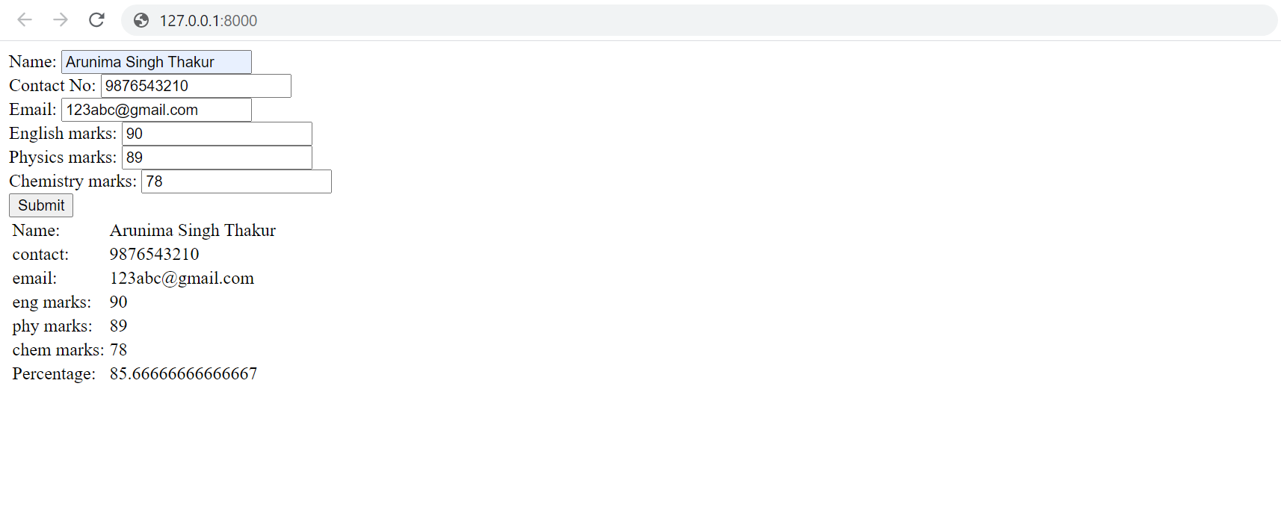

**QUESTION 2:**

***templates/home.html***

<html lang="en">

<head>

<meta charset="UTF-8">

<meta http-equiv="X-UA-Compatible" content="IE=edge">

<meta name="viewport" content="width=device-width, initial-scale=1.0">

<title>Document</title>

</head>

<body>

<form action="selection">

<label for="items">choose an id:</label>

<select id="items" name="emid">

<option value="item1">180905123</option>

<option value="item2">180905221</option>

<option value="item3">180905343</option>

<option value="item4">180905480</option>

<option value="item5">180905555</option>

</select><br>

enter the date of joining: <input type="date" id = "doj" name="doj"><br>

<input type="submit" value="submit"><br>

</form>

</body>

</html>

***Templates/result.py***

<html lang="en">

<head>

<meta charset="UTF-8">

<meta http-equiv="X-UA-Compatible" content="IE=edge">

<meta name="viewport" content="width=device-width, initial-scale=1.0">

<title>Result</title>

</head>

<body>

{{selection}}

</body>

</html>

***Form/views.py***

from django.shortcuts import render

from django.http import HttpResponse

# Create your views here.

def home(request):

return render(request,'home.html')

def select(request):

n1 = request.GET['doj']

n2 = int(n1[:4])

if 2021-n2>5:

n1 = "CONGRATULATIONS YOU ARE ELGIBLE FOR PROMOTION"

else:

n1 = "SORRY YOU ARE NOT ELGIBLE FOR THE PROMOTION"

return render(request,'result.html',{"selection":n1})

***Forms/urls.py***

from django.urls import path

from . import views

urlpatterns = [

path('',views.home,name="home"),

path('selection',views.select,name='selection')

]

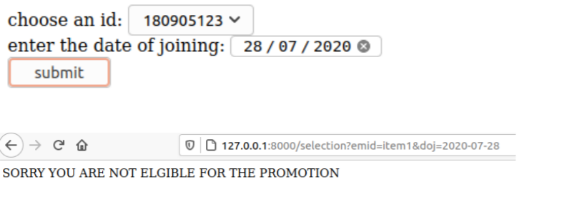

**QUESTION 3:**

***templates/home.html***

<html lang="en">

<head>

<meta charset="UTF-8">

<meta http-equiv="X-UA-Compatible" content="IE=edge">

<meta name="viewport" content="width=device-width, initial-scale=1.0">

<title>Document</title>

</head>

<body>

<script type="text/javascript">

function calculator(){

var n1 = parseFloat(document.getElementById('num1').value);

var n2 = parseFloat(document.getElementById('num2').value);

var n3 = document.getElementById('op').value;

if(n3=="+"){

n4 = n1+n2;

}

else if(n3=="-"){

n4 = n1-n2;

}

else if(n3=="*"){

n4 = n1*n2;

}

else if(n3=="/"){

n4=n1/n2;

}

document.getElementById('result').innerHTML = n4;

}

</script>

<input type="number" id = 'num1'><br>

<input type="number" id = 'num2'><br>

<label for="op">select the operation to be performed</label>

<select name="op" id="op">

<option value="+">+</option>

<option value="-">-</option>

<option value="*">*</option>

<option value="/">/</option>

</select>

<br>

<button onclick="calculator()">calculate</button><br>

<h3 id="result"></h3>

</body>

</html>

***Form/views.py***

from django.shortcuts import render

from django.http import HttpResponse

# Create your views here.

def home(request):

return render(request,'home.html')

***Form/urls.py***

from django.urls import path

from . import views

urlpatterns = [

path('',views.home,name="home"),

]

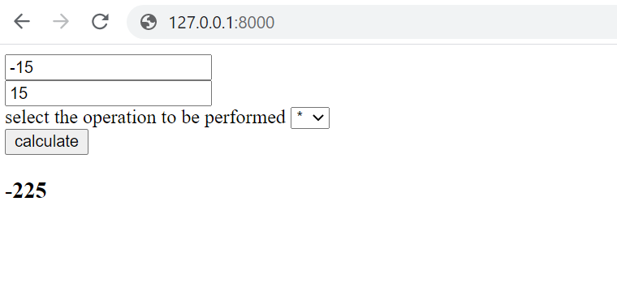

**QUESTION 4:**

***templates/home.html***

{%load static %}

<html lang="en">

<head>

<link rel="stylesheet" href="{% static 'css/q4.css' %}">

<meta charset="UTF-8">

<meta http-equiv="X-UA-Compatible" content="IE=edge">

<meta name="viewport" content="width=device-width, initial-scale=1.0">

<title>Document</title>

</head>

<body>

<script>

function colorChange(color){

document.getElementById('mag').style.backgroundColor=color;

}

function enterText(){

document.getElementById('ct').innerHTML = document.getElementById('text').value;

document.getElementById('ct').style.fontSize=document.getElementById('fs').value;

document.getElementById('ct').style.fontFamily = document.getElementById('font').value;

}

function bgChange1(){

document.getElementById('mag2').style.backgroundImage='url("https://www.extremetech.com/wp-co

ntent/uploads/2016/10/Lamborghini-Egoista-LF-3-4-HERO-640x354.jpg")';

document.getElementById('mag2').style.backgroundSize = 'cover';

document.getElementById('mag2').style.backgroundRepeat='no-repeat';

}

function bgChange2(){

document.getElementById('mag2').style.backgroundImage='url("https://superstarsbio.com/wp-conten

t/uploads/2019/04/Robert-Downey-Jr.-Smile.jpg")';

document.getElementById('mag2').style.backgroundSize = 'cover';

document.getElementById('mag2').style.backgroundRepeat='no-repeat';

}

</script>

<table style="height: 100%;">

<tr>

<td id="col1">

<table style="border-spacing: 0px 50px;">

<tr><th>select color:</th><th><button id="c1" onclick="colorChange('coral')"

class="c"></button></th><th><button id="c2" onclick="colorChange('cornflowerblue')"

class="c"></button></th><th><button id = "c3" onclick="colorChange('yellow')"

class="c"></button></th><th><button id="c4" onclick="colorChange('lightgreen')"

class="c"></button></th></tr>

<tr>

<th>select image:</th>

<th><button id="i1" onclick="bgChange1()" class="i"></button></th>

<th><button id="i2" onclick="bgChange2()" class="i"></button></th>

</tr>

</table>

<table>

<tr>

<th>enter the Text: </th>

<th><textarea name="text" id="text" cols="30" rows="10"></textarea></th>

</tr>

</table>

<table>

<tr>

<th>select the font: </th>

<th><select name="fonts" id="font">

<option value="Times New Roman">Times New Roman</option>

<option value="Arial">Arial</option>

<option value="Helvetica">Helvetica</option>

<option value="sans-serif">sans-serif</option>

<option value="Lucida Console">Lucida Console</option>

</select></th>

</tr>

</table>

<table>

<tr>

<th>enter the font-size:</th>

<th><input type="number" id="fs"></th>

</tr>

</table>

<button onclick="enterText()">submit</button>

</td>

<td id="mag">

<div id="mag2">

<h1 id="magHead">MIT</h1>

</div>

<p id="ct"></p>

</td>

</tr>

</table>

</body>

</html>

***Proj4/settings.py***

STATICFILES_DIRS = [

os.path.join(BASE_DIR,'static')

]

STATIC_ROOT = os.path.join(BASE_DIR, 'assets')

***Form/views.py***

from django.shortcuts import render

from django.http import HttpResponse

# Create your views here.

def home(request):

return render(request,'home.html')

***Static/css/q4.css***

#col1{

width: 40%;

}

#col2{

width:40%;

}

.c{

height: 50px;

width: 50px;

margin: 0px 20px;

}

#c1{

background-color: coral;

}

#c2{

background-color: cornflowerblue;

}

#c3{

background-color:yellow;

}

#c4{

background-color: lightgreen;

}

#i1{

background-image:

url("https://www.extremetech.com/wp-content/uploads/2016/10/Lamborghini-Egoista-LF-3-4-HERO-6

40x354.jpg");

background-size: 100px;

background-repeat: no-repeat;

background-position: center;

height: 60px;

width: 80px;

}

#i2{

background-image:

url("https://superstarsbio.com/wp-content/uploads/2019/04/Robert-Downey-Jr.-Smile.jpg");

background-size: 100px;

background-repeat: no-repeat;

background-position: center;

height: 60px;

width: 80px;

}

.i{

margin: 0px 20px;

}

#mag{

text-align: center;

height: 1000%;

}

#magHead{

font-family: cursive;

font-size: 800%;

color: white;

}

#mag2{

height: 50%;

text-align: center;

}

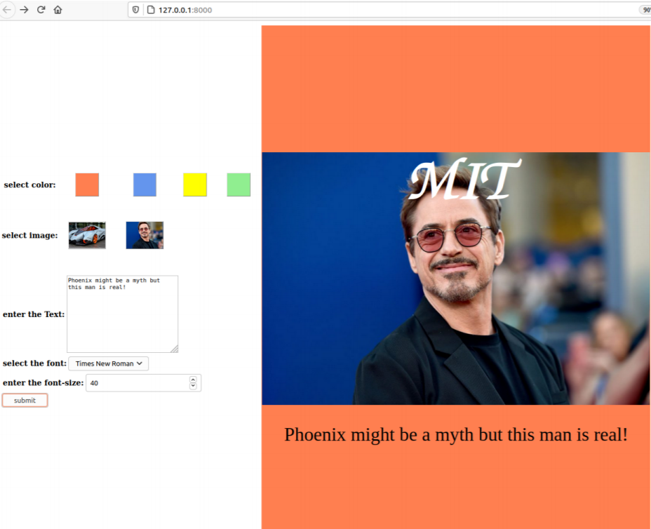

**QUESTION 5:**

***templates/home.html***

{%load static %}

<html lang="en">

<head>

<meta charset="UTF-8">

<meta http-equiv="X-UA-Compatible" content="IE=edge">

<meta name="viewport" content="width=device-width, initial-scale=1.0">

<title>Document</title>

</head>

<body>

<script>

var count = 0;

function validate(){

var c = document.getElementById('inp').value;

if(c=='qGphJ'){

document.getElementById('smg').innerHTML = "This is a

secrete message";

}

else if(count<3){

count+=1;

}

else{

document.getElementById('inp').disabled = true;

document.getElementById('smg').innerHTML = 'you exceeded

the maximum number of attempts';

}

}

</script>

<img src="{% static 'images/q5.png' %}" alt="captcha" style="height:

80px;"><br>

<textarea name="inp" id="inp" cols="20" rows="1" style="font-size:

18px;"></textarea><br>

<button onclick="validate()">submit</button><br>

<p id="smg"></p>

</body>

</html>

***form/views.py***

from django.shortcuts import render

from django.http import HttpResponse

import random

# Create your views here.

def home(request):

return render(request,'home.html')

***form/urls.py***

from django.urls import path

from . import views

urlpatterns = [

path('',views.home,name="home"),

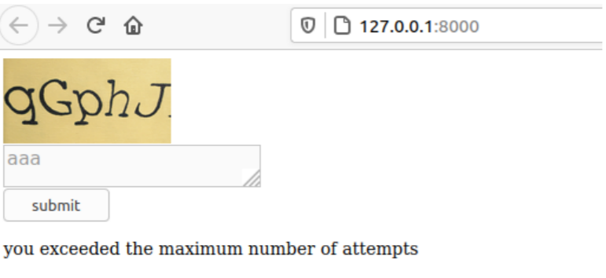

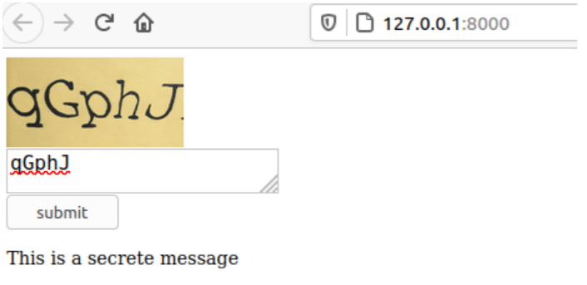

**QUESTION 6:**

***templates/home.html***

<html lang="en">

<head>

<meta charset="UTF-8">

<meta http-equiv="X-UA-Compatible" content="IE=edge">

<meta name="viewport" content="width=device-width, initial-scale=1.0">

<title>Document</title>

</head>

<body style="background-image:

url('https://www.mkgandhi.org/images/autobio-deluxe.jpg');background-size:

1000px;">

<table style="font-size: 20px;margin: 0px 10px;">

<tr>

<th><a href="{% url 'metaData' %}">metadata</a></th>

<th><a href="{% url 'review' %}">review</a></th>

<th><a href="{% url 'author' %}">author info</a></th>

</tr>

</table>

<br>

<h1 style="color: white;">Overview</h1><br>

<p style="color: white;">

The Story of My Experiments with Truth (Gujarati: Satya Na Prayogo

athva Atmakatha, lit. 'Experiments with Truth or Autobiography') is the

autobiography of Mohandas K. Gandhi,<br>

covering his life from early childhood through to 1921. It was

written in weekly installments and published in his journal Navjivan from

1925 to 1929. Its English translation also appeared in <br>

installments in his other journal Young India. It was initiated at

the insistence of Swami Anand and other close co-workers of Gandhi, who

encouraged him to explain the background of <br>

his public campaigns. In 1998, the book was designated as one of

the "100 Best Spiritual Books of the 20th Century" by a committee of

global spiritual and religious authorities. <br>

</p>

</body>

</html>

***templates/review.html***

<html lang="en">

<head>

<meta charset="UTF-8">

<meta http-equiv="X-UA-Compatible" content="IE=edge">

<meta name="viewport" content="width=device-width, initial-scale=1.0">

<title>review</title>

</head>

<body style="background-image:

url('https://www.mkgandhi.org/images/autobio-deluxe.jpg');background-size:

1000px;">

<a href="{% url 'home' %}" style="font-size: 20px;">home</a><br>

<h1 style="color: white;">Review</h1>

<pre style="color: white;font-size: 15px;">

This was a fascinating read. Gandhi's writing is oddly simple, even almast

naive in places.

He faithfully records small personal struggles, giving them the same

weight as major political battles.

Gandhi's zeal and idealism comes across powerfully, as does his lifelong

concern with self-discipline

and purity (bramacharya).

I was especially interested in his evolving understanding of satyagraha

and his

increasingly strict vegetarianism. His ascetism increased in direct

proportion to

his growing political power.

The autobiography ends in 1920, right around the time Gandhi became an

international figure.

The major historical events leading up to Independence are outside the

scope of the book, but

it's fascinating to watch Gandhi become Gandhi during the first half of

his life.

Like all autobiographies, this one leaves out much helpful background

information about people, places,

and evets, so I frequently put down the book to Google. Next I would love

to read a third person biography

to fill in some more of the gaps.

</pre>

</body>

</html>

***templates/metadata.html***

<html lang="en">

<head>

<meta charset="UTF-8">

<meta http-equiv="X-UA-Compatible" content="IE=edge">

<meta name="viewport" content="width=device-width, initial-scale=1.0">

<title>meta data</title>

</head>

<body style="background-image:

url('https://www.mkgandhi.org/images/autobio-deluxe.jpg');background-size:

1000px;">

<a href="{% url 'home' %}" style="font-size: 20px;">home</a><br>

<h1 style="color: white;">meta data</h1>

<p style="color: white;">Translated by (from Gujarati): Mahadev Desai

<br>

General Editor: Shriman Narayan <br>

ISBN 81-7229-149-3

</p>

</body>

</html>

***templates/author.html***

<html lang="en">

<head>

<meta charset="UTF-8">

<meta http-equiv="X-UA-Compatible" content="IE=edge">

<meta name="viewport" content="width=device-width, initial-scale=1.0">

<title>author</title>

</head>

<body style="background-image:

url('https://www.mkgandhi.org/images/autobio-deluxe.jpg');background-size:

1000px;">

<a href="{% url 'home' %}" style="font-size: 20px;">home</a><br>

<h1>About author</h1><br>

<pre style="font-size: 15px;">

Mahatma Gandhi, byname of Mohandas Karamchand Gandhi,

(born October 2, 1869, Porbandar, India—died January 30, 1948,

Delhi), Indian lawyer, politician, social activist, and writer who

became the leader of the nationalist movement against the British

rule of India. As such, he came to be considered the father of his

country. Gandhi is internationally esteemed for his doctrine of

nonviolent protest (satyagraha) to achieve political and social

progress.

</pre>

</body>

</html>

***form/views.py***

from django.shortcuts import render

from django.http import HttpResponse

import random

# Create your views here.

def home(request):

return render(request,'home.html')

def meta(request):

return render(request,'metadata.html')

def review(request):

return render(request,'review.html')

def author(request):

return render(request,'author.html')

***form/urls.py***

from django.urls import path

from . import views

urlpatterns = [

path('',views.home,name="home"),

path('metadata',views.meta,name='metaData'),

path('review',views.review,name='review'),

path('author',views.author,name='author')

]

