**ARUNIMA SINGH THAKUR**

**180905218**

**31, C, CSE**

**IT LAB 5**

**3RD MAY 2021**

**Question1:**

studentapp/views.py

from django.shortcuts import render

from django.http import HttpResponse

def index(request):

    return render(request, 'index.html')

studentapp/urls.py

from django.urls import path

from . import views

urlpatterns = [

    path('', views.index, name='index'),

]

/urls.py

from django.contrib import admin

from django.urls import include, path

urlpatterns = [

    path('', include('studentapp.urls')),

    path('admin/', admin.site.urls),

]

studentapp/templates/index.html

<!DOCTYPE html>

<html lang="en">

  <head>

    <meta charset="UTF-8" />

    <meta http-equiv="X-UA-Compatible" content="IE=edge" />

    <meta name="viewport" content="width=device-width, initial-scale=1.0" />

    <title>Student App</title>

  </head>

  <body>

    <h1>Student App</h1>

    <div id="container">

      <form id="student-form">

        <input type="text" id="name" placeholder="Name" />

        <input type="email" id="email" placeholder="Email" />

        <label for="dob">Date of birth:</label>

        <input type="date" id="dob" />

        <label for="address">Address</label>

        <textarea id="address" form="student-form"></textarea>

        <label for="eng">English Marks: </label>

        <input type="number" id="eng" placeholder="English" />

        <label for="phy">Physics Marks: </label>

        <input type="number" id="phy" placeholder="Physics" />

        <label for="chem">Chemistry Marks: </label>

        <input type="number" id="chem" placeholder="Chemistry" />

        <button id="submit-btn" type="submit">Submit</button>

      </form>

      <div id="results"></div>

    </div>

    <script>

      document

        .getElementById("submit-btn")

        .addEventListener("click", function (event) {

          event.preventDefault();

          results();

        });

      function results() {

        console.log("lmao");

        const resultDiv = document.getElementById("results");

        while (resultDiv.firstChild) {

          resultDiv.removeChild(resultDiv.lastChild);

        }

        let name = document.createElement("h2");

        name.innerHTML = document.getElementById("name").value;

        let email = document.createElement("h3");

        email.innerHTML = document.getElementById("email").value;

        let dob = document.createElement("h3");

        dob.innerHTML = document.getElementById("dob").value;

        let address = document.createElement("h4");

        address.innerHTML = document.getElementById("address").value;

        let eng = document.createElement("p");

        eng.innerHTML = `English: ${document.getElementById("eng").value}`;

        let phy = document.createElement("p");

        phy.innerHTML = `Physics: ${document.getElementById("phy").value}`;

        let chem = document.createElement("p");

        chem.innerHTML = `Chemistry: ${document.getElementById("chem").value}`;

        resultDiv.appendChild(name);

        resultDiv.appendChild(email);

        resultDiv.appendChild(dob);

        resultDiv.appendChild(address);

        resultDiv.appendChild(eng);

        resultDiv.appendChild(phy);

        resultDiv.appendChild(chem);

      }

    </script>

    <style>

      #container {

        display: flex;

        flex-direction: row;

      }

      #results {

        flex: 1;

        flex-grow: 1;

      }

      form {

        flex: 1;

        display: flex;

        flex-direction: column;

        width: 50%;

        margin-right: 16px;

      }

      input,

      textarea,

      button {

        padding: 8px;

        margin-bottom: 16px;

      }

      label {

        margin-bottom: 4px;

      }

    </style>

  </body>

</html>

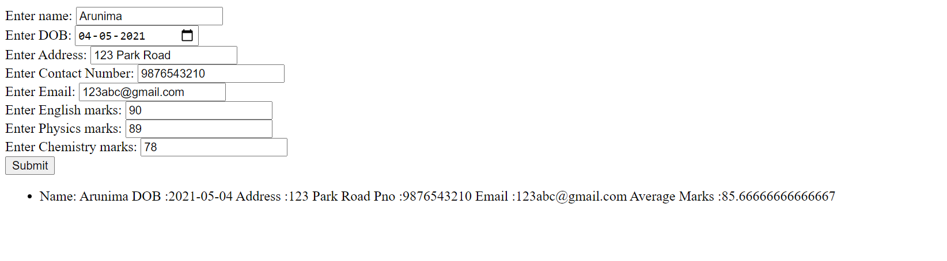

**Question 2**

employeeapp/views.py

from django.shortcuts import render

from django.http import HttpResponse

def index(request):

    return render(request, 'index.html')

employeeapp/urls.py

from django.urls import path

from . import views

urlpatterns = [

    path('', views.index, name='index'),

]

/urls.py

from django.contrib import admin

from django.urls import include, path

urlpatterns = [

    path('', include('studentapp.urls')),

    path('admin/', admin.site.urls),

]

employeeapp/templates/index.html

<!DOCTYPE html>

<html lang="en">

  <head>

    <meta charset="UTF-8" />

    <meta http-equiv="X-UA-Compatible" content="IE=edge" />

    <meta name="viewport" content="width=device-width, initial-scale=1.0" />

    <title>Employee App</title>

  </head>

  <body>

    <h1>Employee App</h1>

    <div id="container">

      <form id="student-form">

        <label for="employees">Employee ID</label>

        <select name="employees" id="employees">

          <option value="1">1</option>

          <option value="2">2</option>

          <option value="3">3</option>

          <option value="4">4</option>

          <option value="5">5</option>

        </select>

        <label for="doj">Date of joining:</label>

        <input type="date" id="doj" />

        <button id="submit-btn" type="submit">

          Am I Eligibile for Promotion?

        </button>

      </form>

      <div id="results"></div>

    </div>

    <script>

      document

        .getElementById("submit-btn")

        .addEventListener("click", function (event) {

          event.preventDefault();

          results();

        });

      function results() {

        console.log("lmao");

        const resultDiv = document.getElementById("results");

        while (resultDiv.firstChild) {

          resultDiv.removeChild(resultDiv.lastChild);

        }

        let id = document.getElementById("employees").value;

        let doj = new Date(document.getElementById("doj").value);

        let yearsDiff = new Date().getFullYear() - doj.getFullYear();

        if (yearsDiff >= 5) {

          document.getElementById("submit-btn").innerHTML = "YES";

        } else {

          document.getElementById("submit-btn").innerHTML = "NO";

        }

      }

    </script>

    <style>

      #container {

        display: flex;

        flex-direction: row;

      }

      #results {

        flex: 1;

        flex-grow: 1;

      }

      form {

        flex: 1;

        display: flex;

        flex-direction: column;

        width: 50%;

        margin-right: 16px;

      }

      input,

      textarea,

      button {

        padding: 8px;

        margin-bottom: 16px;

      }

      label {

        margin-bottom: 4px;

      }

    </style>

  </body>

</html>

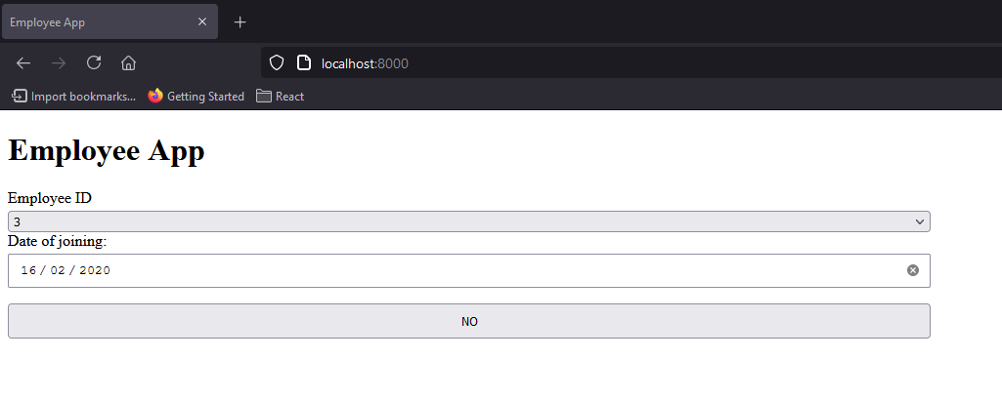

**Question 3:**

calculator/views.py

from django.shortcuts import render

from django.http import HttpResponse

def index(request):

    return render(request, 'index.html')

calculator/urls.py

from django.urls import path

from . import views

urlpatterns = [

    path('', views.index, name='index'),

]

/urls.py

from django.contrib import admin

from django.urls import include, path

urlpatterns = [

    path('', include('studentapp.urls')),

    path('admin/', admin.site.urls),

]

calculator/templates/index.html

<!DOCTYPE html>

<html lang="en">

  <head>

    <meta charset="UTF-8" />

    <meta http-equiv="X-UA-Compatible" content="IE=edge" />

    <meta name="viewport" content="width=device-width, initial-scale=1.0" />

    <title>Calculator App</title>

  </head>

  <body>

    <h1>Calculator App</h1>

    <div id="container">

      <form id="student-form">

        <label for="operation">Operation</label>

        <select name="operation" id="operation">

          <option value="add">Add</option>

          <option value="sub">Subtract</option>

          <option value="mul">Multiply</option>

          <option value="div">Divide</option>

        </select>

        <label for="op1">Operand 1</label>

        <input type="number" id="op1" placeholder="Operand 1" />

        <label for="op2">Operand 2</label>

        <input type="number" id="op2" placeholder="Operand 2" />

        <button id="submit-btn" type="submit">Calculate</button>

      </form>

      <div id="results"></div>

    </div>

    <script>

      document

        .getElementById("submit-btn")

        .addEventListener("click", function (event) {

          event.preventDefault();

          results();

        });

      function results() {

        console.log("lmao");

        const resultDiv = document.getElementById("results");

        while (resultDiv.firstChild) {

          resultDiv.removeChild(resultDiv.lastChild);

        }

        let op1 = Number(document.getElementById("op1").value);

        let op2 = Number(document.getElementById("op2").value);

        let operator = document.getElementById("operation").value;

        let ans = null;

        switch (operator) {

          case "add":

            ans = document.createElement("h1");

            ans.innerHTML = `Answer: ${op1 + op2}`;

            document.getElementById("results").appendChild(ans);

            break;

          case "sub":

            ans = document.createElement("h1");

            ans.innerHTML = `Answer: ${op1 - op2}`;

            document.getElementById("results").appendChild(ans);

            break;

          case "mul":

            ans = document.createElement("h1");

            ans.innerHTML = `Answer: ${op1 * op2}`;

            document.getElementById("results").appendChild(ans);

            break;

          case "div":

            ans = document.createElement("h1");

            ans.innerHTML = `Answer: ${op1 / op2}`;

            document.getElementById("results").appendChild(ans);

            break;

          case "default":

            break;

        }

      }

    </script>

    <style>

      #container {

        display: flex;

        flex-direction: row;

      }

      #results {

        flex: 1;

        flex-grow: 1;

      }

      form {

        flex: 1;

        display: flex;

        flex-direction: column;

        width: 50%;

        margin-right: 16px;

      }

      input,

      textarea,

      button {

        padding: 8px;

        margin-bottom: 16px;

      }

      label {

        margin-bottom: 4px;

      }

    </style>

  </body>

</html>

