***NAME: ARUNIMA SINGH THAKUR***

***SECTION: C***

***REGISTRATION N0: 180905218***

***BRANCH: COMPUTER SCIENCE***

***LAB: 1, IT***

***ROLL NO: 31***

**QUESTION 1:**

*Write a web page which contains table with 3 X 3 dimensions (fill some data) and one image. Style the rows with alternate color. Move the table and image together from right to left when button is clicked.*

<!DOCTYPE html>

<html>

<head>

<!-- CSS style to set alternate table

row using color -->

<style>

.animated {

position: relative;

left: 1000px;

}

table {

border-collapse: collapse;

width: 100%;

}

th, td {

text-align: left;

padding: 8px;

}

tr:nth-child(even) {

background-color: Pink;

}

tr:nth-child(odd) {

background-color: Lightgreen;

}

</style>

</head>

<script src="https://ajax.googleapis.com/ajax/libs/jquery/3.5.1/jquery.min.js"></script>

<script>

$(document).ready(function(){

$("button").click(function(){

$("div").animate({left: '0px'});

});

});

</script>

<body>

<div class="animated">

<img src = "flower.jpg" id ="id1"></img>

<table id ="table1" style="width:25%">

<tr>

<th>Name</th>

<th>Designation</th>

<th>Salary</th>

</tr>

<tr>

<td>Anirudh</td>

<td>CEO</td>

<td>1,00,000</td>

</tr>

<tr>

<td>SURAJ</td>

<td>CFO</td>

<td>50,000</td>

</tr>

<tr>

<td>Abhinav</td>

<td>Analyst</td>

<td>35,000</td>

</tr>

</table>

<button>Start Animation</button>

</div>

</body>

</script>

</html>

**OUTPUT:**

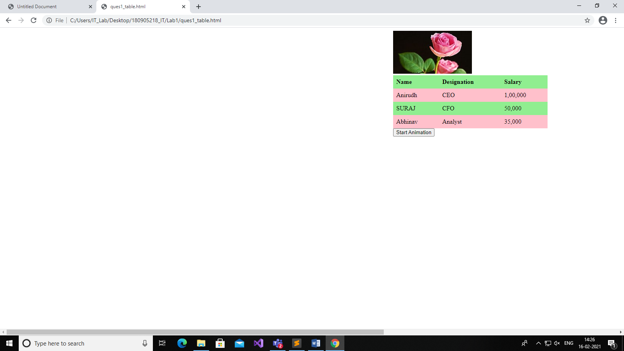

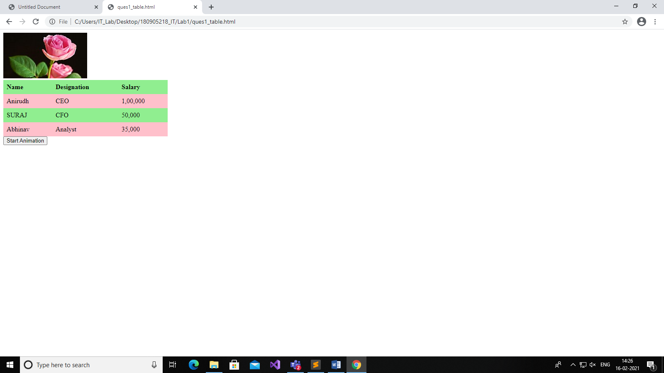

**QUESTION 2:**

*Design a calculator to perform basic arithmetic operations. Use textboxes and buttons to design web page.*

<!DOCTYPE HTML>

<html>

<head>

<meta charset="utf-8">

<title>Untitled Document</title>

<script type="text/javascript" src="http://code.jquery.com/jquery-1.7.2.min.js"></script>

<script type="text/javascript">

$(document).ready(function(e) {

$('#1,#2,#3,#4,#5,#6,#7,#8,#9,#0').click(function(){

var v = $(this).val();

$('#answer').val($('#answer').val() + v);

});

$('#C').click(function(){

$('#answer').val('');

$('#operation').val('');

$('#operation').removeClass('activeAnswer');

$('#equals').attr('onclick','');

});

$('#plus').click(function(e) {

if($('#answer').val() == ''){

return false;

$('#equals').attr('onclick','');

}

else if ( $('#operation').attr('class') == 'activeAnswer') {

$('#operation').val( $('#operation').val() + $('#plus').val() );

$('#answer').val('');

$('#equals').attr('onclick','');

}

else{

$('#operation').val( $('#operation').val() + $('#answer').val() + $('#plus').val() );

$('#answer').val('');

$('#equals').attr('onclick','');

}

});

$('#subtract').click(function(e) {

if($('#answer').val() == ''){

return false;

$('#equals').attr('onclick','');

}

else if ( $('#operation').attr('class') == 'activeAnswer') {

$('#operation').val( $('#operation').val() + $('#subtract').val() );

$('#answer').val('');

$('#equals').attr('onclick','');

}

else{

$('#operation').val( $('#operation').val() + $('#answer').val() + $('#subtract').val() );

$('#answer').val('');

$('#equals').attr('onclick','');

}

});

$('#divide').click(function(e) {

if($('#answer').val() == ''){

return false;

$('#equals').attr('onclick','');

}

else if ( $('#operation').attr('class') == 'activeAnswer') {

$('#operation').val( $('#operation').val() + $('#divide').val() );

$('#answer').val('');

$('#equals').attr('onclick','');

}

else{

$('#operation').val( $('#operation').val() + $('#answer').val() + $('#divide').val() );

$('#answer').val('');

$('#equals').attr('onclick','');

}

});

$('#product').click(function(e) {

if($('#answer').val() == ''){

return false;

$('#equals').attr('onclick','');

}

else if ( $('#operation').attr('class') == 'activeAnswer') {

$('#operation').val( $('#operation').val() + $('#product').val() );

$('#answer').val('');

$('#equals').attr('onclick','');

}

else{

$('#operation').val( $('#operation').val() + $('#answer').val() + $('#product').val() );

$('#answer').val('');

$('#equals').attr('onclick','');

}

});

$('#equals').click(function(){

if($('#equals').attr('onclick') != 'return false'){

var a = $('#answer').val();

var b = $('#operation').val();

var c = b.concat(a);

$('#answer').val(eval(c));

$('#operation').val(eval(c));

$('#operation').addClass('activeAnswer');

$('#equals').attr('onclick','return false');

}

});

});

</script>

<style>

form,input,button { margin:0px; }

</style>

</head>

<body>

<div style="width:200px; margin:auto;">

<form action="" id="calculator">

<input type="hidden" id="operation" value=""/>

<input type="text" id="answer" value="" style="width:98%; height:35px;" disabled="disabled"/>

<input type="button" value="+" id="plus" style="width:50px; height:50px; float:left;"/>

<input type="button" value="-" id="subtract" style="width:50px; height:50px; float:left;"/>

<input type="button" value="/" id="divide" style="width:50px; height:50px; float:left;"/>

<input type="button" value="*" id="product" style="width:50px; height:50px; float:left;"/>

<input type="button" value="1" id="1" style="width:50px; height:50px; float:left;"/>

<input type="button" value="2" id="2" style="width:50px; height:50px; float:left;"/>

<input type="button" value="3" id="3" style="width:50px; height:50px; float:left;"/>

<input type="button" value="4" id="4" style="width:50px; height:50px; float:left;"/>

<input type="button" value="5" id="5" style="width:50px; height:50px; float:left;"/>

<input type="button" value="6" id="6" style="width:50px; height:50px; float:left;"/>

<input type="button" value="7" id="7" style="width:50px; height:50px; float:left;"/>

<input type="button" value="8" id="8" style="width:50px; height:50px; float:left;"/>

<input type="button" value="9" id="9" style="width:50px; height:50px; float:left;"/>

<input type="button" value="0" id="0" style="width:50px; height:50px; float:left;"/>

<input type="button" value="C" id="C" style="width:50px; height:50px; float:left; color:red;"/>

<input type="button" value="=" id="equals" style="width:50px; height:50px; float:left;"/>

</form>

<div style="clear:both;"></div>

</div>

</body>

</html>

**OUTPUT:**

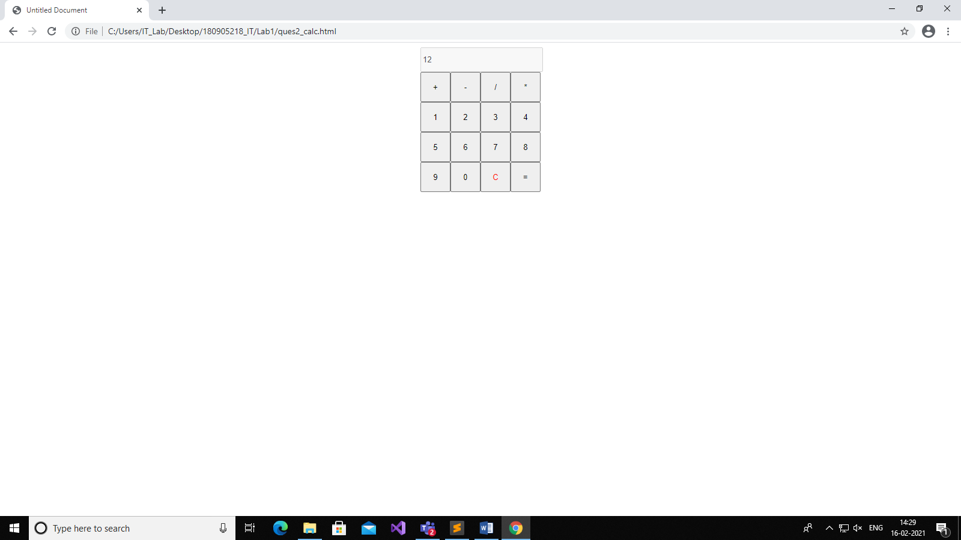

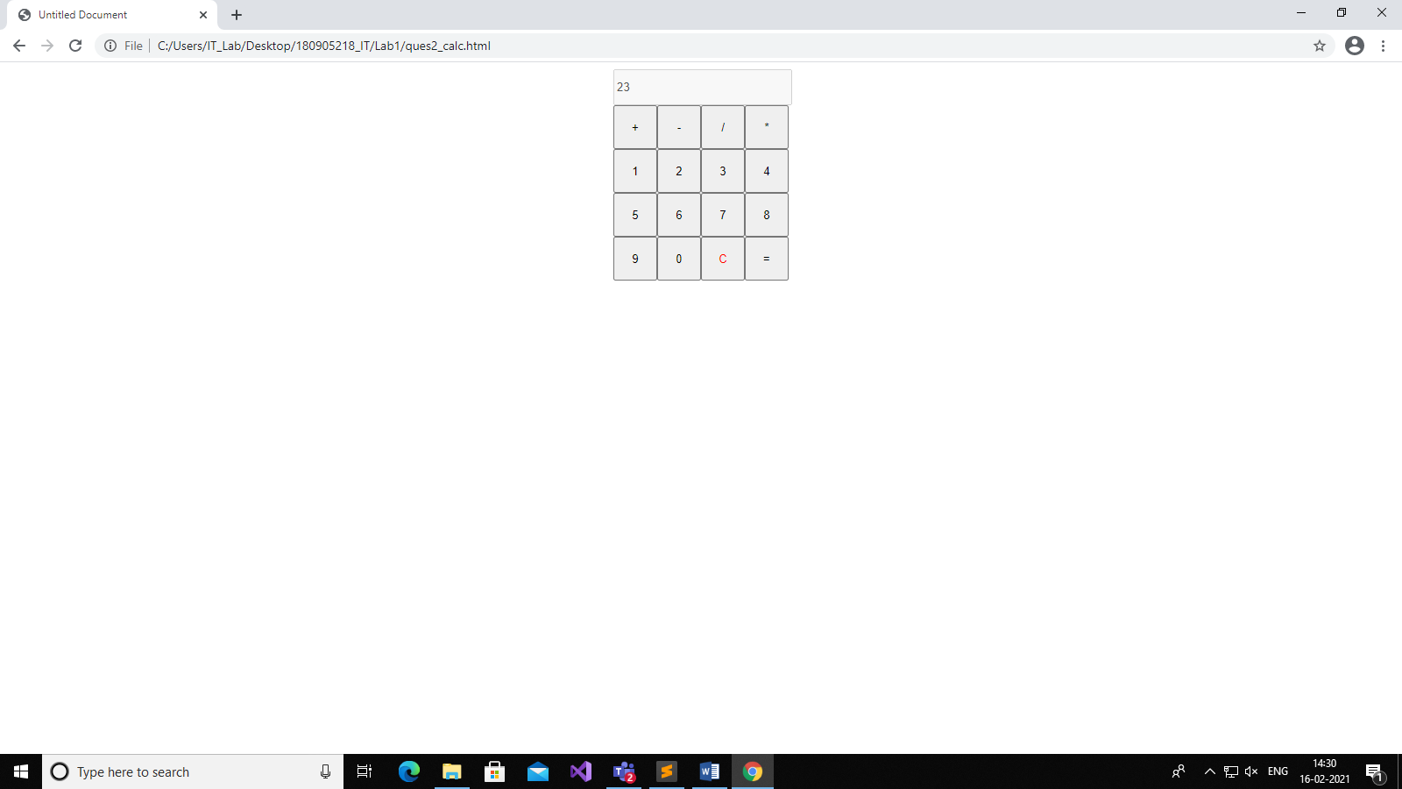

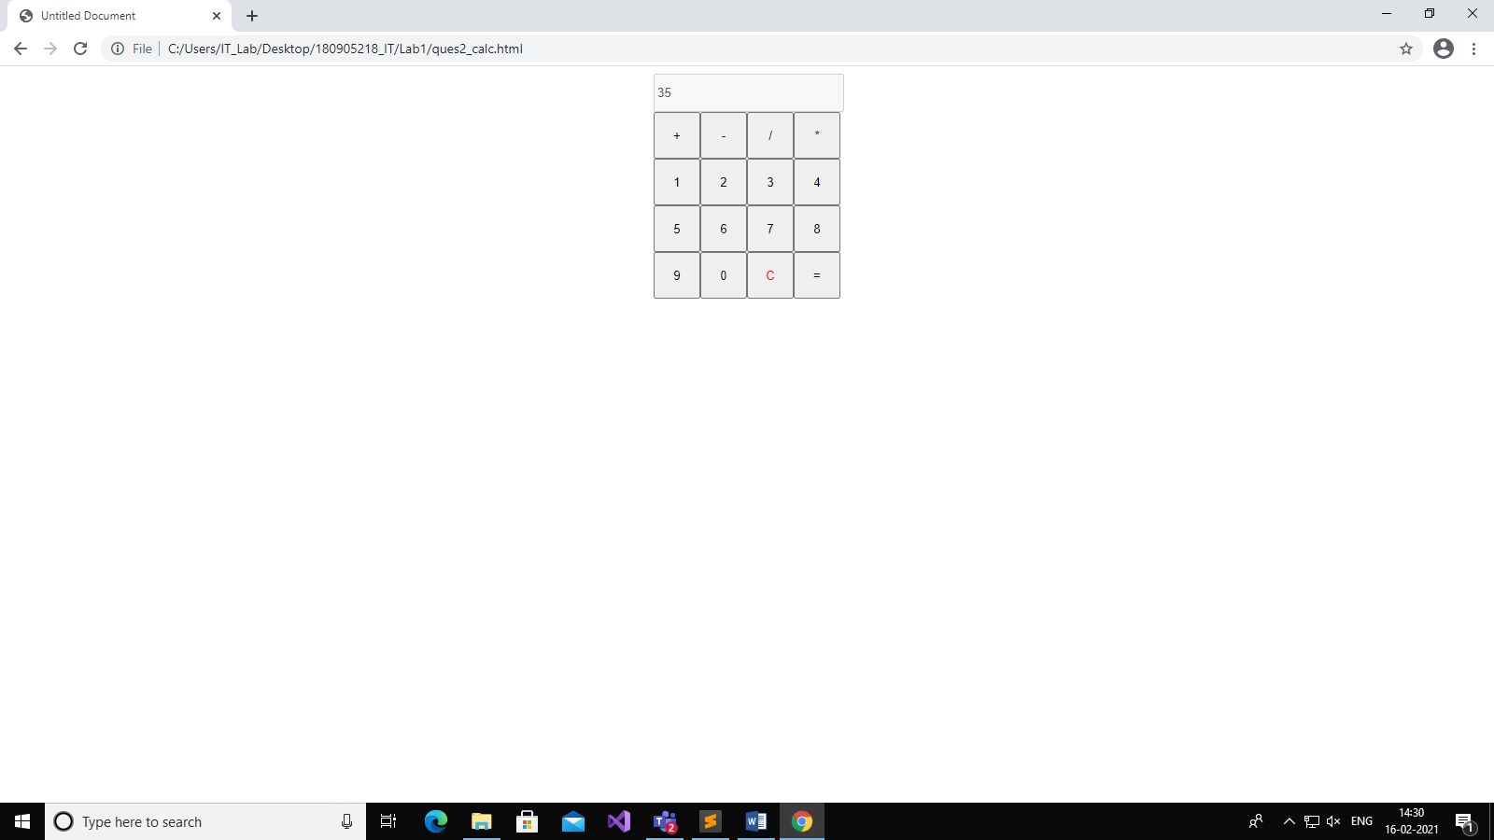

(Addition of 12 and 23=35)

**QUESTION 3:**

*Create a webpage to design a birthday card*

**OUTPUT:**

**QUESTION 4:**

*Design a webpage. The page contains:*

*•Dropdown list with HP, Nokia, Samsung, Motorola, Apple as items.*

*•Checkbox with Mobile and Laptop as items.*

*•Textbox where you enter quantity.*

*•There is a button with text as ‘Produce Bill’.*

*On Clicking Produce Bill button, alert should be displayed with total amount.*

<!DOCTYPE html>

<html>

<head>

<title>Shopping</title>

<script type="text/javascript" src="https://code.jquery.com/jquery-3.5.1.min.js"></script>

<script type="text/javascript">

$(document).ready(function(){

$("button").click(function(){

var sum=0;

if($("select").val()=="HP"){

if($("#text1").prop("checked")==true && $("#text2").prop("checked")==true){

sum=sum+parseInt($("#quantity").val())*10000;

sum=sum+parseInt($("#quantity").val())*40000;

}

if($("#text1").prop("checked")==true){

sum=sum+parseInt($("#quantity").val())*10000;

}

else{

sum=sum+parseInt($("#quantity").val())*40000;

}

}

else if($("select").val()=="Nokia"){

if($("#text1").prop("checked")==true && $("#text2").prop("checked")==true){

sum=sum+parseInt($("#quantity").val())*10000;

sum=sum+parseInt($("#quantity").val())*40000;

}

if($("#text1").prop("checked")==true){

sum=sum+parseInt($("#quantity").val())*10000;

}

else{

sum=sum+parseInt($("#quantity").val())*40000;

}

}

else if($("select").val()=="Samsung"){

if($("#text1").prop("checked")==true && $("#text2").prop("checked")==true){

sum=sum+parseInt($("#quantity").val())*20000;

sum=sum+parseInt($("#quantity").val())*50000;

}

if($("#text1").prop("checked")==true){

sum=sum+parseInt($("#quantity").val())*20000;

}

else{

sum=sum+parseInt($("#quantity").val())*50000;

}

}

else if($("select").val()=="Motorola"){

if($("#text1").prop("checked")==true && $("#text2").prop("checked")==true){

sum=sum+parseInt($("#quantity").val())*30000;

sum=sum+parseInt($("#quantity").val())*60000;

}

if($("#text1").prop("checked")==true){

sum=sum+parseInt($("#quantity").val())*30000;

}

else{

sum=sum+parseInt($("#quantity").val())*60000;

}

}

else{

if($("#text1").prop("checked")==true && $("#text2").prop("checked")==true){

sum=sum+parseInt($("#quantity").val())*40000;

sum=sum+parseInt($("#quantity").val())*70000;

}

if($("#text1").prop("checked")==true){

sum=sum+parseInt($("#quantity").val())*40000;

}

else{

sum=sum+parseInt($("#quantity").val())*70000;

}

}

alert(sum);

});

});

</script>

</head>

<body>

<form>

<select name = "dropdown">

<option value = "HP" selected>HP</option>

<option value = "Nokia">Nokia</option>

<option value = "Samsung">Samsung</option>

<option value = "Motorola">Motorola</option>

<option value = "Apple">Apple</option>

</select>

<br>

<input type="checkbox" id="text1" value="Mobile">Mobile<br>

<input type="checkbox" id="text2" value="Laptop">Laptop<br>

Quantity: <input type="text" id="quantity">

<br>

<button>Produce Bill</button>

</form>

</body>

</html>

**OUTPUT:**





