***NAME: ARUNIMA SINGH THAKUR***

***SECTION: C***

***REGISTRATION NO: 180905218***

***LAB NO: 2***

***LAB: IT***

***QUESTION 1:***

**Design the student bio-data form using button, label, textbox, radio button, table and checkbox.**

<!DOCTYPE html>

<html>

<head>

<style>@import url(https://fonts.googleapis.com/css?family=Raleway:400,500);

html,

body {

background-color: pink;

text-align: center;

font-family: 'Raleway', Helvetica, sans-serif;

min-width: 320px;

}

header {

font-size: 2em;

font-weight: bold;

margin: 20px;

}

#form-outer {

background-color: rgb(250, 250, 250);

margin: 0 auto;

border-radius: 4px;

width: 75%;

max-width: 900px;

padding: 10px;

padding-top: 20px;

}

.labels {

display: inline-block;

text-align: right;

width: 40%;

padding: 5px;

vertical-align: top;

margin-top: 10px;

}

.rightTab {

display: inline-block;

text-align: left;

width: 48%;

vertical-align: middle;

}

.input-field {

height: 20px;

width: 280px;

padding: 5px;

margin: 10px;

border: 1px solid #c0c0c0;

border-radius: 2px;

}

#userAge {

width: 40px;

}

.userRatings,

input[type="checkbox"] {

float: left;

margin-right: 5px;

}

#submit {

background-color: #f18973;

border-radius: 4px;

color: white;

font-size: 1em;

height: 40px;

width: 96px;

margin: 10px;

border: 0px solid;

}

#reset {

background-color: #f18973;

border-radius: 4px;

color: white;

font-size: 1em;

height: 40px;

width: 96px;

margin: 10px;

border: 0px solid;

}

.dropdown {

height: 35px;

width: 140px;

padding: 5px;

margin: 10px;

margin-top: 15px;

border: 1px solid #c0c0c0;

border-radius: 2px;

}

.radio, .checkbox {

position: relative;

left: -43px;

margin-left: 10px;

display: block;

padding-bottom: 10px;

}

@media screen and (max-width: 833px) {

.input-field {

width: 80%;

}

select {

width: 90%;

}

}

@media screen and (max-width: 520px) {

.labels {

width: 100%;

text-align: left;

}

.rightTab {

width: 80%;

float: left;

}

.input-field {

width: 100%;

}

select {

width: 100%;

}

}</style>

</head>

<body>

<script src="https://cdn.freecodecamp.org/testable-projects-fcc/v1/bundle.js"></script>

<h1 id="title">Student Bio Data Form</h1>

<div id="form-outer">

<p id="description">

To know the details of students

</p>

<form id="survey-form" method="GET" action="">

<div class="rowTab">

<div class="labels">

<label id="name-label" for="name">Name: </label>

</div>

<div class="rightTab">

<input autofocus type="text" name="name" id="name" class="input-field" placeholder="Enter your name" required>

</div>

</div>

<div class="rowTab">

<div class="labels">

<label id="fname-label" for="fname">Father's Name: </label>

</div>

<div class="rightTab">

<input autofocus type="text" name="fname" id="fname" class="input-field" placeholder="Enter your father's name" required>

</div>

</div>

<div class="rowTab">

<div class="labels">

<label id="mname-label" for="mname">Mother's Name: </label>

</div>

<div class="rightTab">

<input autofocus type="text" name="mname" id="mname" class="input-field" placeholder="Enter your mother's name" required>

</div>

</div>

<div class="rowTab">

<div class="labels">

<label id="email-label" for="email">Email: </label>

</div>

<div class="rightTab">

<input type="email" name="email" id="email" class="input-field" required placeholder="Enter your Email">

</div>

</div>

<div class="rowTab">

<div class="labels">

<label id="number-label" for="age">Age: </label>

</div>

<div class="rightTab">

<input type="number" name="age" id="number" min="1" max="125" class="input-field" placeholder="Age" required>

</div>

</div>

<div class="rowTab">

<div class="labels">

<label id="dob-label" for="dob">D.O.B: </label>

</div>

<div class="rightTab">

<input type="date" name="dob" id="iddob" class="input-field" required>

</div>

</div>

<div class="rowTab">

<div class="labels">

<label for="department">Department: </label>

</div>

<div class="rightTab">

<select id="dropdown" name="department" class="dropdown">

<option disabled value>Select an option</option>

<option value="it">IT</option>

<option value="cse">CSE</option>

<option value="ece">ECE</option>

<option value="mech">MECH</option>

<option value="civil">CIVIL</option>

<option value="other">Other</option>

</select>

</div>

</div>

<div class="rowTab">

<div class="labels">

<label for="gender">Gender: </label>

</div>

<div class="rightTab">

<ul style="list-style: none;">

<li class="radio"><label><input name="radio-buttons" value="male" type="radio" class="userRatings" >Male</label></li>

<li class="radio"><label><input name="radio-buttons" value="female" type="radio" class="userRatings" >Female</label></li>

<li class="radio"><label><input name="radio-buttons" value="others" type="radio" class="userRatings" >Others</label></li>

</ul>

</div>

</div>

<div class="rowTab">

<div class="labels">

<label for="address">Address: </label>

</div>

<div class="rightTab">

<textarea id="comments" class="input-field" style="height:50px;resize:vertical;" name="address" placeholder="Enter your address here..."></textarea>

</div>

</div>

<div class="rowTab">

<div class="labels">

<label for="pincode">Pincode: </label>

</div>

<div class="rightTab">

<input type="number" name="pincode" id="idpincode" class="input-field" style="height:20px;resize:vertical;" placeholder="6 - - - - -"></div>

</div>

<div class="rowTab">

<div class="labels">

<label for="language">Language Known: </label>

</div>

<div class="rightTab">

<ul id="language" style="list-style: none;">

<li class="checkbox"><label><input name="prefer" value="english" type="checkbox" class="userRatings">English</label></li>

<li class="checkbox"><label><input name="prefer" value="tamil" type="checkbox" class="userRatings">Tamil</label></li>

<li class="checkbox"><label><input name="prefer" value="hindi" type="checkbox" class="userRatings">Hindi</label></li>

<li class="checkbox"><label><input name="prefer" value="malayalam" type="checkbox" class="userRatings">Malayalam</label></li>

<li class="checkbox"><label><input name="prefer" value="kannada" type="checkbox" class="userRatings">Kannada</label></li>

<li class="checkbox"><label><input name="prefer" value="telugu" type="checkbox" class="userRatings">Telugu</label></li>

<li class="checkbox"><label><input name="prefer" value="others" type="checkbox" class="userRatings">Others</label></li>

</ul>

</div>

</div>

<button id="submit" type="submit">Submit</button>

<button id="reset" type="reset">Reset</button>

</form>

</div>

</body>

</html>

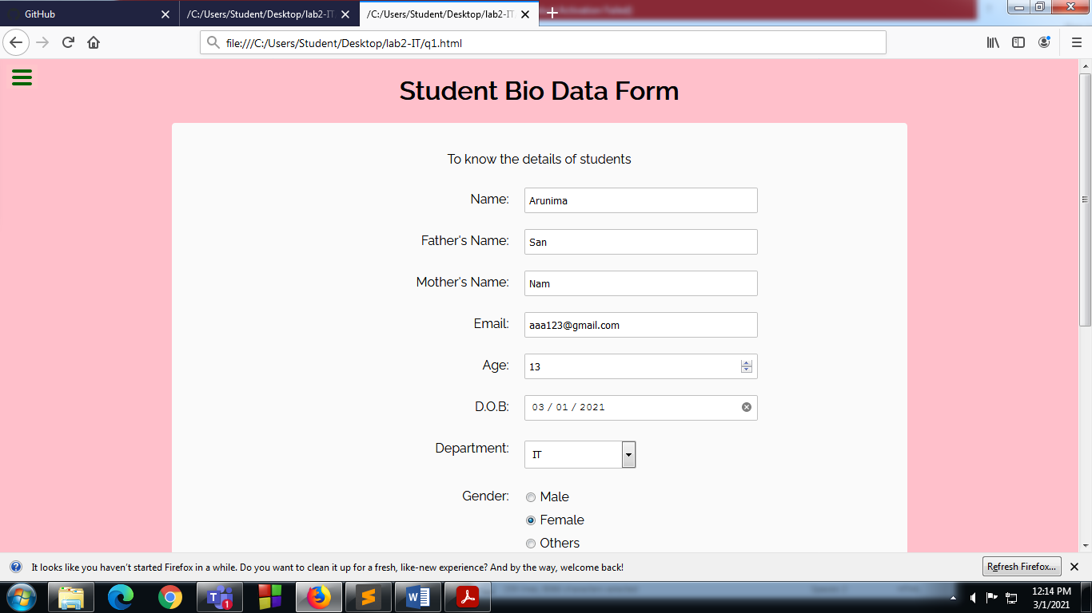

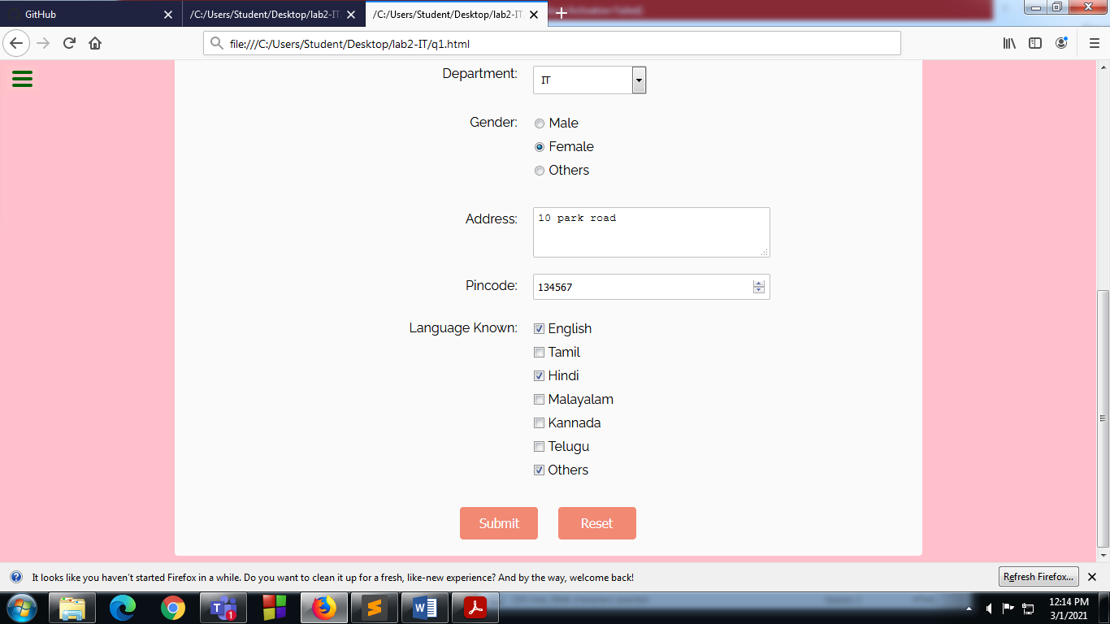

***QUESTION2:***

**Design a web page which shows the database oriented CRUD operation. Consider Employee data.**

<!DOCTYPE html>

<html lang="en">

<head>

<title>Bootstrap Example</title>

<meta charset="utf-8" />

<meta content="width=device-width, initial-scale=1" name="viewport" />

<link

href="https://maxcdn.bootstrapcdn.com/bootstrap/4.4.1/css/bootstrap.min.css"

rel="stylesheet"

/>

<script src="https://ajax.googleapis.com/ajax/libs/jquery/3.4.1/jquery.min.js"></script>

<script src="https://cdnjs.cloudflare.com/ajax/libs/popper.js/1.16.0/umd/popper.min.js"></script>

<script src="https://maxcdn.bootstrapcdn.com/bootstrap/4.4.1/js/bootstrap.min.js"></script>

<script

src="https://code.jquery.com/jquery-3.5.1.slim.min.js"

integrity="sha256-4+XzXVhsDmqanXGHaHvgh1gMQKX40OUvDEBTu8JcmNs="

crossorigin="anonymous"

></script>

<script type="text/javascript">

var name = "",

email = "";

$(document).ready(function () {

$("#btnSubmit").click(function () {

name = $("#nameinput").val();

email = $("#emailinput").val();

$("#nameval").text("Name: " + name);

$("#emailval").text("Email: " + email);

$("#nameupdate").val(name);

$("#emailupdate").val(email);

});

$("#btnRead").click(() => {

$("#readname").text(name);

$("#reademail").text(email);

});

$("#btnUpdate").click(function () {

name = $("#nameupdate").val();

email = $("#emailupdate").val();

$("#nameval").text("Name: " + name);

$("#emailval").text("Email: " + email);

$("#nameupdate").val(name);

$("#emailupdate").val(email);

});

$("#btnDelete").click(() => {

name = "";

email = "";

$("#readname").text("");

$("#reademail").text("");

$("#nameinput").val("");

$("#emailinput").val("");

$("#nameupdate").val("");

$("#emailupdate").val("");

});

});

</script>

</head>

<body style="background-color: powderblue">

<div class="container">

<h3>Create</h3>

<form>

<div class="form-group">

<label for="exampleInputEmail1">Name</label>

<input

type="text"

class="form-control"

id="nameinput"

aria-describedby="emailHelp"

placeholder="John Doe"

/>

</div>

<div class="form-group">

<label for="exampleInputEmail1">Email</label>

<input

type="text"

class="form-control"

id="emailinput"

aria-describedby="emailHelp"

placeholder="johndoe@lala.com"

/>

</div>

<input

type="button"

class="btn btn-primary btnSeccion"

id="btnSubmit"

value="Create"

/>

</form>

<br />

<h6>Data:</h6>

<div class="container" id="data">

<p id="nameval">Name: No Data</p>

<p id="emailval">Email: No Data</p>

</div>

<h3>Read</h3>

<input

type="button"

class="btn btn-primary btnSeccion"

id="btnRead"

value="Read Data"

/>

<br /><br />

<div class="container" id="data">

<table class="table">

<thead>

<tr>

<th scope="col">Name</th>

<th scope="col">Email</th>

</tr>

</thead>

<tbody>

<tr>

<td id="readname"></td>

<td id="reademail"></td>

</tr>

</tbody>

</table>

</div>

<h3>Update</h3>

<div class="container" id="data">

<form>

<div class="form-group">

<label for="exampleInputEmail1">Name</label>

<input

type="text"

class="form-control"

id="nameupdate"

aria-describedby="emailHelp"

placeholder=""

/>

</div>

<div class="form-group">

<label for="exampleInputEmail1">Email</label>

<input

type="text"

class="form-control"

id="emailupdate"

aria-describedby="emailHelp"

placeholder=""

/>

</div>

<input

type="button"

class="btn btn-primary btnSeccion"

id="btnUpdate"

value="Update"

/>

</form>

</div>

<br />

<h3>Delete</h3>

<input

type="button"

class="btn btn-primary btnSeccion"

id="btnDelete"

value="Delete Data"

/>

<br /><br />

</div>

</body>

</html>

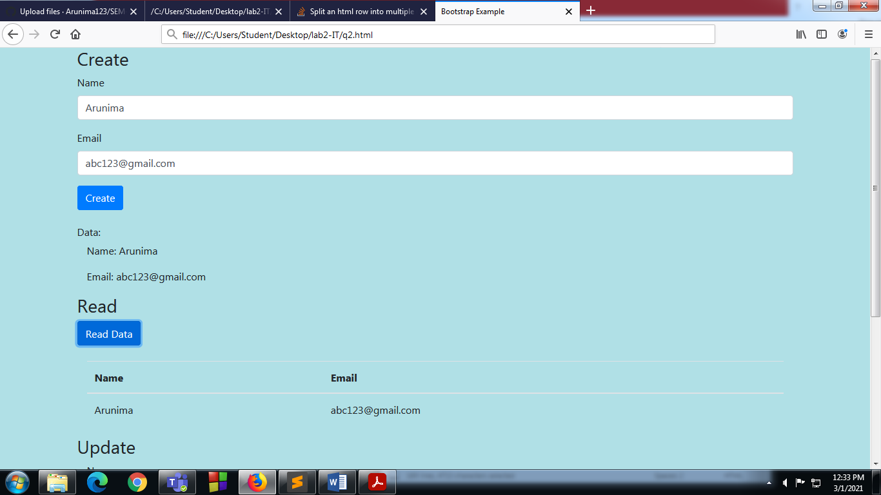

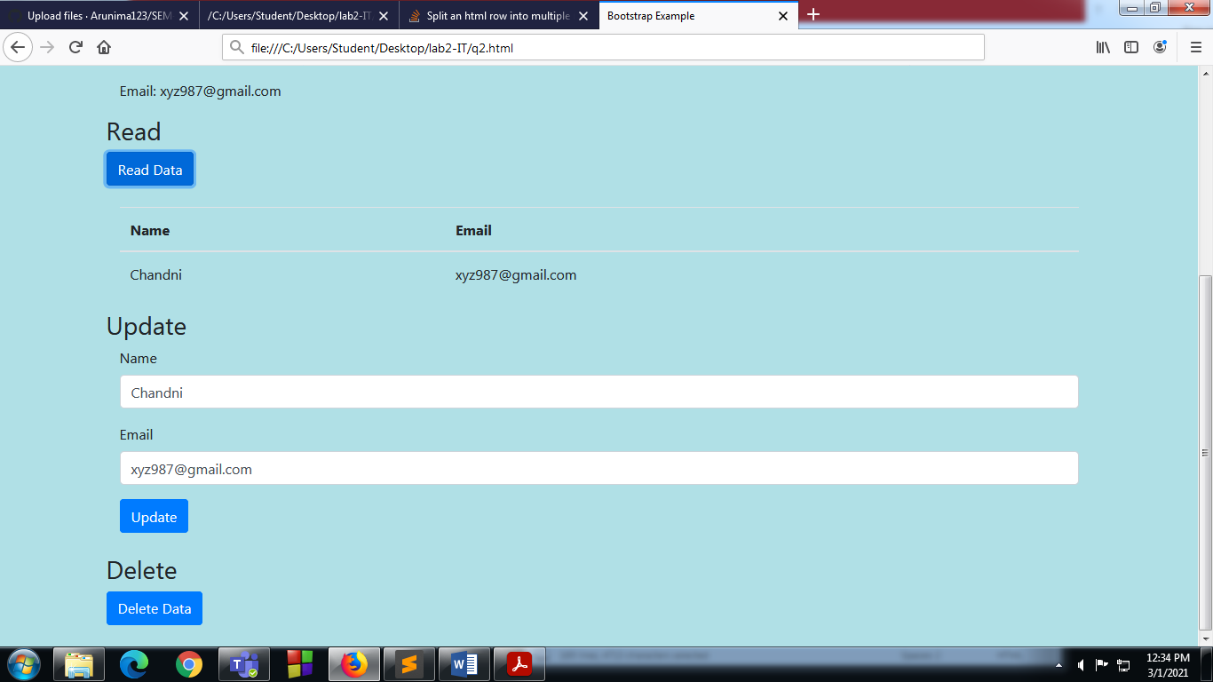

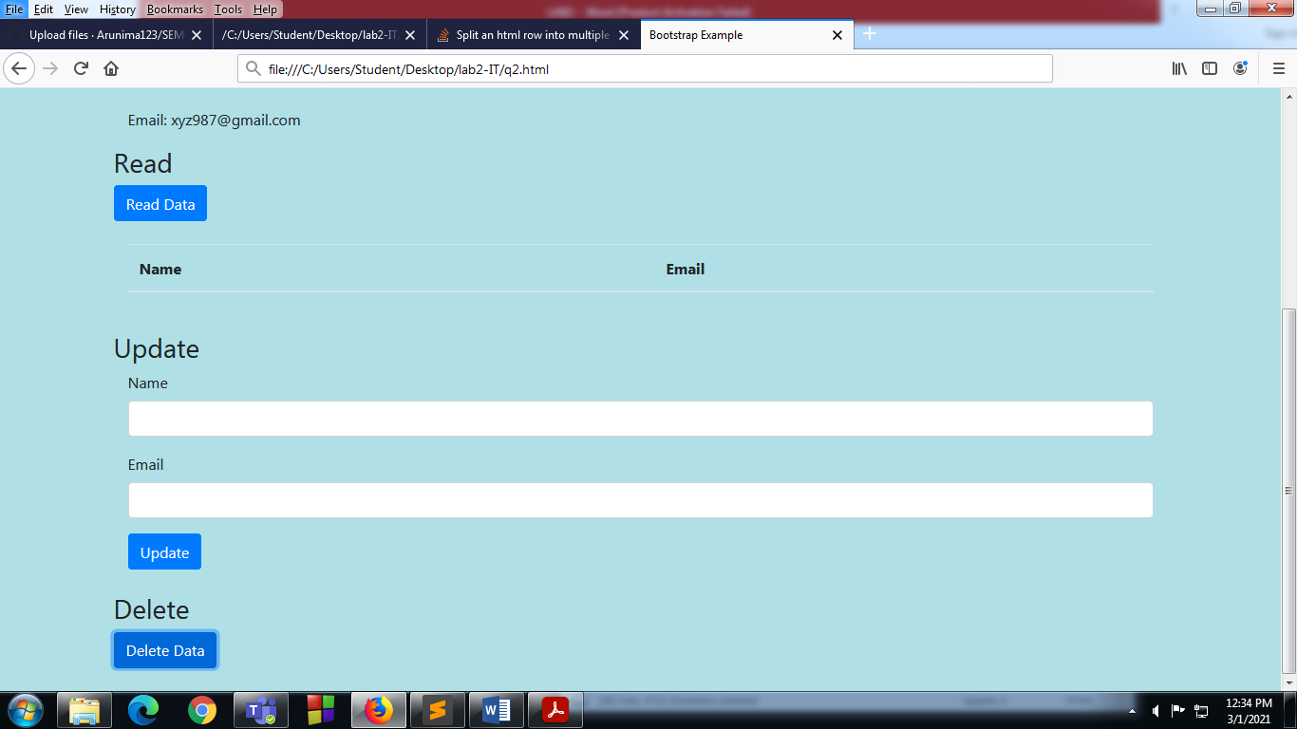

***QUESTION 3:***

**Create a web page using bootstrap as mentioned. Divide the page in to 2 parts top and bottom, then divide the bottom into 3 parts and design each top and bottom part using different input groups, input, badges, buttons and button groups. Make the design more attractive.**

<!DOCTYPE html>

<html style="height: 100%; width: 100%;">

<head>

<title>Question 3</title>

<meta charset="utf-8">

<meta name="viewport" content="width=device-width, initial-scale=1">

<link rel="stylesheet" href="https://maxcdn.bootstrapcdn.com/bootstrap/4.4.1/css/bootstrap.min.css">

<script src="https://ajax.googleapis.com/ajax/libs/jquery/3.4.1/jquery.min.js"></script>

<script src="https://cdnjs.cloudflare.com/ajax/libs/popper.js/1.16.0/umd/popper.min.js"></script>

<script src="https://maxcdn.bootstrapcdn.com/bootstrap/4.4.1/js/bootstrap.min.js"></script>

</head>

<body style="min-height: 100%; width: 100%; background-color:maroon;">

<div class="container" style="min-height: 100%; height: 100%;">

<div class="row">

<div class="col-sm">

<div class="jumbotron">

<h1 class="display-3">IT Lab</h1>

<hr class="my-2">

<p>Get Started</p>

</div>

</div>

</div>

<div class="row" >

<div class="col-sm" style="background-color: #FEE; padding: 20px;">

<form>

<h4>Login</h4>

<div class="form-group">

<label for="">Registration Number</label>

<input type="text" name="inpReg" id="inpReg" class="form-control" placeholder="Enter registration number" aria-describedby="helpReg">

<small id="helpReg" class="text-muted">123456789</small>

</div>

<div class="form-group">

<label for="">Password</label>

<input type="password" name="inpPass" id="inpPass" class="form-control" placeholder="Enter password" aria-describedby="helpReg">

</div>

</form>

<br>

<button type="button" name="" id="" class="btn btn-primary btn-md btn-block">Submit</button>

</div>

<div class="col-sm" style="background-color: #EFE; padding: 20px;">

<h4>Download Manual</h4>

<div class="form-check">

<label class="form-check-label">

<input type="checkbox" class="form-check-input" name="inpL1" id="inpL1" value="checkedValue" checked>

Lab 1

</label>

</div>

<div class="form-check">

<label class="form-check-label">

<input type="checkbox" class="form-check-input" name="inpL1" id="inpL1" value="checkedValue" checked>

Lab 2

</label>

</div>

<div class="form-check">

<label class="form-check-label">

<input type="checkbox" class="form-check-input" name="inpL1" id="inpL1" value="checkedValue" checked>

Lab 3

</label>

</div>

<div class="form-check">

<label class="form-check-label">

<input type="checkbox" class="form-check-input" name="inpL1" id="inpL1" value="checkedValue" checked>

Lab 4

</label>

</div>

<br>

<h6>Format</h6>

<div class="form-check">

<label class="form-check-label">

<input type="radio" class="form-check-input" name="inpFormat" id="inpPDF" value="checkedValue" checked>

PDF

</label>

</div>

<div class="form-check">

<label class="form-check-label">

<input type="radio" class="form-check-input" name="inpFormat" id="inpWord" value="checkedValue">

Word

</label>

</div>

<br>

<button type="button" name="" id="" class="btn btn-primary btn-md btn-block">Submit</button>

</div>

<div class="col-sm" style="background-color: #EEF; padding: 20px;">

<h4>Submit Assignment <span class="badge badge-info">New</span></h4>

<div class="form-group">

<label for="inpLab">Lab</label>

<input type="number" class="form-control" name="inplab" id="inpLab" aria-describedby="helpLab" placeholder="">

</div>

<div class="form-group">

<label for="inpAssgn">Solution</label>

<textarea class="form-control" name="inpAssgn" id="inpAssgn" rows="2"></textarea>

</div>

<button type="button" name="" id="" class="btn btn-primary btn-md btn-block">Submit</button>

</div>

</div>

</div>

</body>

</html>

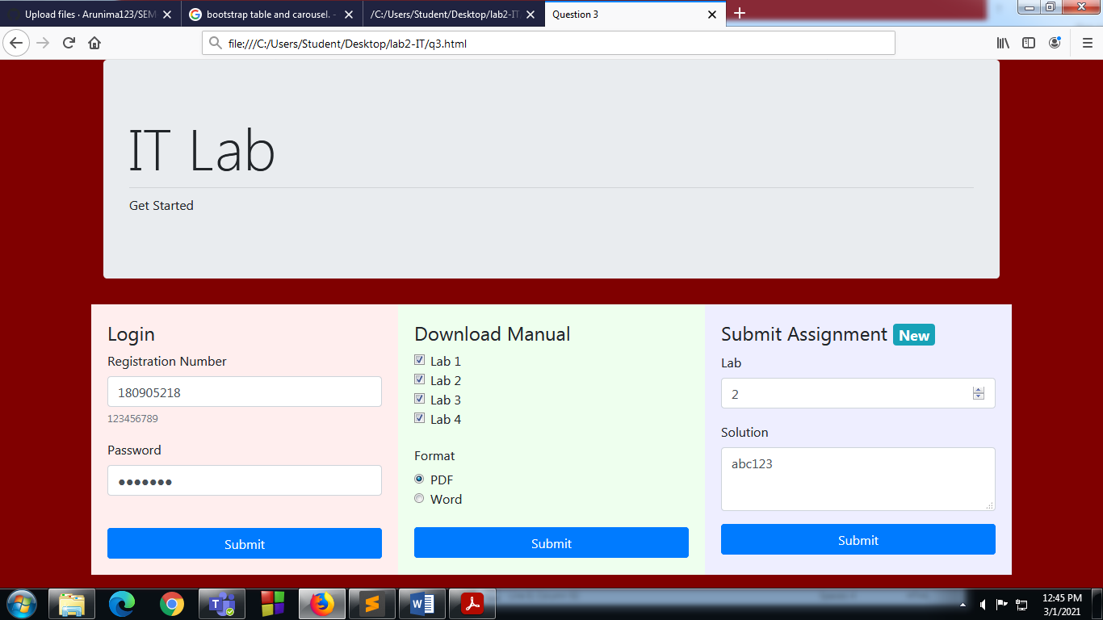

***QUESTION 4:***

**Design your class timetable using bootstrap table and carousel.**

<!DOCTYPE html>

<html lang="en">

<head>

<title>Bootstrap Example</title>

<meta charset="utf-8">

<meta name="viewport" content="width=device-width, initial-scale=1">

<link rel="stylesheet" href="https://maxcdn.bootstrapcdn.com/bootstrap/4.5.2/css/bootstrap.min.css">

<script src="https://ajax.googleapis.com/ajax/libs/jquery/3.5.1/jquery.min.js"></script>

<script src="https://cdnjs.cloudflare.com/ajax/libs/popper.js/1.16.0/umd/popper.min.js"></script>

<script src="https://maxcdn.bootstrapcdn.com/bootstrap/4.5.2/js/bootstrap.min.js"></script>

<style>

.carousel-inner img {

width: 100%;

height: 100%;

}

</style>

</head>

<body>

<div id="demo" class="carousel slide" data-ride="carousel">

<!-- Indicators -->

<ul class="carousel-indicators">

<li data-target="#demo" data-slide-to="0" class="active"></li>

<li data-target="#demo" data-slide-to="1"></li>

</ul>

<!-- The slideshow -->

<div class="carousel-inner">

<div class="carousel-item active">

<img src="logo.png" style="height: fit-content" >

</div>

<div class="carousel-item">

<table class="table table-bordered table-dark">

<thead>

<tr>

<th scope="col"></th>

<th></th>

<th scope="col">8-10</th>

<th scope="col">10-12</th>

<th scope="col">12-2</th>

</tr>

</thead>

<tbody>

<tr>

<th scope="row">1</th>

<td>Monday</td>

<td>DS</td>

<td>PCAP</td>

<td>IT Lab</td>

</tr>

<tr>

<th scope="row">2</th>

<td>Tuesday</td>

<td>EEFM</td>

<td>--</td>

<td>OE-III</td>

</tr>

<tr>

<th scope="row">3</th>

<td>Wednesday</td>

<td>PCAP</td>

<td>DS Lab</td>

<td>--</td>

</tr>

<tr>

<th scope="row">3</th>

<td>Thursday</td>

<td>PE-II</td>

<td>--</td>

<td>PE-I</td>

</tr>

<tr>

<th scope="row">3</th>

<td>Friday</td>

<td>DS</td>

<td>PCAP Lab</td>

<td>EEFM</td>

</tr>

<tr>

<th scope="row">3</th>

<td>Saturday</td>

<td>--</td>

<td>PE-II</td>

<td>OE-III</td>

</tr>

</tbody>

</table>

</div>

</div>

<!-- Left and right controls -->

<a class="carousel-control-prev" href="#demo" data-slide="prev">

<span class="carousel-control-prev-icon"></span>

</a>

<a class="carousel-control-next" href="#demo" data-slide="next">

<span class="carousel-control-next-icon"></span>

</a>

</div>

</body>

</html>

