NAME: ARUNIMA SINGH THAKUR
REGISTRATION NO: 180905218
LAB NO: 4
LAB: DS
ROLL NO: 31
SECTION: C

SAMPLE QUESTIONS:

1A) Write a program where client can send a message to the server and the server can receive the message and send, or echo, it back to the client.

Server

import socket
HOST = '127.0.0.1' # Standard loopback interface address (localhost)
PORT = 2053 # Port to listen on (non-privileged ports are > 1023)
with socket.socket(socket.AF_INET, socket.SOCK_STREAM) as s:
s.bind((HOST, PORT))
s.listen()
conn, addr = s.accept()
with conn:
print('Connected by', addr)
while True:
data = conn.recv(1024)
if data:
print("Client: ",data.decode())
data = input("Enter message to client:");
if not data:
break; # sending message as bytes to client.
conn.sendall(bytearray(data, 'utf-8'));
conn.close()

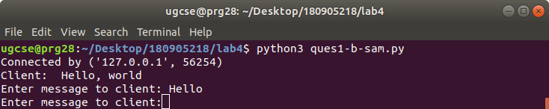

Client

import socket
HOST = '127.0.0.1' # The server's hostname or IP address
PORT = 2053 # The port used by the server
with socket.socket(socket.AF_INET, socket.SOCK_STREAM) as s:
s.connect((HOST, PORT))
s.sendall(b'Hello, world')
data = s.recv(1024)
print('Received Connection')
print('Server:', data.decode())

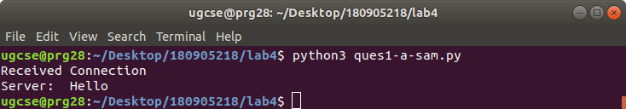

2A) Write a program to create TCP time server in Python

Time Server

# server.py
import socket
import time
# create a socket object
serversocket = socket.socket(socket.AF_INET, socket.SOCK_STREAM)
# get local machine name
host = socket.gethostname()
port =9991
# bind to the port
serversocket.bind((host, port))
# queue up to 5 requests
serversocket.listen(5)
while True:
# establish a connection
clientsocket,addr = serversocket.accept()
print("Got a connection from %s" % str(addr))
currentTime = time.ctime(time.time()) + "\r\n"
clientsocket.send(currentTime.encode('ascii'))

clientsocket.close()

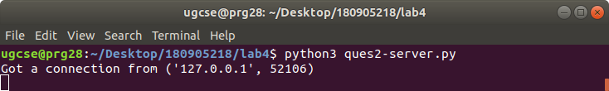

Time Client

#client.py
import socket

# create a socket object
s = socket.socket(socket.AF_INET, socket.SOCK_STREAM)
# get local machine name
host = socket.gethostname()
port = 9991
# connection to hostname on the port.
s.connect((host,port)) # Receive no more than 1024 bytes
tm = s.recv(1024)
print(' Current time from Sever :', tm.decode())
s.close()
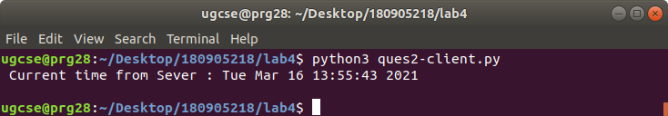

3A) Write a TCP chat server in python using socket programming.

Server chat

# server.py
import socket
HOST = '127.0.0.1' # Standard loopback interface address (localhost)
PORT = 31621 # Port to listen on (non-privileged ports are > 1023)
s = socket.socket()
s.bind((HOST, PORT))
s.listen()
print("\nWaiting for incoming connections...\n")
conn, addr = s.accept()
print("Received connection from ", addr[0], "(", addr[1], ")\n")

s_name = conn.recv(1024)
s_name = s_name.decode()
print(s_name, "has connected to the chat room\nEnter [e] to exit chat room\n")
name = input(str("Enter your name: "))
conn.send(name.encode())
while True:
message = input(str("Me : "))
if message == "[e]":
message = "Left chat room!"
conn.send(message.encode())
print("\n")
break
conn.send(message.encode())
message = conn.recv(1024)
message = message.decode()
print(s_name, ":", message)

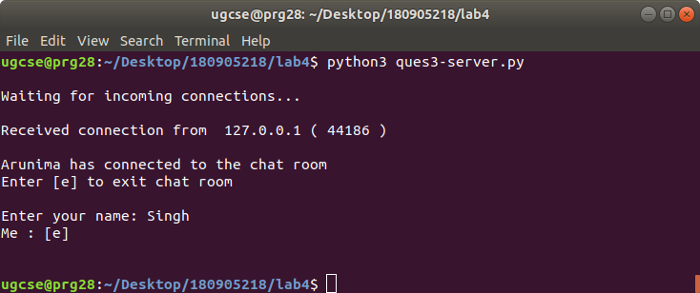

Client chat

import socket
HOST = '127.0.0.1' # Standard loopback interface address (localhost)
PORT = 31621 # Port to listen on (non-privileged ports are > 1023)
s = socket.socket()
name = input(str("\nEnter your name: "))
print("\nTrying to connect to ", HOST, "(", PORT, ")\n")

s.connect((HOST, PORT))
print("Connected...\n")

s.send(name.encode())
s_name = s.recv(1024)
s_name = s_name.decode()
print(s_name, "has joined the chat room\nEnter [e] to exit chat room\n")

while True:
message = s.recv(1024)
message = message.decode()
print(s_name, ":", message)
message = input(str("Me : "))
if message == "[e]":
message = "Left chat room!"
s.send(message.encode())
print("\n")
break
s.send(message.encode())
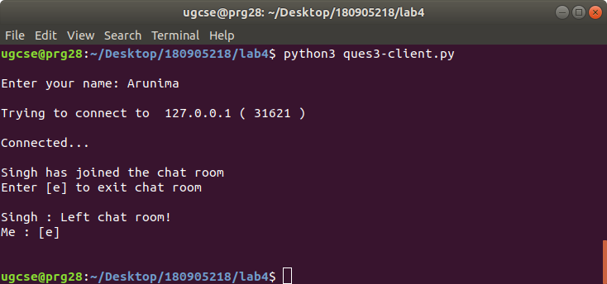
4A) Forking/ Threading (Concurrent Server)

Client Program

import socket
ClientSocket = socket.socket()
host = '127.0.0.1'
port = 11596
print('Waiting for connection')
try:
ClientSocket.connect((host, port))
except socket.error as e:
print(str(e))
Response = ClientSocket.recv(1024)
while True:
Input = input('Client Say Something: ')
ClientSocket.send(str.encode(Input))
Response = ClientSocket.recv(1024)
print('From Server : ' + Response.decode())
ClientSocket.close()

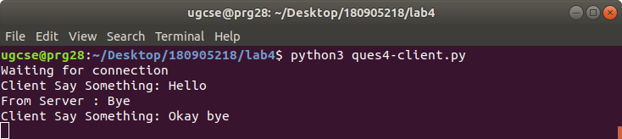

Server Program

import socket
import os
from _thread import *
ServerSocket = socket.socket()
host = '127.0.0.1'
port = 11596
ThreadCount = 0
try:
ServerSocket.bind((host, port))
except socket.error as e:
print(str(e))
print('Waitiing for a Connection..')
ServerSocket.listen(5)
def threaded_client(connection):
connection.send(str.encode('Welcome to the Server'))
while True:
data = connection.recv(2048)
print('Received from client ' + str(ThreadCount) +" : "+data.decode())
Inputs = input('Server Says: ')
if not data:
break
connection.sendall(Inputs.encode())
connection.close()
while True:
Client, address = ServerSocket.accept()
print('Connected to: ' + address[0] + ':' + str(address[1]))
start_new_thread(threaded_client, (Client, ))
ThreadCount += 1
print('Thread Number: ' + str(ThreadCount))
ServerSocket.close()

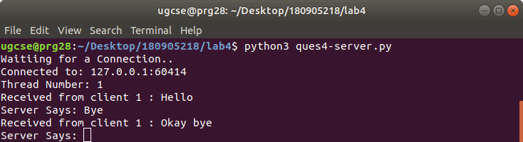

EXERCISES:

1. Write a UDP time server to display the current time and day.

Server

import socket
import time
UDPServerSocket = socket.socket(family=socket.AF_INET, type=socket.SOCK_DGRAM)
host="127.0.0.1"
port=20001
UDPServerSocket.bind((host, port))
bufferSize=1024
print("Waiting for client")
bytesAddressPair=UDPServerSocket.recvfrom(bufferSize)
address=bytesAddressPair[1]
currentTime = time.ctime(time.time())
bytesToSend=str.encode(currentTime)
UDPServerSocket.sendto(bytesToSend, address)

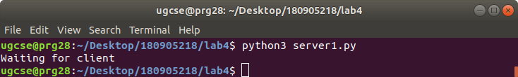

Client

import socket
UDPClientSocket = socket.socket(family=socket.AF_INET, type=socket.SOCK_DGRAM)
bufferSize=1024
serverAddressPort=("127.0.0.1", 20001)
bytesToSend=str.encode("Send time")
UDPClientSocket.sendto(bytesToSend, serverAddressPort)
msgFromServer = UDPClientSocket.recvfrom(bufferSize)
msg1="{}".format(msgFromServer[0])
msg="Client received: "+msg1[1:]
print(msg)

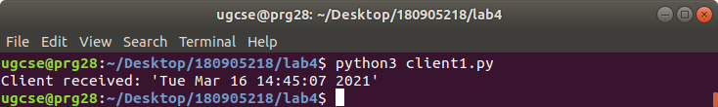

2. Write a UDP simple chat program for message sendand receive.

Server

import socket
UDPServerSocket = socket.socket(family=socket.AF_INET, type=socket.SOCK_DGRAM)
host="127.0.0.1"
port=20001
UDPServerSocket.bind((host, port))
bufferSize=1024

while(True):
print("#####Server is listening#######")
bytesAddressPair=UDPServerSocket.recvfrom(bufferSize)
message=bytesAddressPair[0]
address=bytesAddressPair[1]
print(message)
print("Do CTRL-C to exit the program")
clientMsg1="{}".format(message)
print("Server receievd: "+clientMsg1[1:])
msgFromServer=input("Type some text to send => ")
print("Sever sent: ",msgFromServer)
bytesToSend=str.encode(msgFromServer)
UDPServerSocket.sendto(bytesToSend, address)

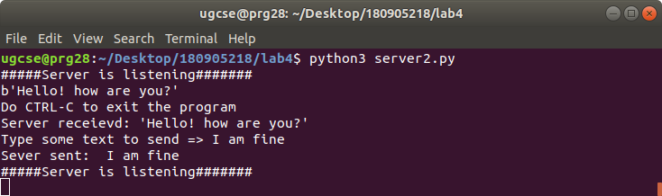

Client

import socket
i=0
while i<1:
UDPClientSocket = socket.socket(family=socket.AF_INET, type=socket.SOCK_DGRAM)
print("Do CTRL-C to exit the program")
msgFromClient=input("Type some text to send => ")
print("Client sent:",msgFromClient)
bytesToSend=str.encode(msgFromClient)
serverAddressPort=("127.0.0.1", 20001)
bufferSize=1024
UDPClientSocket.sendto(bytesToSend, serverAddressPort)
msgFromServer = UDPClientSocket.recvfrom(bufferSize)
msg1="{}".format(msgFromServer[0])
msg="Client received: "+msg1[1:]
print(msg)

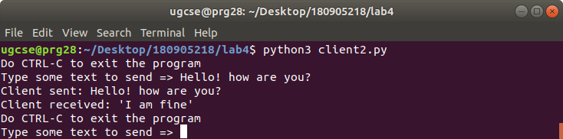

3. Write a TCP/UDP peer to peer chat system between two different machines.

Server

import socket

sock = socket.socket(socket.AF_INET, socket.SOCK_STREAM)

host = '172.16.58.48'
port = 12345

sock.bind((host, port))

sock.listen()

print("Hostname: ", socket.gethostbyname(host), "Port: ", port)
print("Waiting for incoming connections...\n")
conn, addr = sock.accept()

print("Received connection from ", addr[0], "(", addr[1], ")\n")
s_name = conn.recv(1024)
s_name = s_name.decode()

print(s_name, "has connected to the chat room\nEnter [e] to exit chat room\n")

name = input(str("Enter your name: "))
conn.send(name.encode())

print()

while True:
message = input(str("YOU : "))

if message == "[e]":
message = "Left chat room!"
conn.send(message.encode())
print("\n")
sock.close()
break

conn.send(message.encode())
message = conn.recv(1024)
message = message.decode()
print(s_name, ":", message)

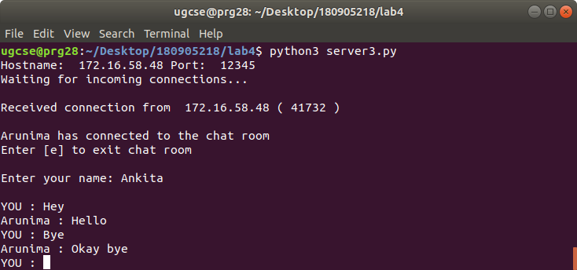

Client

import socket

host, port = input("Enter IP and port of the server: ").split()
port = int(port)

sock = socket.socket()
name = input(str("\nEnter your name: "))
print("\nTrying to connect to ", host, ":", port)

sock.connect((host, port))
print("Connected...\n")

sock.send(name.encode())
sock_name = sock.recv(1024)
sock_name = sock_name.decode()

print(sock_name, "has joined the chat room\nEnter [e] to exit chat room\n")

while True:
message = sock.recv(1024)
message = message.decode()
print(sock_name, ":", message)
message = input(str("YOU : "))

if message == "[e]":
message = "Left chat room!"
sock.send(message.encode())
print("\n")
sock.close()
break

sock.send(message.encode())
