NAME: ARUNIMA SINGH THAKUR
SECTION: C
REGISTRATION NO: 180905218
LAB NO: 1
LAB: DISTRIBUTED SYSTEMS LAB
BRANCH: COMPUTER SCIENCE
ROLL NO: 31

ASSIGN:

counter=100
miles=1000.0
name="John"
print(counter)
print(miles)
print(name)

ASSIGN(SEVERAL):

a=b=c=1
print(a)
print(b)
print(c)
a,b,c=1,2,"john"
print(a)
print(b)
print(c)

STRING:

str='Hello World!'
print(str)
print(str[0])
print(str[2:5])
print(str[2:])
print(str * 2)
print(str+"TEST")

OUTPUT(all three)

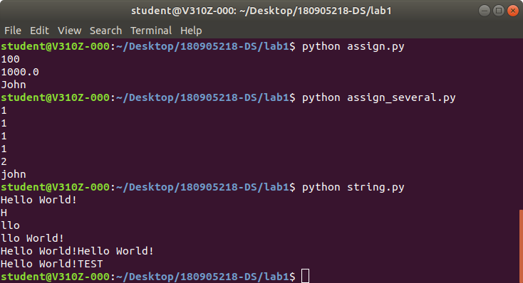
EXAMPLES:

1)

num=float(input('Enter a number:'))
if num>0:
print('pos number')
elif num==0:
print('zero')
else:
print('Neg number')

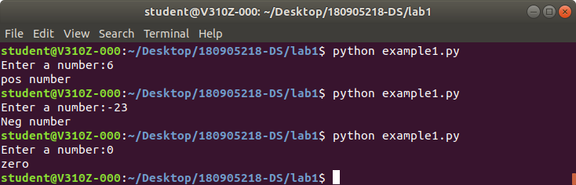
2)

x=float(input('Enter a number:'))
if x<10:
print('smaller')
if x>20:
print('bigger')
print('Finished')

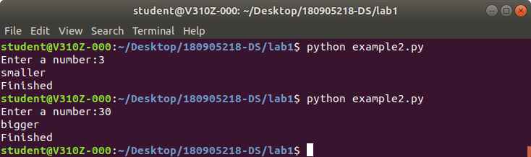

3)

x=5
print('Before 5')
if x==5:
print('this is 5')
print('still 5')
print('After 5')
print('Before 6')
if x==6:
print('this is 6')
print('After 6')

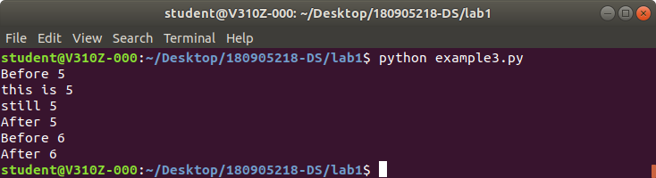

4)

x=float(input('Enter a number:'))
if x<20:
print('Below 20')
elif x<10:
print('Below 10')
else:
print('something else')

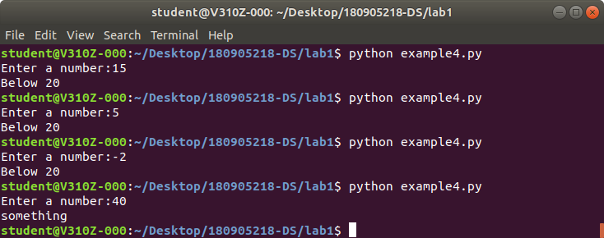
5)

x=42
if x>1:
print('above one')
if x<100:
print('less than 100')
print('All done')

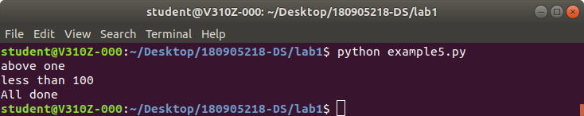

6)

age=15
b=('kid' if age<18 else 'adult')
print(b)

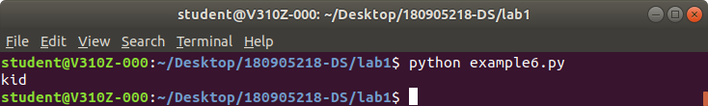

FOR LOOP EXAMPLES:

1)

for val in [5,4,3,2,1]:
print(val)
print('Done')

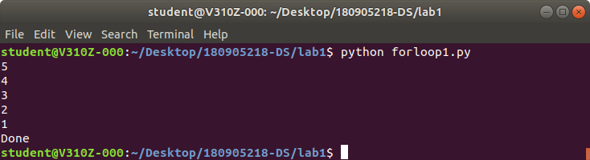

2)

stud=['Ram','Vijay','Nithya','Anu','Ramesh','Suja']
for k in stud:
print('Hello: ',k)
print('Done')

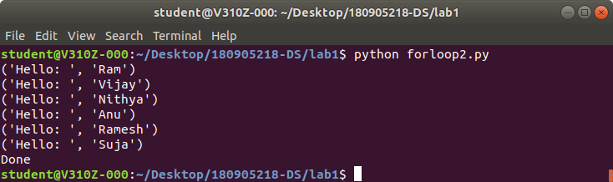

3)

for i in range(5):
print(i)
if i>2:
print('Bigger than 2')
print('Done with i',i)

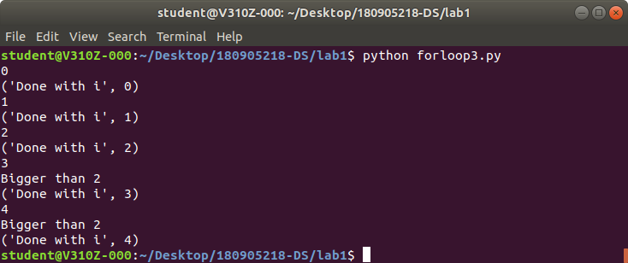

4)

x=int(input('Enter a number:'))
for i in range(1,x+1):
if x%i==0:
print(i)

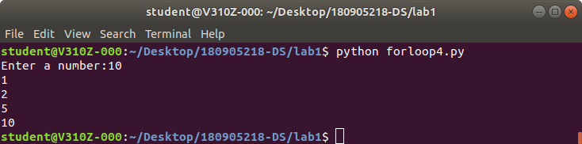
5)

from math import *
x=[9,41,12,3,74,15]
Largest=-float('inf')
for i in x:
if i>Largest:
Largest=1
print(Largest)

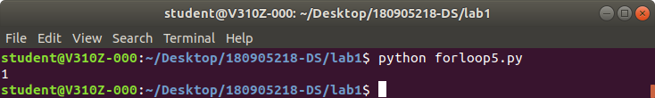

6)

from math import *
x=[9,41,12,3,74,15]
smallest=float('inf')
for i in x:
if i<smallest:
smallest=i
print(smallest)

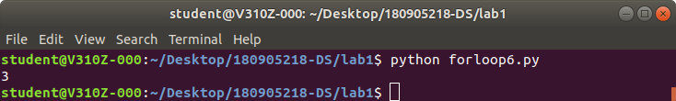
7)

x= [9, 41, 12, 3, 74, 15]
count=sum=avg=0
for i in x:
count=count+1
sum=sum+1
avg=sum/count
print(count)
print(sum)
print(avg)

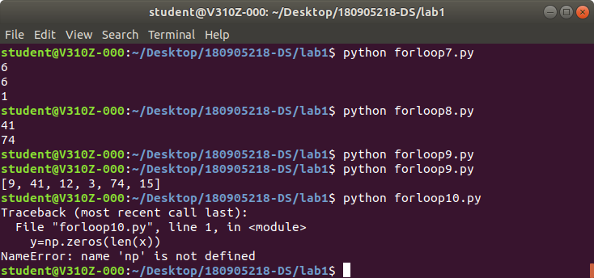

8)

x= [9, 41, 12, 3, 74, 15]
for i in x:
if i>20:
print (i)
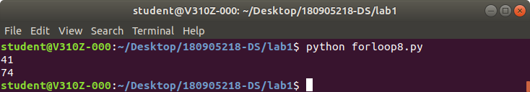

9)

x= [9, 41, 12, 3, 74, 15]
res=[]
for i in x:
if i>20:
res.append(i)
print(x)

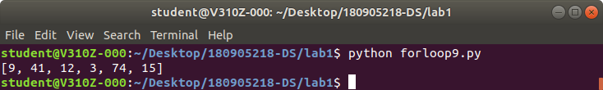

10)

y=np.zeros(len(x))
for i in range(len(x)):
if x[i]>20:
y[i]=x[i]
print(y)

