NAME: ARUNIMA SINGH THAKUR
REGISTRTION NO: 180905218
LAB NO: 2
LAB: DS
ROLL NO: 31
BATCH: C1

QUESTION 1:

Write a program to find the area of rectangle. Take input from user.

w = float(input('Please Enter the Width of a Rectangle: '))
h = float(input('Please Enter the Height of a Rectangle: '))

Area = w * h

print("\n Area of a Rectangle is: %.2f" %Area)

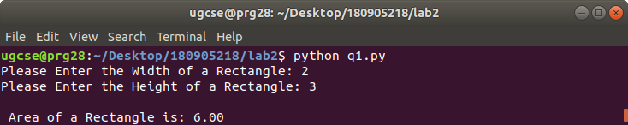

QUESTION 2:

Write a program to swap the values of two variables.

x = int(input('Please Enter value 1: '))
y = int(input('Please Enter value 2: '))

temp = x
x = y
y = temp

print('The value of x after swapping: {}'.format(x))
print('The value of y after swapping: {}'.format(y))

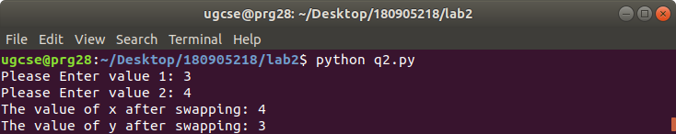

QUESTION 3:

Write a program to find whether a number is even or odd.

num = int(input("Enter a number: "))
if (num % 2) == 0:
print("{0} is Even".format(num))
else:
print("{0} is Odd".format(num))

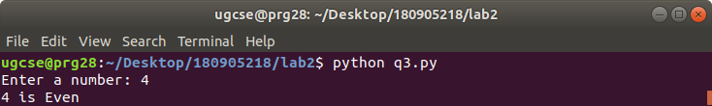
QUESTION 4:

Write a program to check the largest among the given three numbers.

num1 = float(input("Enter first number: "))
num2 = float(input("Enter second number: "))
num3 = float(input("Enter third number: "))

if (num1 >= num2) and (num1 >= num3):
largest = num1
elif (num2 >= num1) and (num2 >= num3):
largest = num2
else:
largest = num3

print("The largest number is", largest)

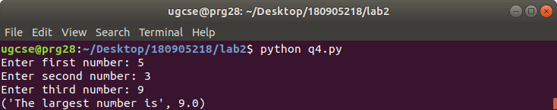

QUESTION 5:

Write a program to demonstrate while loop with else.

n = 5
while n > 0:
n = n - 1
if n == 2:
break
print(n)
else:
print("Loop is finished")

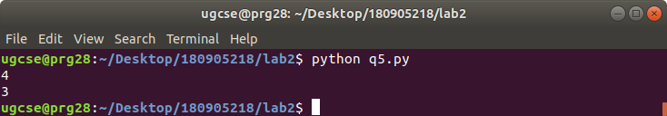

QUESTION 6:

Write a program to print the prime numbers for a user provided range.

upper = int(input("Enter upper range: "))
lower = int(input("Enter lower range: "))

print("Prime numbers between", lower, "and", upper, "are:")

for num in range(lower, upper + 1):
# all prime numbers are greater than 1
if num > 1:
for i in range(2, num):
if (num % i) == 0:
break
else:
print(num)
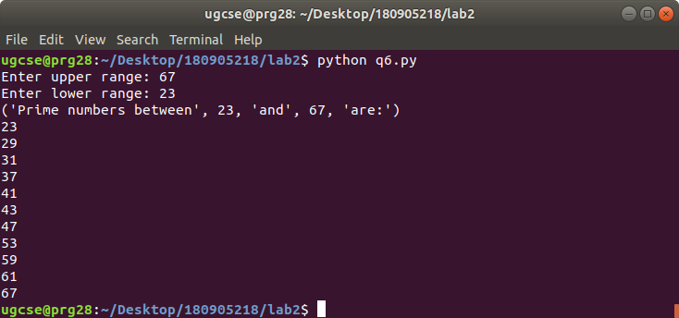
QUESTION 7:

Write a program to demonstrate List functions and operations.

arr = []
print(f"List: {arr}\n\nAppend 1,1,2,3: ")
arr.append(1)
arr.append(1)
arr.append(3)
arr.append(2)
print(f"{arr}\n\nCount of 1: {arr.count(1)}")
print(f"\nIndex of 2: {arr.index(2)}")
arr.reverse()
print(f"\nReverse list: {arr}")
arr.sort()
print(f"\nSort list: {arr}")
print(f"\nClear list")
arr.clear()
print(f"{arr}")

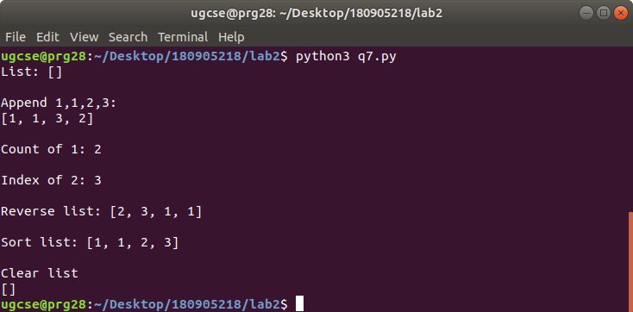

QUESTION 8:

Consider the tuple(1,3,5,7,9,2,4,6,8,10). Write a program to print half its values in one line and the other half in the next line.

tp = (1,3,5,7,9,2,4,6,8,10)
tp1 = tp[:5]
tp2 = tp[5:]
print tp1
print tp2

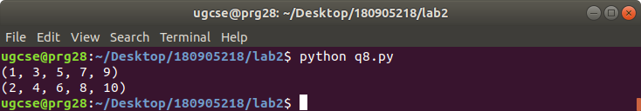

QUESTION 9:

Consider the tuple (12, 7, 38, 56, 78 ). Write a program to print another tuple whose values are even number in the given tuple.

thistuple=(12, 7, 38, 56, 78 )
t=list(thistuple)
x=[]
i=0
while i<len(thistuple):
if thistuple[i]%2==0:
x.append(thistuple[i])
i+=1

y=tuple(x)
i=0
while i<len(y):
print y[i]
i+=1

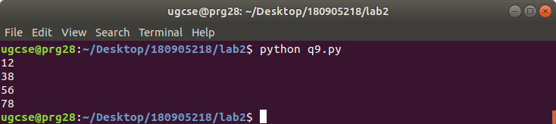

QUESTION 10:

Write a Python program to print negative Numbers in a List using for loop. Eg. [11, -21, 0, 45, 66, -93].

x=[11, -21, 0, 45, 66, -93]

for i in x:
if i<0:
print i

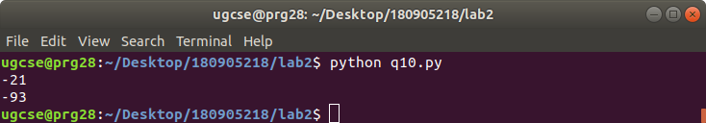

QUESTION 11:

Write a program to print negative Numbers in a List using while loop.

x=[11, -21, 0, 45, 66, -93]

i=0
while i<len(x):
if x[i]<0:
print x[i]
i+=1

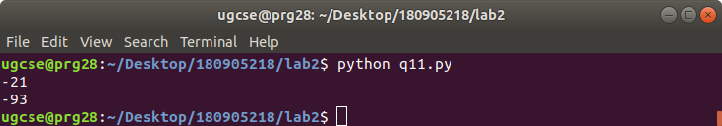
QUESTION 12:

Write a Python program to count positive and negative numbers in a List.

list1 = [10, -21, 4, -45, 66, -93, 1]

pos_count, neg_count = 0, 0

for num in list1:

# checking condition
if num >= 0:
pos_count += 1

else:
neg_count += 1

print("Positive numbers in the list: ", pos_count)
print("Negative numbers in the list: ", neg_count)

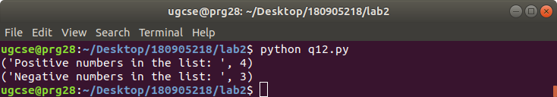

QUESTION 13:

Write a Python program to remove all even elements from a list .

list = [11, 22, 33, 44, 55]

print "Original list:"
print list

for i in list:
if(i%2 == 0):
list.remove(i)

print "list after removing EVEN numbers:"
print list

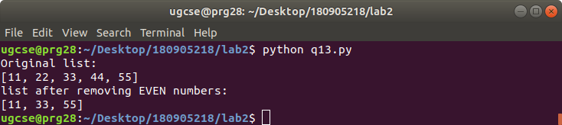

QUESTION 14:

Define a dictionary containing Students data {Name, Height, Qualification}.
a) Convert the dictionary into DataFrame
b) Declare a list that is to be converted into a new column (Address}
c) Using 'Address' as the column name and equate it to the list and display the result.

import pandas as pd
data = [['Dinesh',178,"B.Tech"],['Nithya',128,"M.Tech"],['Raji',135,"B.Tech"]]
df = pd.DataFrame(data,columns=['Name','Height','Qualification'])
address=["Ranchi","Delhi","Mumbai"]
df["Address"]=address
print df

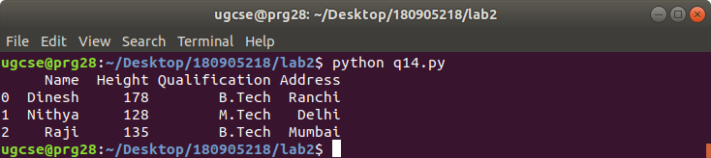

QUESTION 15:

Define a dictionary containing Students data {Name, Height, Qualification}.
a) Convert the dictionary into DataFrame
b) Use DataFrame.insert() to add a column and display the result.
import pandas as pd
data = [['Dinesh',178,"B.Tech"],['Nithya',128,"M.Tech"],['Raji',135,"B.Tech"]]
df = pd.DataFrame(data,columns=['Name','Height','Qualification'])
df.insert(3,"roll",[3,5,6])
print df
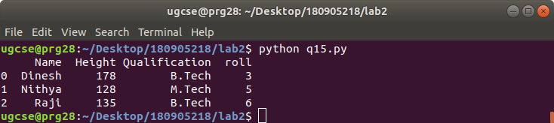
SAMPLE QUESTIONS:

QUESTION 1:

#Panda Series with sum,max and min functions
import pandas as pd
import numpy as np
s=pd.Series([3,9,-2,10,5])
print("Total Sum: ",s.sum())
print("Minimum: ",s.min())
print("Maximum: ",s.max())

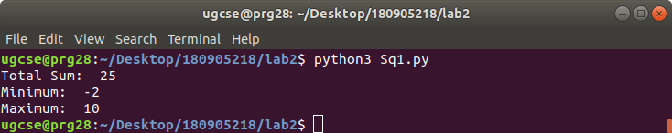

QUESTION 2:
#Creating a Data Frame
import pandas as pd
data=[['Dinesh',10],['Nithya',12],['Raji',13]]
df=pd.DataFrame(data,columns=['Name','Age'])
print("Normal Dataframe")
print(df)

print("\nIndexed Data Frame")
data = {'Name':['Kavitha', 'Sudha', 'Raju','Vignesh'],'Age':[28,34,29,42]}
df = pd.DataFrame(data, index=['rank-1','rank-2','rank-3','rank-4'])
print(df)

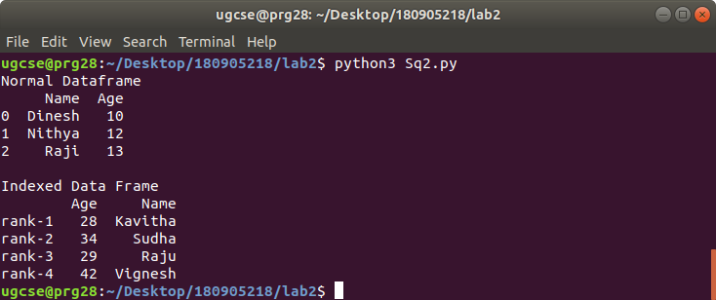

QUESTION 3:

#Create Dataframe using Dictionary
import pandas as pd
import numpy as np
df1=pd.DataFrame({
'A':pd.Timestamp('20130102'),
'B':np.array([3,2,1,3,4,5,6,7,43,4]),
'C':pd.Categorical(['Male','Female','Male','Female','Male','Female','Male','Female','Male','Female'])
})
print(df1)
print("Number of Rows and Columns in data frame using shape tuple: ",df1.shape)
print("Display first five records: head()")
print(df1.head())
print("Display last five records: tail()")
print(df1.tail())

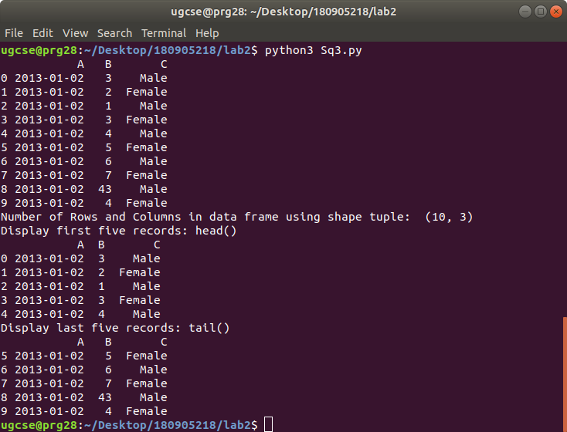

QUESTION 4:

#Creating Dataframe using randomn values
import pandas as pd
import numpy as np
#generates 100 randomn days
dates=pd.date_range('20130101',periods=100)
df=pd.DataFrame(np.random.randn(100,4),index=dates,columns=list('ABCD'))
print(df)
print("First five records of data frame: head()")
print(df.head())
print("Last five records of data frame: tail()")
print(df.tail())
print("To print the list of index: index tuple object")
print(df.index)
print("To view column names: columns tuple")
print(df.columns)
print("Sorting by Axis: ")
print(df.sort_index(axis=1,ascending=False))
print("Slicing the rows: Displaying first 3 rows")
print(df[0:3])
print("Slicing the rows with index range: 2013-01-05 TO 2013-01-10")
print(df['20130105':'20130110'])
print("Slicing with row and Column Index: df.iloc[0]- fetches first row")
print("Third row with df.iloc[2]\n",df.iloc[2])
print('Selecting a single column of A,B,C D: "A"\n',df['A'])
print('Selecting more than one column of A,B,C D: "A" & "B"\n',df[['A','B']])
print('Selecting more than one column of A,B,C D: "A" & "B" & "C"\n',df[['A','B','C']])
print("Selecting 2 or more columns with fixed number of rows\n",df[['A','B','C']][:5])

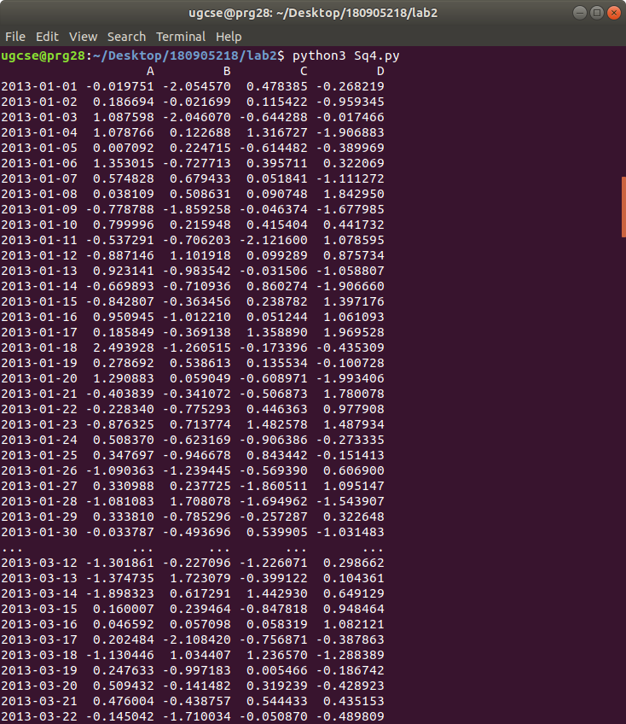
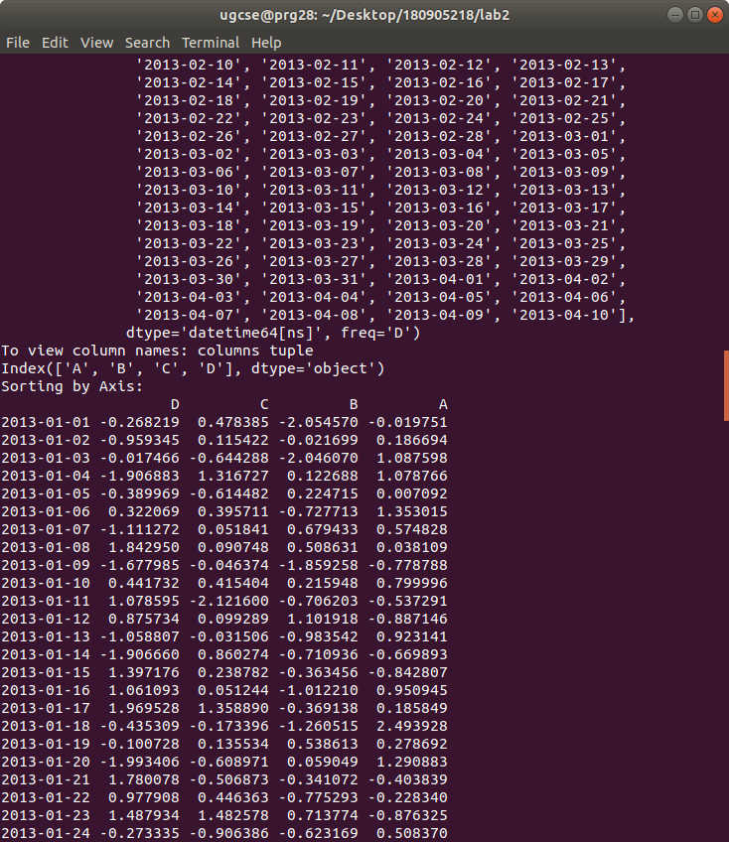
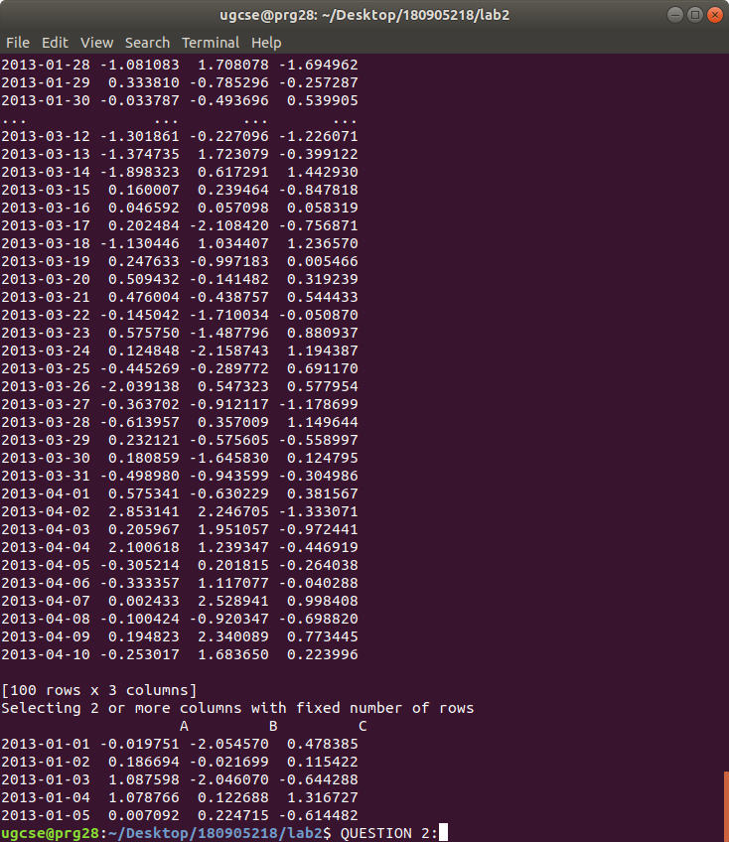
QUESTION 5:

#Boolean Indexing of Dataframes
import pandas as pd
import numpy as np
dates=pd.date_range('20210301',periods=10)
df=pd.DataFrame(np.random.randn(10,5),index=dates,columns=list('ABCDE'))
print("All Records with Value in column A as positive:\n",df[df.A>0])
print("Adding a sixth column:")
df['F']=['Male','Female','Male','Female','Male','Female','Male','Female','Male','Female']
print(df)
print("Replacing all values in a given column:\n")
df.loc[:,'D']=np.array([5]*len(df))
print("Replaced COLUMN 'D' with all 5\n")
print(df)
print("sorting the values by Column B:\n",df.sort_values(by='B'))

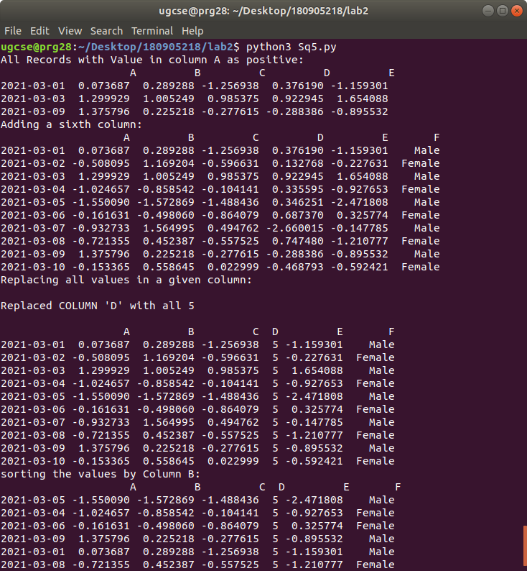
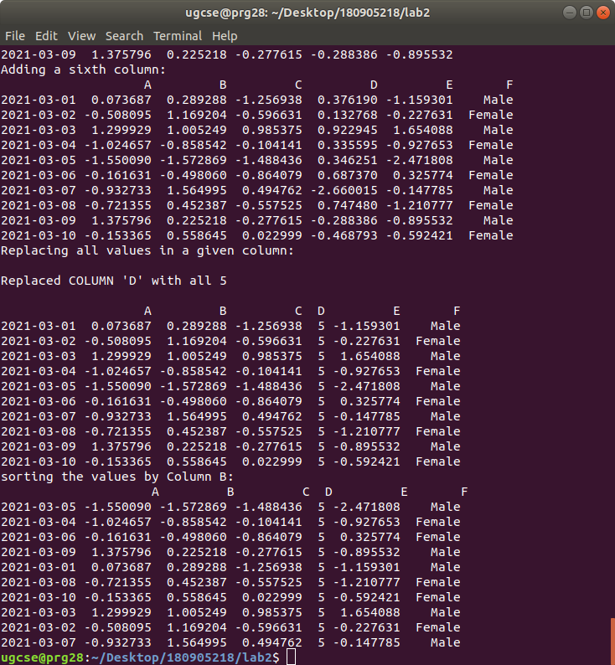
QUESTION 6:

#Deleting rows and columns in Dataframe
import pandas as pd
import numpy as np
df=pd.DataFrame(np.random.randn(10,3),index=list('abcdefghij'),columns=list('ABC'))
print("Original Dataframe:\n",df)
df.drop('A',axis=1,inplace=True)
print("Dropping column A:\n",df)
df.drop('e',axis=0,inplace=True)
print('Dropping 5th row: using index- "e"\n',df)

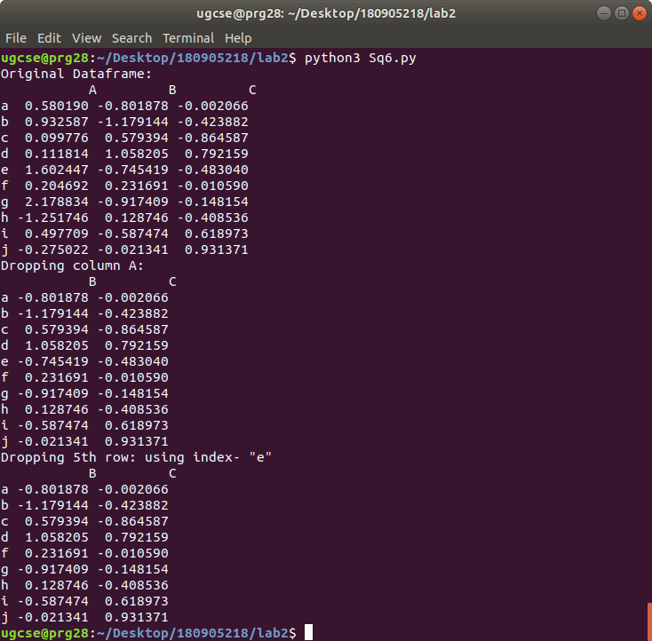

QUESTION 7:

#Data frame concatenation
import pandas as pd
import numpy as np
df1=pd.DataFrame(np.random.randn(10,5),index=list('abcdefghij'),columns=list('ABCDE'))
df2=pd.DataFrame(np.random.randn(10,3),index=list('abcdefghij'),columns=list('ABC'))
print("Data Frame 1: ",df1.shape)
print("Data Frame 2: ",df2.shape)
print("Horizontal Concatenation:")
df_new=pd.concat([df1,df2],axis=1)
print('Dimensions of new Horizontal Data Frame: ',df_new.shape)
print("\nVertical Concatenation")
df_vert=pd.concat([df1,df2],axis=0)
print('Dimensions of new Vertical Data Frame: ',df_vert.shape)
print("Absent values substituted by NaN:\n",df_vert)

