NAME: Arunima Singh Thakur
SECTION: C
ROLL NO: 31
REGISTRATION: 180905218

SAMPLE QUESTION

#include "mpi.h"
#include <stdio.h>

int main(int argc, char *argv[])
{
int rank,size,N,A[10],B[10],c,i;
MPI_Init(&argc,&argv);
MPI_Comm_rank(MPI_COMM_WORLD,&rank);
MPI_Comm_size(MPI_COMM_WORLD,&size);

if(rank==0)
{
N=size;
fprintf(stdout,"Enter %d values: \n",N);
fflush(stdout);
for(i=0;i<N;i++)
scanf("%d",&A[i]);
}
MPI_Scatter(A,1,MPI_INT,&c,1,MPI_INT,0,MPI_COMM_WORLD);
fprintf(stdout,"I have received %d in process %d\n",c,rank);
fflush(stdout);

c=c*c;
MPI_Gather(&c,1,MPI_INT,B,1,MPI_INT,0,MPI_COMM_WORLD);

if(rank==0)
{
fprintf(stdout,"The Result gathered in the root \n");
fflush(stdout);
for(i=0;i<N;i++)
fprintf(stdout,"%d\t",B[i]);
fflush(stdout);
fprintf(stdout,"\n");
}

MPI_Finalize();
return 0;
}

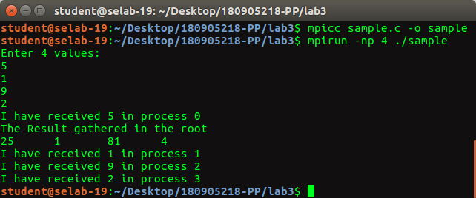
Q1: Factorial using n processes

#include <stdio.h>
#include <mpi.h>

int factorial(int x)
{
int ans = 1;
for(int i = x; i > 0; i--)
ans = ans*i;
return ans;
}

void main(int argc, char* argv[])
{
int rank,size, c;
int N;
int sum=0;
int a[N], b[N];

MPI_Init(&argc,&argv);
MPI_Comm_size(MPI_COMM_WORLD,&size);
MPI_Comm_rank(MPI_COMM_WORLD,&rank);

if(rank == 0)
{
N=size;
printf("Enter %d values: ",N);
for(int i=0; i<N; i++)
{
scanf("%d", &a[i]);
}
}

MPI_Scatter(a, 1, MPI_INT, &c, 1, MPI_INT, 0, MPI_COMM_WORLD);

c = factorial(c);

MPI_Gather(&c, 1, MPI_INT, b, 1, MPI_INT, 0, MPI_COMM_WORLD);

if(rank == 0)
{
for(int i=0; i<N; i++)
{
printf("Root recieved %d from process %d \n", b[i], i);
sum+=b[i];
}
printf(“The sum of all the factorials: %d”,sum);
}

MPI_Finalize();

}

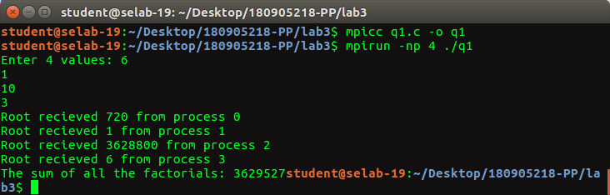

Q2: Average of NxM array

#include <stdio.h>
#include <mpi.h>

float avg(int *x, int M)
{
float ans = 0.0;
for(int i = 0; i < M; i++)
ans = ans+x[i];
return ans/M;
}

void main(int argc, char* argv[])
{
int rank,size;
float c;
int N;
int M;

MPI_Init(&argc,&argv);
MPI_Comm_size(MPI_COMM_WORLD,&size);
MPI_Comm_rank(MPI_COMM_WORLD,&rank);

if(rank == 0)
{
N=size;
printf("Enter value of M: ");
scanf("%d", &M);
}

MPI_Bcast(&M, 1, MPI_INT, 0, MPI_COMM_WORLD);

int b[M];
float x[N];

int a[N*M];

if(rank == 0)
{
printf("Enter %d values: ", N*M);
for(int i=0; i<N*M; i++)
{
scanf("%d", &a[i]);
}

}

MPI_Scatter(a, M, MPI_INT, b, M, MPI_INT, 0, MPI_COMM_WORLD);

c = avg(b, M);

printf("value of average in rank %d : %f \n", rank, c);

MPI_Gather(&c, 1, MPI_FLOAT, x, 1, MPI_FLOAT, 0, MPI_COMM_WORLD);

if(rank == 0)
{
float ans = 0.0;
for(int i = 0; i < N; i++)
ans = ans+x[i];
ans = ans/N;
printf("\nFinal Avg = %f \n", ans);
}

MPI_Finalize();

}

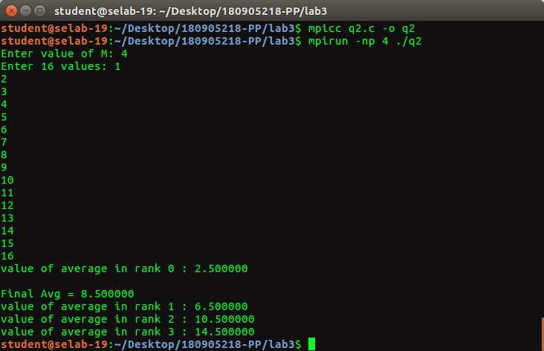

Q3: Non vowels

#include <mpi.h>
#include <stdio.h>
#include <stdlib.h>
#include <string.h>

int main(int argc, char *argv[]){
int rank, size, len, l_v_c = 0, t_v_c = 0, *p_v_c;
char str[100], recvStr[100];

MPI_Init(&argc, &argv);
MPI_Comm_rank(MPI_COMM_WORLD, &rank);
MPI_Comm_size(MPI_COMM_WORLD, &size);
MPI_Status status;

if(rank == 0){
printf("Enter a string of length n * %d: ", size);
scanf("%s", str);
len = strlen(str);

if(len%size != 0){
printf("Invalid string.\n");
MPI_Abort(MPI_COMM_WORLD, EXIT_FAILURE);
}
}

MPI_Bcast(&len, 1, MPI_INT, 0, MPI_COMM_WORLD);

MPI_Scatter(str, len/size, MPI_CHAR, recvStr, len/size, MPI_CHAR, 0, MPI_COMM_WORLD);

for(int i = 0; i < len/size; i++){
char ch = recvStr[i];
if(ch != 'a' && ch != 'e' && ch != 'i' && ch != 'o' && ch != 'u' &&
ch != 'A' && ch != 'E' && ch != 'I' && ch != 'O' && ch != 'U') {
l_v_c++;
}
}

fprintf(stdout, "Rank %d:\t non-vowels count = %d\n", rank, l_v_c);
fflush(stdout);

p_v_c = (int*)malloc(size*sizeof(int));
MPI_Gather(&l_v_c, 1, MPI_INT, p_v_c, 1, MPI_INT, 0, MPI_COMM_WORLD);

if(rank == 0){
for(int i = 0; i < size; i++){
t_v_c += p_v_c[i];
}
fprintf(stdout, "Rank %d:\t total non-vowels = %d\n", rank, t_v_c);
fflush(stdout);
}
MPI_Finalize();
return 0;
}
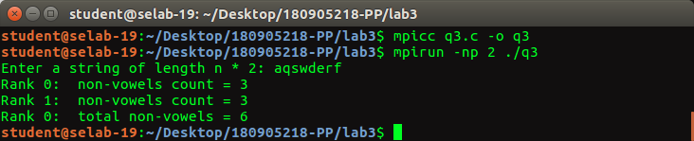

Q4: Alternating string concat

#include <stdio.h>
#include "mpi.h"
#include <string.h>
int main(int argc, char *argv[])
{
MPI_Init(&argc,&argv);
int rank,size;
MPI_Status status;
MPI_Comm_rank(MPI_COMM_WORLD,&rank);
MPI_Comm_size(MPI_COMM_WORLD,&size);
int m;
char s1[100],c1[100],s2[100],c2[100],l[200],ans[200];
if(rank==0){
fprintf(stdout, "Enter a string of length %d*n: ", size);
fflush(stdout);
scanf("%s",s1);
fprintf(stdout, "Enter a string of length %u: ", strlen(s1));
fflush(stdout);
scanf("%s",s2);
m=strlen(s1)/size;
}
MPI_Bcast(&m,1,MPI_INT,0,MPI_COMM_WORLD);
MPI_Scatter(s1,m,MPI_CHAR,c1,m,MPI_CHAR,0,MPI_COMM_WORLD);
MPI_Scatter(s2,m,MPI_CHAR,c2,m,MPI_CHAR,0,MPI_COMM_WORLD);

c1[m]='\0';
c2[m]='\0';
for(int i=0;i<2*m;i+=2){
l[i]=c1[i/2];
l[i+1]=c2[i/2];
}
l[2*m]='\0';
fprintf(stdout, "Recieved '%s' and '%s' by Rank %d\n",c1,c2,rank);
fflush(stdout);
MPI_Gather(l,2*m,MPI_CHAR,ans,2*m,MPI_CHAR,0,MPI_COMM_WORLD);
if(rank==0){
fprintf(stdout, "Answer: %s in Rank %d\n",ans,rank);
fflush(stdout);
}
MPI_Finalize();
return 0;
}

