NAME: ARUNIMA SINGH THAKUR
SECTION: C
LAB NO: 3
LAB: DS
REGISTRATION NO: 180905218
ROLL NO: 31

QUESTION 1:

Write a program to find the factors of a given number (get input from user) using for loop.

x=int(input("Enter a number: "))
def print_factors(x):
print("The factors of",x,"are:")
for i in range(1,x+1):
if x % i == 0:
print(i)

print_factors(x)

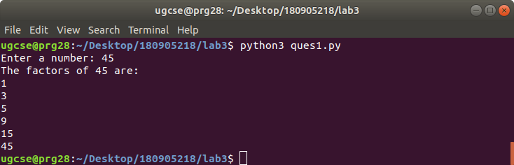

QUESTION 2:

Find the sum of columns and rows using axis.

import numpy as numpy
def get_input():
r=int(input("Enter the number of rows: "))
c=int(input("Enter the number of columns: "))
arr=[]
for i in range(r):
arr.append([int(x) for x in input(f"Enter {c} numbers for row {i}: ").split()])
return numpy.array(arr)

def main():
arr=get_input()
print("Matrix: ")
print(arr)
print("Sum of columns: ")
print(arr.sum(axis=0))
print("Sum of rows: ")
print(arr.sum(axis=1))

if __name__ == "__main__":
main()

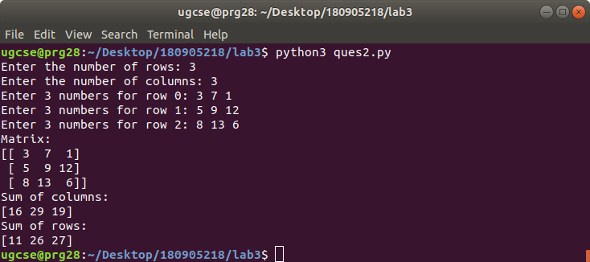
QUESTION 3:

Operations on Arrays (use numpy wherever required):
- Create array from list with type float
- Create array from tuple
- Creating a 3X4 array with all zeros
- Create a sequence of integers from 0 to 20 with steps of 5
- Reshape 3X4 array to 2X2X3 array
- Find maximum and minimum element of array, Row wise max and min, column wise max and min and sum of elements. (Use functions max(), min(), sum())

import numpy as np

def a():
arr = [0, 1, 2, 3, 4, 5, 6, 7, 8, 9]
print("A:\nList:")
print(arr)
print("Numpy array:")
print(np.array(arr, dtype=float))
print()

def b():
tpl = (0, 1, 2, 3, 4, 5, 6, 7, 8, 9)
print("B:\nTuple:")
print(tpl)
print("Numpy array:")
print(np.array(tpl))
print()

def c():
print("C:\nNumpy array:")
print(np.zeros((3,4)))

def d():
print("D:\nSequence:")
print(np.arange(0, 20, 5))

def e():
arr = np.random.randint(10, size=(3,4))
print("E:\nOriginal array:")
print(arr)
print("Modified array:")
print(arr.reshape(2, 2, 3))

def f():
arr = np.random.randint(10, size=(3,4))
print("F:\nArray:")
print(arr)
print(f"Overall : Max: {arr.max()}\t Min: {arr.min()}\t\t Sum: {arr.sum()}")
print(f"Col-wise: Max: {arr.max(axis=0)} Min: {arr.min(axis=0)}\t Sum: {arr.sum(axis=0)}")
print(f"Row-wise: Max: {arr.max(axis=1)}\t Min: {arr.min(axis=1)}\t Sum: {arr.sum(axis=1)}")

def main():
a()
print()
b()
print()
c()
print()
d()
print()
e()
print()
f()

if __name__ == "__main__":
main()

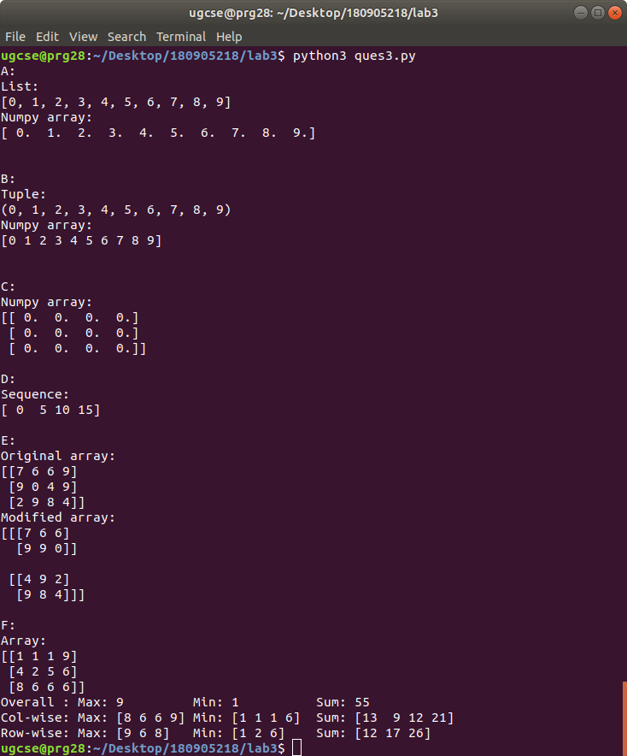
QUESTION 4:

Write a program to transpose a given matrix.

import numpy as numpy

def get_input():
r=int(input("Enter the number of rows: "))
c=int(input("Enter the number of columns: "))
arr=[]
for i in range(r):
arr.append([int(x) for x in input(f"Enter {c} numbers for row {i}: ").split()])
return numpy.array(arr)

def main():
arr=get_input()
print("Original Matrix: ")
print(arr)
print("Transposed Matrix: ")
print(arr.transpose())

if __name__ == "__main__":
main()

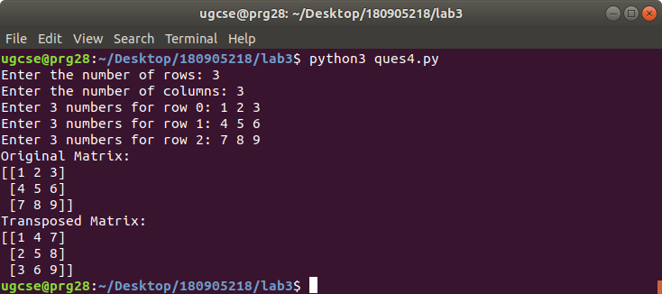

QUESTION 5:

Write a program to add two matrices.

import numpy as numpy

def get_input():
r=int(input("Enter the number of rows: "))
c=int(input("Enter the number of columns: "))
arr=[]
for i in range(r):
arr.append([int(x) for x in input(f"Enter {c} numbers for row {i}: ").split()])
return numpy.array(arr)

def main():
arr1=get_input()
print("Matrix 1: ")
print(arr1)
arr2=get_input()
print("Matrix 2: ")
print(arr2)
print("Sum of the two matrices: ")
print(arr1+arr2)

if __name__ == "__main__":
main()
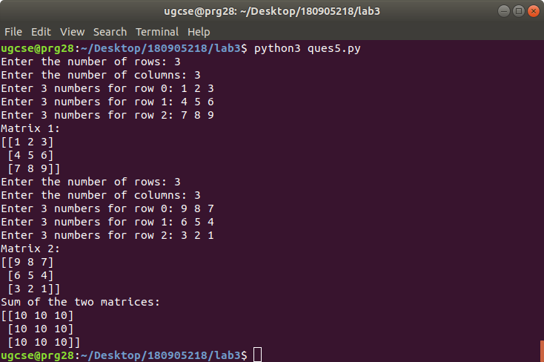

QUESTION 6:

Write a program to find element wise product between two matrices.

import numpy as numpy

def get_input():
r=int(input("Enter the number of rows: "))
c=int(input("Enter the number of columns: "))
arr=[]
for i in range(r):
arr.append([int(x) for x in input(f"Enter {c} numbers for row {i}: ").split()])
return numpy.array(arr)

def main():
arr1=get_input()
print("Matrix 1: ")
print(arr1)
arr2=get_input()
print("Matrix 2: ")
print(arr2)
print("Element wise product between two matrices: ")
print(arr1*arr2)

if __name__ == "__main__":
main()

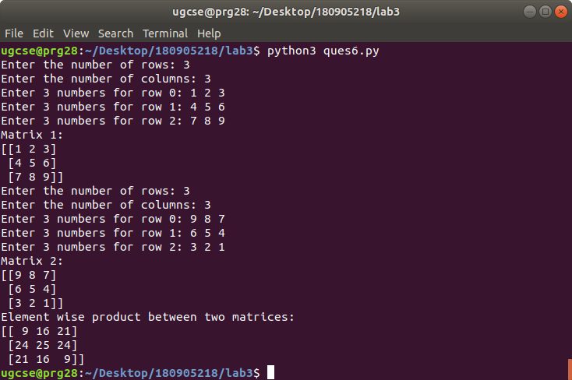
SAMPLE QUESTIONS:

QUESTION 1:

#Array Creation
import numpy as np
A=np.array([2,5,10])
print("Integer Array 'A': ",A)
print("Data Type of array created of: [2,5,10]: dtype= ",A.dtype)
B=np.array([2.3,5.65,10])
print("Floating Array 'B': ",B)
print("Data Type of array created of: [2.3,5.65,10]: dtype= ",B.dtype)

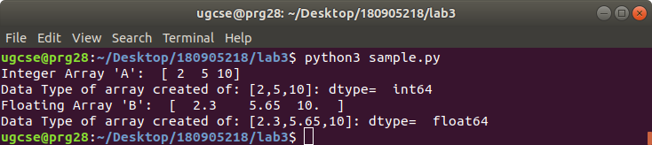

QUESTION 2:
#Creating 2D arrays
import numpy as np
print("Creating Hard-Coded arrays:\n",np.array([(3,4,5),(6,7,8)]))
print("Creating Array of only Zeroes 2*4:\n",np.zeros((2,4)))
print("Creating Array of only Ones 3*3:\n",np.ones((3,3)))

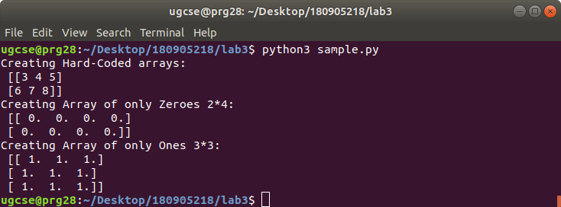
QUESTION 3:

#Creating Sequences of data
import numpy as np
print("Integer Sequence from 10-30 with 5 step intervals: ",np.arange(10,30,5))
print("Float Sequence from 0-2 with 0.3 step intervals: ",np.arange(0,2,0.3))

#Creating Sequence by giving total number of elements
print("Sequence from 0-2 divided in 9 intervals: ",np.linspace(0,2,9))

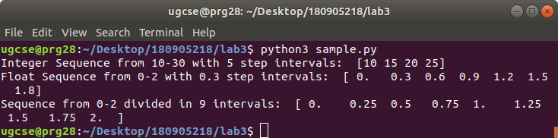
QUESTION 4:

#usage of random functions
import random
print('pick one number from the list randomly: ',random.choice([1,2,3,4,5]))
print('pick one character from the string randomly: ',random.choice('python'))
print('pick one integer between 25 to 50: ',random.randrange(25,50))
print('pick one integer between 25 to 50 with step size of 2: ',random.randrange(25,50,2))
print('pick a random number between 0 to 1: ',random.random())
print('pick a floating point number between 5 to 10: %.2f'%(random.uniform(5,10)))
A=random.shuffle([1,2,3,4,5])
print('shuffle the list elements: ',A)
print("get same random value during every execution: ",random.seed(10))

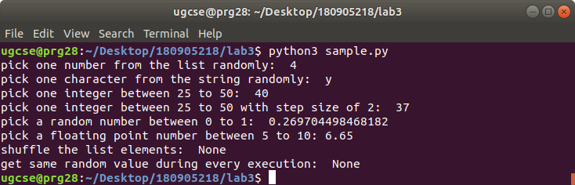

QUESTION 5:

#2-Dimensional Array(Matrix) and 3-Dimensional Arrays
import numpy as np
a=np.arange(15).reshape(3,5)
print("Print 2 D array in range 0-14 with 3*5 Dimensions using arange() and reshape:\n",a)
print("To get the Size of matrix: shape tuple ",a.shape)
a.T;
print("Transpose matrix with size: ",a.T.shape)
print(a.T)

a=np.arange(24).reshape(2,3,4)
print("Print 3D array in range 0-23 with 2*3*4 Dimensions using arange() and reshape:\n",a)
print("To get the Size of matrix: shape tuple ",a.shape)

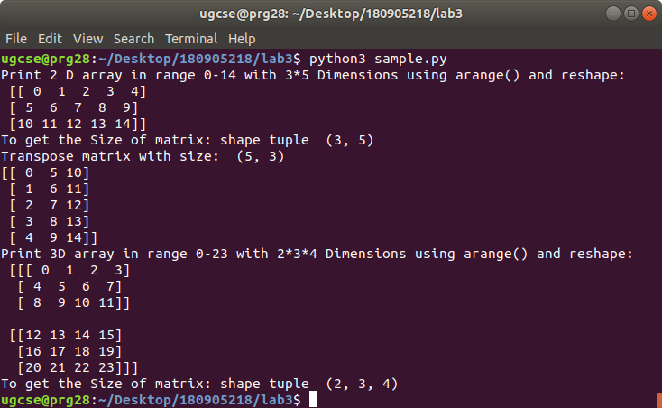

QUESTION 6:

#Array Operations
import numpy as np
a = np.array( [20,30,40,50] )
print("A: ",a)
b = np.arange( 4 )
print("B: ",b)
c = a-b
print("A-B: ",c)
print("B*2: ",b*2)
print("Square of elements in B: ",b*2)
print("Multiply 10 by sin of all values in A: ",10*np.sin(a))
print("Boolean array for checking values in A<35",a<35)

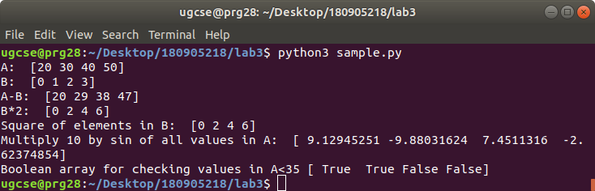
QUESTION 7:

# Matrix Operations
import numpy as np
A= np.array([[1,2],[3,4]])
B= np.array([[2,0],[0,1]])
print("A:\n",A)
print("B:\n",B)
print("Element Wise Product: A*B\n",A*B)
print("Matrix Produt using ** np.dot **:\n",np.dot(A,B))

C=np.arange(12).reshape(3,4)
print("Print 2 D array in range 0-11 with 3*4 Dimensions using arange() and reshape:\n",C)
print("Sum of each column axis=0: ",C.sum(axis=0))
print("Sum of each row axis=1: ",C.sum(axis=1))

arr=np.arange(10);
print("1-D Array from 0-9:\n",arr)
print("All Elements of arr raised to cube: ",arr**3)
print("Slicing array from index 2 to 5: ",arr[2:5])

b=np.arange(20).reshape(5,4)
print("Array b:\n",b)
print("Fetching element at index 3,4: ",b[2,3])
print("Fetching second column: ",b[0:5,1])
print("\nFetching each row of matrix:")
for row in b:
print(row)
print("\nDisplaying all elements as 1-D array:")
for element in b.flat:
print(element, sep=" ", end=" ")
print("\n")

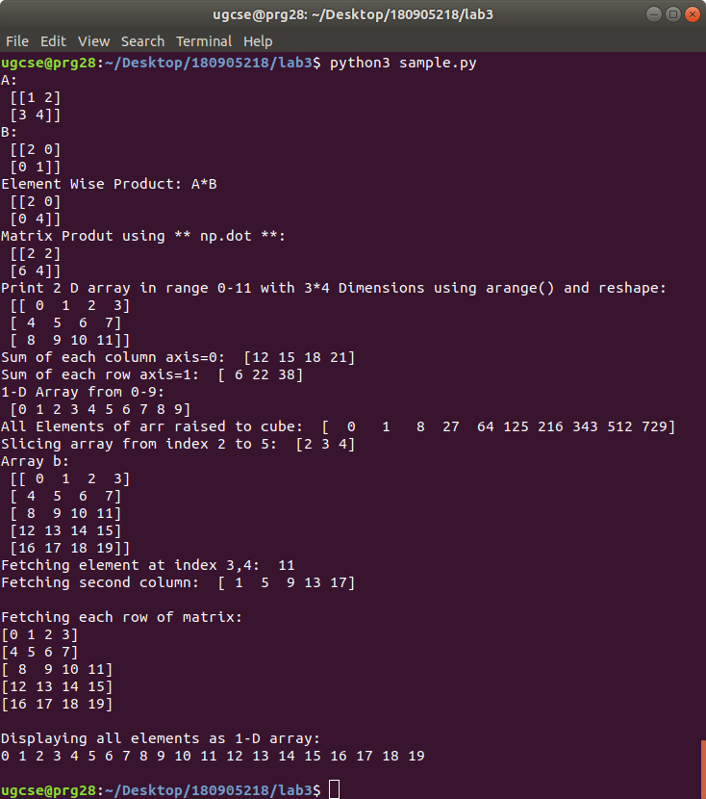

QUESTION 8:

#Reshaping The Matrix
import numpy as np
from numpy import newaxis
b=np.arange(12).reshape(3,4)
print("Reshaping B as flat array: ",b.ravel())
b=b.ravel()
print("Reshaping into 2D Matrix of 4*3:\n",b.reshape(4,3))

a=np.array([2,4])
b=np.array([3,8])
print("Column stack of a and b",a,b,np.column_stack((a,b)),sep="\n")
print("Concatenation of a and b: hstack()",a,b,np.hstack((a,b)),sep="\n")
print("using hstack() for column stack:\n",np.hstack((a[:, newaxis],b[:, newaxis])))

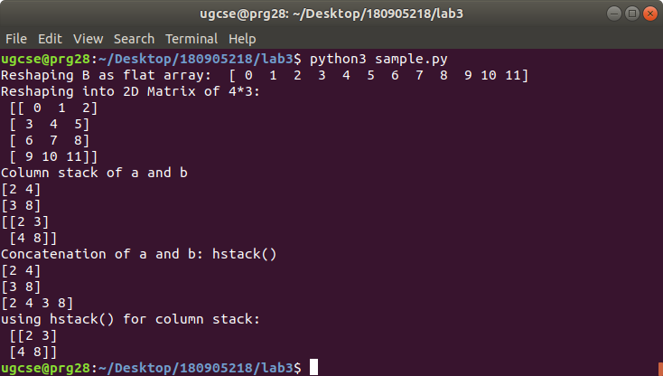
QUESTION 9:

#Indexing array with array of indices
import numpy as np
a=np.arange(12)**2
i=[1,1,3,8,5]
print("Index A's Elements using index array i: ",a[i])
j=np.array([[3,4],[9,7]])
print("Using Bi-Dimensional index on A: ",a)
print("Prints 3,4,9 and 7 index in same shape as bi-dimesnional array")
print(a[j])

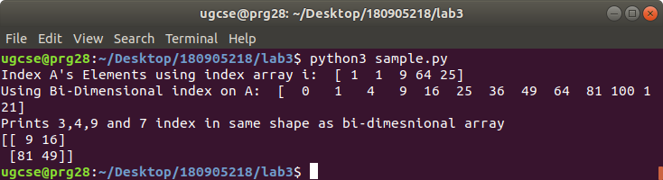
QUESTION 10:

#Usage of for loop mapping by value
#calculate sum of all elements in a 2D numpy array
import numpy as np
a=np.array(((3,2,9),(1,6,7)))
s1=0;
for row in a:
for col in row:
s1=s1+col
print(s1)

#Usage of for loop mapping by index
#calculate sum of all elements in a 2D numpy array (iterate over range)
s=0;
for i in range(a.shape[0]):
for j in range(a.shape[1]):
s=s+a[i,j]
print(s)

