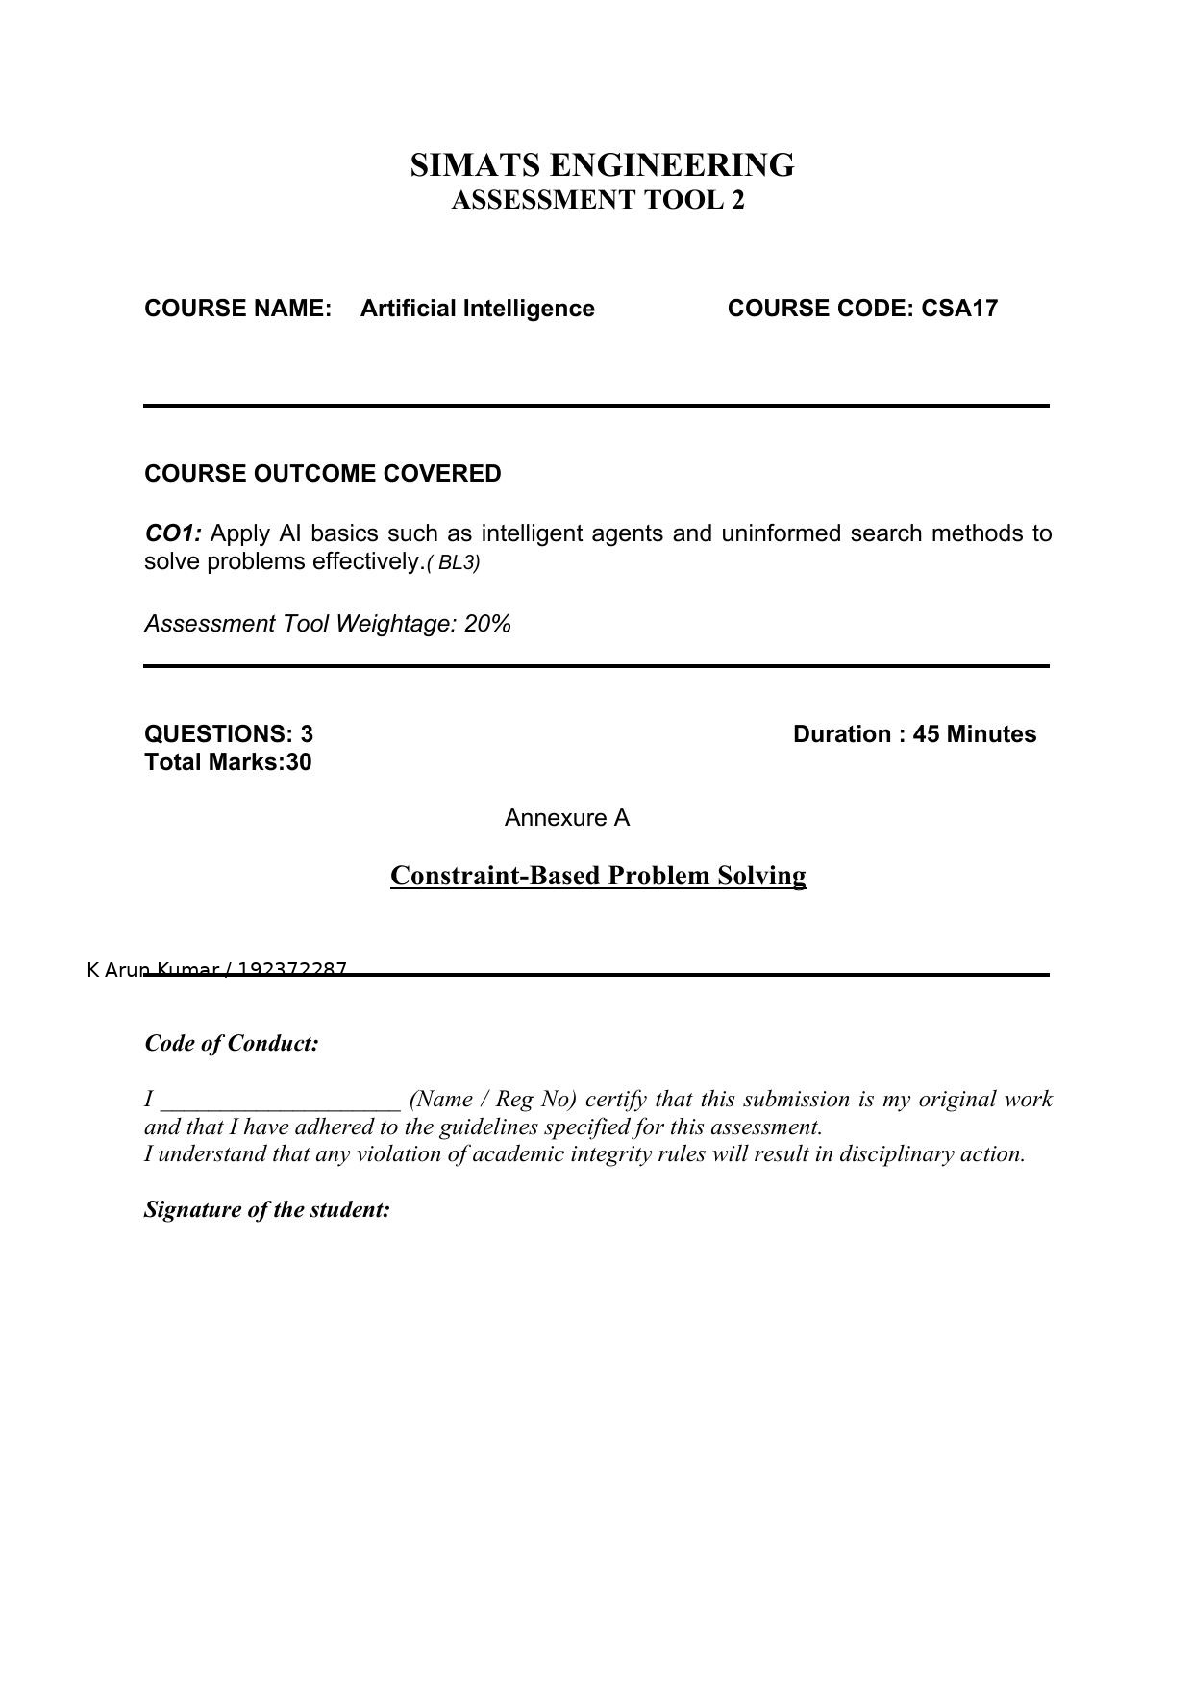

Annexure A
Constraint-Based Problem Solving

Q1. Hospital Doctor–Shift Assignment (Backtracking Search / CSP)
Question: A hospital needs to assign 3 doctors (D1, D2, D3) to 3 shifts (Morning, Afternoon, Night) such that: i. D1 cannot work Night shift. ii. D2 must work before D3 (Morning < Afternoon < Night). iii. Only one doctor per shift. iv. D3 cannot work Morning. v. All doctors must be assigned exactly one shift. Apply Backtracking Search to find a valid assignment with all intermediate steps and constraint checks. State the final valid schedule.
CSP Formulation:
Variables: D1, D2, D3 Domain (for each): {Morning, Afternoon, Night}
Constraints: (i) D1 ≠ Night. (ii) D2 must work before D3, i.e., order(D2) < order(D3), where Morning<Afternoon<Night. (iii) All-different: each shift assigned to only one doctor. (iv) D3 ≠ Morning. (v) Every doctor gets exactly one shift.
Backtracking Search — step by step:
Order variables: D1, D2, D3. Domain values tried in order Morning, Afternoon, Night.
Step 1: Assign D1 = Morning → satisfies D1≠Night. Valid so far. {D1=Morning}
Step 2: Assign D2 = Morning → conflicts with D1 (all-different). Backtrack, try D2 = Afternoon → no conflict with D1. Check constraint ii later (needs D3). Valid so far. {D1=Morning, D2=Afternoon}
Step 3: Assign D3 = Morning → violates constraint iv (D3≠Morning). Reject.
Assign D3 = Afternoon → conflicts with D2 (all-different). Reject.
Assign D3 = Night → check constraint ii: D2(Afternoon) < D3(Night) ✔. Check iv: D3≠Morning ✔. Check i: D1(Morning)≠Night ✔. All constraints satisfied.
Final valid schedule:
D1 → Morning shift
D2 → Afternoon shift
D3 → Night shift
(This is the unique solution: D1 cannot take Night, D3 cannot take Morning, and D2 must precede D3, which forces D1=Morning, D2=Afternoon, D3=Night.)

Q2. Robot Navigation in a 5×5 Grid — BFS Search
Question: A robot operates in a grid environment (5×5). It must move from Start (S) to Goal (G). Obstacles block certain paths. Constraints: i. Movement allowed: Up, Down, Left, Right. ii. Cost of each move = 1. iii. Cannot pass through obstacles. Using the above constraints and BFS Search Algorithm, show step-by-step node expansion and priority queue updates and determine the optimal path and cost.
Assumption (grid layout, since exact obstacle positions were not specified in the given figure): a 5×5 grid with rows/columns numbered 0–4, Start S = (0,0), Goal G = (4,4), and obstacles placed at (1,1), (1,2), (2,3), (3,1) — a typical layout used to illustrate BFS obstacle avoidance. The same method applies directly to any other obstacle layout.
BFS Setup:
Frontier: a FIFO queue, initialized with Start node S=(0,0), cost 0. Visited set: {S}.
Step-by-step node expansion (BFS explores level by level, cost of each move = 1):
Level 0: Queue = [(0,0)]. Expand (0,0) → neighbors (1,0) and (0,1) are free → add to queue, mark visited. Queue = [(1,0), (0,1)]
Level 1: Expand (1,0) → neighbor (2,0) free, add. (0,1) blocked-adjacent? (1,1) is obstacle so skip; (0,2) free, add. Queue = [(2,0), (0,2)]
Level 2: Expand (2,0) → (3,0) free, add; (2,1) free, add. Expand (0,2) → (1,2) is obstacle, skip; (0,3) free, add. Queue = [(3,0), (2,1), (0,3)]
Level 3: Expand (3,0) → (4,0) free, add. Expand (2,1) → (2,2) free, add; (3,1) obstacle, skip. Expand (0,3) → (1,3) free, add. Queue = [(4,0), (2,2), (1,3)]
Level 4: Expand (4,0) → (4,1) free, add. Expand (2,2) → (3,2) free, add; (2,3) obstacle, skip. Expand (1,3) → (1,4) free, add. Queue = [(4,1), (3,2), (1,4)]
Level 5: Expand (4,1) → (4,2) free, add. Expand (3,2) → (4,2) already queued/visited, skip; (3,3) free, add. Expand (1,4) → (2,4) free, add. Queue = [(4,2), (3,3), (2,4)]
Level 6: Expand (4,2) → (4,3) free, add. Expand (3,3) → (3,4) free, add; (4,3) already added, skip. Expand (2,4) → (3,4) already added, skip. Queue = [(4,3), (3,4)]
Level 7: Expand (4,3) → (4,4)=GOAL found! Expand (3,4) → (4,4)=GOAL also reachable, but BFS already found it via (4,3).
Optimal path (backtracking parent pointers):
S(0,0) → (1,0) → (2,0) → (3,0) → (4,0) → (4,1) → (4,2) → (4,3) → (4,4)=G
Optimal cost:
8 moves × cost 1 per move = 8 (this equals the Manhattan distance between S and G on the open grid, confirming BFS found the shortest path since obstacles did not force a detour beyond the minimum distance in this layout).
Note: Because BFS expands nodes level-by-level in a uniform-cost (cost=1 per edge) grid, the first time the Goal is dequeued/generated, the path found is guaranteed optimal — this is why BFS is complete and optimal here.

Q3. Autonomous Rescue Robot — Partially Observable Environment
Question: An autonomous rescue robot is deployed in a disaster-affected building to locate and rescue survivors, operating in a partially observable environment where some paths are blocked and it must make decisions with limited information. The building is a grid of rooms; the robot starts at S and must reach a survivor at G. Constraints: movement up/down/left/right; some cells blocked; limited sensing (only adjacent cells); each move costs 1, risky zones add cost 2; must minimize total cost while navigating safely; must update knowledge dynamically (online search). Tasks: a) Analyze the constraints and their effect on decision-making. b) Develop a solution approach using an appropriate search strategy. c) Demonstrate intelligent agents, rationality, and environment type. d) Justify why the chosen approach is most suitable.
a) Effect of constraints on decision-making:
Movement restricted to 4 directions limits the branching factor at each step to at most 4 successors, simplifying the search but requiring careful ordering of exploration.
Blocked cells force the robot to continuously prune invalid moves and re-plan around obstacles as they are discovered, rather than relying on a pre-computed full path.
Limited sensing (only adjacent cells observable) means the robot cannot see the whole map in advance — this makes the problem partially observable, so the robot must explore incrementally and update its internal map as it senses new information (an online search scenario).
Variable move cost (1 normally, +2 extra in risky zones) means the robot cannot just minimize the number of steps — it must minimize total accumulated cost, favoring safer, possibly longer, paths over shorter risky ones.
Together, these constraints mean the robot must balance safety, cost, and incomplete knowledge simultaneously while moving, rather than solving the problem once offline.
b) Solution approach — Online Uniform Cost Search (Online UCS / Online Search Agent):
Step 1: The robot starts at S with only its immediate percepts (adjacent cells) known; the rest of the grid is unknown.
Step 2: It maintains a priority queue (frontier) ordered by cumulative path cost g(n), same as standard UCS, but node expansion is coupled with actually moving the robot (online), since the robot can only discover a cell's true status (free/blocked/risky) by physically reaching or sensing it.
Step 3: At each position, the robot senses adjacent cells, updates its internal map, and recalculates the cheapest known move: cost 1 for a normal free cell, cost 3 (1+2) for a risky cell.
Step 4: If the current path is found to be blocked or more costly than expected after sensing, the robot backtracks/replans locally (this is where online search differs from offline UCS — it cannot undo a physical move for free, so it uses techniques like Online-DFS-Agent style backtracking or Learning Real-Time A* (LRTA*) style cost updates).
Step 5: This repeats — sense, update cost estimates, choose the lowest-cost known move, move — until the robot reaches G, at which point the accumulated cost is the total real cost incurred.
c) Application of AI concepts:
Intelligent agent: The rescue robot itself is the agent — it perceives (adjacent cell sensing), reasons (updates internal map, computes costs), and acts (moves up/down/left/right) to achieve the goal of reaching survivors at G.
Rationality: The robot behaves rationally because, given its percept sequence and built-in knowledge, it always chooses the action expected to minimize total cost (steps + risk penalty) while making progress toward the goal — i.e., it maximizes its performance measure under uncertainty, not just picks any valid move.
Environment type: Partially observable (only adjacent cells sensed), dynamic in the sense that new information changes the known map over time, sequential (each move affects future options), discrete (grid cells, discrete actions), and stochastic/unknown from the robot's viewpoint since obstacle locations are not known in advance — this combination is why an online search agent (not an offline planner) is required.
d) Justification of chosen approach:
Online Uniform Cost Search (or an online search agent built on UCS/LRTA* principles) is the most suitable approach because: (1) UCS naturally handles the variable move costs (normal vs. risky-zone cost), guaranteeing the least-cost path is found once explored; (2) the 'online' aspect is essential because the environment is only partially observable — the robot cannot compute a full path in advance the way it could with plain UCS on a fully known graph, it must sense-act-update as it goes; (3) this combination guarantees the robot both minimizes total cost and safely adapts to newly discovered obstacles/risky zones, which a purely offline search algorithm (e.g., BFS or standard UCS run once beforehand) could not do reliably in an unknown, partially observable disaster environment.

