**K-Means Clustering**

**Instructions to run the code:**

**How to compile and execute**

**mpirun** is the command used to execute MPI program argument 1 is number of process and argument 2 is file name to be executed

**mpicc main.c - o main**

**mpirun -np 2 main**

Data points , search data point and number of centroids are randomly generated in the program.

**Screenshots of sample execution**

Below execution is screen shot with 100 data points and 2 dimension

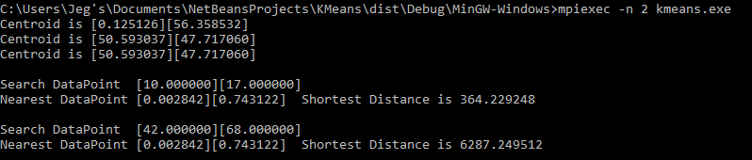

Below execution is screen shot with 10000 data points and 3 dimension

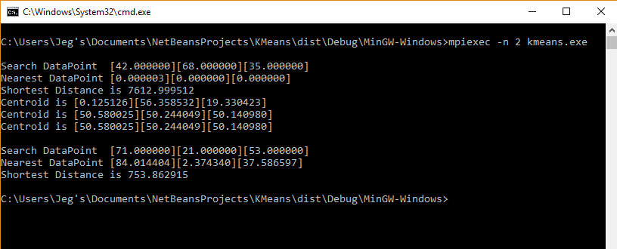

Below execution is screen shot with 10000 data points and 15 dimension

