Ec2

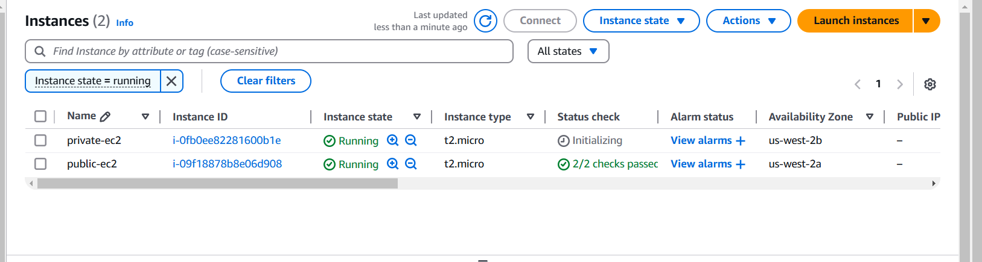

Vpc created

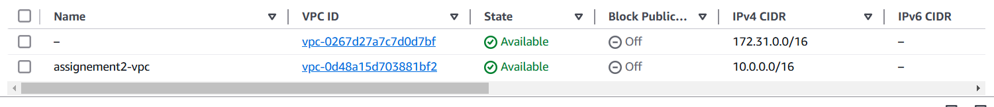

Subnets



Internet gateway

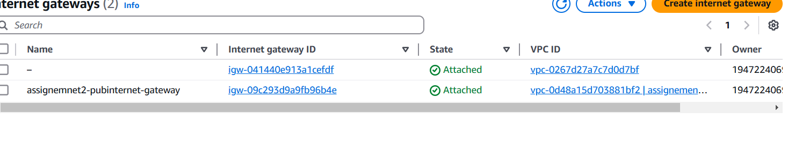

Route table

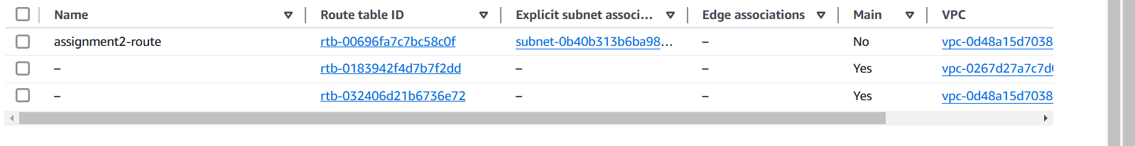

Resourse map

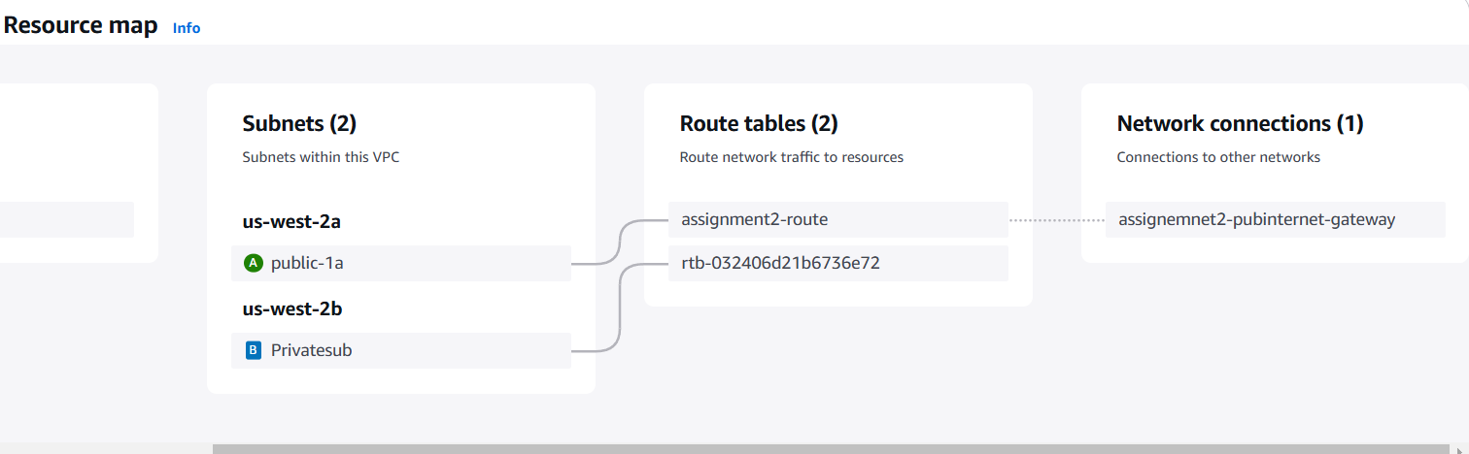

User is able to access the internet from public subnet

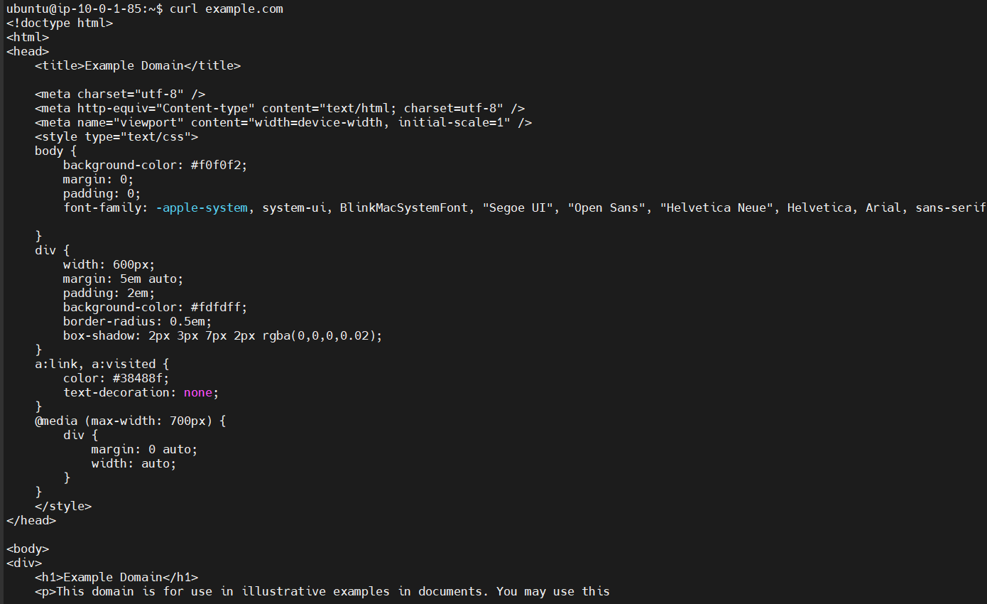

User is able to access the private subnet

Logged to private subnet from public subnet

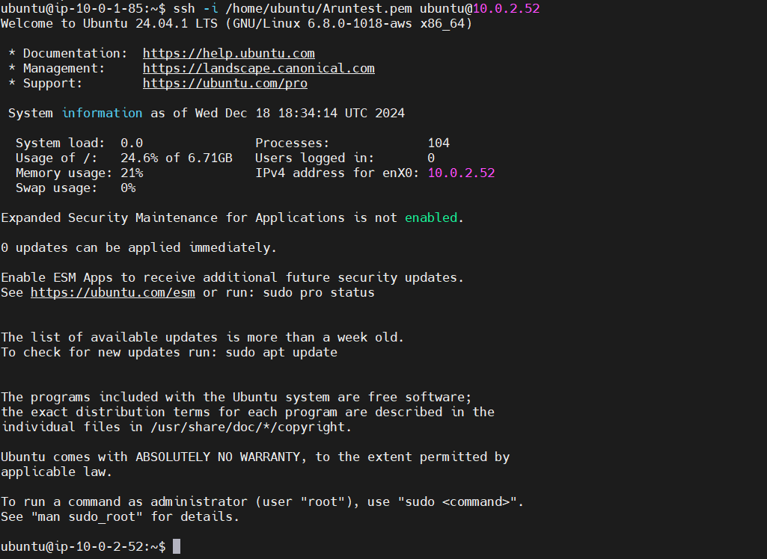

Not able to acces internet from private subnet

