****

**SKILL TRACKER**

Table of Contents:

[Introduction 3](#_Toc245105483)

[Scope: 3](#_Toc245105484)

[Assumptions 3](#_Toc245105485)

[Management Summary 3](#_Toc245105486)

[System Objectives / Overview 4](#_Toc245105487)

[Figure 1 System Context Diagram 4](#_Toc245105488)

[Refrences 5](#_Toc245105489)

[Initial requirement document 5](#_Toc245105490)

[Common requirements: 5](#_Toc245105491)

[Message Sequencing Requirements 5](#_Toc245105492)

[Message Persistence Requirements 5](#_Toc245105493)

[Message Size Requirements 6](#_Toc245105494)

[Error & Exception Handling Requirements 6](#_Toc245105495)

[Auditing/Logging Requirements 6](#_Toc245105496)

[Functional Requirement 1 – Process the Meter Message 6](#_Toc245105497)

[Brief Description 6](#_Toc245105498)

[Interface Details 6](#_Toc245105499)

[Table of requirement 6](#_Toc245105500)

[Email template: 7](#_Toc245105501)

[Database Schema: 8](#_Toc245105502)

[SQL Script for table creation: 8](#_Toc245105503)

[Test Cases: 8](#_Toc245105504)

[Unit Test Cases – SDS 8](#_Toc245105505)

[Integration Test Cases – SDS 9](#_Toc245105506)

[NFR – Test cases 9](#_Toc245105507)

[XML Schema 9](#_Toc245105508)

[Adhoc Reporting 9](#_Toc245105509)

[Disclaimer 10](#_Toc245105510)

[Products to be used: 10](#_Toc245105511)

[Resource & References: 11](#_Toc245105512)

**INTRODUCTION**

**SCOPE**

The main scope of this application is keeping track of skill of individual full stack Engineers. To use the single page application (skill tracker) to keep track of employee skills. The skill Tracker should be the single page application (SPA). Using the internal portal an admin will be able to perform following operations.

* Search by associate name
* Search by associate ID
* Search by associate Email ID
* Search by associate Mobile Number
* Search by associate Strong Skills
* Add new associate

The admin will be able to add new associate and its respective Full Stack Development Skills.

The associate which is searched can be updated , deleted and viewed.

**ASSUMPTIONS**

This app is developed for the main purpose of tracking the skills of individual Full Stack Engineers.

**MANAGEMENT SUMMARY**

John Dempsey works in an IT company. He is a new age HR Academic Manager. Few of his responsibilities includes:

1. Search associate: John will be able to search associate with following criteria

* Search by associate name
* Search by associate ID
* Search by associate Email ID
* Search by associate Mobile Number
* Search by associate Strong Skills

1. Add new Associate

The admin will be able to add new associate and its respective Full Stack Development Skills.

1. Edit, Delete & View Associate

The associate which is searched can be updated, deleted and viewed.

1. Add skills

It will allow the john to add new skills so that it can be used in “add new Associate “ page.

**SYSTEM OBJECTIVES AND OVERVIEW**

Employee

By Mobile

By Skills

By Name

By Email

By ID

Search

View

Admin

Delete

Update

Add

**USECASE DIAGRAM**

**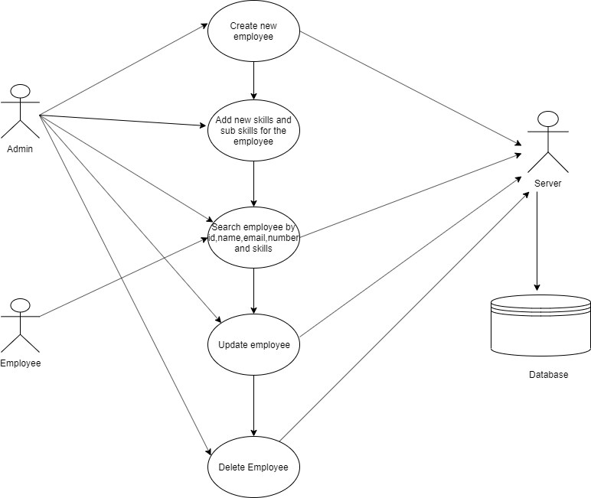**Figure 2: Usecase diagram for Admin and Employee

An Admin has a property of searching employees by their id, name, email id, mobile number and skills.

And also an admin able to add, delete, update and view associate with the help of server and database.

An employee also has only one property such as searching other employees by their id, name, email id, mobile number and skills

|  |  |
| --- | --- |
| Admin | Has a main role of searching employees, add new associate, deleting employee, updating employees by using employee credentials |
| Employee | Has a property of searching other employees. |

**REFERENCES**

**INITIAL REQUIREMENT DOCUMENT**



**COMMON REQUIREMENT**

**FUNCTIONAL REQUIREMENT**

**Brief description**

An Admin add the new associate, search employees, delete employees, update employees, provides rating to the skills with the help of server and database. An employee can able to view other employees.

**Interface requirement**

See the use case diagram between employee and admin.

Table Requirement

|  |  |
| --- | --- |
| Database | It used to store and retrieve the values of employees to and from the database respectively with the help of server. |
| Server | It is a interconnection between the client and database and provide response to the client. |

**Email Template**

Dear <Employee Name>,

Your current monthly reading is <incoming meter reading from the message>. Based on this your current monthly charges is Rs.<calculated amount for that consumer>

Your due date is 15th <running month – running year>.

At your service,

ABC corp.

**DATABASE SCHEMA**

|  |
| --- |
| **C:\Users\B4ibmjava31\AppData\Local\Microsoft\Windows\INetCache\IE\SU4H1O6T\325px-Table_icon.svg[1].png Employee** |
| **Id**  **name**  **email\_id**  **mobile\_number**  **Skills** |

|  |
| --- |
| **Skills** |
| **id**  **type**  **name** |