

Module Code & Module Title
Application Development

30% Individual Coursework
Submission:Milestone:1 Academic Semester:
Autumn Semester 2025
Credit: 30 credit Year long module

Student Name: Arun K.C.

London Met ID: 23048760
College ID: NP04CP4A23041
Assignment Due Date: 08/01/2026
Assignment Submission Date: 08/01/2026 Submitted
To: Projwol Pokhrel

GitHub Link

Contents
1. Introduction. 3
2. Project overview. 4
2.1. Project Purpose 4
2.2. Project Scope 4
2.3. Project Objectives 5
3. Wireframe. 6
4. Data Modeling 8
5. Technology Stack 9
5.1. Framework 9
5.2. External Libraries 9
5.3. Persistence Mechanism 9
6. Implemented Features 10

Table Of Figure.
Figure 1 Login wireframe 6
Figure 2. Dashboard wireframe 6
Figure 3. Today entry Wireframe 7
Figure 4. Calendar view wireframe 7

Introduction.
As digital technologies are being rapidly developed, people are starting to use software applications as the means of managing personal information in the most efficient and the safest way. Historically, journaling was a paper-based experience, but it has now taken the form of a digital behavior where the user is able to capture ideas, feelings as well as daily experiences in a better structured and searchable and safer way. Nonetheless, it is common to find that most of the available journaling solutions do not have a robust privacy, or they do not offer useful insights about user data.
This coursework is the design and development of MyJournal, a cross-platform desktop journaling app created in.NET MAUI Blazor. It is a day-to-day journaling application that lets users create, edit and manage a single journal record each day and has rich-text or Markdown formatting. The focus is made on the data security, usability, and data analytics that allow users to not only document their experience but also reflect on the emotional patterns and the journaling behaviors over the years.
It shows that the modern concepts of software engineering are used in the project, such as component based UI design, service oriented architecture, data storage in SQLite, and simple analytics visualization.

Project overview.
The goal of this coursework is to design and build a secure, enhanced personal journaling system using MAUI Blazor. The way this project has been designed is with a layered architecture, which separates data/concerns by Pages and Components, Models, Services, Helpers and Data access layers. This layered architecture provides a method of maintaining and growing the system, rather than it being a monolithic application.
The system's Core Features Include:
- Login and password hash security
- Daily journal entries: create, edit and delete your entries
- Select mood and tags per entry
- Calendar view of your past entries
- Dashboard with analytics of your entries including mood trend, mood tags, word count, and streak.
- Store the data locally in SQLite for offline storage.
- Print your entries in PDF format from your device.

Project Purpose
This project is aimed at the development and design of MyJournal, a safe and convenient online journaling app with .NET MAUI Blazor Hybrid. The project will change the usage of traditional paper-based journaling to a digital one (modern). The purpose of the project is to provide users with the ability to document their thoughts, feelings, and experiences in a structured and organized way on a daily basis.
Besides journal entry storage, the application also prioritizes the privacy of data, ease of use, and self-reflection by offering analytic tools like mood patterns, journal entry streaks, and word count statistics. Under this project, the practical application development skills are presented with the help of the modern framework and architectural concepts.

Project Scope
The project scope will consist of the creation of a desktop, offline-first, single-user application, which will run on the platform with support of the .NET MAUI that supports mostly Windows. The system will enable the users to add, modify, read, and delete journal entries, but only one journal entry can be made on a single day to ensure consistency of the data.
All application data is accessible locally with an embedded SQLite database, so the contents of the personal journals are private and can be viewed even without an internet connection. Some of the application features included in the project scope are authentication, moods and tags management, calendar-based navigation, analytics visualization, and export.
The project does not clearly indicate cloud synchronization, multi-user collaboration, social sharing and mobile deployment. These exclusions assist in keeping a narrow scope of development in check with the requirements of the course work and the time limits.

Project Objectives
- The key goals of the MyJournal project are:
- To create and deploy a cross-platform journaling application based on .NET MAUI Blazor Hybrid.
- To use component-based UI design principles with reusable Blazor components.
- To establish secure user authentication on password hash based methods.
- To store and operate journal information effectively using SQLite.
- To empower users to make a tag and mood entries.
- To offer analytical data like moods, word counts, and the number of journaling streaks.
- To illustrate the knowledge of service based architecture and separation of concerns.

Wireframe.
- Wireframe of Login.
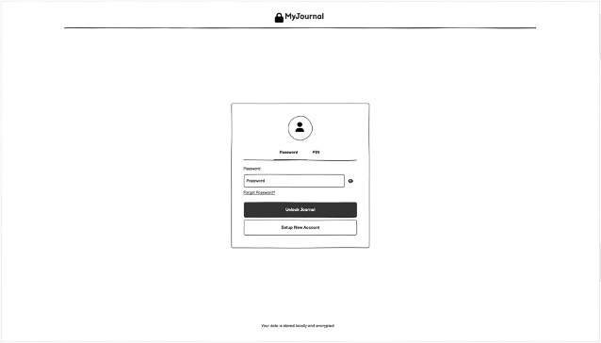
Figure 1 Login wireframe
- Wireframe of Dashboard.

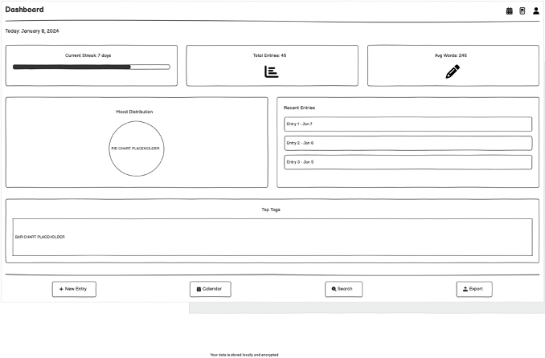
Figure 2. Dashboard wireframe

- Wireframe of Today Entry.
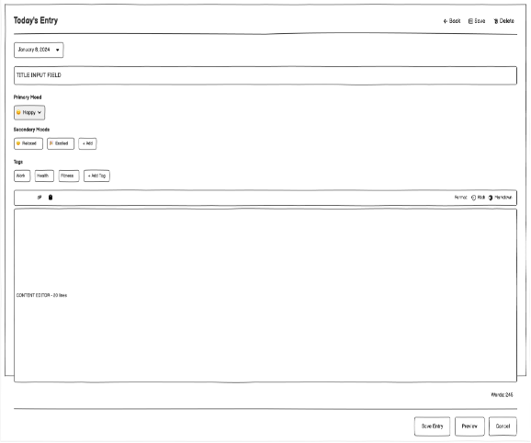
Figure 3. Today entry Wireframe
- Wireframe of Claendar view

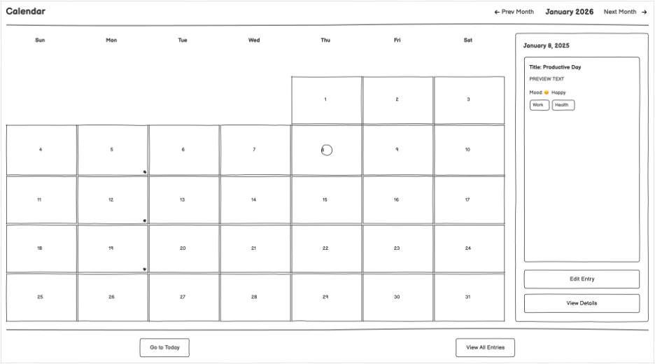
Figure 4. Calendar view wireframe

Data Modeling
The system is based on a relational data model which is implemented in SQLite. Each of the entities is meant to depict a fundamental aspect of the journaling process.
Key Entities
User
S.N | Attributes
1 | UserId(Primary Key)
2 | Username
3 | PaswordHash
4 | CreateDate

JournalEntry
S.N. | Attributes
1 | EntryId
2 | EntryDate
3 | Content
4 | WordCount
5 | MoodId

Mood
S.N. | Attributes
1 | MoodId
2 | MoodName
3 | Icon

S.N. | Atttributes
1 | TagId (Primary Key)
2 | TagName (Unique)
3 | EntryTag
4 | EntryId (Foreign Key)
5 | TagId (Foreign Key)

Entity Relationships
A Single User --> Numerous JournalEntries.
One Mood Many JournalEntries.
Many JournalEntries 2 Many Tags (through EntryTag)

Technology Stack

Framework
· .NET MAUI Blazor Hybrid
- ◦ enables developers to create cross-platform desktop applications
- ◦ combines native MAUI’s features and functionalities with Blazor’s component-based architecture
- ◦ provides support for dependency injection and Razor components

External Libraries
The following libraries were chosen to add functionality to this application:
- SQLite-net-pcl
light-weight object relational mapper (ORM) for working with SQLite databases
- Markdig
provides the ability to parse markdown content and format content for journal entries
- System.Security.Cryptography
The hashing algorithm used to hash passwords and encrypt sensitive data
- Blazor Components
reusable UI components such as MoodSelector, TagSelector, CalendarView. Optional components to be added in future releases
- QuestPDF (for exporting to PDF format)
- MudBlazor (for adding additional advanced UI components)

Persistence Mechanism
- MyJournal uses an embedded SQLite database as a local persistence mechanism.
- MyJournal supports offline-first architectures, which means that all CRUD operations performed against the application are managed through a service layer that maintains all user entry data and provides users with a secure local storage mechanism for journal entries and other sensitive information. SQLite was selected because it has a lightweight footprint, is a robust database solution, and is compatible with all .NET MAUI applications.

Implemented Features
The project successfully implements four core features, fulfilling the coursework requirement.

- Secure User Authentication
  - Login system with hashed passwords
- Journal Entry Management
  - Create, edit, and delete daily entries
- Mood Tracking
  - Associate moods with journal entries
- Tag Management
  - Categorize entries using tags

