
ARUN CODEX
WEB DEVELOPER | DESIGNER | INNOVATOR
SOFTWARE REQUIREMENTS SPECIFICATION (SRS)
Gudi Chemicals ERP — Production, Inventory, GST & High-Speed POS System
Project Name: | Gudi Chemicals ERP (Release 1.0) | Prepared By: | ARUN CODEX
Document Standard: | IEEE 830-1998 Format | Core Focus: | High-Speed POS & Billing Module

1. Executive Summary & Project Context
Gudi Chemicals ERP is an enterprise-level chemical resource planning and sales automation suite engineered by ARUN CODEX (Web Developer | Designer | Innovator). The software addresses specific challenges in industrial chemical manufacturing: recipe/BOM versioning, evaporation loss calculations, density/viscosity quality control tests, multi-tier raw material and packaging inventories, moving average inventory valuations, and statutory Indian Goods and Services Tax (GST) compliance.

2. High-Speed POS & GST Billing Module (Deep Dive)
The Billing Desk is the primary operational heart of the system. During counter rush hours, cashier speed and absolute tax accuracy are paramount.

Core Billing Capabilities:
- Keyboard-First Single-Screen POS: Full functionality accessible via keyboard shortcuts (F2 for Search, F4 for Customer, F7 for Price Tier, F8 for Checkout). Eliminates mouse-dependent delays.
- Barcode Hardware Scanner Workflow: Instant barcode scan recognition in under 80 milliseconds. Automatically adds scanned product to cart or increments quantity if already present.
- Dual-Tier Pricing Engine: Dynamic switching between Retail Selling Price (RSP) for walk-in retail counter buyers and Wholesale Selling Price (WSP) for registered B2B distributors.
- Comprehensive Indian GST Tax Engine: Automated partitioning into CGST 50% + SGST 50% for Intra-State sales (Maharashtra Code 27) and IGST 100% for Inter-State sales. Freezes exact tax snapshots per line item.
- Multi-Mode Split Payment Handling: Enables dividing invoice totals across Cash, UPI QR, Card, Bank Transfer, and Customer Credit with live change-due computation.
- Sequential Gapless Invoice Numbering: Generates sequential invoice numbers (e.g. GC/2026-27/0001) using atomic database row-locking (lockForUpdate) to eliminate race conditions.

Figure 2.1: High-Speed POS Fast Billing Interface with Live Tax Calculation

3. Dual-Format Invoicing & Print Engine
The system supports dual print outputs to cater to different operational scenarios:
- 80mm Thermal Receipt (POS Slip): Ultra-fast slip printing for counter walk-in retail sales.
- Standard A4 GST Tax Invoice: Formal 3-copy commercial tax invoice compliant with GST Rule 46. Features full seller and buyer GSTIN, HSN tax distribution table, and bank RTGS details.
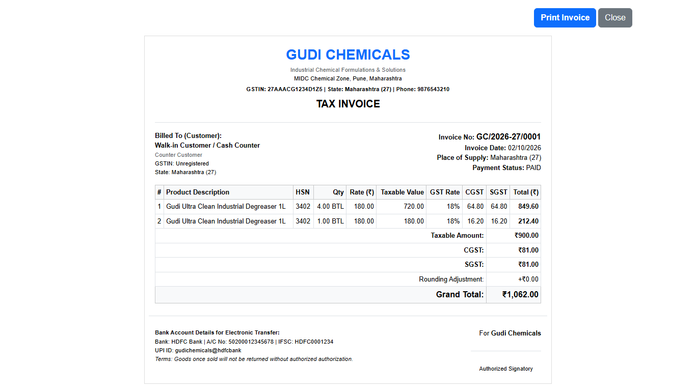
Figure 3.1: Standard A4 GST Tax Invoice Print Preview with Complete HSN & Tax Distribution

4. Chemical Manufacturing & Inventory Management
Chemical products are organized into 5 categories: Raw Chemicals, Semi-Finished Intermediates, Finished Bottled Goods, Packaging Materials, and Trading Goods. The manufacturing workflow supports versioned recipes (BOM), automatic ingredient scaling, QC testing (pH, density, viscosity), and atomic stock deduction.
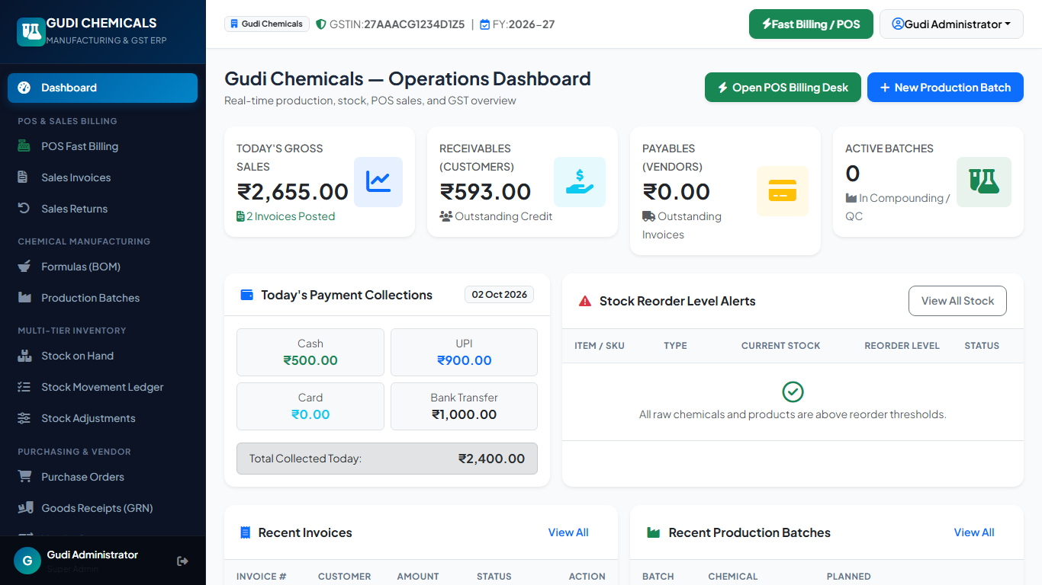
Figure 4.1: Real-Time Operational Dashboard with KPIs and Stock Alerts

5. Technical Certification & Author Sign-Off
This Software Requirements Specification has been officially certified and authored by ARUN CODEX (Web Developer | Designer | Innovator) as the technical baseline for Gudi Chemicals ERP.

