
ARUN CODEX
WEB DEVELOPER | DESIGNER | INNOVATOR
GUDI CHEMICALS ERP USER MANUAL
Complete Operations & Training Guide with Exhaustive Billing Masterclass
System: | Gudi Chemicals ERP (Release 1.0) | Author & Designer: | ARUN CODEX
Target Users: | Cashiers, Storekeepers, Chemists, Managers | Language: | Simple, Lucid & Practical English

Chapter 1: Getting Started & System Access
Welcome to the official Gudi Chemicals ERP Operations Manual, authored by ARUN CODEX (Web Developer | Designer | Innovator). To log in, open your browser and navigate to the application URL. Enter your corporate email and password to access the system.
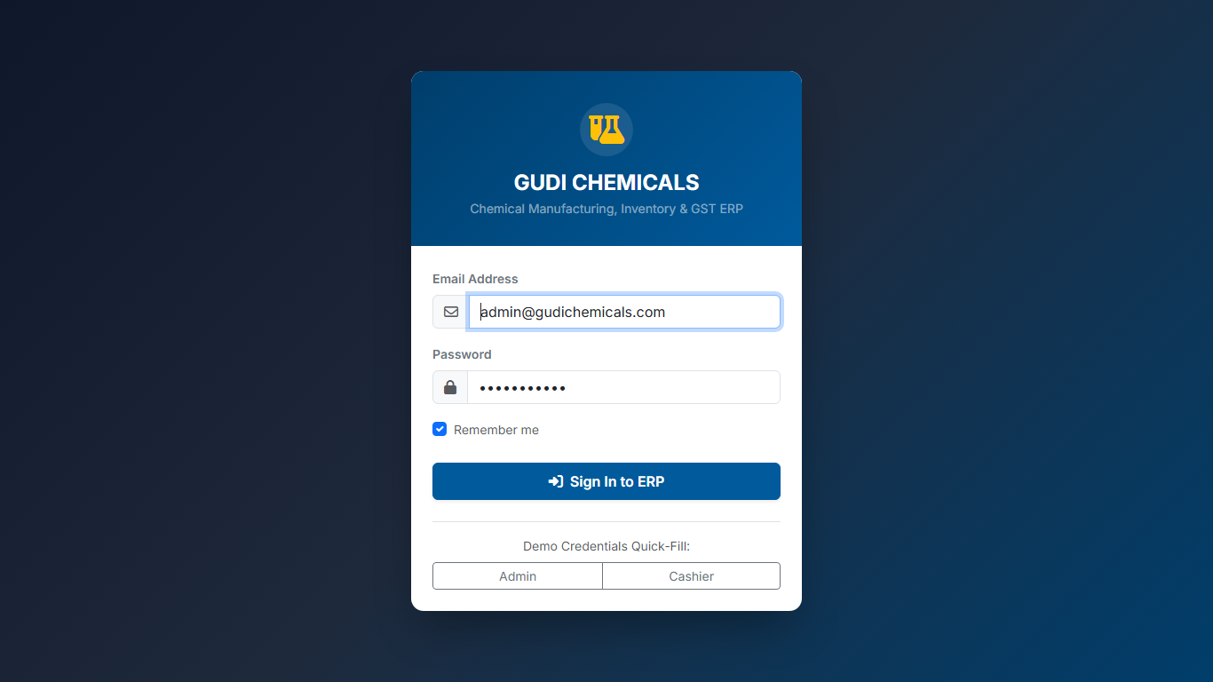
Figure 1.1: Gudi Chemicals ERP Secure Login Screen

Chapter 2: High-Speed POS Billing Masterclass
The Billing Desk is where you serve customers and record sales. Gudi Chemicals ERP makes this process fast and simple.

Key POS Operations Guide:
- Scanning Products: Point your barcode scanner at any chemical container. The item is automatically added to the cart.
- Quick SKU Search: Press F2 on your keyboard to instantly focus the search box. Type product name and press Enter.
- Customer Selection: Press F4 to choose between Walk-in Retail Customer or registered B2B Wholesale Accounts.
- Price Tier (Retail vs Wholesale): Press F7 to toggle between Retail Price (RSP) and Wholesale Price (WSP). Wholesale price automatically applies for B2B buyers.
- Payment & Checkout: Press F8 to open checkout. Enter Cash Tendered to see exact Change Due, or choose UPI QR, Card, or Customer Credit.
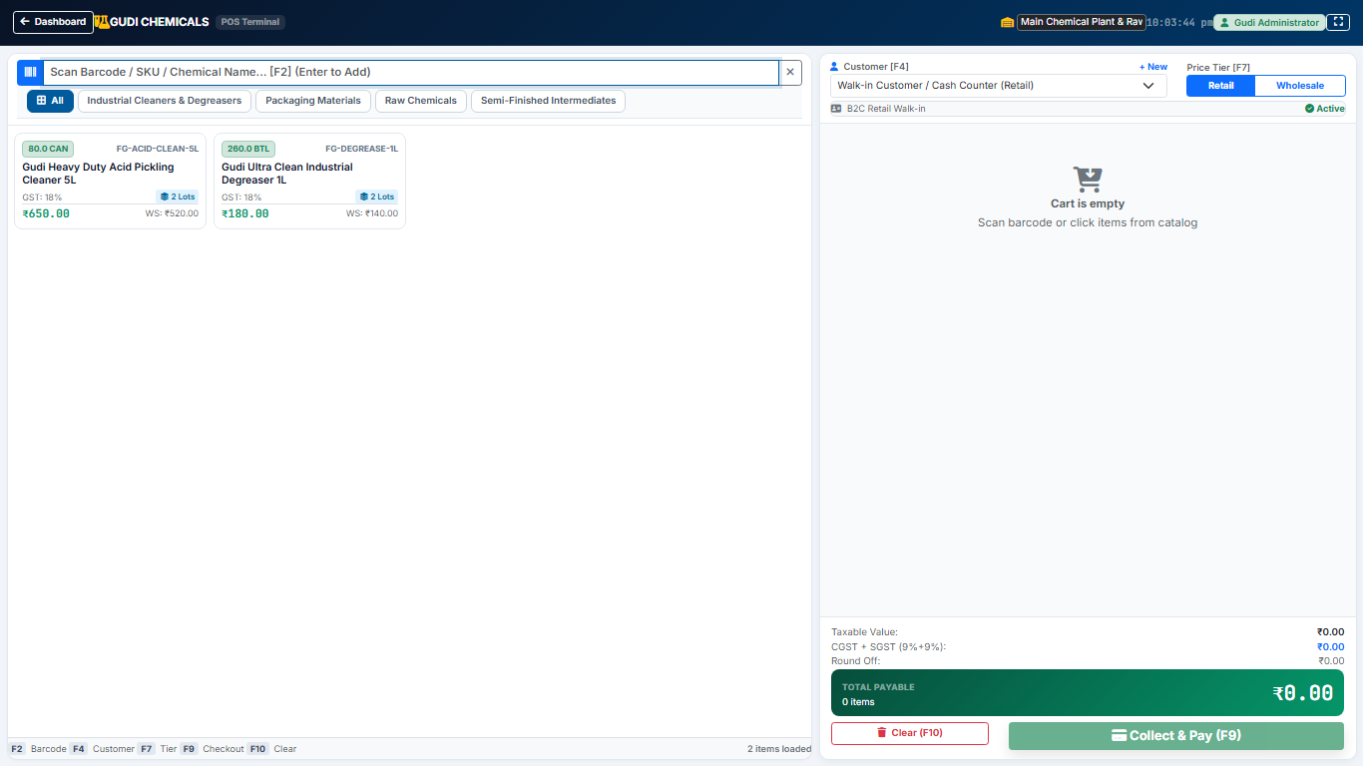
Figure 2.1: The POS Fast Billing Screen with Live Cart and Real-Time Totals

Chapter 3: Invoicing, Printing & Document Dispatch
From the Invoices screen, cashiers can click "Print Thermal" for fast 80mm counter receipts, or "Print A4" for formal commercial GST tax invoices. PDFs can also be downloaded directly or shared with customers via WhatsApp.
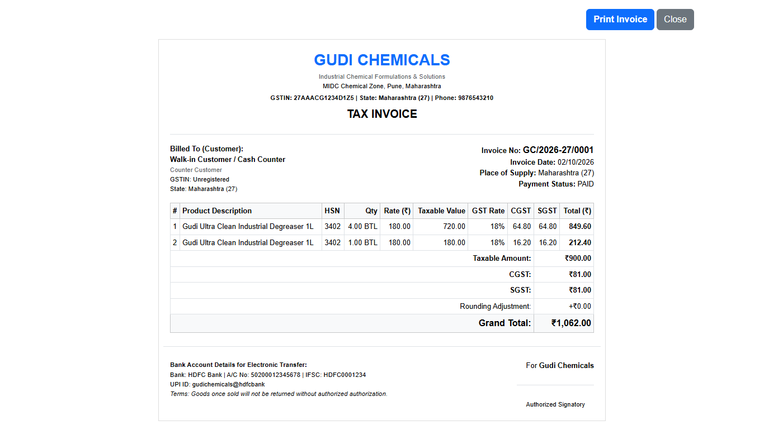
Figure 3.1: Standard A4 GST Tax Invoice Print Preview

Chapter 4: Inventory, Manufacturing & Support
The manual covers master data creation, chemical formula BOM recipes, production order execution, goods receipt notes (GRN), and daily sales reporting.
For technical support, custom features, or questions, please contact ARUN CODEX (Web Developer | Designer | Innovator). All rights reserved.

