
ARUN CODEX
WEB DEVELOPER | DESIGNER | INNOVATOR
GUDI CHEMICALS ERP USER MANUAL
Complete Step-by-Step Operations Guide with Live Screen Visuals for All Modules
Target Enterprise: | Gudi Chemicals (Coimbatore, Tamil Nadu) | Author & Designer: | ARUN CODEX
Address: | Spic, Thenkarai, Tamil Nadu 641010 | Hours & Tax: | 9:00am–6:30pm | TN Code 33

Chapter 1: User Login & Session Security
To log in, open your browser and go to your ERP address (http://127.0.0.1:8000/login). Enter your assigned email address and password to sign in safely.
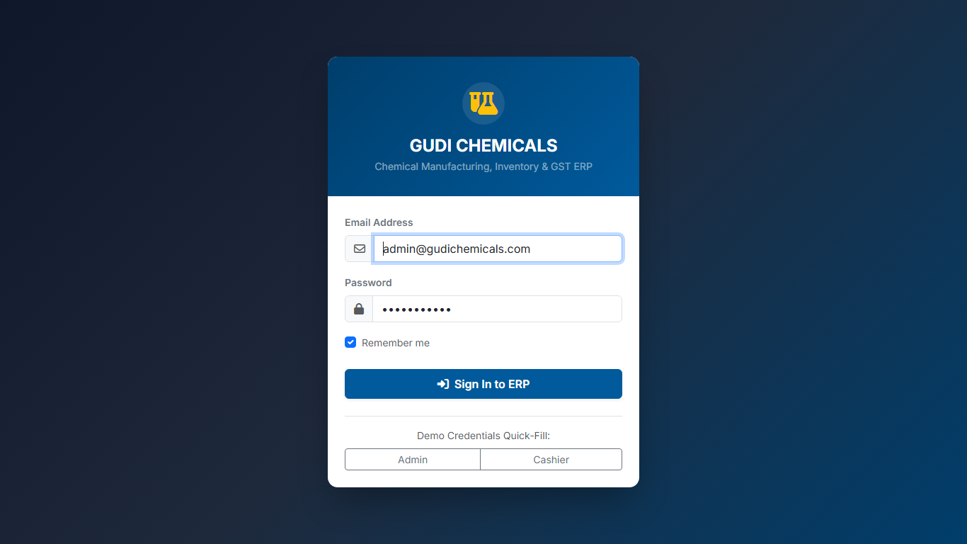
Figure 1.1: Secure User Login Screen with Input Credentials

Chapter 2: Executive Operational Dashboard
The Dashboard displays your daily turnover, total invoices generated, low stock alerts, and interactive revenue velocity charts.
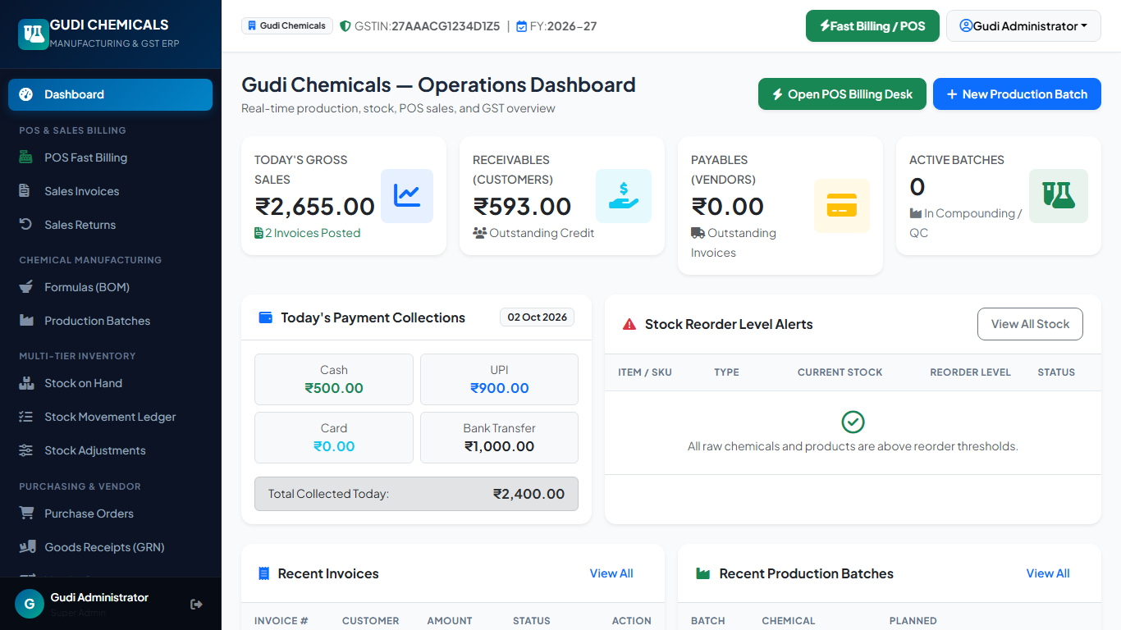
Figure 2.1: Operational Dashboard with Live Revenue KPIs and Low Stock Alerts

Chapter 3: High-Speed POS Fast Billing Desk
The single-screen POS desk lets cashiers scan barcodes, search items (F2), select retail or wholesale customers (F4), switch price tiers (F7), and checkout with cash (F8).
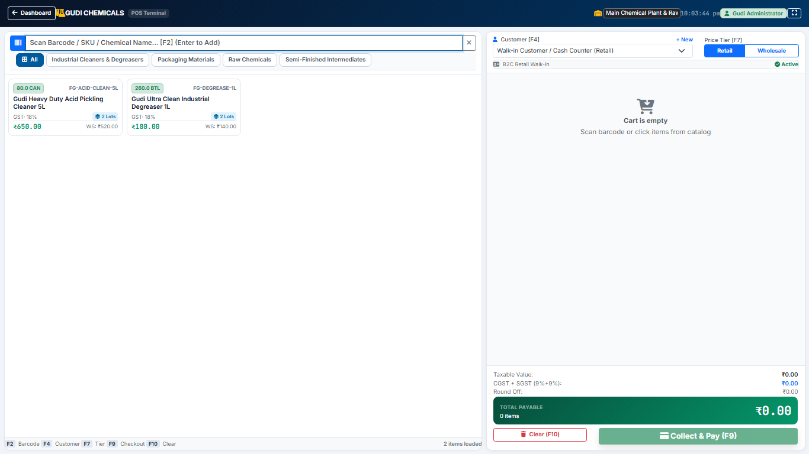
Figure 3.1: POS Billing Screen with Product Catalog Grid and Live Order Cart

Chapter 4: POS Cash Checkout & Change Due
In the payment modal, entering Cash Tendered automatically computes exact Change Due for the customer in bold green numerals. Clicking Complete opens the cash drawer and prints the receipt.
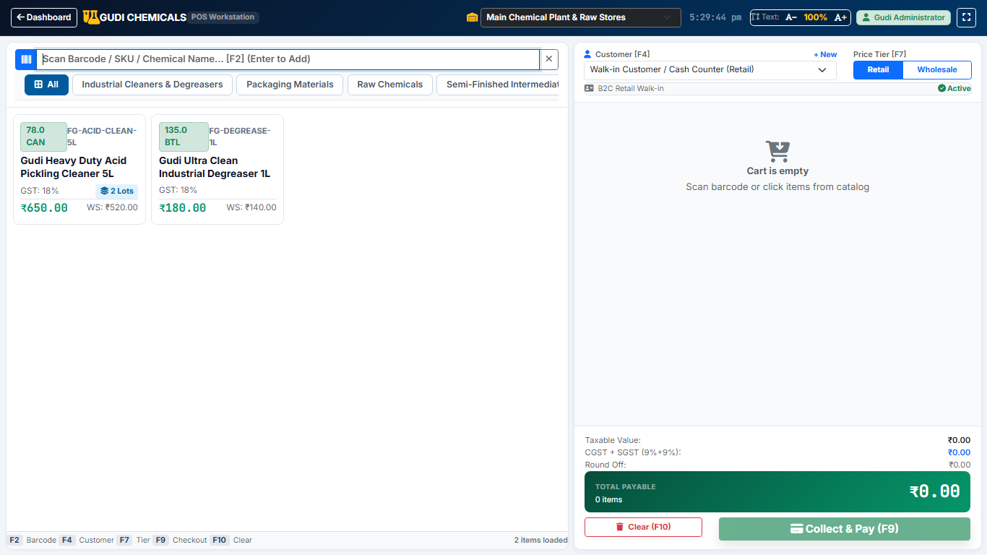
Figure 4.1: Cash Payment Modal showing Net Payable, Cash Tendered, and Change Due

Chapter 5: Sales Invoices Register & Shift Log
The Invoices screen maintains a searchable register of all posted tax invoices with one-click actions for Thermal Print, A4 Tax Print, and PDF download.
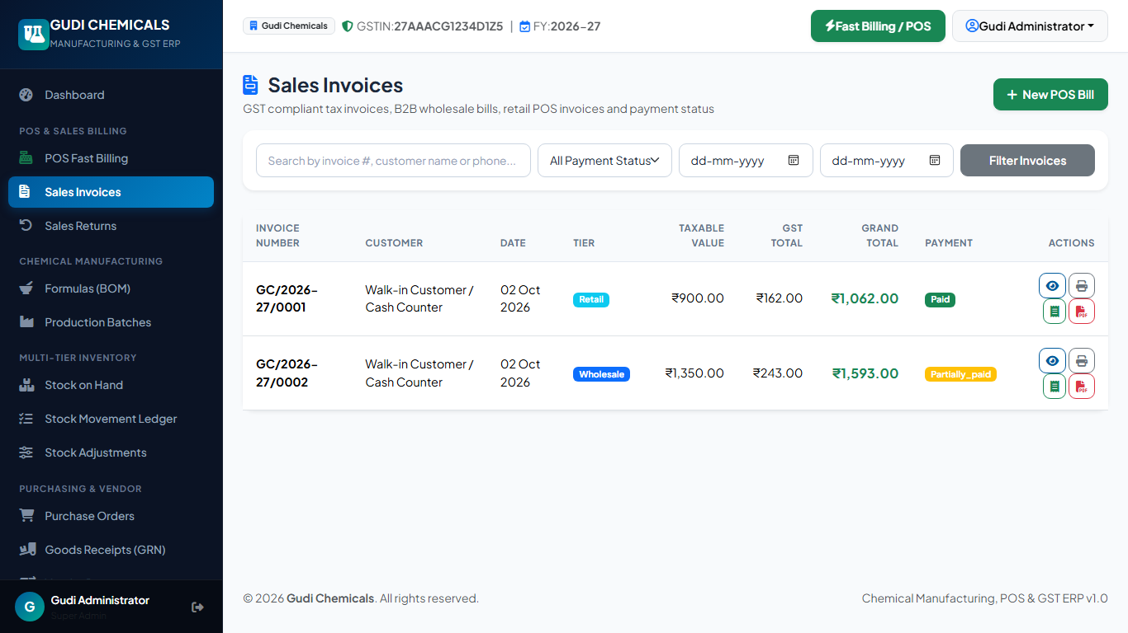
Figure 5.1: Invoices Register with Real-Time Filters and Printing Actions

Chapter 6: Detailed Invoice View & Action Center
Displays line-by-line itemization, CGST/SGST tax breakdown, customer address, payment settlement records, and linked inventory movement logs.
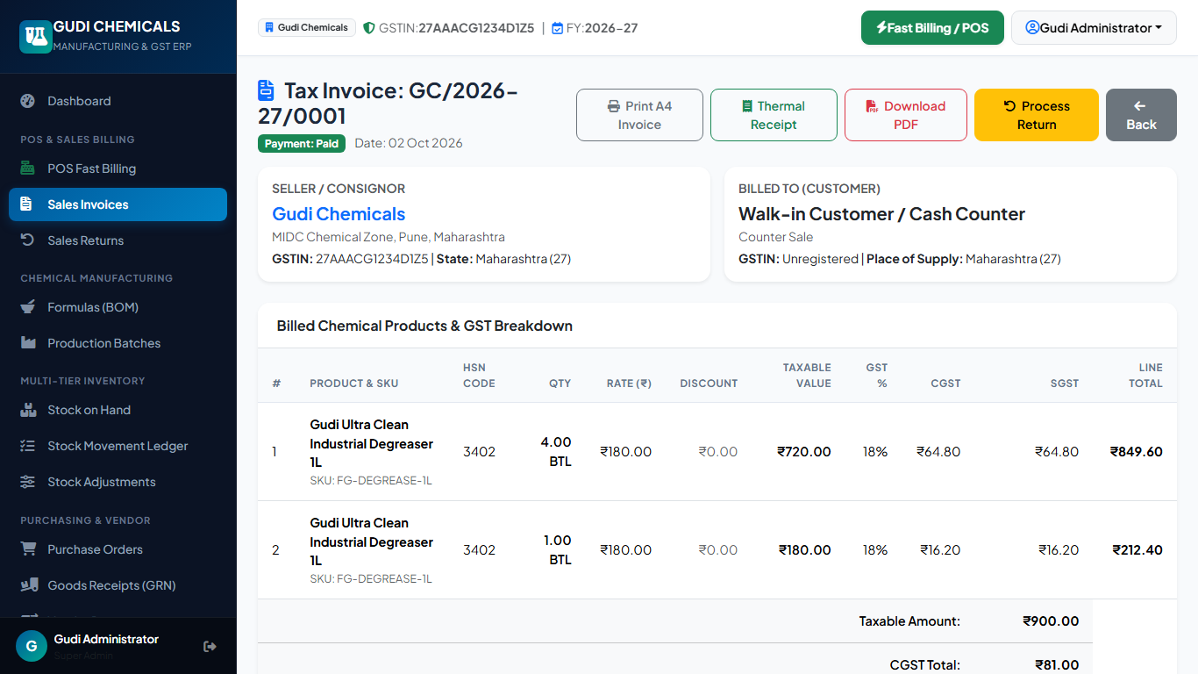
Figure 6.1: Detailed Invoice Management Screen with Audit Records

Chapter 7: Dual-Format Print Engine (A4 & Thermal)
Supports 80mm high-speed thermal counter slips and formal 3-copy commercial A4 GST tax invoices compliant with Rule 46 of the CGST Rules.
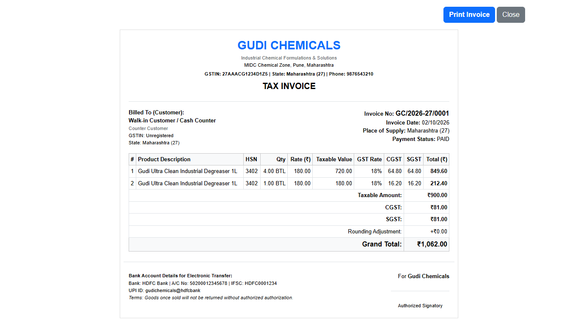
Figure 7.1: Standard A4 GST Tax Invoice Print Preview with Full HSN Distribution

Chapter 8: Chemical Products Master Catalog
Manage Floor Cleaners, Toilet Cleaners, Degreasers, Packaging Jerry Cans, and Raw Chemicals with dual pricing (Retail RSP vs Wholesale WSP).
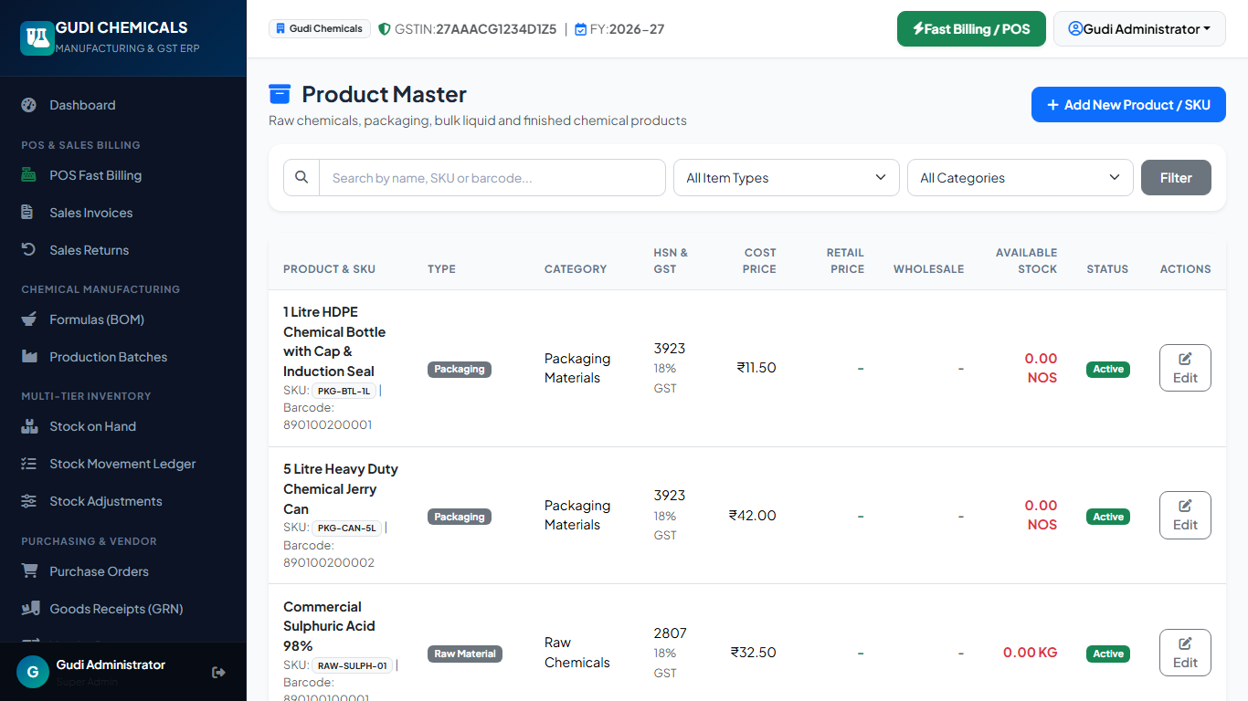
Figure 8.1: Products Master Catalog with Dual Pricing and Stock Quantities

Chapter 9: Multi-Tier Chemical Inventory & Stock Ledgers
Real-time warehouse inventory balances, batch lot numbers, manufacturing and expiry dates, and an immutable movement ledger.
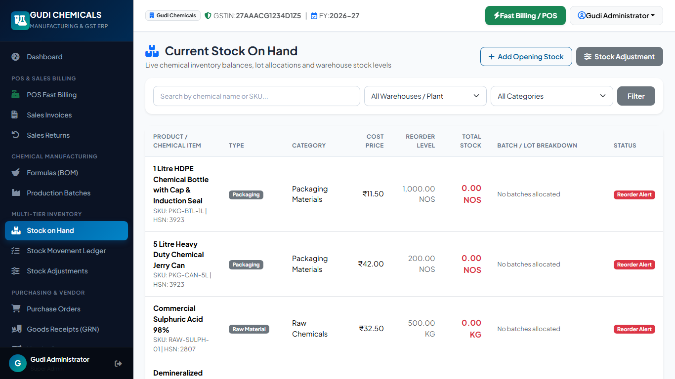
Figure 9.1: Multi-Tier Inventory Status and Batch Valuation Screen

Chapter 10: Chemical Formulas & Bill of Materials (BOM)
Plant chemists define versioned master recipes specifying standard batch sizes, expected yields, process evaporation losses, and ingredient mixing ratios.
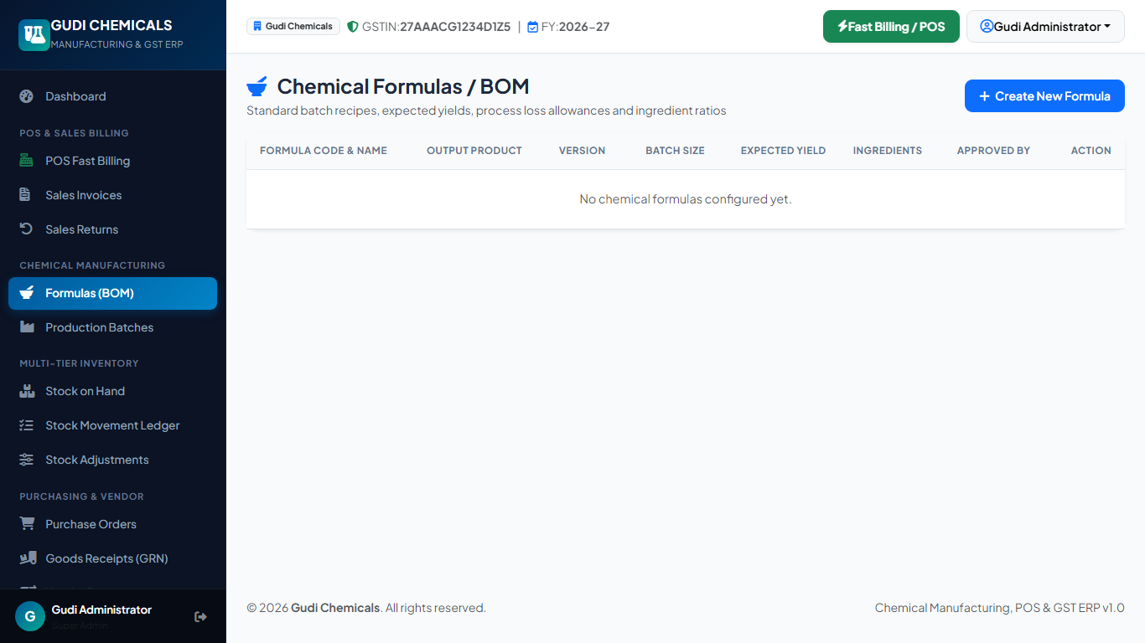
Figure 10.1: Master Chemical Recipes & Bill of Materials (BOM) Management

Chapter 11: Production Orders & Laboratory QC Gates
Manage the 4-stage batch manufacturing lifecycle: Draft planning, ingredient reservation, laboratory QC testing (pH, density, viscosity), and atomic finalization.
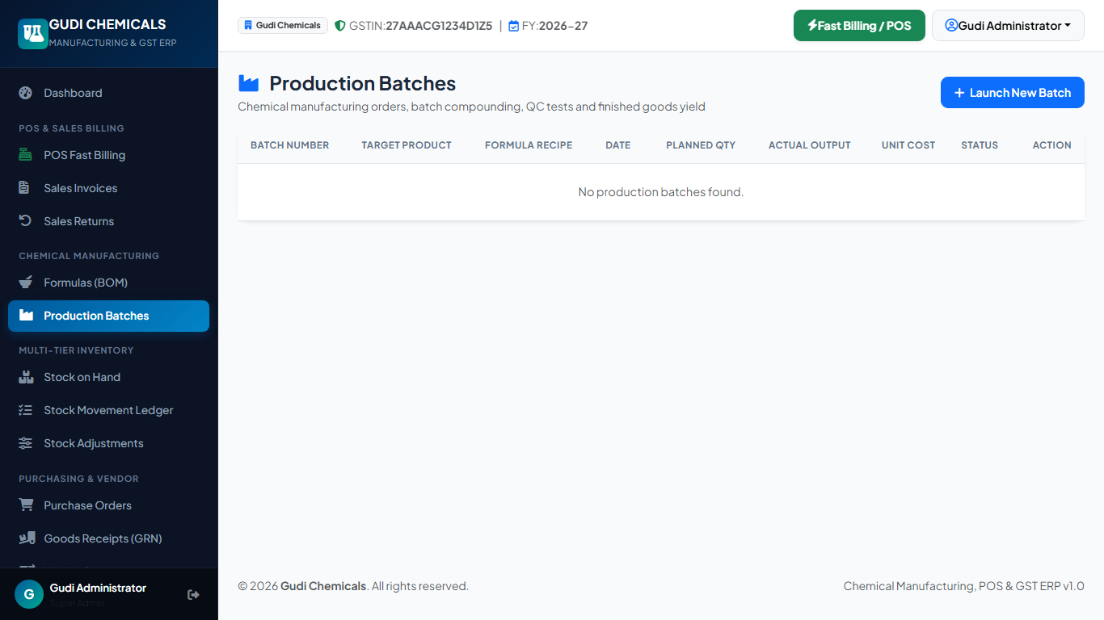
Figure 11.1: Production Orders Lifecycle Desk with Laboratory QC Verification

Chapter 12: Purchasing & Goods Receipt Notes (GRN)
Create supplier purchase orders, inspect incoming chemical deliveries at the depot gate, and post Goods Receipt Notes (GRN) to update warehouse stock.
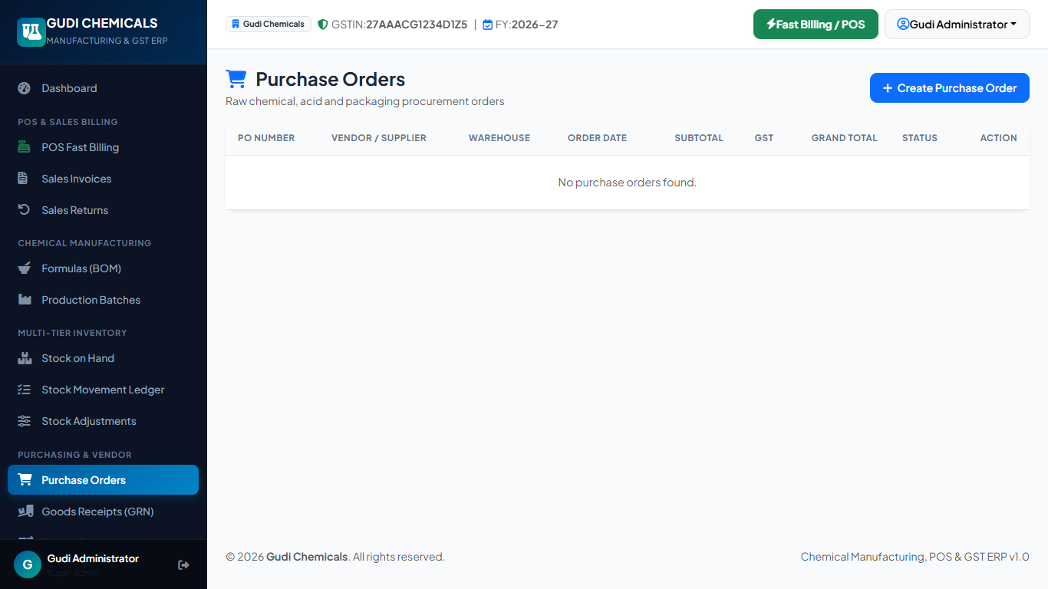
Figure 12.1: Purchasing and Goods Receipt (GRN) Management Desk

Chapter 13: Sales Returns & GST Credit Notes
Process customer returns with mandatory original invoice linking, segregating returned containers into Saleable Stock vs Quarantined Damaged Chemical Waste.
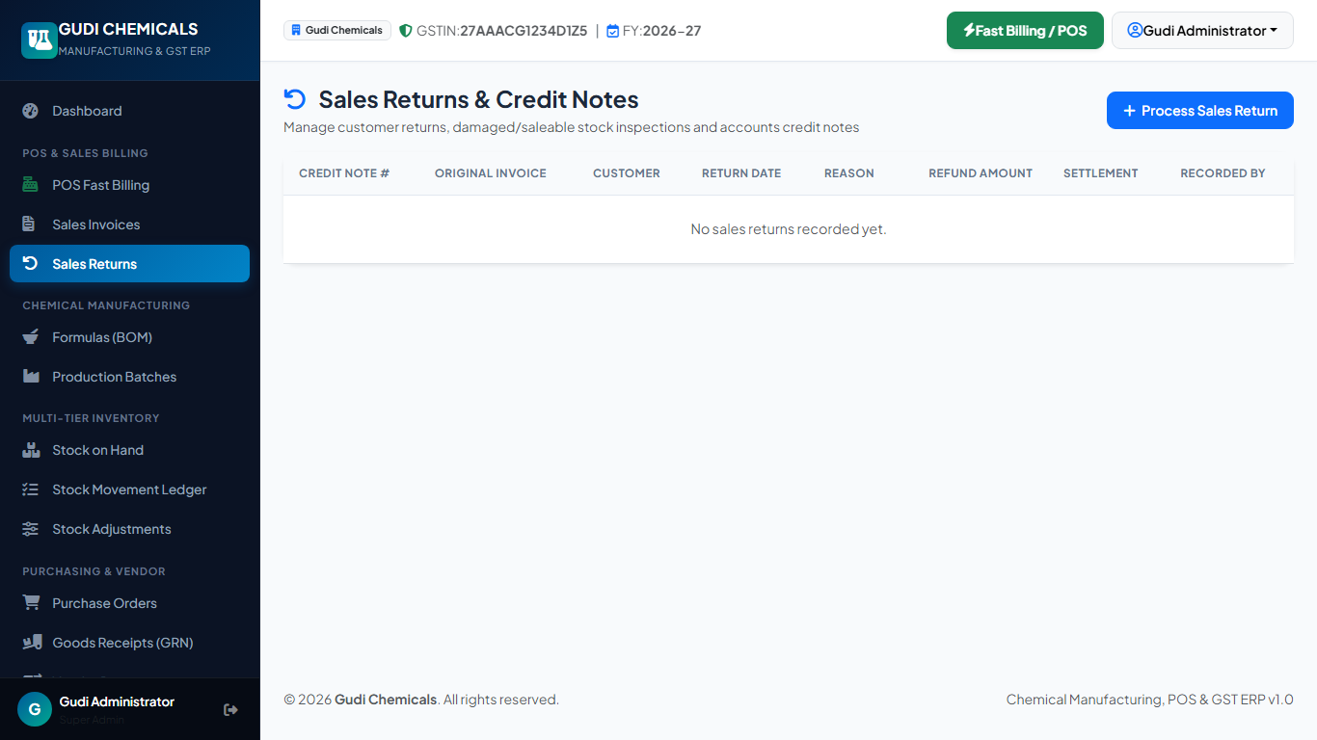
Figure 13.1: Sales Returns and Credit Note Management Desk

Chapter 14: Sales & Statutory GSTR-1 Tax Analytics
Generate daily sales registers, cash collection audits, inventory valuation reports, and monthly GSTR-1 outward supply tax summaries for filing.
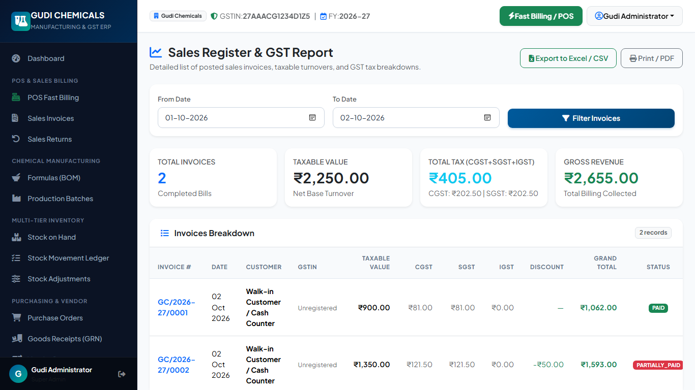
Figure 14.1: Sales & Statutory Tax Analytics Report with Date Filtering

Chapter 15: System Settings & User Administration
Configure company profile, GSTIN credentials (33AAACG1234D1Z5), Coimbatore Thenkarai address, 80mm thermal receipt margins, and staff login permissions.
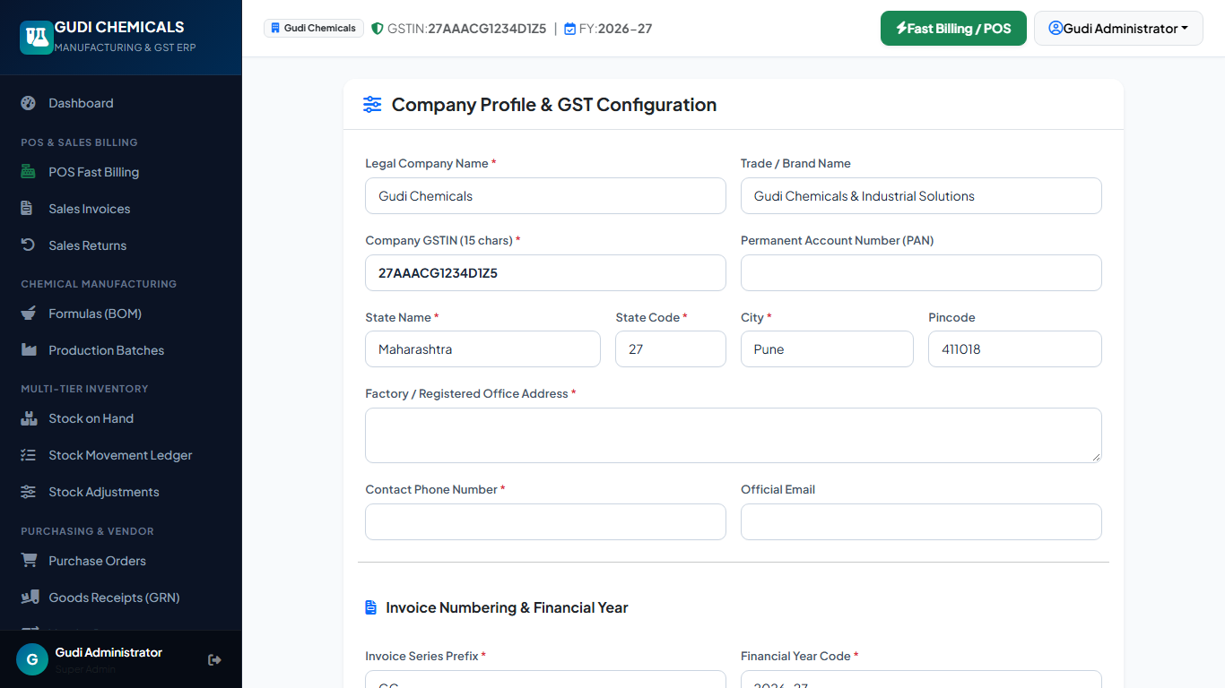
Figure 15.1: System Configuration Desk — Company Profile, Tax & Hardware Setup

Chapter 16: Keyboard Shortcuts & Technical Support
Function keys for counter cashiers: F2 (Search/Scan), F4 (Customer), F7 (Price Tier), F8 (Cash Checkout), Enter (Complete Bill), Esc (Clear/Close).
Prepared & Engineered By: ARUN CODEX (Web Developer | Designer | Innovator) for Gudi Chemicals (Spic, Thenkarai, Coimbatore, Tamil Nadu 641010). All rights reserved.

