
ARUN CODEX
WEB DEVELOPER | DESIGNER | INNOVATOR
SOFTWARE REQUIREMENTS SPECIFICATION (SRS)
Gudi Chemicals ERP — Commercial Trading, Inventory, GST & Cash-Only POS System
Project Name: | Gudi Chemicals ERP (v1.0 - Commercial Edition) | Prepared By: | ARUN CODEX
Payment Method: | Cash-Only Settlement (Fast Counter) | Scope Focus: | Trading, Inventory & Sales (Production Skipped)

1. Executive Summary & Revised Scope
This revised Software Requirements Specification is authored by ARUN CODEX (Web Developer | Designer | Innovator) for the commercial trading, inventory management, and high-speed counter checkout operations of Gudi Chemicals.
Key adjustments incorporated into this edition:
- Cash-Only Billing Architecture: Counter checkout transactions are streamlined strictly to Cash payment. Cashiers input Cash Tendered, the system instantly computes Change Due, and transactions are posted with zero gateway latency.
- Production Module Skipped: The chemical manufacturing menu (BOM recipes, intermediate compounding vats, production order execution, and laboratory QC gates) is completely excluded from this specification to focus squarely on merchandising and warehouse sales.

2. High-Speed POS & Billing Module (Cash-Only Focus)
The billing desk is the core commercial interface. It is designed for maximum speed and simplicity.
- Keyboard-Driven Cockpit: F2 for Search/Barcode, F4 for Customer, F7 for Price Tier (Retail vs Wholesale), F8 for Cash Checkout.
- Hardware Barcode Scanner Support: Automatic detection of 1D/2D container barcodes with sub-80ms cart addition and auto-incrementing quantity.
- Cash Tendered & Change Due Mechanism: Cashiers input the physical currency handed over by the customer (e.g. ₹1,000 for an ₹885 bill). The system calculates and displays Change Due (₹115.00) in bold green numerals.
- Indian GST Engine: Automatic 50:50 equal split into CGST and SGST for Intra-State sales in Tamil Nadu (State Code 33) and 100% IGST for Inter-State sales.
- Sequential Gapless Invoice Numbers: Atomic numbering (e.g. GC/2026-27/0001) using lockForUpdate concurrency locks to guarantee legal compliance.
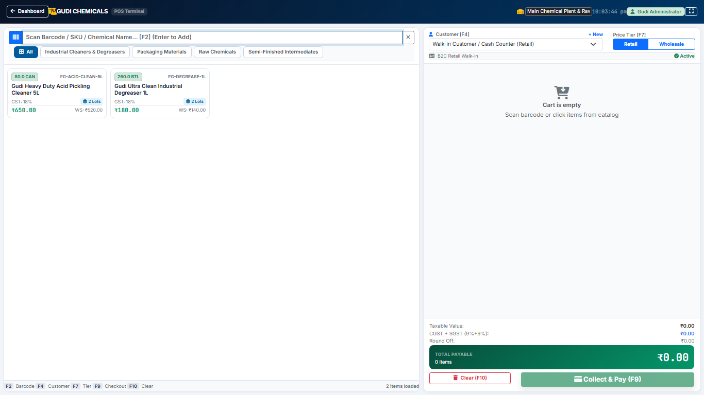
Figure 2.1: High-Speed POS Fast Billing Interface with Live Tax Calculation
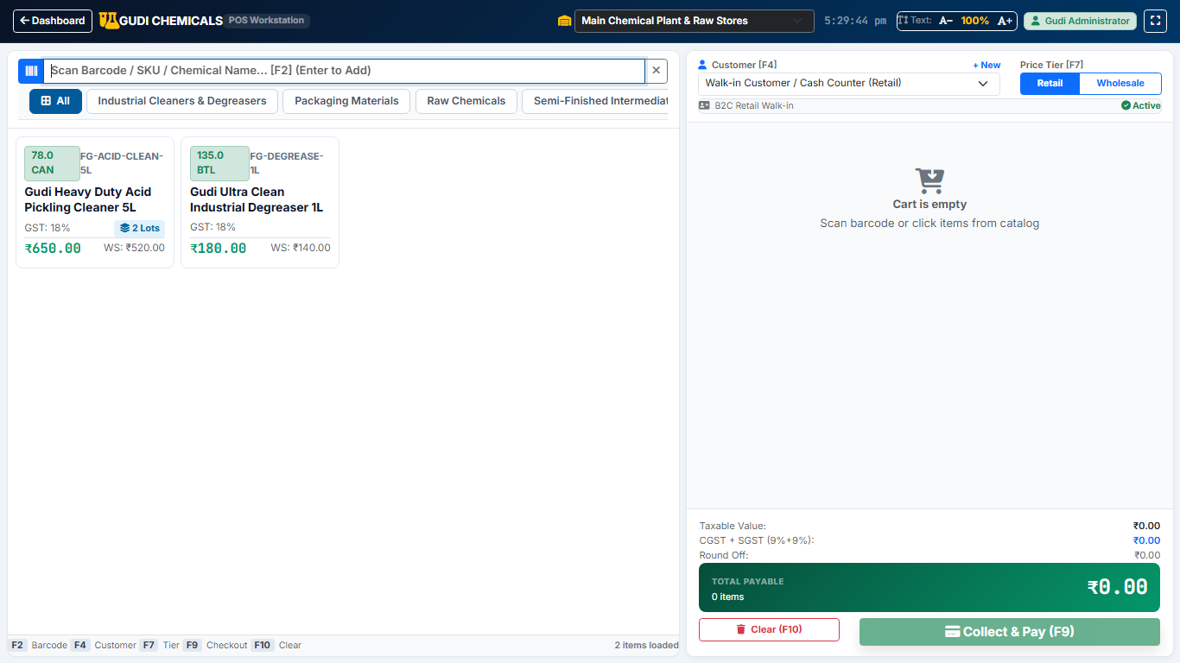
Figure 2.2: POS Cash Payment Checkout Modal with Cash Tendered and Change Due Calculation

3. Dual-Format Invoicing & Document Printing
Once a cash transaction is committed, the cashier can print in either of two standard formats:
- 80mm Thermal Receipt (POS Slip): Instant slip with store header, HSN line items, GST breakdown, cash tendered, and change returned.
- Standard A4 GST Tax Invoice: Official 3-copy commercial tax invoice compliant with GST Rule 46 with complete HSN tax summary table.
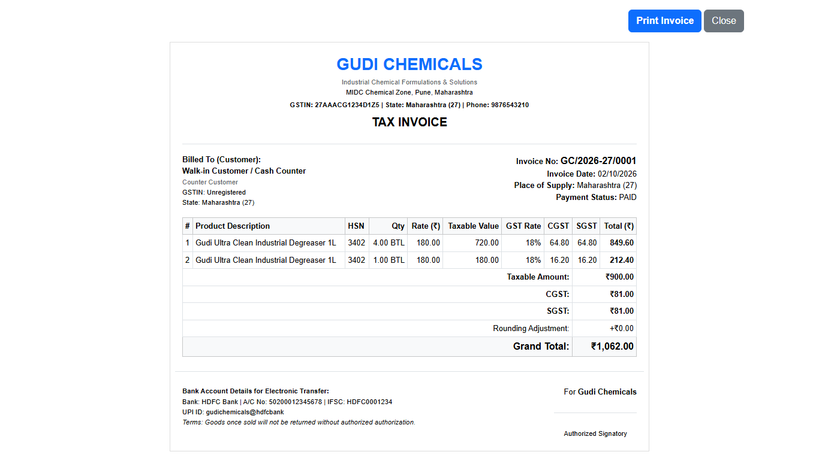
Figure 3.1: Standard A4 GST Tax Invoice Print Preview with Complete HSN & Tax Distribution

4. Inventory, Purchasing & Reporting Suite
The system provides real-time stock balances with batch tracking, goods receipt notes (GRN) from suppliers, sales returns with stock isolation, operating expense logs, and statutory GSTR-1 summaries.
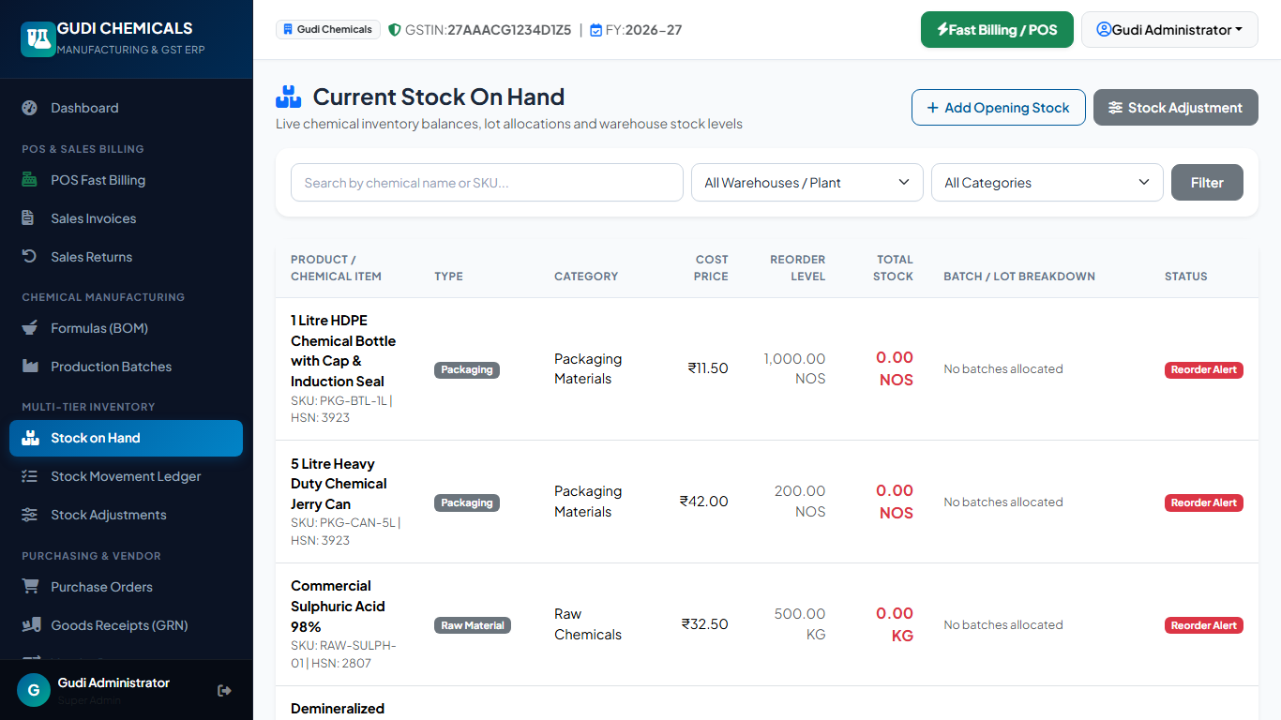
Figure 4.1: Real-Time Multi-Tier Inventory Status and Batch Valuation Screen

5. Technical Certification & Author Sign-Off
This revised Software Requirements Specification (Commercial & Cash-Only Edition) has been officially prepared and certified by ARUN CODEX (Web Developer | Designer | Innovator) as the technical baseline for Gudi Chemicals ERP.

