

LUXEDRIVE
Premium Car Showroom Management System

Submitted by
B ARUN KUMAR
BTECH IN AI &DS

Table of Contents

- Abstract 1
- Introduction 2
- System Architecture 5
- Technology Stack 7
- Features 9
- Database Design 12
- User Interface Screens 15
- Testing & Validation 18
- Conclusion & Future Scope 20
- References 22

LUXEDRIVE – Premium Car Showroom Management System

Abstract

UXEDRIVE is a comprehensive car showroom management system designed to streamline the operations of premium automotive dealerships. This software engineering project addresses the critical need for an integrated platform that manages inventory, customer relationships, sales transactions, and
L
administrative tasks in luxury car showrooms.

The system is built using modern web technologies including React for the frontend interface, Flask as the backend framework, and SQLite for efficient data management. The application provides a dual-interface approach with distinct functionalities for end-users (customers) and administrators (showroom staff).

Key features include real-time inventory management, advanced vehicle search and filtering, detailed car specifications display, appointment scheduling, customer inquiry management, and comprehensive sales analytics. The system emphasizes user experience through an intuitive interface design that reflects the premium nature of luxury automotive retail.

This project demonstrates the application of software engineering principles including requirements analysis, system design, database normalization, API development, and user interface design. The resulting system provides a scalable, maintainable, and secure solution for modern car showroom operations.
Key Highlights
•
Full-stack web application with React and Flask
•
Role-based access control for users and administrators
•
Real-time inventory and sales management
•
Responsive design optimized for all devices
LUXEDRIVE – Premium Car Showroom Management

Introduction

Background
The automotive retail industry, particularly in the luxury segment, faces unique challenges in managing complex operations involving high-value inventory, discerning customers, and intricate sales processes. Traditional methods of showroom management often rely on disconnected systems, manual record-keeping, and inefficient communication channels, leading to operational bottlenecks and suboptimal customer experiences.


Problem Statement
Premium car showrooms lack an integrated digital platform that can efficiently manage inventory, track customer interactions, process sales transactions, and provide real-time analytics. There is a critical need for a system that consolidates these functions while maintaining the high standards expected in luxury automotive retail.

Project Objectives

- Develop a user-friendly web interface for browsing luxury vehicles
- Implement secure authentication and role-based access control

- Create comprehensive inventory management system
- Enable efficient customer inquiry and appointment handling

- Provide real-time sales tracking and analytics
- Ensure scalability and maintainability of the system

Scope LUXEDRIVE – Premium Car Showroom Management System

Technology Stack

The LUXEDRIVE system is built using modern, industry-standard technologies selected for their reliability, performance, and developer ecosystem support.
React
Frontend Framework
v18.x
Component-based JavaScript library
for building user interfaces with virtual DOM for optimal performance.
Tailwind CSS
CSS Framework
v4.x
Utility-first CSS framework for rapid UI
development with responsive design capabilities.
Flask
Backend Framework
v3.x
Lightweight Python web framework for
building RESTful APIs with extensible architecture.
SQLite
Database
v3.x
Self-contained, serverless SQL
database engine providing reliable data storage.
React Router
Routing Library
v7.x
Declarative routing for React
applications enabling seamless navigation.
Lucide React
Icon Library
vLatest
Beautiful and consistent icon set for
modern web applications.

System Architecture

LUXEDRIVE follows a three-tier architecture pattern, separating presentation, business logic, and data management layers for optimal maintainability and scalability.

Frontend
Presentation
Layer

HTTP/REST

Backend
Business
Logic Layer

SQL

Database
Data Layer

React Tailwind CSS React Router

Flask RESTful API Authentication
SQLite Relational DB ACID Compliant

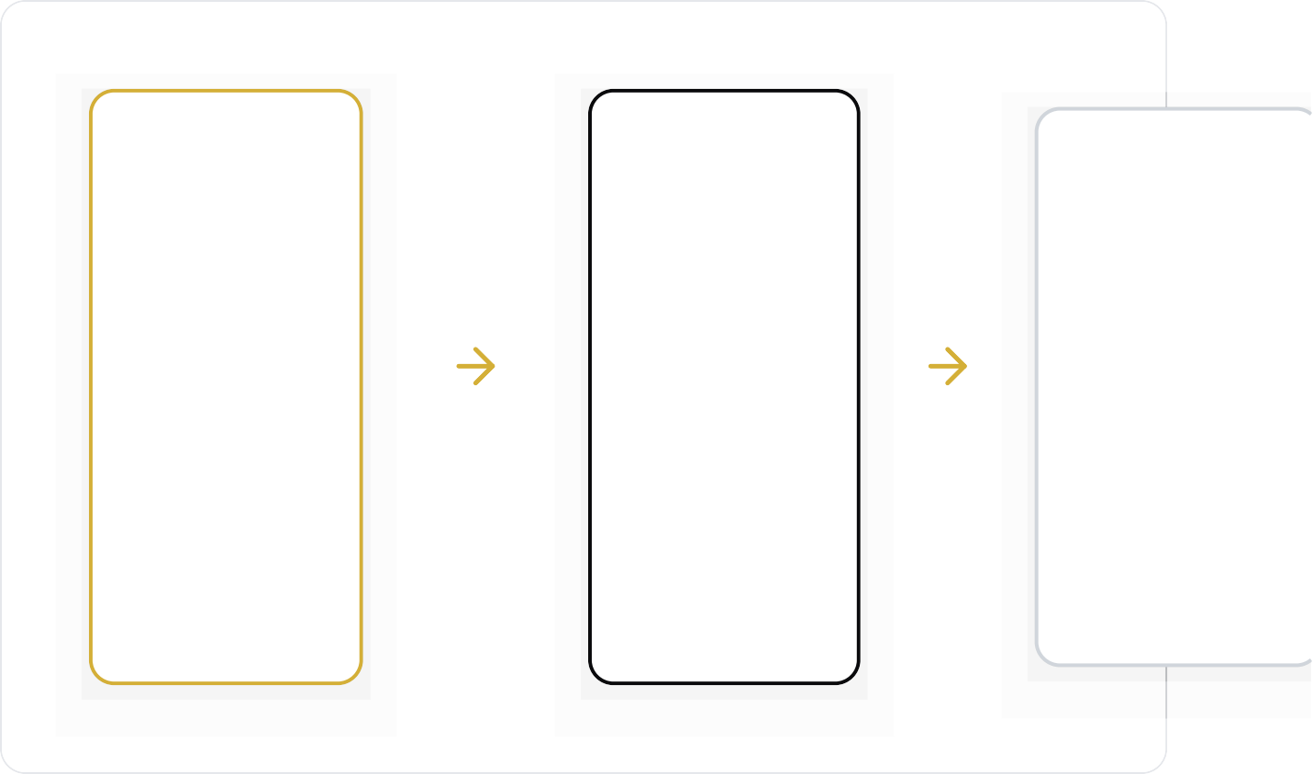
Presentation Layer
React-based single-page application providing an interactive user interface with component-based architecture and responsive design using Tailwind CSS.
Application Layer
Flask framework handling business logic, request routing, authentication, authorization, and
serving RESTful API endpoints to the frontend.

LUXEDRIVE – Premium Car Showroom Management System
Data Layer
SQLite database managing persistent storage with normalized schema
design, ensuring data
integrity and efficient query performance.

Features

User Features




Advanced Vehicle Search Filter cars by brand, model, price range, year, and
specifications

Detailed Car Information View comprehensive specs, high-res images, and pricing
details

Test Drive Booking
Schedule appointments for test drives at preferred time slots

Inquiry System
Submit purchase inquiries and receive prompt responses

User Profile
Manage personal information and view inquiry history

Admin Features


Inventory Management
Add, update, and remove vehicle listings with real-time updates

Sales Analytics
Track sales performance, revenue, and customer trends


Appointment Management
View and manage test drive
schedules and customer
bookings
Customer Management Access customer profiles, inquiries, and interaction history

LUXEDRIVE – Premium Car Showroom Management System

 Database Design

The database schema is designed following normalization principles to ensure data integrity, minimize redundancy, and optimize query performance.
Users
Stores user account information
user_id
INTEGER
PK
Primary key
username
VARCHAR(50)
Unique username
email
VARCHAR(100)
UNIQUE
User email
password_hash
VARCHAR(255)
Hashed password
role
VARCHAR(20)
user/admin
created_at
DATETIME
Registration date
FIELD NAME DATA TYPE KEY DESCRIPTION

Vehicles
Stores vehicle inventory
FIELD NAME | DATA TYPE KEY DESCRIPTION
vehicle_id | INTEGER PK Primary key
brand | VARCHAR(50) Car brand
model | VARCHAR(50) Car model
year | INTEGER Manufacturing year
price | DECIMAL(12,2) Price in USD
status | VALRUCXHEDARRI(VE20– )Premium Car Showroom Management Syasvteamilable/sold

Appointments
Manages test drive bookings
FIELD NAME | DATA TYPE | KEY | DESCRIPTION
image_url | VARCHAR(255) | Image path

FIELD NAME | DATA TYPE | KEY | DESCRIPTION
appointment_id | INTEGER | PK | Primary key
user_id | INTEGER | FK | References Users
vehicle_id | INTEGER | FK | References Vehicles
appointment_date | DATETIME |  | Scheduled date/time
status | VARCHAR(20) |  | pending/confirmed/completed

FIELD NAME | DATA TYPE | KEY | DESCRIPTION
inquiry_id | INTEGER | PK | Primary key
user_id | INTEGER | FK | References Users
vehicle_id | INTEGER | FK | References Vehicles
message | TEXT |  | Inquiry message
created_at | DATETIME |  | Submission date
status | VARCHAR(20) |  | new/responded

Key Relationships

Inquiries
Customer inquiries and messages
- One User can have multiple Appointments and Inquiries (One-to-Many)
- One Vehicle can be associated with multiple Appointments and Inquiries (One-to-Many)
- Foreign key constraints ensure referential integrity across tables

 User Interface Screens

The user interface is designed with a focus on elegance, usability, and responsive design principles. Below are the key screens of the application.
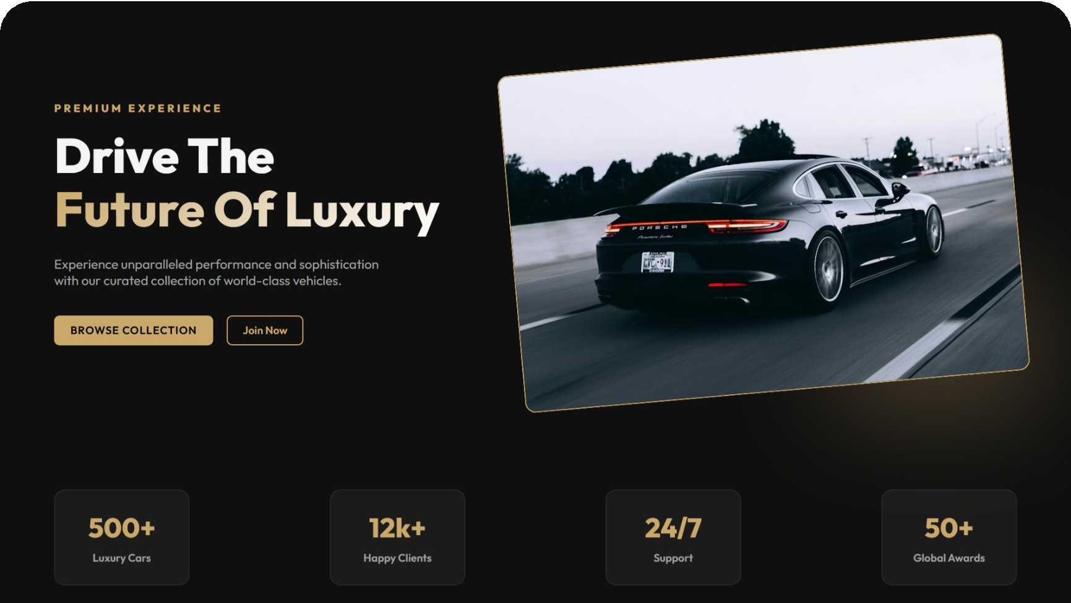
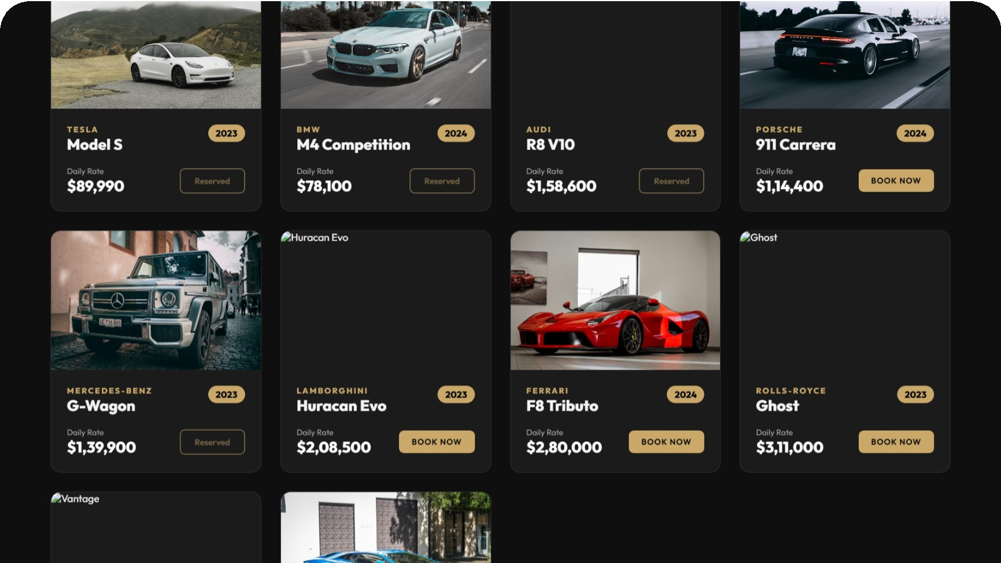
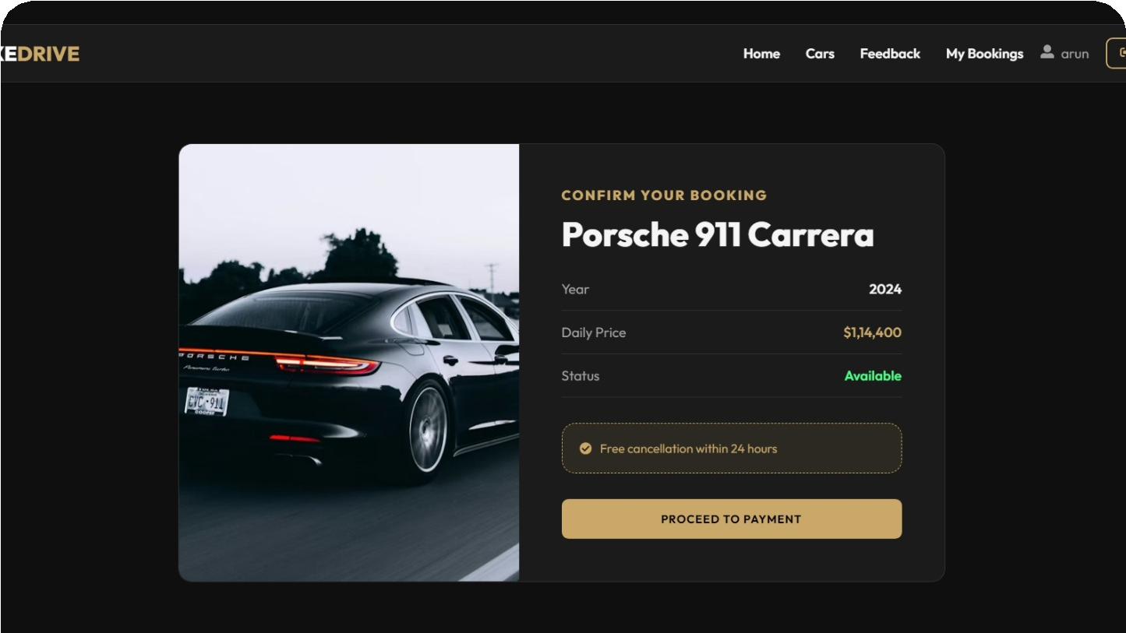
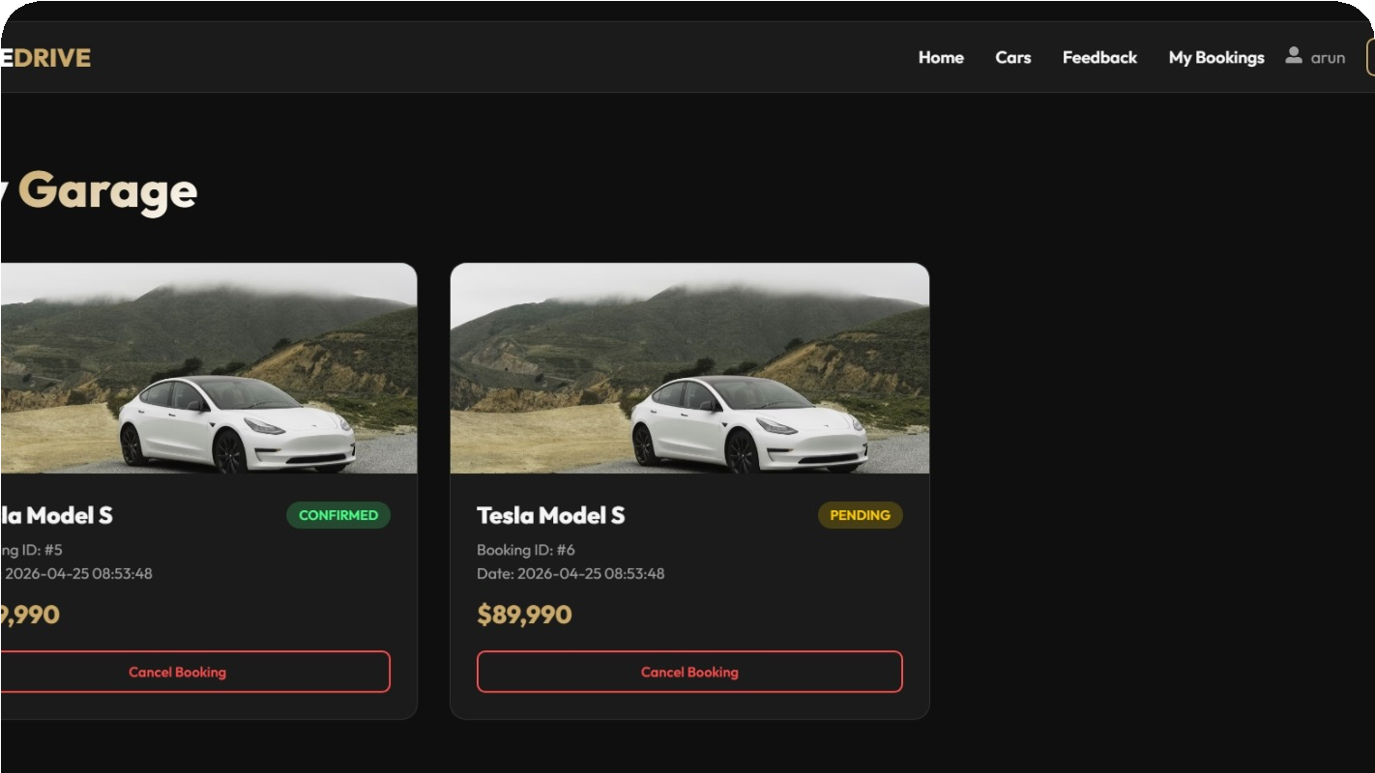
Home Page
Landing page with featured vehicles and search functionality
Figure 1
Vehicle Catalog
Grid view of all available vehicles with filtering options
Figure 2
Vehicle Details
Detailed view with specifications, images, and inquiry form
Figure 3
User Dashboard
User profile, appointment history, and saved vehicles
Figure 4

LUXEDRIVE – Premium Car Showroom Management System

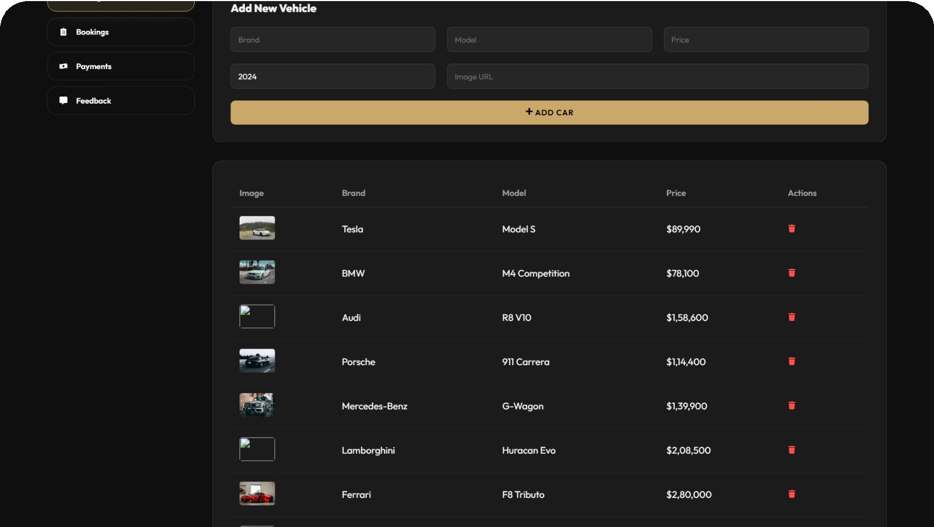
Admin Dashboard
Overview of sales, inventory, and system statistics
Figure 5
Inventory Management
Admin interface for adding and managing vehicle listings
Figure 6

Design Principles

Responsive Design
Optimized for desktop, tablet, and mobile devices
Consistent Branding
Unified color scheme and typography throughout
Intuitive Navigation
Clear user flows and accessible interface elements

Conclusion & Future Scope

Conclusion
The LUXEDRIVE Premium Car Showroom Management System successfully addresses the critical challenges faced by luxury automotive dealerships in managing their operations efficiently. Through the integration of modern web technologies and adherence to software engineering best practices, the system delivers a comprehensive solution that streamlines inventory management, enhances customer engagement, and provides valuable business insights.
The project demonstrates the practical application of full-stack web development principles, encompassing frontend design with React, backend API development with Flask, and database design with SQLite. The implementation showcases key concepts including component-based architecture, RESTful API design, authentication and authorization, and responsive user interface development.
The resulting system provides a robust, scalable, and user-friendly platform that elevates the showroom experience for both customers and administrators. By automating routine tasks and providing real-time data access, LUXEDRIVE enables showroom staff to focus on what matters most: delivering exceptional customer service and driving sales.

Key Achievements
- Successful implementation of role-based access control

- Efficient database schema with normalized structure

- Intuitive and responsive user interface design
- RESTful API architecture for scalability

Future Enhancements

The following enhancements are proposed to extend the system's capabilities and adapt to evolving business needs:

LUXEDRIVE – Premium Car Showroom Management System

Integration with payment gateways for online transactions and deposit processing

AI-powered recommendation system based on user preferences and browsing history

Mobile application development for iOS and Android platforms

Advanced analytics dashboard with predictive insights and business intelligence

Integration with third-party services (insurance, financing, vehicle history)

Multi-language support for international expansion

Virtual showroom with 360° vehicle views and AR features

Customer relationship management (CRM) enhancements

LUXEDRIVE represents a significant step forward in automotive retail technology, demonstrating how thoughtful software design can transform traditional business operations into efficient, modern, and customer-centric experiences.

