**IBM Virtual Faculty Buildathon 2023**

**Project Report on**

**E-Shikshana**

**An application to assess online education system. Comparative study about traditional and online education system**

**Submitted by**

**Name : Aruna Kumar P**

**College: JNN College of Engineering, Shivamogga, Karnataka, India**

**Email: [arunkumarp@jnnce.ac.in](mailto:arunkumarp@jnnce.ac.in)**

**College ID / Employee ID: 10166**

**IBM Virtual Faculty Buildathon 2023: Data Analytics with Cognos**

**Badge Secured: Journey to Cloud: Envisioning Your Solution**

**Contents**

|  |  |  |
| --- | --- | --- |
| **Sl.No** | **Titles** | **Page No** |
| 1 | **Introduction** |  |
| 2 | **Literature Survey** |  |
| 3 | **Theoretical Analysis** |  |
| 4 | **Experimental Investigations** |  |
| 5 | **Flowchart** |  |
| 6 | **Result** |  |
| 7 | **Advantages & Disadvantages** |  |
| 8 | **Applications** |  |
| 9 | **Conclusion** |  |
| 10 | **Future Scope** |  |
| 11 | **Biblography** |  |
|  | **Appendix** |  |

**CHAPTER 1:**

**INTRODUCTION**

In this chapter online education system is briefly explained also purpose of new education system are explained.

* 1. **Overview**

Traditional education system was adopted manual methods of teaching, assessing the students. Which will leads to delayed and wrong assessment some time. Here, new approach is introduced to give the education through the advanced software tools and technologies. Online education System offers education for wide range of students through online tools.

* 1. **Purpose**

Now a days online education is offered by many organizations by using all the advanced technologies to offer quality and effective education. New education systems offers skill based and activity based education instead of traditional approaches to meet the requirements of Industry. So online education systems trying to fulfill all the expectations and requirements of the industry. So here the advanced tools and technologies are used to assess and check the performance of the students through software tools, which will save the time and assess the performance more accurately.

**CHAPTER 2:**

**LITERATURE SURVEY**

In this chapter some information about traditional and new education systems are discussed.

**2.1 Existing Problem**

Existing education system is traditional approach. In which students has to attend classes regularly. Test will be conducted manually to assess the students. This manual assessment leads to wrong assessment. Also students learning capability and skills are not explored properly due to human errors in traditional education system

**2.1 Proposed Solution**

Proposed online education system will overcome all the drawbacks of traditional education system. Online education system will attracts the students through activity based learning, skill enhancement problems and will create interests on learners. Also they can work more flexible and gain the knowledge.

**CHAPTER 3:**

**THEORITICAL ANALYSIS**

**3.1 Block Diagram**

**Assessment Tools**

**Trainers / Faculty**

**Students**

**Online Education System**

Online education system act as the central hub for all stakeholders. Students are take the course upon their interest. Students can go through all the contents available in the software tool. If they need interaction regards any particular topic of interest or facing difficulty to understand any topic can contact the faculty or trainers.

Faculty or trainers can conduct online classes for the offered courses in scheduled time slot and make the discussion among the students through the online portal. Also they can conduct separate meetings for brainstorming sessions to solve any problems which are difficult.

Many assessment software tools and technologies are used to assess the students performance. If any student/s unable to meet the requirements of the course can be easily detected on in time , and further actions will be taken place.

**3.2 Hardware / Software designing**

To find the solution its requires some hardware and software tools

1. **Hardware Requirements**

* Computers, Laptops, Tabs
* Internet connectivity
* Web Cameras
* Printers

1. **Software Requirements**

* Operating systems
* Browsers
* Cloud space

**CHAPTER 4:**

**EXPERIMENTAL INVESTIGATIONS**

**Step1: Data set has been uploaded into IBM Cognos**

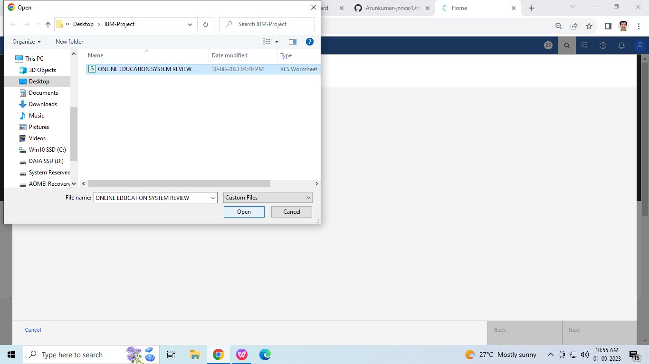

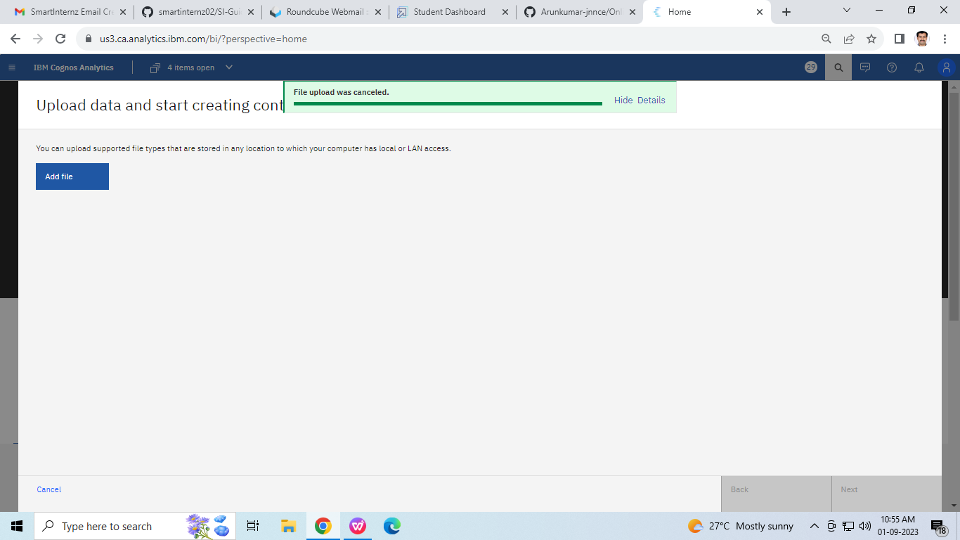

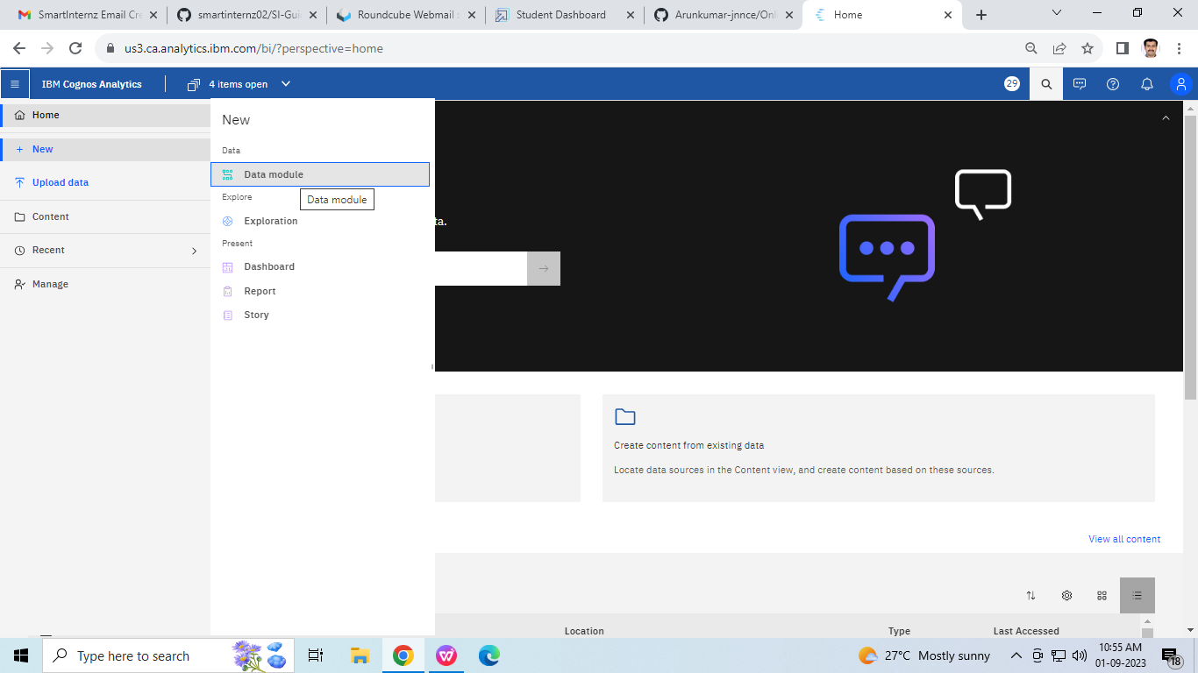

**Step2: Data set has been uploaded into IBM Cognos**

**Step3: Many explorations are created**

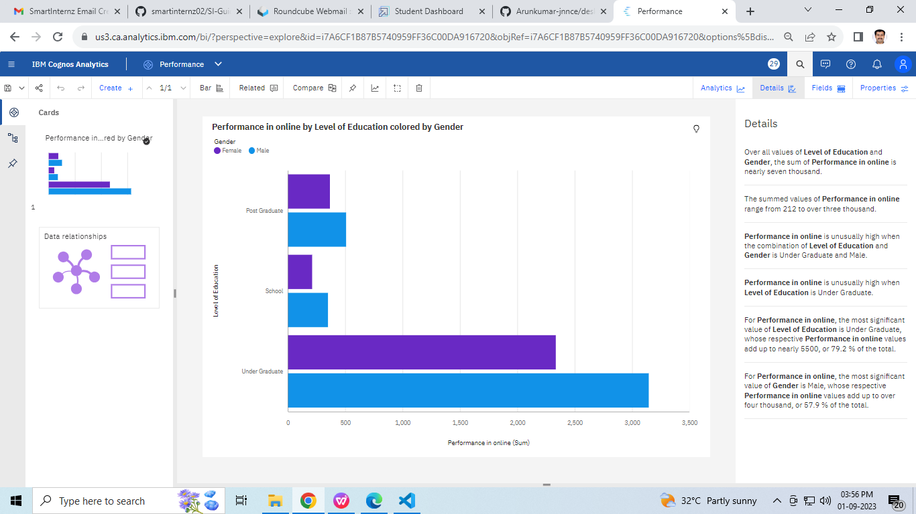

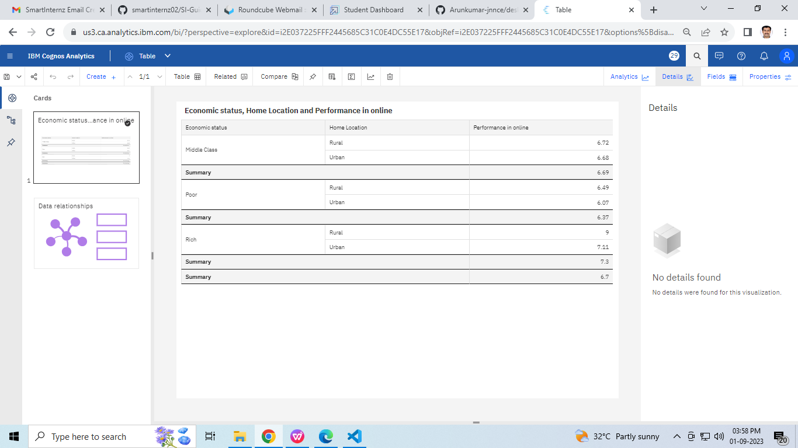

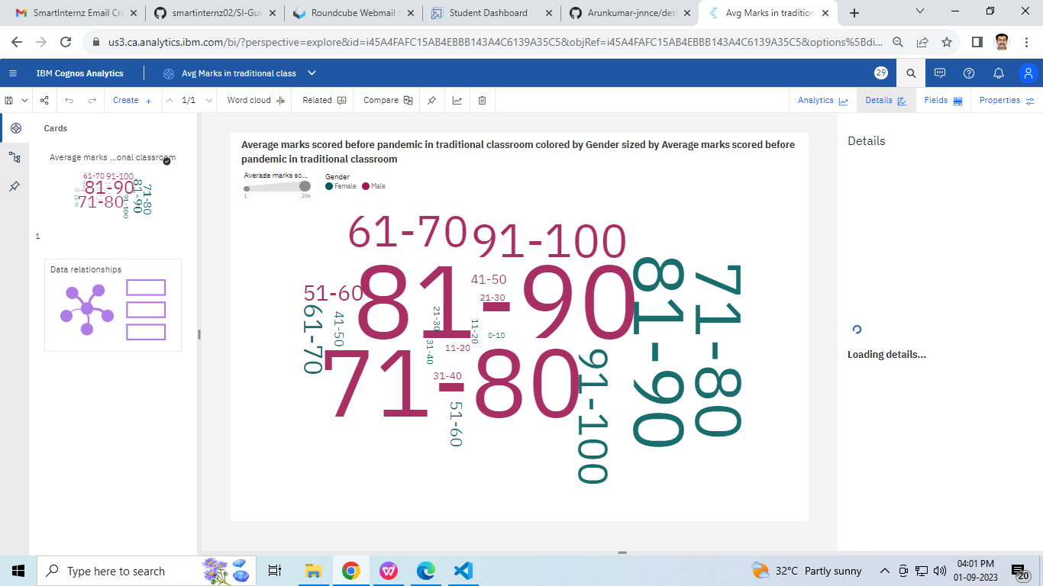

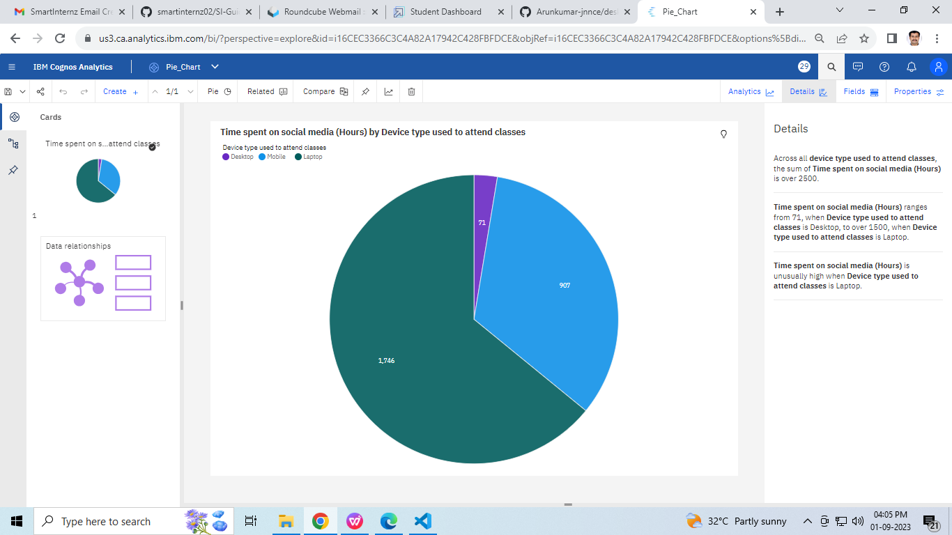

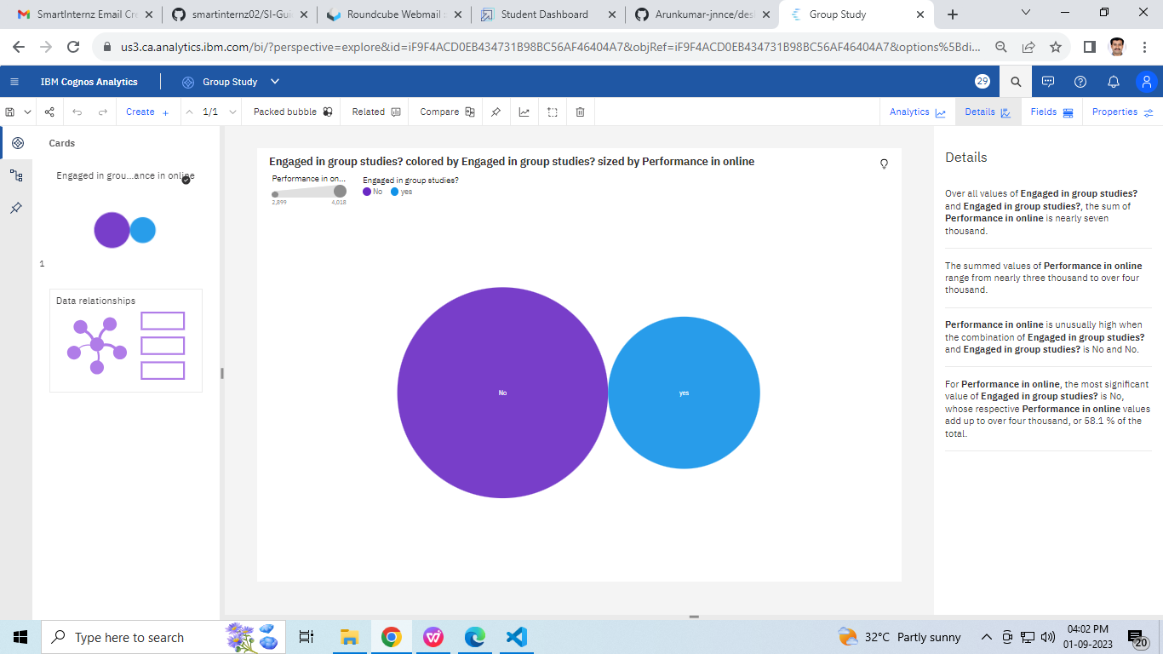

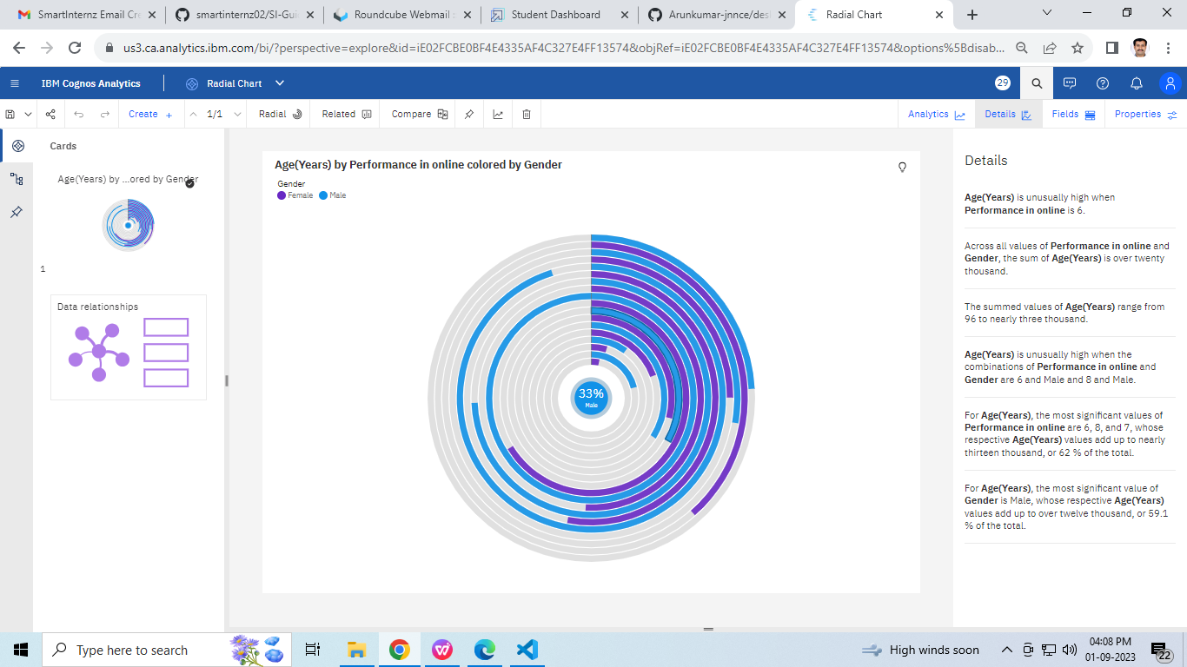

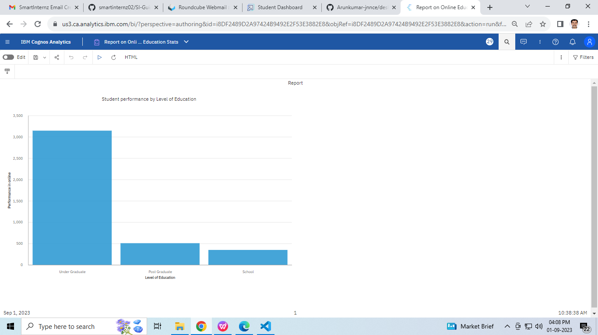

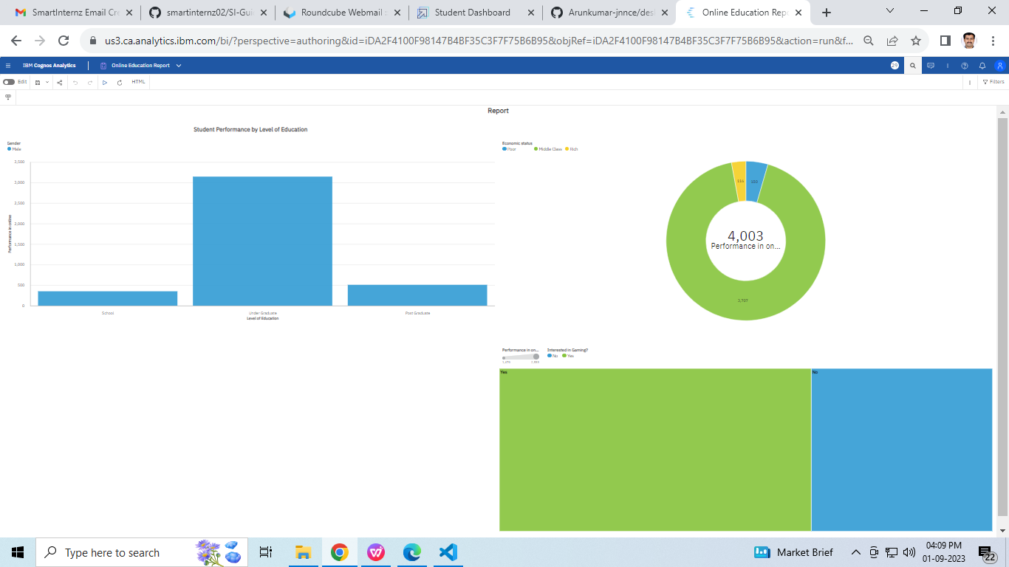

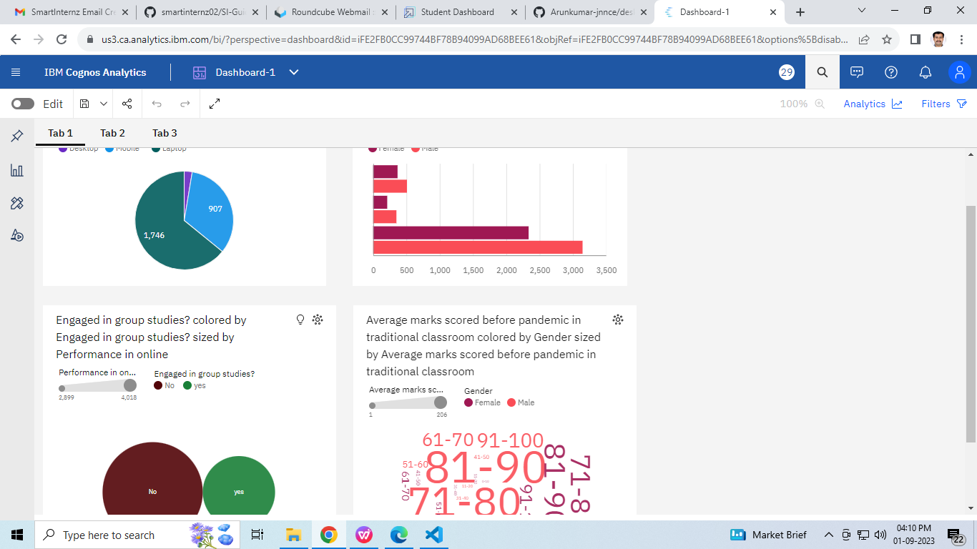

**CHAPTER 5:**

**ADVANTAGES AND DISADVANTAGES**

**5.1 ADVANTAGES**

* Easy to learn
* Cheaper in cost
* Time saving
* More flexible in time management
* Wider range of scalability
* Freedom in learning
* More tools are available
* Available at any time
* Assessment is accurate and fast
* Progress can be visible

**5.2 DIS-ADVANTAGES**

* No proper interaction between learner and trainer
* May leads to improper learning
* May not possible to clear doubts in time
* Lack of connection between trainer and learner decreases humanity

**CHAPTER 6:**

**APPLICATIONS**

Online education system can be used in following areas

* To offer online courses
* To train the group of people for training any particular tool
* To train the new employees

**CONCLUSION**

Online education system is good replacement over traditional education system, which will enable much better environment for learners and will create learning atmosphere among the students. Also automated assessment tools are enables trainer to assess students / learners learning capability on time more reliable.