**Student Portfolio**

|  |  |
| --- | --- |
| **ARUNKUMAR S** | |
|  | **Register Number: RA2311056010053**  **Mail ID: ak4085@srmist.edu.in**  **Department: Data Science &Business Systems**  **Year / Sem/ Section: 2-Year / 3-Sem / AL-1** |
| **Subject Title: 21CSC201J Data Structures and Algorithms**  **Handled By: Dr. K.Rajkumar** | |
| **Email: arunkumar.s051020@gmail.com**  **LinkedIn: https://www.linkedin.com/in/arun-kumar-162b25287**  **GitHub: https://github.com/Arunkumar2010/Arun**  **Portfolio Website (if any): https://arunkumar201005.my.canva.site/coming-soon-website-coming-soon-page-in-black-white-dark-futuristic-style** | |
| **E-Lab Completion Status** | |
| **Lab Experiment Completion status** | |
| **SOLVED REAL WORLD PROBLEM / CONCEPTUAL TASK** | |
| **CERTIFICATIONS (Coursera/edX/etc.)**  **Include any online courses, workshops, or certifications related to Dat Structures and algorithms, problem-solving** | |
| **NPTEL/HOTS QUESTIONS SOLUTION** | |
| **CODING COMPETITIONS**  **Any notable rankings or achievements in coding contests**  **(e.g., LeetCode, CodeChef, HackerRank, Codeforces, ICPC)** | |

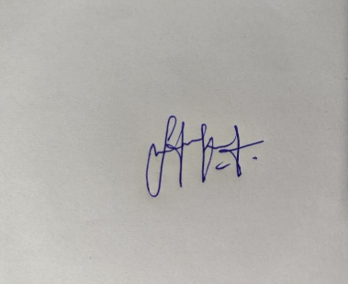

**Signature of the Student**