Django framework

Django is a Python framework that makes it easier to create web sites using Python.

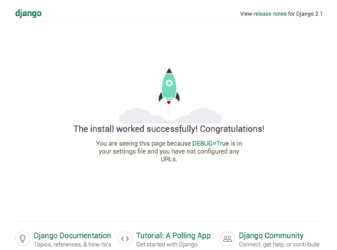

Django takes care of the difficult stuff so that you can concentrate on building your web applications.

Django emphasizes reusability of components, also referred to as DRY (Don’t Repeat Yourself), and comes with ready-to-use features like login system, database connection and CRUD operations (Create Read Update Delete).

Templates

In the Django Intro page, we learned that the result should be in HTML, and it should be created in a template, so let’s do that.

Create a templates folder inside the members folder, and create a HTML file named myfirst.html.

The file structure should be like this:

My_tennis_club

Manage.py

My_tennis_club/

Members/

Templates/

Myfirst.html

Open the HTML file and insert the following:

My_tennis_club/members/templates/myfirst.html:

<!DOCTYPE html>

<html>

<body>

<h1>Hello World!</h1>

<p>Welcome to my first Django project!</p>

</body>

</html>

Modify the View

Open the views.py file and replace the members view with this:

My_tennis_club/members/views.py:

From django.http import HttpResponse

From django.template import loader

Def members(request):

Template = loader.get_template(‘myfirst.html’)

Return HttpResponse(template.render())

Change Settings

To be able to work with more complicated stuff than “Hello World!”, We have to tell Django that a new app is created.

This is done in the settings.py file in the my_tennis_club folder.

Look up the INSTALLED_APPS[] list and add the members app like this:

T

My_tennis_club/my_tennis_club/settings.py:

INSTALLED_APPS = [

‘django.contrib.admin’,

‘django.contrib.auth’,

‘django.contrib.contenttypes’,

‘django.contrib.sessions’,

‘django.contrib.messages’,

‘django.contrib.staticfiles’,

‘members’

]

Then run this command: QQ



Flash framework

Flask Tutorial provides the basic and advanced concepts of the Python Flask framework. Our Flask tutorial is designed for beginners and professionals.

Flask is a web framework that provides libraries to build lightweight web applications in python. It is developed by Armin Ronacher who leads an international group of python enthusiasts (POCCO).

Return ‘The project page’

@app.route(‘/about’)

Def about():

Return ‘The about page

Variable Rules

You can add variable sections to a URL by marking sections with <variable_name>. Your function then receives the <variable_name> as a keyword argument. Optionally, you can use a converter to specify the type of the argument like <converter:variable_name>.

From markupsafe import escape

@app.route(‘/user/<username>’)

Def show_user_profile(username):

# show the user profile for that user

Return f’User {escape(username)}’

@app.route(‘/post/<int:post_id>’)

Def show_post(post_id):

# show the post with the given id, the id is an integer

Return f’Post {post_id}’

@app.route(‘/path/<path:subpath>’)

Def show_subpath(subpath):

# show the subpath after /path/

Return f’Subpath {escape(subpath)}’