ASSET MANAGEMENT SYSTEM
End-User Operations Manual & UI Guide
Client Organization: KT Telematic Solutions Private Limited
Platform Tech Stack: Node.js, Express, PostgreSQL (Neon DB), Pug, Bootstrap
Created: July 2026
This manual describes the system features and step-by-step procedures for employee registration, asset onboarding, allocation, returns, and scrap workflows.

1. Dashboard (Stock View)
The Stock View dashboard provides a bird's eye view of the entire organization's hardware inventory that is currently in stock and available for assignment. It displays metrics for total count, total monetary value of available stock, a summary table detailing count and value per branch, and a search-enabled table listing specific available asset items.
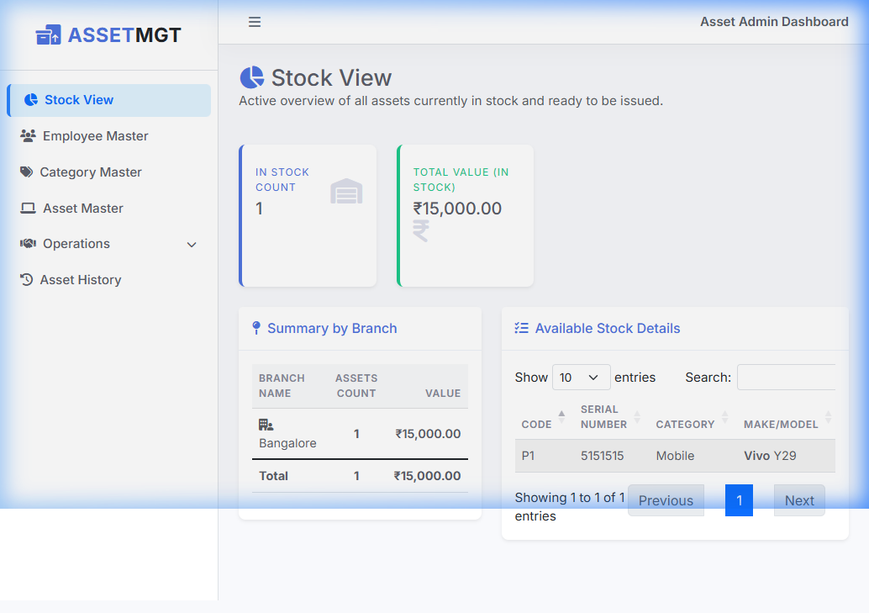

2. Employee Master
The Employee Master interface allows system administrators to register new employees, update details for existing ones, search for employees by name or email, and apply filters to view Active or Inactive staff members. This registry acts as the source for asset allocation.
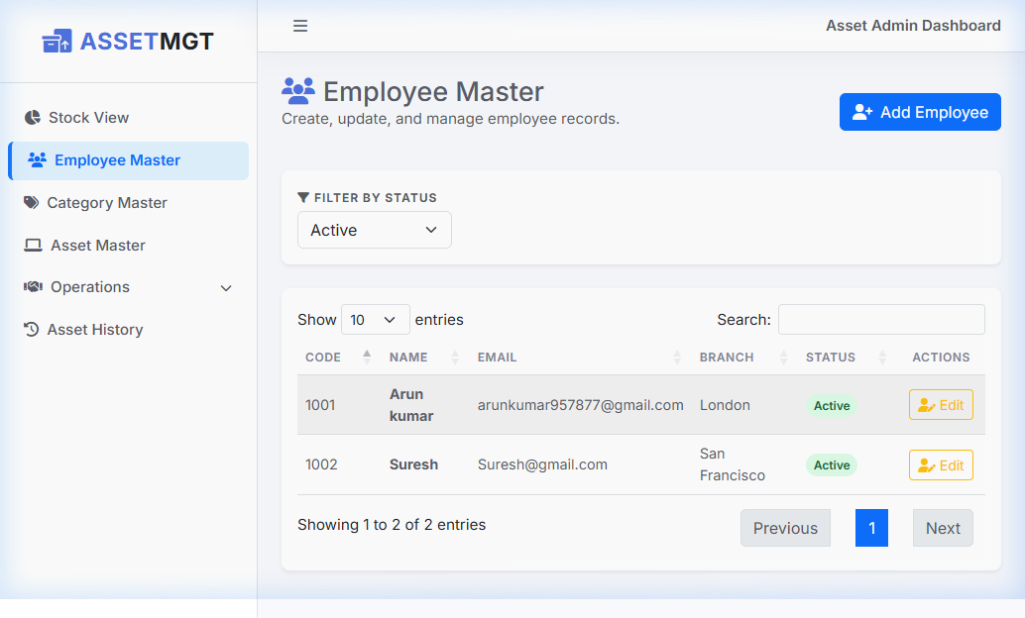

3. Asset Master
The Asset Master module enables registering, updating, and viewing all physical hardware inventory assets. Each item is registered with its unique Asset Code, Serial Number, Category, Make, Model, Purchase Date, Value, and Branch. Advanced filtering and searching make it easy to find specific models.
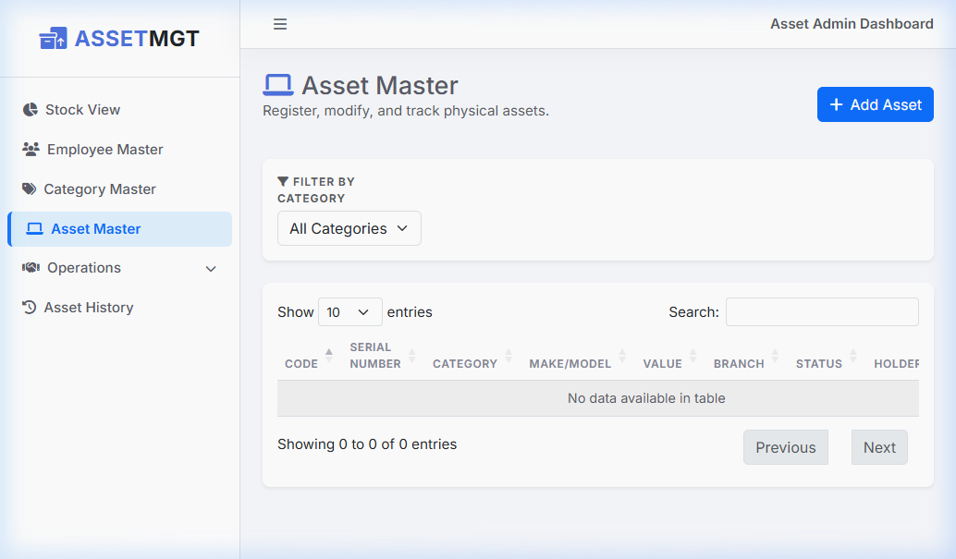

4. Asset Category Master
The Asset Category Master manages hardware groups/types such as Laptops, Mobile Phones, Screwdrivers, etc. This taxonomy drives category lists, sorting, and reporting throughout the application.
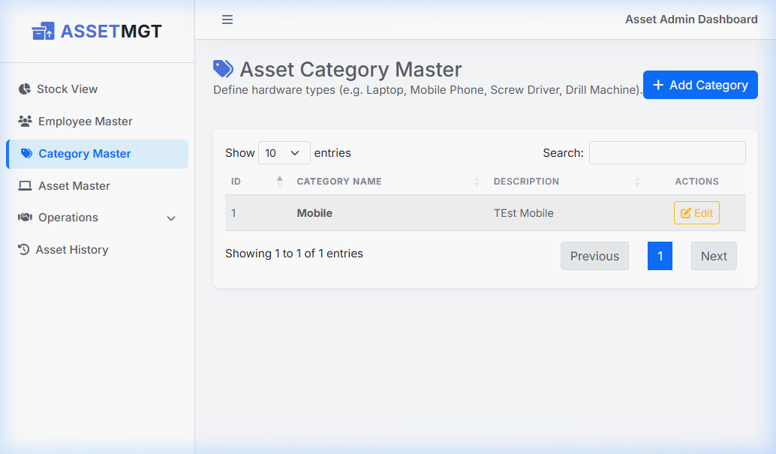

5. Issue Asset
The Issue Asset wizard allows staff to allocate physical hardware assets directly to employees. The system lists available in-stock items, selects the target active employee, and updates the asset status from 'In Stock' to 'Issued'.
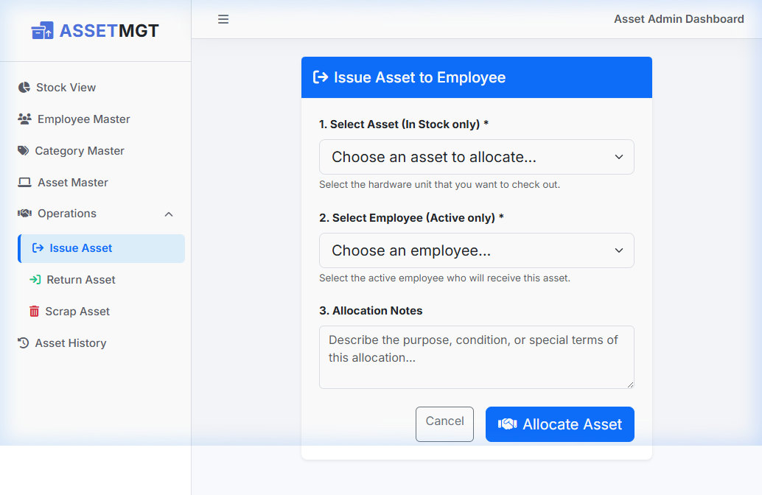

6. Return Asset
The Return Asset page handles taking back hardware from employees. It registers return reasons such as upgrade, repair, or employee resignation, and returns the asset to 'In Stock' status or marks it for other pipelines.
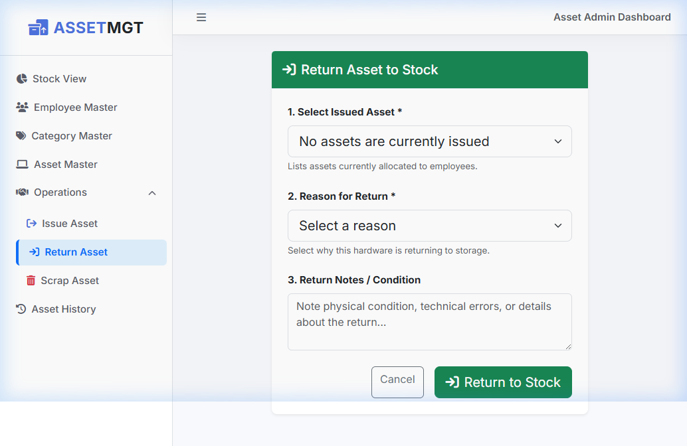

7. Scrap Asset
The Scrap Asset page allows users to declare assets obsolete or broken. Scrap reasons (e.g. damaged, out of date) and comments are captured, following which the asset is hidden from active stock lists and remains only visible in historical reports.
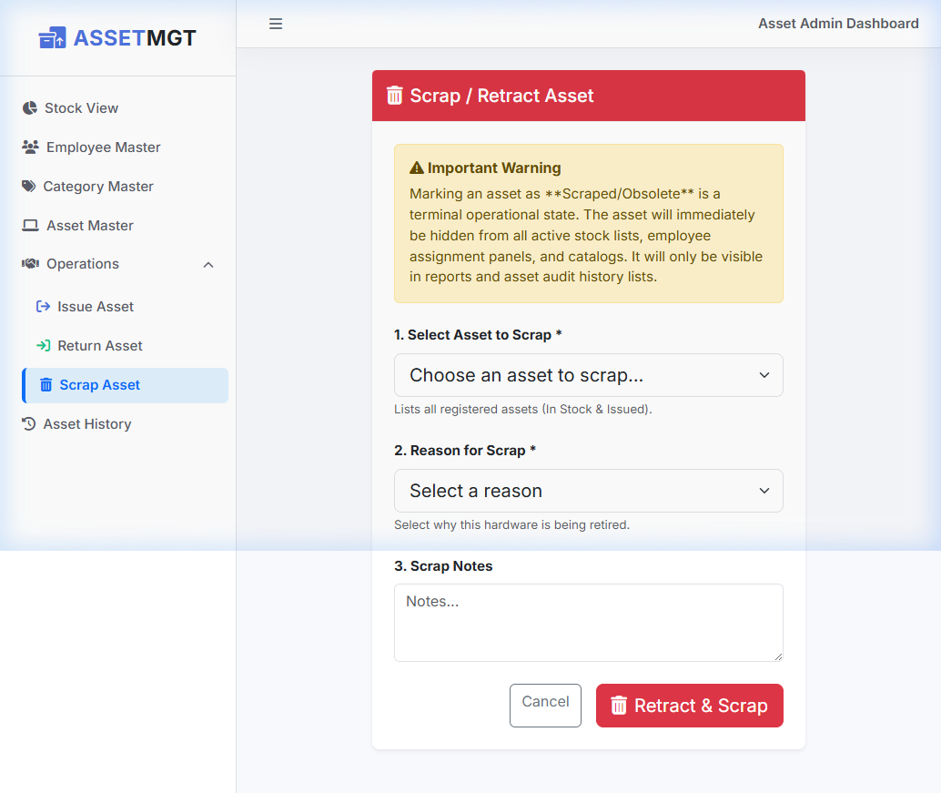

8. Asset History
The Asset History module displays the full lifecycle log of an asset from its initial registration/purchase, through all employee allocations/returns, up to its final scrap declaration. This details utilization, return reasons, and history.
