Suven Consultants & Technology Pvt. Ltd.

***Official member to***

**CERTIFICATE OF INTERNSHIP**

This is to certify that **ARUN KUMAR K** has successfully completed **2 weeks (or 70 hrs) HTML5+CSS3** Coding Internship.

1. 365 Entertainment - similar to Hotstar.com
2. Blogging - similar to Medium.com
3. CSS3 Animations
4. Voter Registration - Replica of National Voter Service Portal Form 6

The projects were assessed by AI Engine trained by mentors as listed on [**https://mentor.suvenconsultants.com**](https://mentor.suvenconsultants.com/)

# Your performance was **Enviable** - in the Online Internship. Wishing you all the best for more internships and a great career.

Your Internship Profile can be viewed on [https://internship.suvenconsultants.com/user?u=YXJ1bmt1bWFyazE2NjRAc2N0cGw=](https://internship.suvenconsultants.com/user?u=YXJ1bmt1bWFyazE2NjRAc2N0cGw%3D)

**Date of Issue:** 02-08-2022

This is auto generated by our ai engine

Domain Expert: Rocky Jagtiani Technical Head - SCTPL [https://suvenconsultants.com](https://suvenconsultants.com/)

Domain Expert: Niraj Sharma UI/UX expert and Software Engineer

## NeoSOFT Technologies

Domain Expert: Tarik Sheth MCP,HP(AIS),CSTE,CSQA,CSTM

## VP(in Investment Banking MNC)

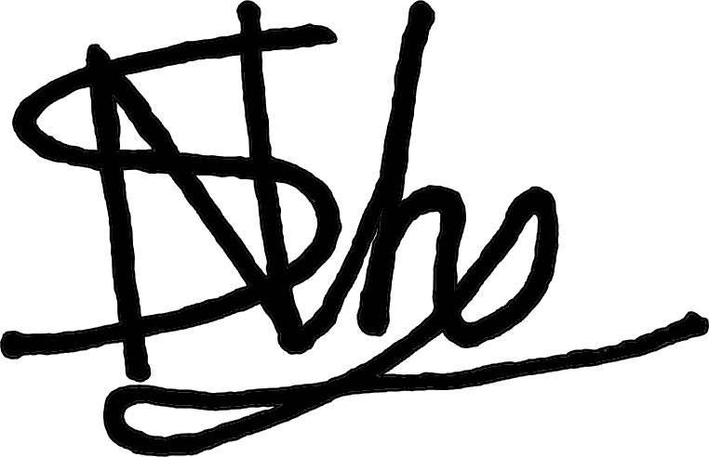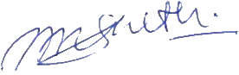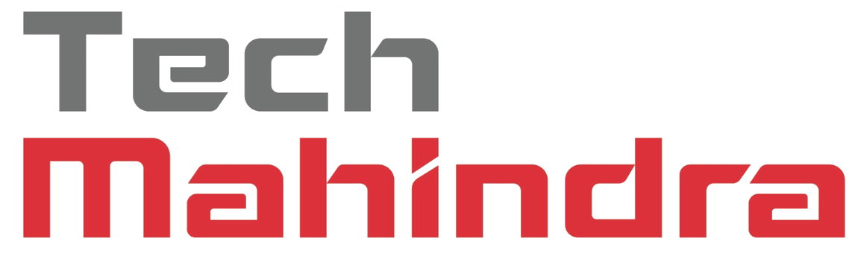

Companies Recruiting ... & Many More