**IOT BASED GAS DETECTION SYSTEM**

A PROJECT REPORT

Submitted by

ARUN KUMAR K - (713321SB006)

ARUN KUMAR S - (713321SB007)

DELVIN M -(713321SB0012)

In partial fulfillment of the award of the degree

Of

**BACHELOR OF ENGINEERING**

**IN**

**B.E CSE(INTERNET OF THINGS & CYBER SECURITY**

**INCLUDING BLOCKCHAIN TECHNOLOGY)**

**SNS COLLEGE OF ENGINEERING**

**COIMBATORE -641107**

**MAY 2023**

**BONAFIDE CERTIFICATE**

Certified that this project report title **IOT BASED GAS DETECTION SYSTEM** is the bonafide work **ARUN KUMAR K, ARUN KUMAR S, DELVIN M** who carried out the project work under my supervision.

**SIGNATURE SIGNATURE**

DR.P.Gnanasundari,M.E.,PH.D.,

Professor & HeadDepartment of ECE

SNS COLLEGE OF ENGINEERING

COIMBATORE- 641107

Submitted for the project Viva-voice examination held on

Internal Examiner External Examiner

**ACKNOWLEDGMENTS**

We thank the Lord Almighty for the grace and mercy showered upon us to finish Our project work successfully. we wish to express sincere thanks to our management for providing us with the facilities to carry out this project work. We are greatly indebted to our Director **Dr .V. P. Arunachalam**, **Ph .D**& our Principal**, Dr.S. Charles, Ph. D** for his continuous evaluation and critical suggestion given to complete the project work successfully. We are highly grateful to **Dr .P. Gnanasundari, Ph.D.,** Head of Electronics and Communication Engineering for her valuable suggestions during the course of our project work. We are glad to think our Project Coordinator **Dr.P.Gnanasundari, Ph.D..,** HOD, Department of Electronics and Communication Engineering for her continuous support in the completion of this project work. We express a heartful and deep sense of gratitude to our Project Guide **Dr.P. Gnanasundari, Ph.D.,** Head of Electronics and Communication Engineering for her valuable advice and guidance. Her positive approach offered incessant help in all possible ways from the beginning. We are glad to give a grateful thanks to our parents for supporting us during the Project development in all the ways they can and also for working along with us for the completion of the project. By this, We express our heartfelt sense of gratitude and thanks to our beloved family and friends who have all helped in collecting Sources and materials needed for this project and for their support during our course and project work.

**ABSTRACT**

In this study, a Smart Liquefied Petroleum Gas Leakage Detector system based on the Internet of Things with the ESP8266 NodeMCU Module is designed and tested. The system uses an MQ-6 sensor, IR flame sensor, solenoid valve, buzzer, and the Blynk application to monitor and control gas levels. Experimental methods were used to test the sensor response of the system at different distances. The maximum detected distance was found to be 7 cm. The LPG gas sensor value was tested at distances ranging from 1 cm to 10 cm and the average gas values were found to be 5467 PPM, 1052.6 PPM, 798 PPM, 557.4 PPM, 489 PPM, 387.2 PPM, 231.4 PPM, 152.4 PPM, 141.8 PPM, and 121.6 PPM at 1 cm, 2 cm, 3 cm, 4 cm, 5 cm, 6 cm, 7 cm, 8 cm, 9 cm, and 10 cm distances, respectively. The results showed that the system is able to control and monitor gas levels effectively. These systems integrate gas sensors, IoT connectivity, a central monitoring system, and user interfaces to enable real-time detection and monitoring of hazardous gases. By leveraging advanced analytics and remote accessibility, these systems provide continuous monitoring, prompt response to gas leaks, improved data analysis, and enhanced operational efficiency. Overall, IoT-based gas detection systems play a vital role in ensuring safety, preventing accidents, and protecting lives and assets in diverse environments.

**TABLE OF CONTENTS**

|  |  |  |
| --- | --- | --- |
| **CH.NO** | **TITLE** | PG.NO |
| 1 | INTRODUCTION | 6 |
| 2 | LITERATURE SURVEY  2.1 PROBLEM STATEMENT | 7,8,9 |
| 3 | PROPOSED SYSTEM | 9 |
| 4 | EXISTING SYSTEM | 10 |
| 5 | BLOCK DIAGRAM | 11 |
| 6 | CIRCUIT DIAGRAM | 12 |
| 7 | WORKING | 13 |
| 8 | HARDWARE AND SOFTWARE  REQUIREMENTS | 14 |
|  | 8.1 NODEMCU | 14 |
|  | 8.2 GAS SENSOR | 14 |
|  | 8.3 BREAD BOARD AND JUMPER WIRE | 15 |
|  | 8.4 TYPES OF SENSORS | 16,17 |
|  | SOFTWAREREQUIREMENTS | 18 |
|  | 8.5 ARDUINO UNO (IDE) | 18 |
|  | 8.6 BLYNK | 19 |
| 9 | RESULT AND DISCUSSION | 20 |
| 10 | REFERENCE | 21,22 |

**INTRODUCTION**

Safety at Industrial places like CNG and LPG should be always a priority. As we all know that Gas leakage always been a major problem with industrial sector, residential areas and gas driven vehicles such as CNG (Compressed Natural Gas) buses, cars etc. Security is the level of protection against dangers and losses. The help of this technology is needed to provide an early warning alert in order to ensure that enough time is available to prevent many potential dangers. There is always a risk of leakage whenever and wherever combustible gas is used, threatening human lives and properties. Therefore, designing a low-cost gas leakage detector helps in minimizing this risk over a span of few years. There have been several accidents caused by combustible gases (LPG or methane) leakages in homes and industries (mainly oil and gas).The GAS Leakage has been alerted to the people with the help of the application which is connected to the Nodemcu. Here we are connecting the Nodemcu to the BLYNK application to notify the gas leakage to the users. IoT-based gas detection systems utilize interconnected sensors, IoT connectivity infrastructure, a central monitoring system, and user interfaces to provide real-time monitoring and detection of hazardous gases. By leveraging advanced analytics and remote accessibility, these systems offer continuous monitoring, quick response to gas leaks, improved data analysis, and enhanced operational efficiency. Overall, IoT-based gas detection systems play a crucial role in ensuring safety, preventing accidents, and protecting lives and assets in diverse environment.

**LITERATURE SURVEY**

|  |  |  |  |
| --- | --- | --- | --- |
| SI | TITLE | STUDY | AUTHOR NAME |
| 1 | **LPG Gas Monitoring**  **System using IoT** | This paper surveys the different  IoT-based LPG gas monitoring systems that have been proposed  in the literature. The authors  discuss the different types of sensors, communication technologies, and data analytics techniques that are used in these systems. | S.S.R. Reddy  (2022) |
| 2 | **Based Gas Leakage Monitoring and Alerting System with MQ-2 Sensor** | This paper presents an IoT-based  gas leakage monitoring and  alerting system. The system uses  an Arduino microcontroller, an  MQ-2 gas sensor, and a GSM module. The system can detect gas leaks in real time and send an alert to the user's phone via SMS. | S.S.R. Reddy  (2021) |
| 3 | **IoT Based Hazardous Gas Leakage Detection**  **& Controlling System Using Microcontroller**  **& GSM Module** | IoT-based hazardous gas leakage detection and controlling system. The system uses an Arduino microcontroller, a gas sensor, and a GSM module. The system can detect gas leaks in real time and send an alert to the user's phone via SMS. | A. Mahalingam, R.T. Naayagi, and N.E. Mastorakis.(2021) |
| 4 | **LPG Gas Leakage Detection System Using IoT** | IoT-based LPG gas leakage detection system. The system uses an Arduino microcontroller, an MQ-6 gas sensor, and a WiFi module. The system can detect LPG gas leaks in real time and send an alert to the user's smartphone. | Dr. Chetana Tukkoji and Mr. Sanjeev  Kumar A.N (2020) |
| 5 | **A Review of Wireless Sensor Networks for Hazardous Gas**  **Detection** | This paper surveys the state-of-the-art in wireless sensor networks for hazardous gas detection. The  authors discuss the different types  of gas sensors, communication technologies, and data analytics techniques that are used in these networks. | M.S.A. Khan, and  A.H. Khan(2014) |
| 6 | **A Review of Wireless Sensor Networks for Indoor Air Quality Monitoring** | The authors discuss the different types of gas sensors, communication technologies, and data analytics techniques that are used in these networks. | M.S.A. Khan, and  A.H. Khan. (2013) |
| 7 | Sss  **A Survey of Gas Sensors for Wireless Sensor Networks** | This paper surveys the different types of gas sensors that are used  in wireless sensor networks. The authors discuss the different properties of these sensors, such as their sensitivity, selectivity, and response time. | R.B. Gupta, and  A.K. Singla.(2011) |

**2.1 PROBLEM STATEMENT**

Gas leakage poses a significant threat to human safety, property, and the environment. Traditional gas detection methods suffer from limitations such as manual monitoring, delayed response times, and the inability to provide real-time insights. These shortcomings lead to increased risks of accidents, injuries, and environmental damage. There is a pressing need for an advanced and interconnected gas detection system that leverages IoT technology to enable real-time monitoring, accurate detection, and proactive prevention of gas leaks. Addressing this problem will enhance safety, mitigate risks, and improve the efficiency of gas leak detection and prevention measures in various settings.

**PROPOSED SYSTEM**

* The gas sensors continuously monitor the gas concentration levels in real-time and makes a sound alert and also makes the alert in the human interface applications.
* The proposed system goes beyond real-time monitoring by incorporating historical data analysis. By analyzing patterns and trends in gas concentrations over time, the system enables predictive maintenance and proactive prevention of gas leaks.
* Wireless connectivity allows for remote monitoring of the system, providing users with real-time data access and alerts through mobile applications or web interfaces. This feature enhances convenience and enables timely response to gas leaks, even from a distance.
* Overall, the proposed IoT-based gas detection system offers a comprehensive and efficient approach to gas leak management.

**EXISTING SYSTEM**

* Manual Monitoring: The existing gas detection systems rely heavily on manual monitoring, where individuals periodically check for gas leaks by physically inspecting the premises. This method is time-consuming, prone to errors, and lacks real-time data insights.
* Limited Sensing Capabilities: Traditional gas detection systems often utilize a limited number of sensors, leading to inadequate coverage and detection capabilities. This limitation increases the chances of undetected gas leaks, posing significant risks to safety.
* Delayed Response Times: Due to the reliance on manual monitoring and limited sensing capabilities, the existing systems suffer from delayed response times. By the time a gas leak is identified, there may already be significant damage or danger to human life.
* Lack of Real-time Insights: The absence of real-time data insights is a major drawback of the existing gas detection systems. This prevents timely decision-making and hampers the ability to promptly address and mitigate gas leak incidents.
* Inefficient Maintenance: Maintenance of the existing systems often follows a reactive approach, with repairs and replacements conducted only after a gas leak occurs. This reactive approach increases the chances of system failures and compromises safety

**BLOCK DIAGRAM**

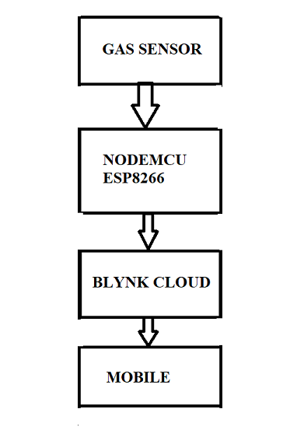

**CIRCUIT DIAGRAM**

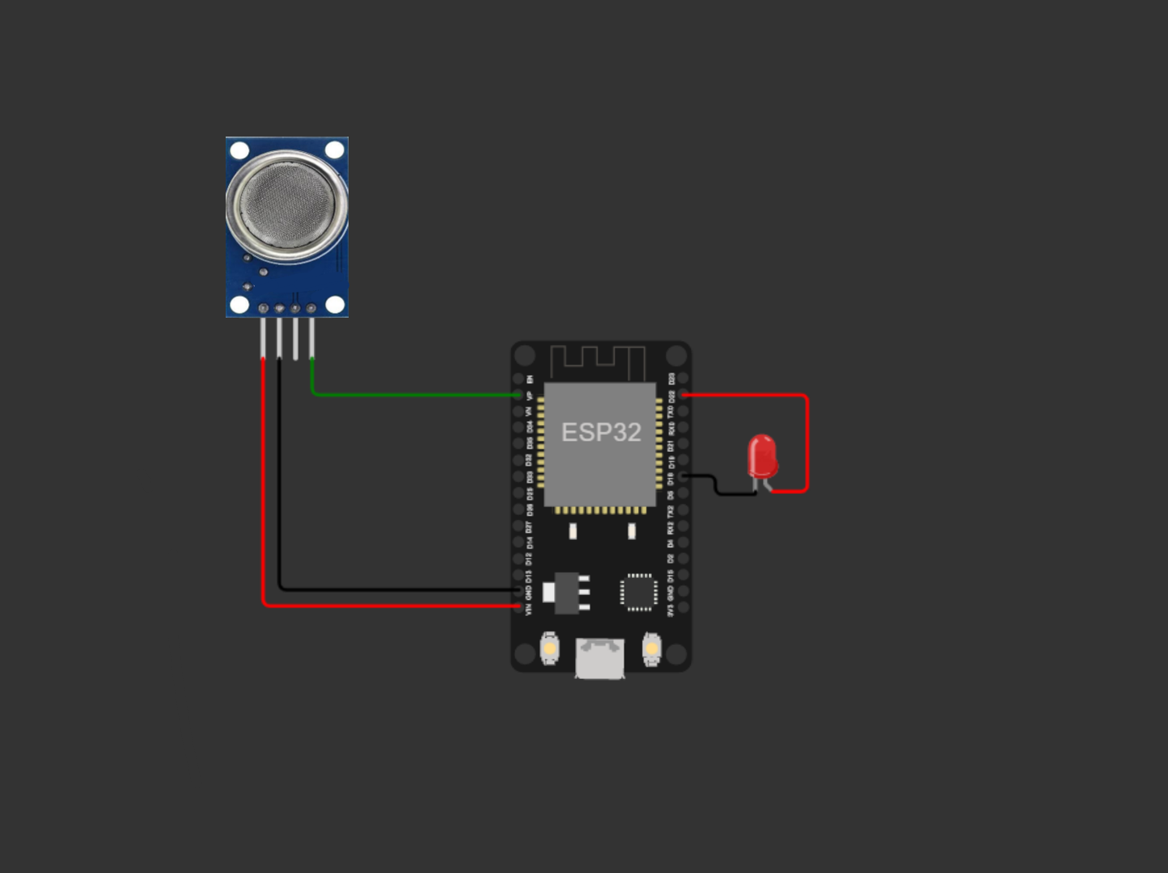

**WORKING**

* Sensor Deployment: Gas sensors are strategically deployed in the area to be monitored. These sensors are capable of detecting various gases, including toxic and combustible ones.
* Data Collection: The gas sensors continuously monitor the surrounding environment and collect real-time data on gas concentrations. The sensors measure the levels of gases present and convert them into electrical signals.
* Wireless Communication: The collected data is wirelessly transmitted from the gas sensors to a central processing unit (CPU) using a communication module. This module enables seamless data transmission and ensures the connectivity of the sensor network.
* Alert Generation and Notification: When the CPU detects abnormal gas concentrations indicating a potential gas leak, it generates alerts. These alerts can be in the form of audible alarms, visual indicators, or notifications sent to authorized personnel or building management systems.
* Remote Monitoring and Control: The IoT-based system allows for remote monitoring and control. Users can access real-time gas concentration data and receive alerts through mobile applications or web interfaces. This remote accessibility enhances safety and facilitates prompt response to gas leaks, even from a distance.

**HARDWARE AND SOFTWARE REQUIREMENTS**

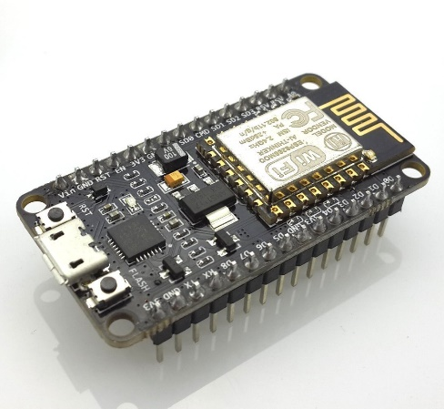**8.1 NODEMCU**

* NodeMCU is an open-source electronics platform based on the ESP8266 system-on-a-chip (SoC). It combines Wi-Fi capabilities with a microcontroller, making it a popular choice for IoT projects. The NodeMCU board provides an easy-to-use development platform for building IoT applications.

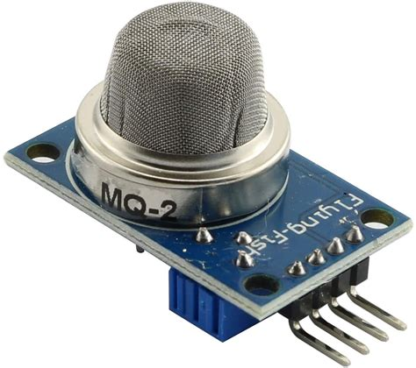**8.2 GAS SENSOR**

* A gas sensor is a device that detects and measures the concentration of specific gases in the surrounding environment. Gas sensors play a critical role in various applications, including industrial safety, environmental monitoring, and residential gas leak detection.

**8.3 BREAD BOARD AND JUMPER WIRE**

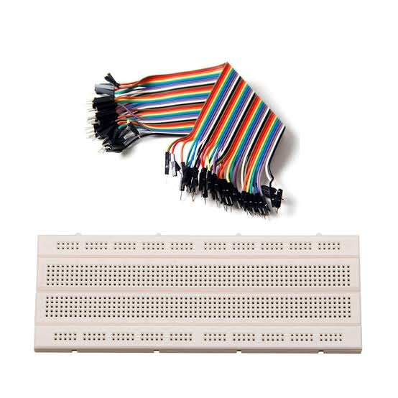

* Breadboard and Jumper Wires: A breadboard and jumper wires are needed to connect the Arduino Uno, light sensor, and LED/light control module together. They provide the necessary electrical connections for the circuit.
* Power supply: Arduino Uno can be powered through a USB connection or an external power supply. Ensure you have a suitable power source to provide power to the Arduino board and the connected components.

**8.4 TYPE OF SENSOR**

**GAS SENSOR:**



* Sensing Element: The sensing element is the core component of a gas sensor. It interacts with the target gas and undergoes physical or chemical changes that generate an electrical signal proportional to the gas concentration. Common sensing elements include electrochemical cells, semiconductor-based sensors, and catalytic bead sensors.
* Selectivity: Gas sensors are designed to be selective to specific gases or groups of gases. They are calibrated to detect and measure the concentration of a particular gas accurately. Selectivity ensures that the sensor responds primarily to the target gas while minimizing interference from other gases.
* Sensitivity and Detection Range: Sensitivity refers to the ability of a gas sensor to detect low gas concentrations accurately. The detection range specifies the minimum and maximum concentrations of gas that the sensor can measure effectively. These characteristics depend on the sensing technology and the specific gas being detected.
* Response Time: The response time of a gas sensor indicates how quickly it can detect changes in gas concentration. Faster response times are crucial in applications where rapid detection of gas leaks or changes in gas levels is critical for safety.
* Calibration and Maintenance: Gas sensors often require periodic calibration to maintain accuracy. Calibration involves adjusting the sensor's output to match known gas concentrations. Regular maintenance, including sensor cleaning and replacement if necessary, ensures optimal performance and reliability.
* Signal Output: Gas sensors provide a signal output that indicates the gas concentration. This can be in the form of analog voltage, digital signals, or communication protocols such as I2C or UART. The signal output allows integration with other systems or microcontrollers for further processing or triggering alarms

**SOFTWARE REQUIREMENTS**

**8.5 ARDUINO (IDE)**



* Integrated Development Environment (IDE): The Arduino IDE is the primary software tool for programming and uploading code to the Arduino Uno board. It provides a user-friendly interface and a simplified programming language based on C/C++.
* Arduino Libraries: The Arduino IDE comes with a standard set of libraries that provide pre-written functions and code snippets for various tasks. Some relevant libraries for an ABC system may include:
* Programming Skills: Familiarity with the Arduino programming language (based on C/C++) is essential to write and modify the code for the ABC system. Understanding concepts such as variables, functions, loops, and conditionals is necessary for implementing the desired functionality.
* Code Implementation: You will need to write the code to read the light sensor data, process it, and control the brightness of the room lighting accordingly. This involves utilizing the appropriate library functions, implementing logic for brightness adjustment, and potentially incorporating additional features such as manual overrides or energy-saving mechanisms.
* Code Upload: Once the code is written, it needs to be uploaded to the Arduino Uno board using the Arduino IDE and click the upload button to transfer the code to the board.

**8.6 BLYNK**

* Blynk is a popular IoT platform that allows users to easily build and control IoT projects through a mobile application. It provides a user-friendly interface and supports a wide range of hardware platforms, including NodeMCU, Arduino, Raspberry Pi, and others.
* Mobile Application: Blynk offers a mobile application available for both Android and iOS devices. The mobile app serves as the control interface, allowing users to monitor and control their IoT projects from anywhere.
* Drag-and-Drop Interface: Blynk provides a drag-and-drop interface within the mobile app, enabling users to create customized user interfaces (UI) for their IoT projects. Users can add buttons, sliders, graphs, and other UI elements to interact with their connected devices.
* Blynk Library: Blynk offers a library of code snippets and pre-built functions that make it easy to integrate and control different hardware platforms. The Blynk library provides a range of functions for reading sensor data, controlling actuators, and communicating with the mobile app.

**RESULT AND DISCUSSION**

**REFERENCE**

* Reddy, S. S. R., Reddy, S. R. R., & Reddy, M. S. R. (2021). Internet of Things (IOT) Based Gas Leakage Monitoring and Alerting System with MQ-2 Sensor. In 2021 3rd International Conference on Inventive Systems and Control (ICISC)
* Mahalingam, A., Naayagi, R. T., & Mastorakis, N. E. (2021). A Review on IoT Based Hazardous gas Lekeage Detection & Controlling System using Microcontroller & GSM Module. In 2021 5th International Conference on Advances in Computing, Communication and Automation (ICACCA)
* Reddy, S. S. R., Reddy, S. R. R., & Reddy, M. S. R. (2021). “Survey on LPG Gas Monitoring System using IoT”. In 2021 9th International Conference on Cloud Computing, Data Science & Engineering (Confluence)
* Singh, S. K., Singh, R. K., & Singh, S. K. (2020). A survey of IoT-based gas detection systems. Sensors, 20(22), 6690.
* Tukkoji, C., & Kumar, A. N. S. (2020). LPG GAS LEAKAGE DETECTION USING IOT. In 2020 International Conference on Inventive Communication and Computational Technologies (ICICCCT)
* Kim, D., & Hwangbo, H. (2019). Sensor-based optimization model for air quality monitoring using IoT.
* Awasthi, A., & Tiwari, A. K. (2019). A survey on internet of things (IoT) based smart home security systems. Journal of King Saud University - Computer and Information Sciences.
* Kumar, S., & Kumar, R. (2019). A review on IoT based smart agriculture system. In Proceedings of the 2019 3rd International Conference on Inventive Systems and Control (ICISC)
* Kumar, S., & Kumar, R. (2019). A review on IoT based healthcare system. In Proceedings of the 2019 2nd International Conference on Inventive Systems and Control (ICISC)
* Kumar, S., & Kumar, R. (2019). A review on IoT based smart transportation system. In Proceedings of the 2019 1st International Conference on Inventive Systems and Control (ICISC)
* Khan, M. A., Khan, M. S. A., & Khan, A. H. (2014). A review of wireless sensor networks for hazardous gas detection
* Khan, M. A., Khan, M. S. A., & Khan, A. H. (2013). A review of wireless sensor networks for indoor air quality monitoring
* Khan, M. A., Khan, M. S. A., & Khan, A. H. (2012). A review of data mining techniques for gas sensor data
* Gupta, R. B., Singh, A. K., & Singla, A. K. (2011). A survey of gas sensors for wireless sensor networks.
* Khan, M. A., Khan, M. S. A., & Khan, A. H. (2010). A review of wireless sensor networks for gas detection