**Deploying a Basic Java based application using Apachen Maven & Tomcat**

**Step1:** Create a Ec2-Instance with port ssh & HTTP-8080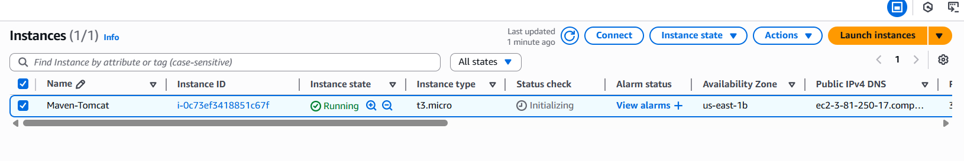

**Step2:** Update the server and Install required Packages.

* java -v
* sudo apt install openjdk-17-jre-headless
* java -version

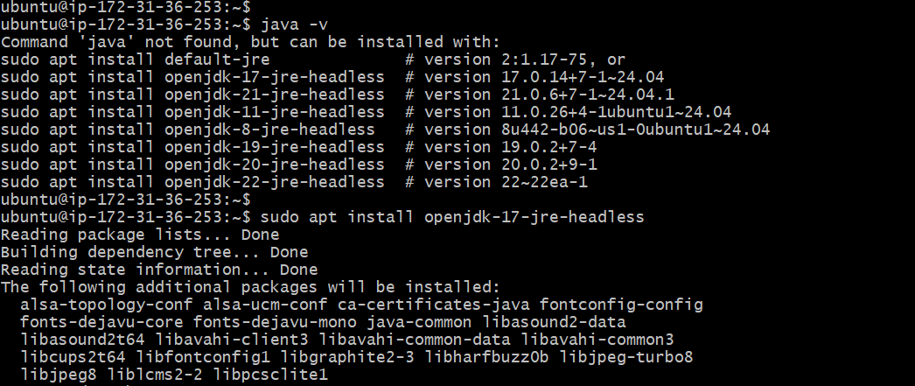

* sudo apt install maven -y
* mvn -v

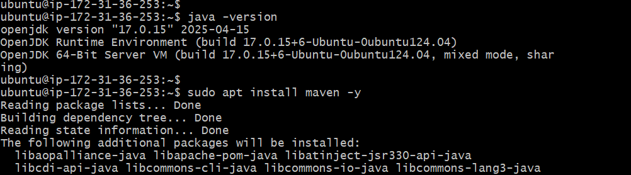

* wget <https://dlcdn.apache.org/tomcat/tomcat-11/v11.0.9/bin/apache-tomcat-11.0.9.zip>
* sudo apt install unzip
* unzip apache-tomcat-11.0.9.zip
* sudo mv apache-tomcat-11.0.9 /opt/tomcat
* cd /opt/tomcat/

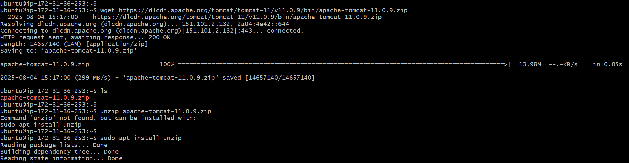

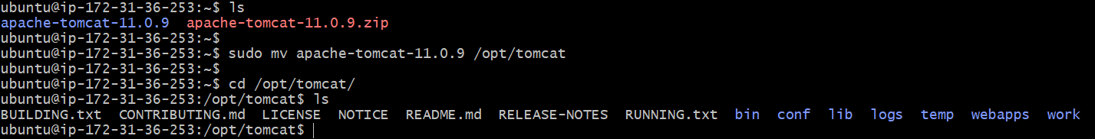

* cd bin/
* sudo chmod 755 startup.sh shutdown.sh catalina.sh
* ls
* ./startup.sh

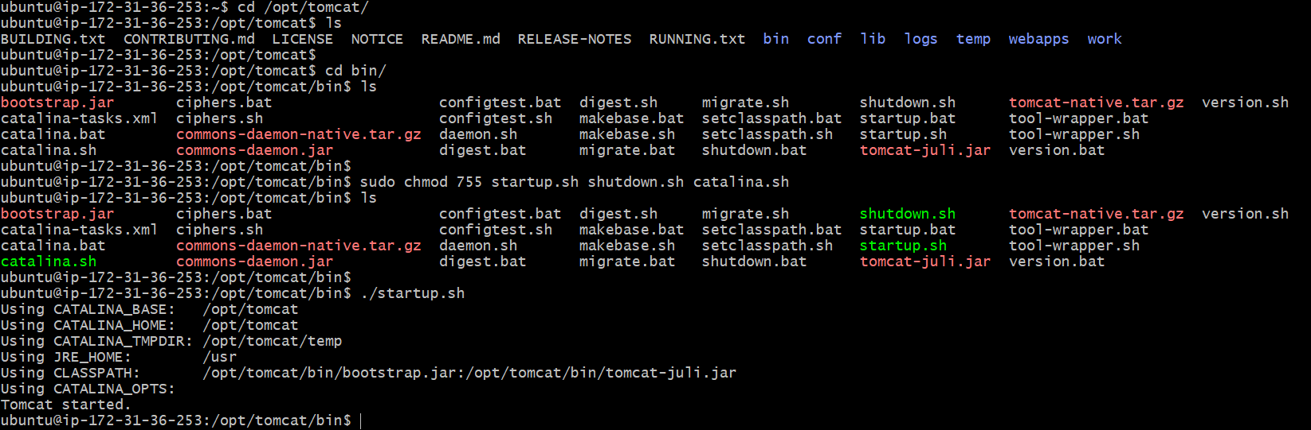

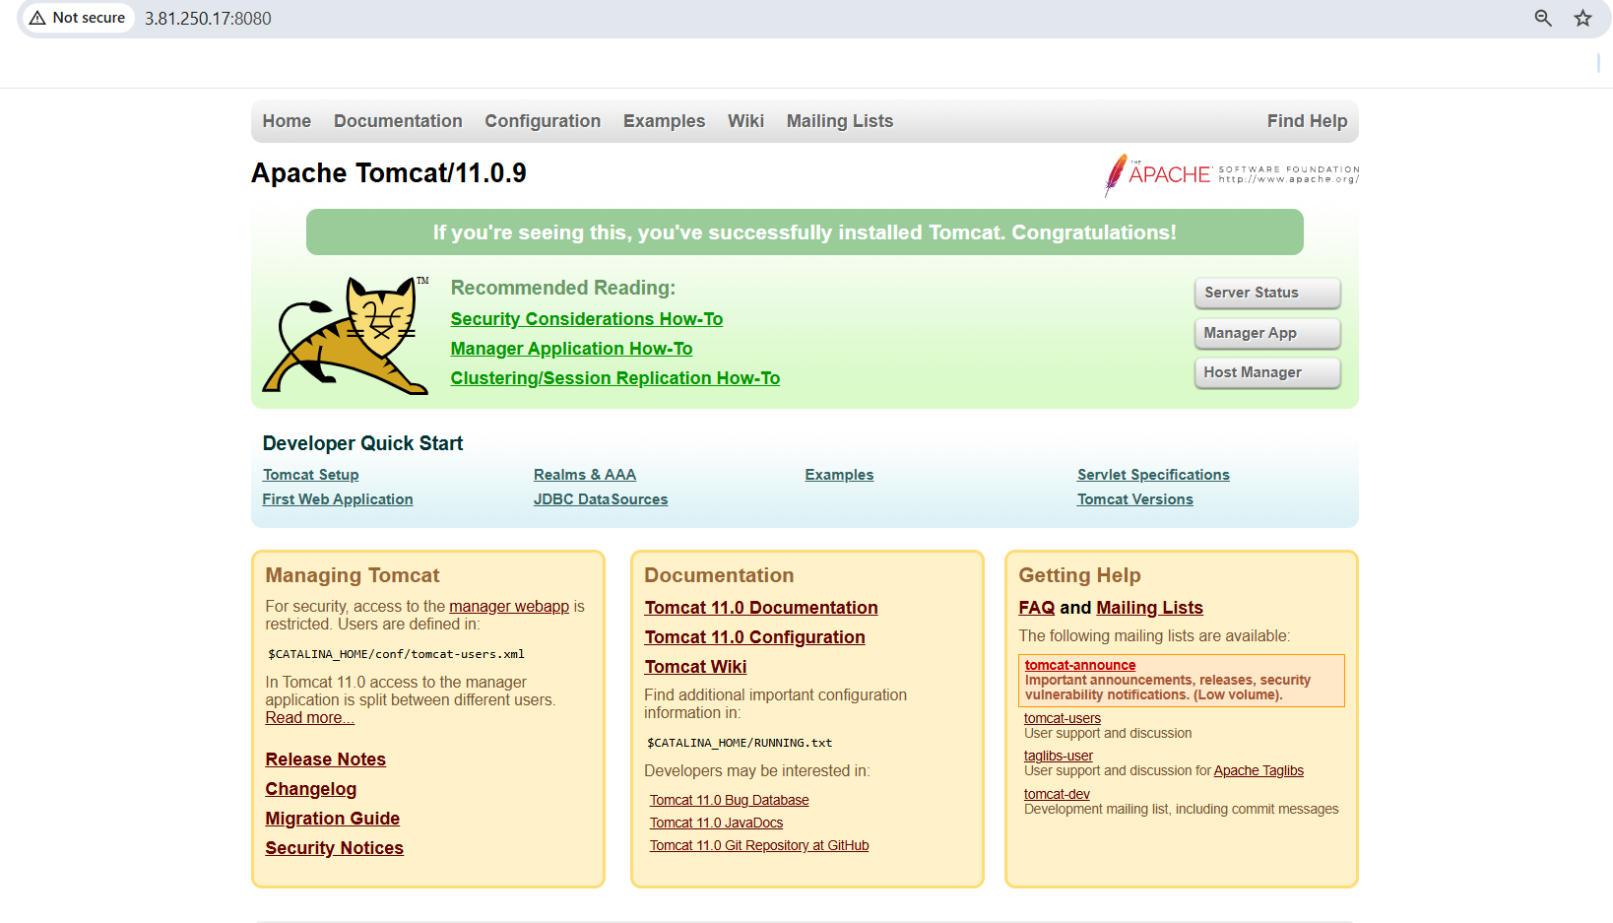

**Step3:** Ensure the credentials to login

* cd conf/
* ls
* vi tomcat-users.xml



<www.linkedin.com/in/arun-kumar-akula>

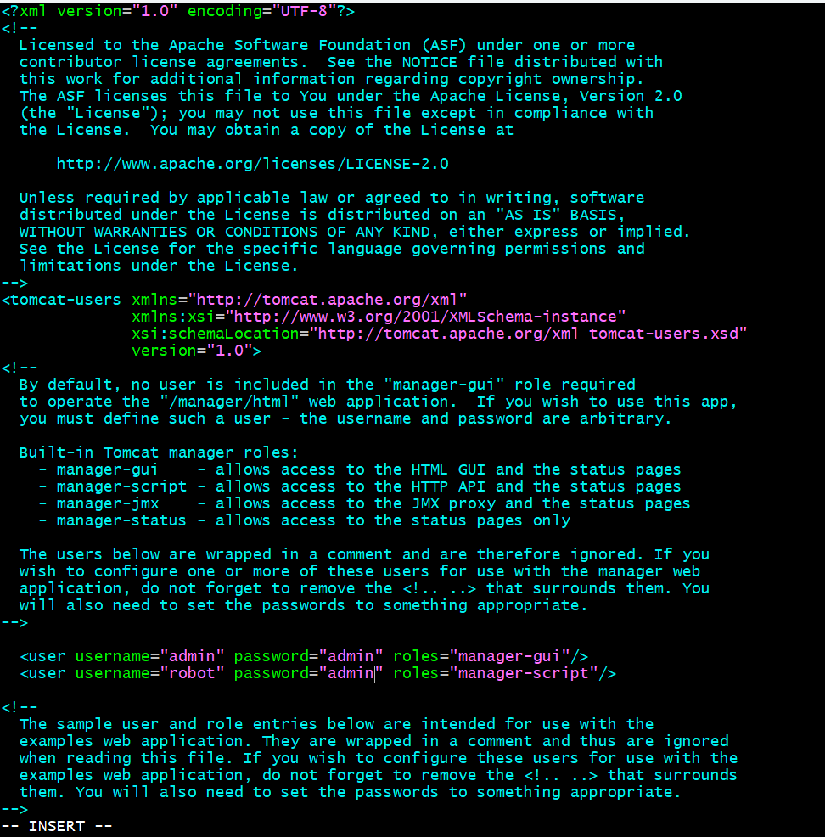

* cd /opt/tomcat/webapps/
* cd host-manager/
* cd META-INF/
* vi context.xml

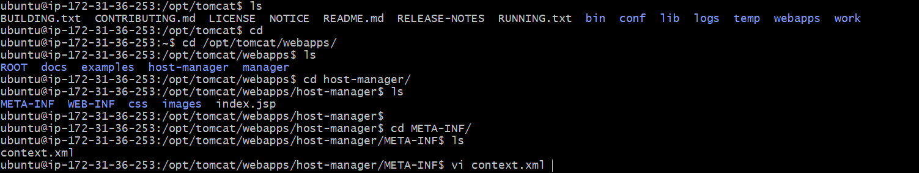

* Here change the allow=”127.0.0.0 to “.*”

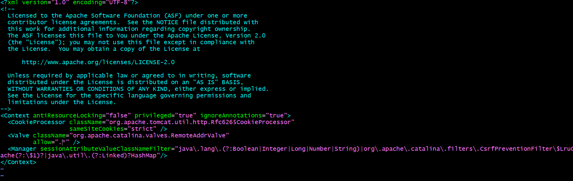

* cd manager/
* cd META-INF/
* vi context.xml

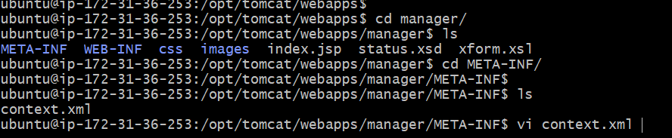

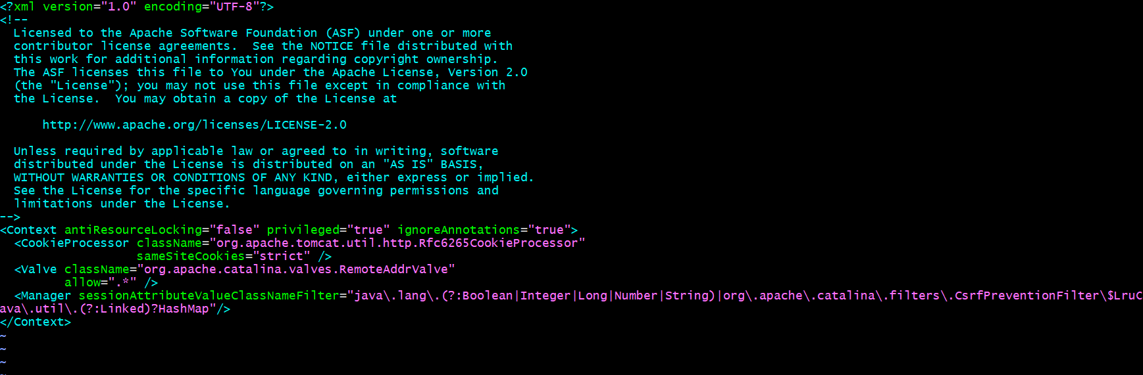

* Same changes as Host-manager file in Manager file.

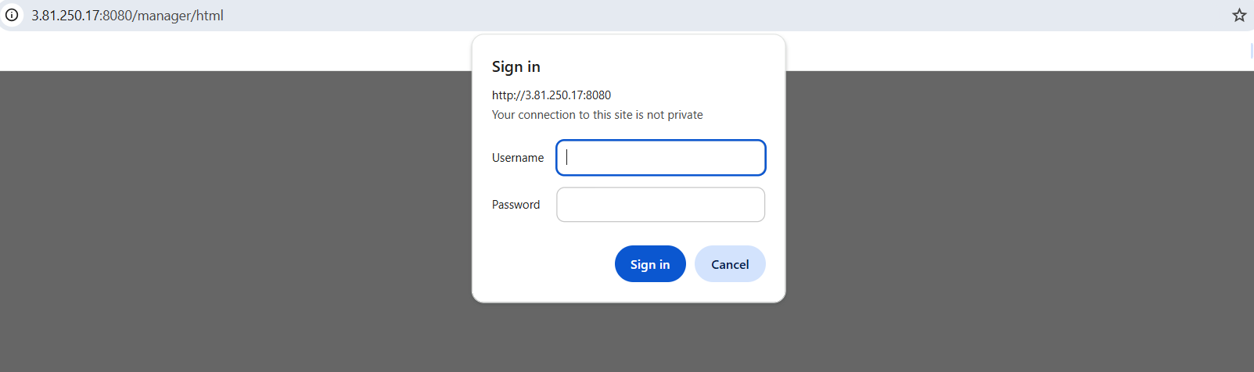

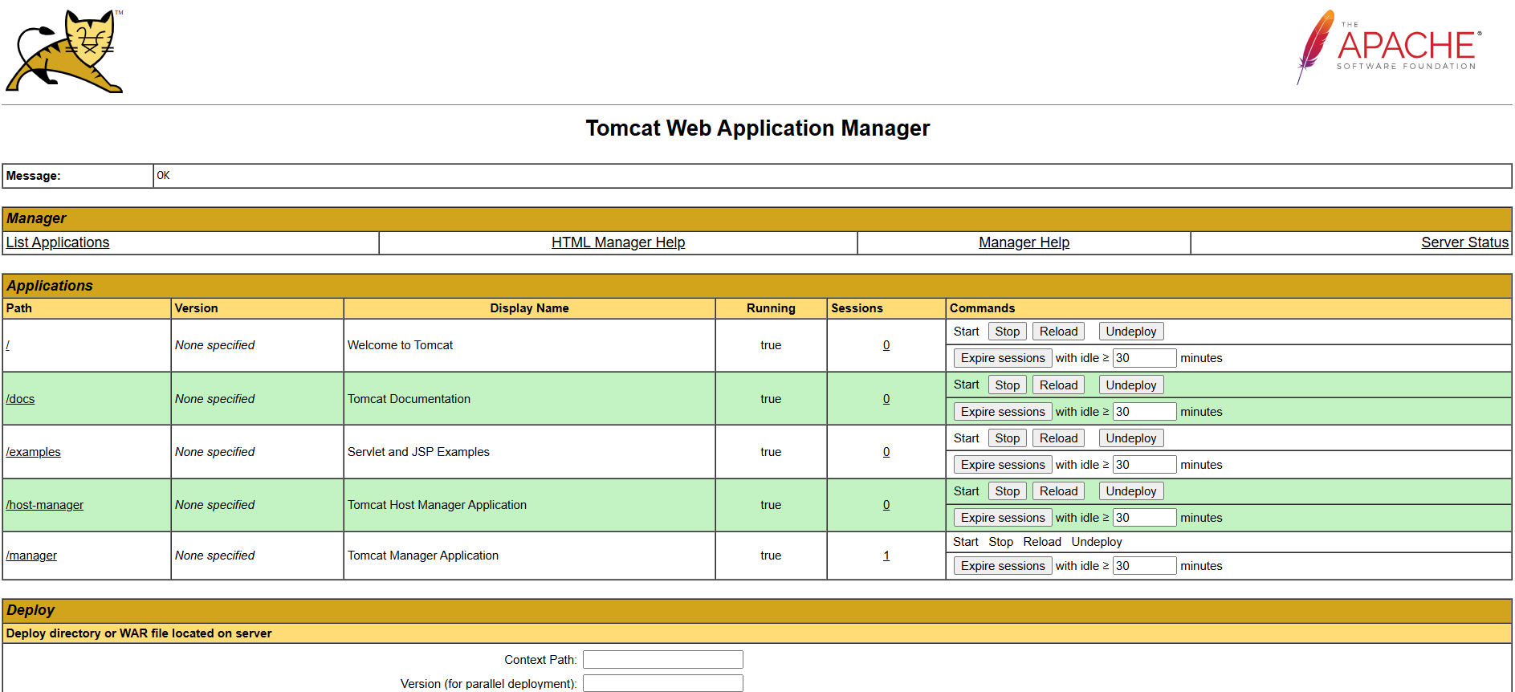

**Step4:** Clone the code as Build the code

* git clone <https://github.com/shashirajraja/Train-Ticket-Reservation-System.git>
* cd Train-Ticket-Reservation-System/

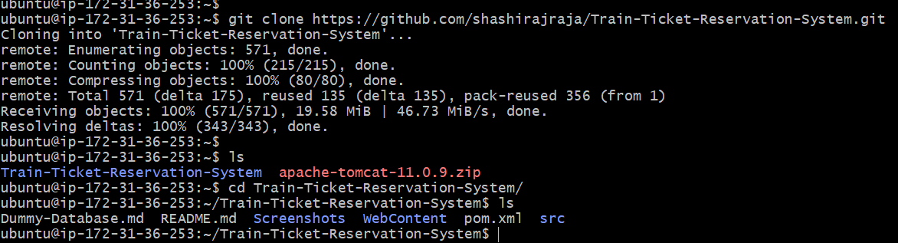

<www.linkedin.com/in/arun-kumar-akula>

* Mvn validate
* Mvn test

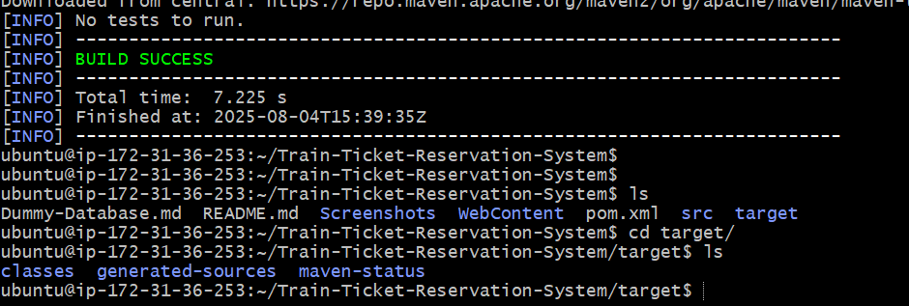

* After Test phase maven will create the Target without the war file.
* Mvn compile
* Mvn package

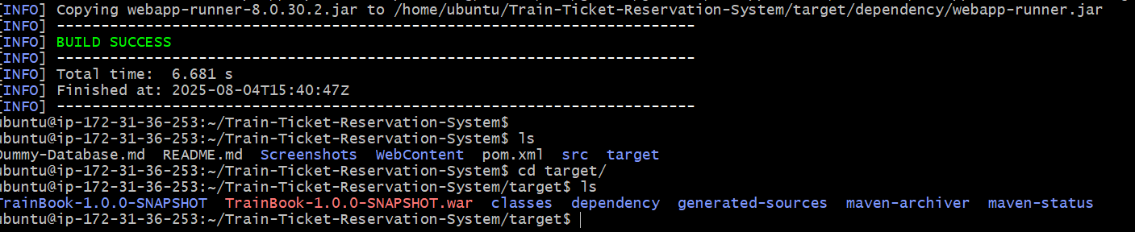

* Now the Build is successfully completed.

**Step5:** Now deploy the war into the Tomcat webapps

* pwd
* cp /home/ubuntu/Train-Ticket-Reservation-System/target/*.war /opt/tomcat/webapps/

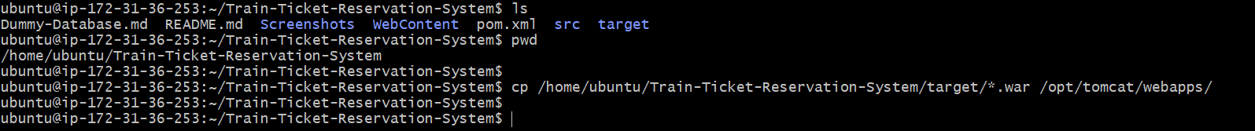

<www.linkedin.com/in/arun-kumar-akula>

* Check the application whether the application is deploy in **Tomcat** or not.!

