Task-10

WIFI ROUTER

Assessment Report by : AMJAD AMEEN |21-09-2024

1.ISP Details

ISP provider- Reliance Jio Infocomm Limited

ASN-AS55836 RELIANCEJIO-IN Reliance Jio Infocomm Limited, IN (registered Oct 27, 2010)

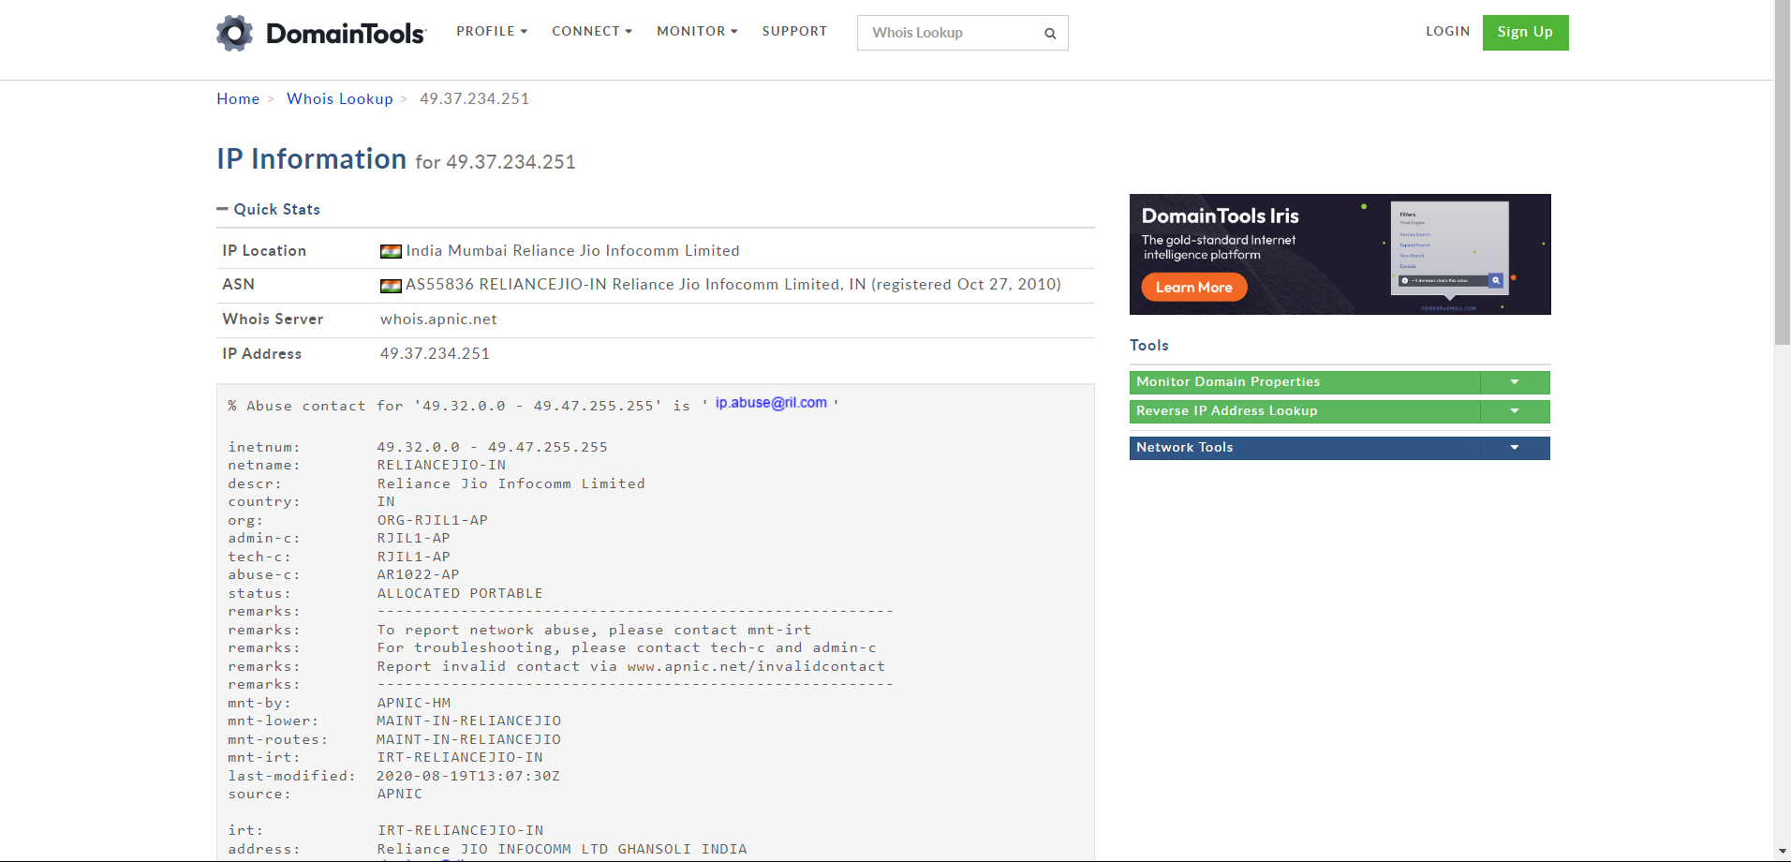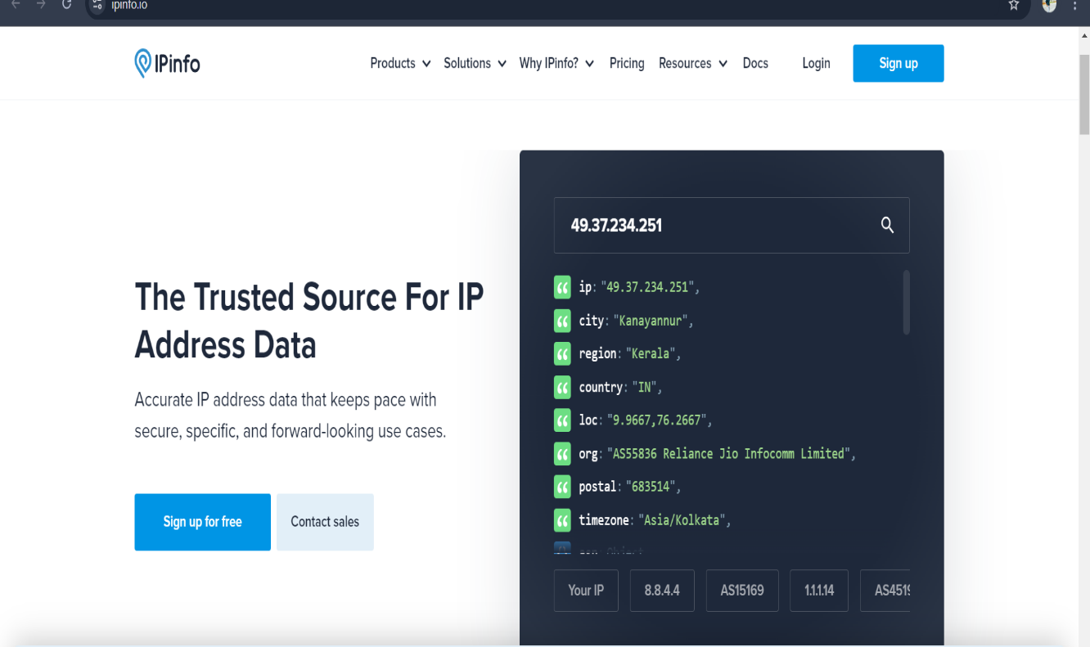

Fig 1 & 2

2. Device Details

Device - JCOW411

Connection type - optical fiber connection

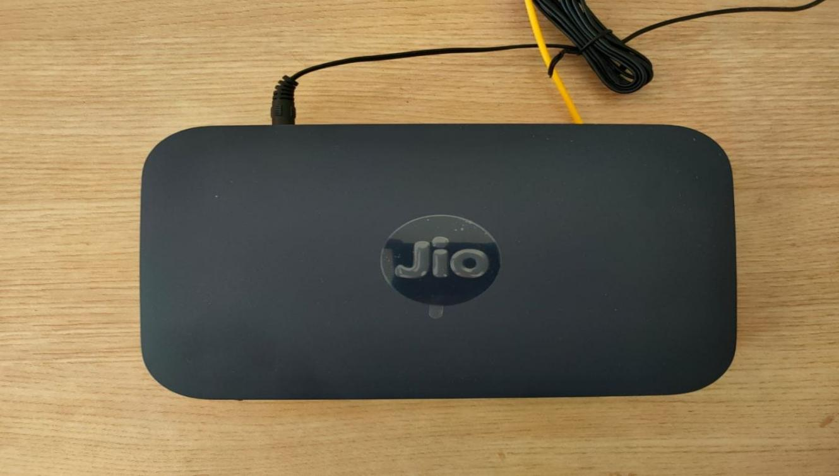

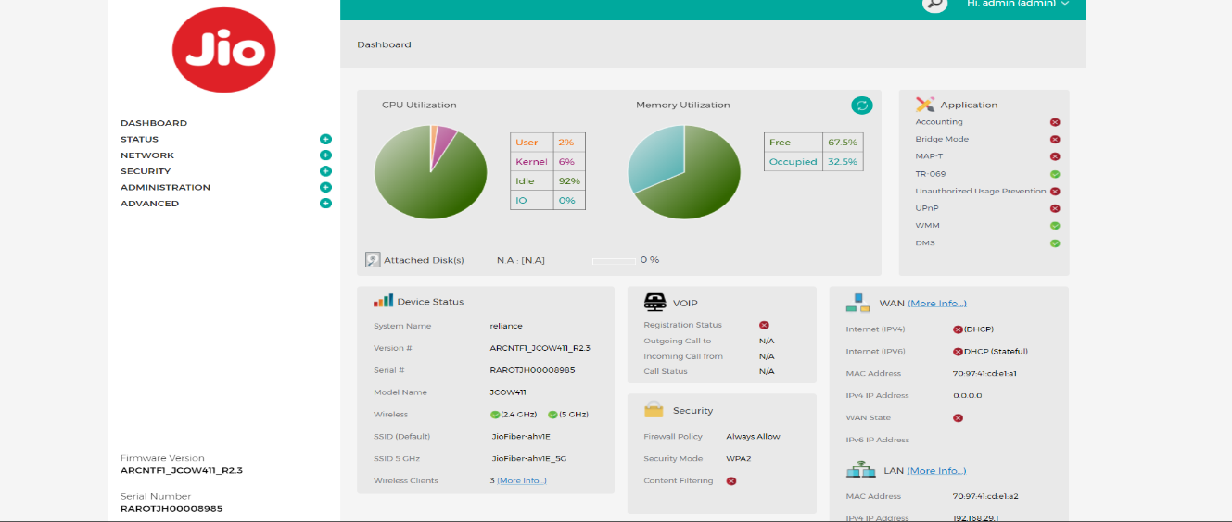 Fig 3 & 4

3 . Wifi Password Details

Default password- Jiocentrum

I have changed the default password to a secure one. No resistance from the user.

4 . Network Configuration

* Take the data on control panel -> network and internet -> network connections

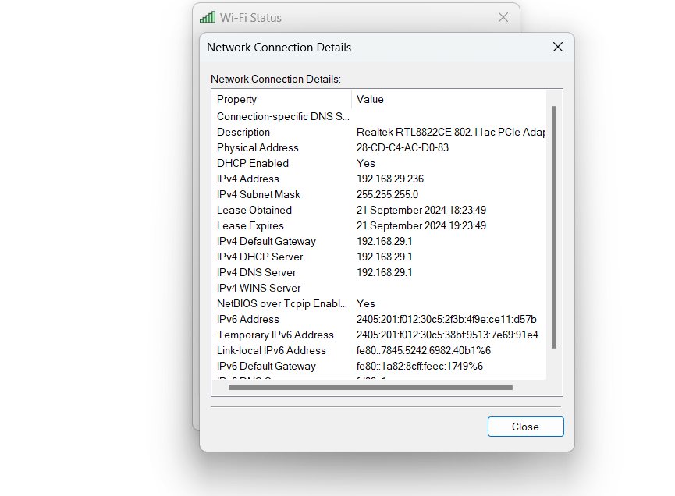

Fig – 5

* Take the data on command prompt

#ipconfig /all

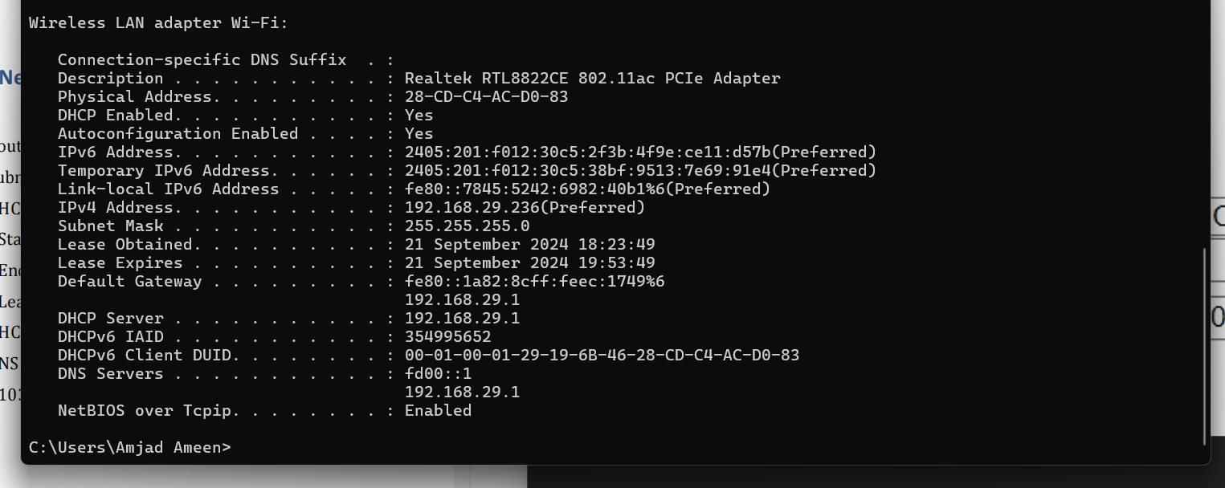

Fig – 6

- Router IP Address: 192.168.29.236

- Subnet Mask: 255.255.255.0

- DHCP Settings:

- Start IP Address: 192.168.29.1

- End IP Address: 192.168.29.256

- Lease Time: One day

- DHCP Proxy Server IP Address: 192.168.29.1

- DNS Mode: From ISP

5.Router Login Details

* Router login was successful using default password Jiocentrum .
* Firstly we can change the default passwords and relogin

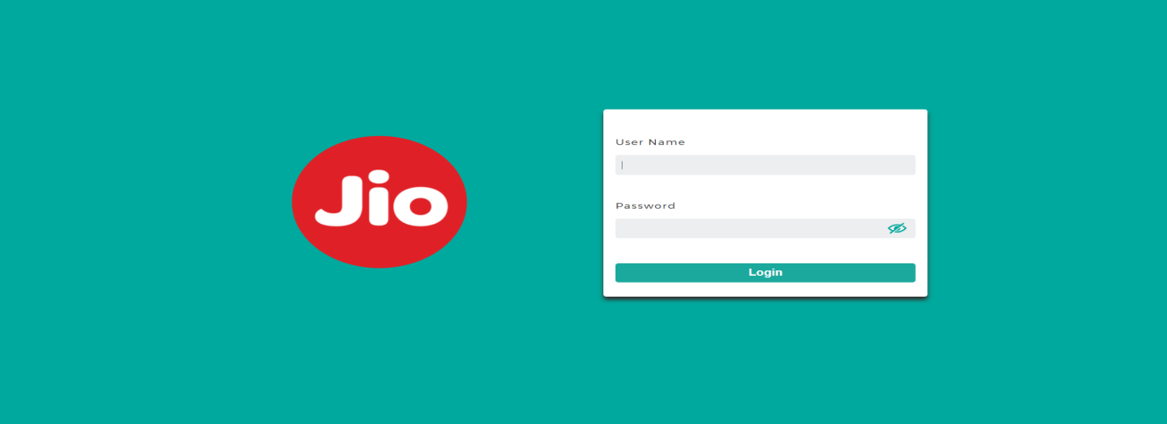

Fig – 7

* 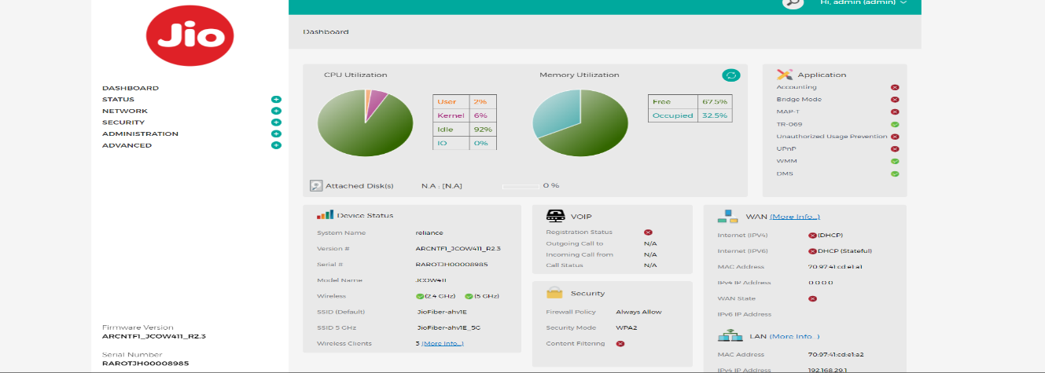Then open Dashboard and see all details of router

Fig - 8

6 . Connected Devices

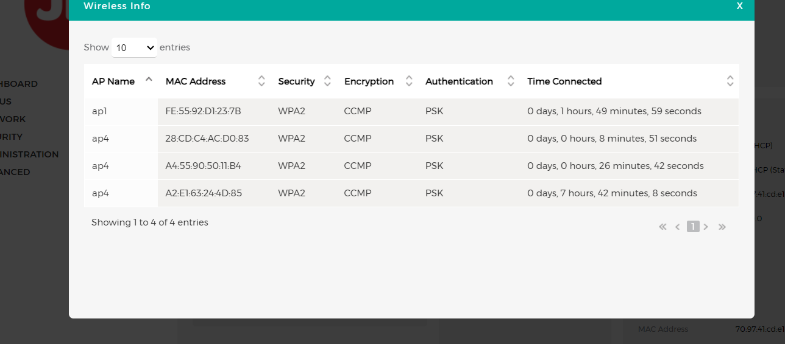

Fig - 9